# Developing a Social App with .Net & Angular

This guide covers the steps required to develop a social app with .Net and Angular. For this project .Net v5.0.402 and Node v16.13.0 is used.

## # Creating the .Net API Project using .Net CLI

Create a new folder for your project. This folder will contain the API and the Angular project.

Open command prompt in this folder end write the command

dotnet new sln

This will create a .sln file in the folder and by default name of the file will be same as the containing folder. Now let’s create a folder for the API project. We will name this folder API. Run the command

dotnet new webapi –o API

This will create a folder named API with few folders and files already in it. Now we need to add the API project to the .sln file. Because right now they are not linked. So run the command

dotnet sln add API

So now the .sln file and the API projects are linked.

## # Some steps will go here

## # Adding API Controller

Create a new controller named UsersController in the Controllers folder.

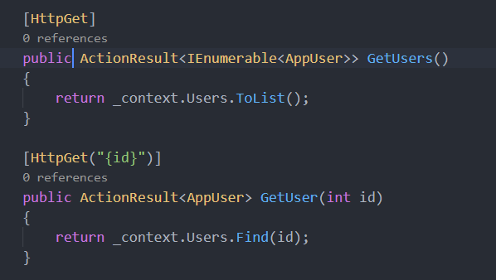

But this code is not asynchronous. We need to make our code more scalable so we will make this code asynchronous.

