|  |  |  |  |  |  |  |  |  |
| --- | --- | --- | --- | --- | --- | --- | --- | --- |
| **Type** | **At stop** | **Location** | **Sample size** | **Max (km/h)** | **Min (km/h)** | **Mean (km/h)** | **Median (km/h)** | **SD (km/h)** |
| Near side | With bus | Upstream area | 102 | 16.67 | 7.35 | 11.77 | 11.62 | 2.19 |
| Bus stop area | 102 | 19.78 | 7.69 | 13.64 | 13.85 | 2.80 |
| Downstream area | 102 | 27.69 | 10.53 | 17.87 | 18.18 | 3.78 |
| Without bus | Upstream area | 102  102  102 | 25.35 | 8.26 | 16.55 | 16.67 | 3.35 |
| Bus stop area | 102 | 28.13 | 6.82 | 16.70 | 17.31 | 4.44 |
| Downstream area | 102 | 32.14 | 6.74 | 16.46 | 17.14 | 8.07 |
| Far side | With bus | Upstream area | 102 | 32.14 | 4.89 | 15.86 | 15.69 | 4.84 |
| Bus stop area | 102  102  102 | 20.69 | 4.04 | 11.09 | 10.59 | 3.65 |
| Downstream area | 102 | 20.93 | 5.92 | 12.23 | 12.22 | 3.04 |
| Without bus | Upstream area | 102 | 40.00 | 12.00 | 24.52 | 24.83 | 5.91 |
| Bus stop area | 102 | 33.96 | 11.25 | 21.03 | 21.95 | 5.43 |
| Downstream area | 102  102  102 | 32.73 | 10.00 | 21.09 | 22.37 | 6.15 |
| Mid-block | With bus | Upstream area | 102 | 35.29 | 6.62 | 18.33 | 18.29 | 5.82 |
| Bus stop area | 102 | 21.18 | 6.59 | 13.64 | 13.74 | 3.29 |
| Downstream area | 102 | 30.00 | 5.06 | 15.08 | 14.89 | 3.95 |
| Without bus | Upstream area | 102  102  102 | 37.50 | 14.40 | 25.59 | 25.71 | 4.76 |
| Bus stop area | 102 | 27.69 | 12.24 | 18.98 | 18.95 | 3.27 |
| Downstream area | 102 | 31.03 | 13.43 | 19.97 | 19.57 | 3.45 |

C:\Users\dell\Desktop\test1.tif

F:\C盘及桌面内容\近期任务\论文\（16年5月）Effects of stopping buses on non-bus vehcles\图\洪武路（near side）速度变化图.tif

(a) Near side

F:\C盘及桌面内容\近期任务\论文\（16年5月）Effects of stopping buses on non-bus vehcles\图\后标营路（far side）速度变化图.tif

(b) Far side

F:\C盘及桌面内容\近期任务\论文\（16年5月）Effects of stopping buses on non-bus vehcles\图\湖南路（mid-block）速度变化图.tif

(c) Mid-block

**Figure**

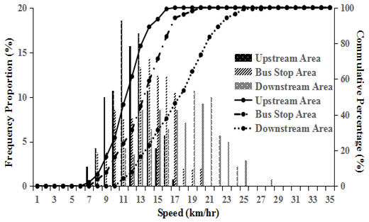 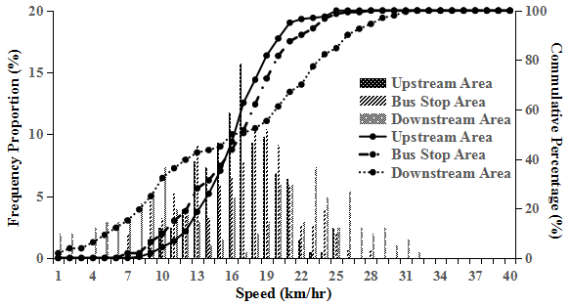 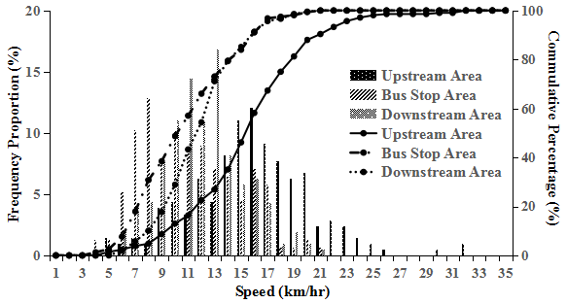

(a1) Near side (with bus at stop) (a2) Near side (without bus at stop) (b1) Far side (with bus at stop)

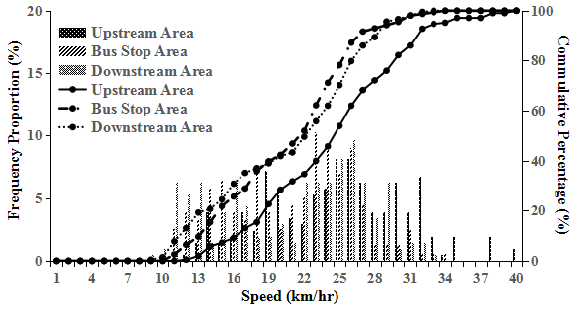 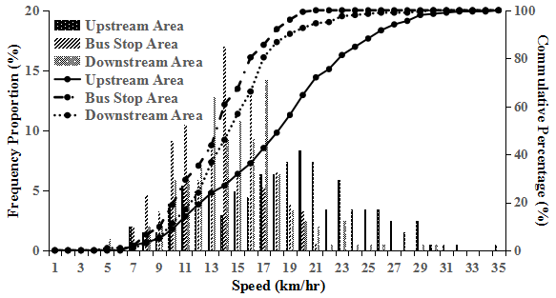 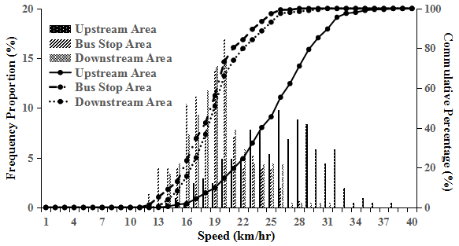

(b2) Far side (without bus at stop) (c1) Mid-block (with bus at stop) (c2) Mid-block (without bus at stop)

**Figure**

|  |  |  |  |  |
| --- | --- | --- | --- | --- |
| **t-Test results** | | **Upstream vs.**  **Bus stop area** | **Bus stop vs.**  **Downstream area** | **Upstream vs.**  **Downstream area** |
| Near side | With bus at stop | 0.000 (Yes) | 0.000 (Yes) | 0.000 (Yes) |
| Without bus at stop | 0.737 (No) | 0.751 (No) | 0.904 (No) |
| Far side | With bus at stop | 0.000 (Yes) | 0.003 (Yes) | 0.000 (Yes) |
| Without bus at stop | 0.000 (Yes) | 0.922 (No) | 0.000 (Yes) |
| Mid-block | With bus at stop | 0.000 (Yes) | 0.001 (Yes) | 0.000 (Yes) |
| Without bus at stop | 0.000 (Yes) | 0.010 (Yes) | 0.000 (Yes) |

|  |  |  |  |
| --- | --- | --- | --- |
| **t-Test results** | **With bus at stop vs. Without bus at stop** | | |
| **Near side** | **Far side** | **Mid-block** |
| Upstream area | 0.000 (Yes) | 0.000 (Yes) | 0.000 (Yes) |
| Bus stop area | 0.000 (Yes) | 0.000 (Yes) | 0.000 (Yes) |
| Downstream area | 0.062 (No) | 0.000 (Yes) | 0.000 (Yes) |
| Total | 0.000 (Yes) | 0.000 (Yes) | 0.000 (Yes) |