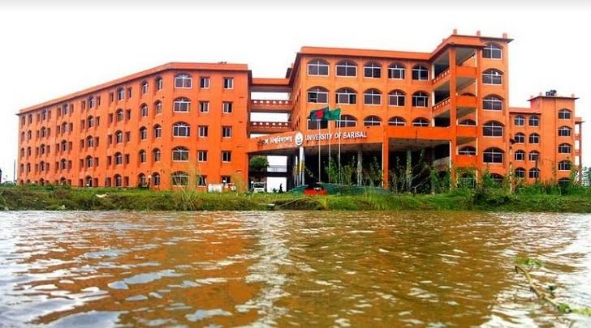

Project about Unemployment Problem In Bangladesh

**Unemployment Problem In Bangladesh**

When a worker fails to get a job with the current wage, is called an unemployed worker. When the unemployed situation occurs in an economy is called unemployment. A worker is willing to join a job in the current market wage but there is nothing for him is called unemployment.Unemployment hinders the economic development of Bangladesh. The economic development of this country will not be possible without educated and young people.Bangladesh has to serve unemployment in rural areas than in urban areas. The total number of unemployed persons in rural areas is 1.82 million whereas in urban areas 0.77 million.Bangladesh has more than 50% of the youth, workable person while the developed countries have only 20-25% young people.[Foreign employment](https://oikosmist.com/remittance-bangladesh/) opportunity is a great chance for our countries’ human labor.In a report of UNDP, from 189 countries the rank of BD is 135 and the HDI value is 0.614 and it is at a moderate level.



**Causes of unemployment in Bangladesh**

1. **Overpopulation**: Higher population growth rate and overpopulation are the principal reasons for unemployment in this country. The population is increasing day by day but there is a shortage of investment.
2. **Underdeveloped economy**: The economy of Bangladesh is underdeveloped and based on agriculture. It is very hard to employ all the people in an underdeveloped economy.
3. **Lack of capital:**Bangladeshi people have small savings because of lower per capita income. So, capital formation is not possible here or only a small capital can be formed here. Lack of capital means no investment and employment.
4. **Lack of technical education**: There is a need for skilled labor in all industries. Most Bangladeshi workers don’t know enough about the latest technology and skills.
5. **Natural calamities**: Every year many people get unemployed because of river erosion, floods, cyclones, etc.
6. **Political instability:** Political instability and unskilled administration weaken our social structures. It brings fear to people on new investments.
7. **Agriculture dependency**: Most of the people of Bangladesh directly or indirectly depend on agriculture. The seasonal unemployment problem occurs in agriculture.
8. **Corruption**: There is corruption in every stage of business. Foreign investors feel disappointed because of corruption.
9. **Annihilate cottage industries:** Bangladeshi cottage industries vanish because they fail to compete with foreign industries. This creates unemployment.

* With the above reason, there are some other reasons which enhance the unemployment problem. Those are-
* Lack of investment
* Lack of women’s employment
* Indolent people
* Lack of proper industrial policy
* Contractionary fiscal policy
* Lack of planning
* Improvements in artificial intelligence lower human labor.

**Nature of unemployment in Bangladesh**

1. **Disguised unemployment:** It is seen in rural areas, especially in the agriculture sector of Bangladesh. All persons of the family work on their farm. If one or two members stay idle their total production will remain the same. It seems all works there but the marginal productivity of those workers is negative or zero.
2. **Educated unemployment**: Although they have an educational certificate, they don’t have enough qualifications or willingness to join an existing job.
3. **Regular unemployment**: In our country, some people remain unemployed all the time as they are idle or not getting expected jobs.
4. **Seasonal unemployment**: Agriculture has a huge number of seasonal workers because they only need workers to sow the seeds and harvest.
5. **Various unemployment:** With the above all unemployment there is another type of unemployment seen in Bangladesh. Those are- technological unemployment, frictional unemployment, voluntary unemployment, etc.



**Unemployment rate in Bangladesh**

After 2008 the highest unemployment rate was 5% in 2009 and the lowest unemployment rate was 3.38% in 2010. After 2010, the unemployment rate increased again till 2013 when it was 4.43%. Then the unemployment rate decreased slowly in 2017, 2018, and 2019 it was respectively 4.37%, 4.28% and 4.19%. The total number of unemployed people in 2016 was 2.7 billion and in 2019 it was about 2.6 billion.

The total labor force of this country in 2019 is 69,706,740. Those laborers are 15+ years older and 30.52 percent are female workers.

   Bangladesh unemployment rate data

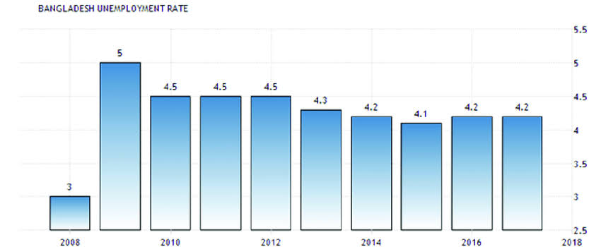

Unemployment rate in Bangladesh

**Unemployment between Individuals:**

High female**unemployment results from various intersecting factors, worsened by the COVID-19 crisis**and its aftermath. During the pandemic, women were disproportionately affected, often losing jobs, and remaining unemployed post-lockdown, as highlighted in the

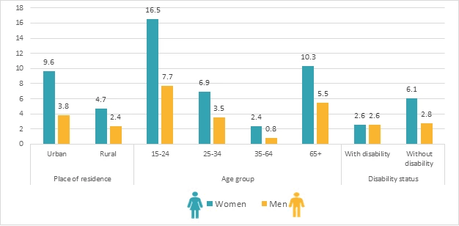

Individual unemployment Rate

Bangladesh Country Gender Assessment 2021. This scenario is worsened by structural barriers that contribute to women’s unemployment, including gender discrimination, job access constraints, occupational segregation, heavy domestic and caregiving duties, limited networking opportunities, entrenched social norms, and inadequate supportive policies and infrastructure.

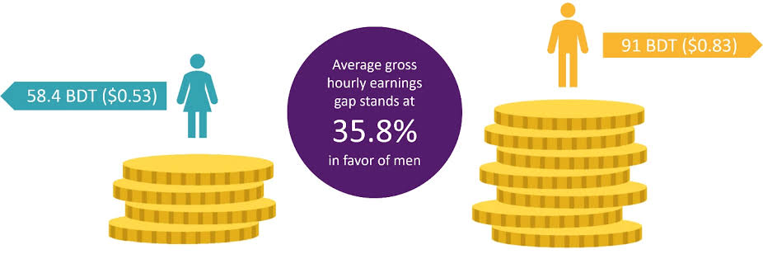

Average Income Of men and womenn

**So, all this were the actual problem which now effecting a lot in Bangladesh. It is actually the main headache right now.**