

American International University-Bangladesh (AIUB)  
**Department of Computer Science  
Faculty of Science &Technology (FST)  
Summer 18_19**

**Section: H**

**Group- 01**

**Online Health Care System**

A software Engineering project submitted

By

**Hasan, MD. Mahmudul (17-34711-2)**

**Alam, Muntasir (17-34712-2)**

**Ahmed, MD. Iftekhar (17-34731-2)**

**Ahmed, MD. Rony (17-34738-2)**

The project will be Evaluated for the following Course Outcomes

|  |  |
| --- | --- |
| CO3: Choose appropriate software engineering model in a software development environment | Total Marks |
|  |
| Content Knowledge [5Marks] |  |
| Argumentation [5Marks] |  |
| Evidence of Argumentation [5Marks] |  |
| Completeness, Spelling, grammar and Organization of the Answer [5Marks] |  |
|  | |
| CO4: Explain the roles and their responsibilities in the software project management activities | Total Marks |
|  |
| Project Background Analysis [5Marks] |  |
| Project Role identification [5Marks] |  |
| Responsibility Description [5Marks] |  |
| Completeness, Spelling, grammar and Organization of the Answer [5Marks] |  |

1. **PROBLEM DOMAIN**
   1. **Background to the Problem**

* The background description that helps putting the project into the right context of a problem domain and gives everyone involved a common view of the project is given below.
* Online health care system is a way to provide consultations by medical experts. We can get medical advice at the comfort of sitting at home. This app will help people living in distance locations becomes hard to travel long distances for consulting a doctor, for immediate consultations in the middle of the night, calling an ambulance immediately and lot like more.

* The root cause of this problem-
* Bangladesh still does not have a comprehensive health policy to strengthen the entire health system. Clearly, the most crucial challenge is the absence of a dynamic and proactive stewardship able to design and enforce policies to further strengthen and enhance the overall health system. Such strong leadership could bring about meaningful and effective health system reform, which will work more efficiently for the betterment of the health of the people of Bangladesh. Many places are not developed in Bangladesh. That places people suffer many types of health problems that’s why we want give online heath care.

The problem is so important to consider because-

* Such type of health care system, a person can take care about of him/her. In this type of health care system this application will have doctor, hospital, ambulance and medicine shop. A person can contact easily doctor, hospital, ambulance driver and can order medicine. In health care system a person can take also doctor appointment, user can also contact with doctor live in video chat if user can’t go to the doctor. If a person need an ambulance in any kind of emergency circumstances he or she can contact with ambulance driver. This system will be trusted and secure because in this system all employee biography and address take strictly that’s why people will face no problem and they will feel secure while using this system. People can use this system anywhere any places in Bangladesh Online health care system have also online storage service where user can save their important data, prescription and health report.
  1. **Solution to the Problem**

Proposed solution-

* From many types of health problem and existing solution problem we want to give online health care service. Our online health care service anyone can use from any place in Bangladesh. In our health care system we add many feature such as we want to add online doctor, nearby hospital service, ambulance service, diet and fitness plan, online medicine shop so that all user can use all feature in one apps. In our health care system people can sign up and after sign up they can log in to the system. User can found all feature which feature user want to use they can use. We keep help option in our health care system so that user does not face any difficulty so that they can take help from help option. If user need emergency ambulance service user can call ambulance driver, user can do a live video conference with doctor, our health care system also have nearby hospital service and also user can take doctor appointment. If user need medicine, user can order medicine from online medicine shop. Our health care system will be more secure. We take biography of employee and user so that any one can’t misuse our system. Our system will also have log out option.

There is no business perspective. We want to develop the health care system of this country. Because we are far behind in this sector from other countries.

* There are not much software solutions in our country. But few of these software related to health care system is not much good. They don’t have so much features. Sometimes there some major features are missing.

1. **SOLUTION DESCRIPTION**
   1. **System Features**

* The system functional requirements-
* **Interface Requirements -**An **interface requirement** is a system **requirement** that involves an interaction with another system. The format of the **interface requirement** is such that it includes a reference (pointer) to the specific location in the definition document that defines the **interface.**
* **Regulatory Requirements -**The restrictions, licenses and laws applicable to a product or business, imposed by the government.
* **Security Requirements:** Members of the data entry group can enter requests but cannot approve or delete request. Admin can approve or delete requests.

Quality attributes in each system feature that is necessary for the software-

* **Availability:** Availability is a measure of the planned up time during which the system is actually available for use and fully operational.
* **Performance:** Performance requirements define how well or how rapidly the system must perform specific functions.
* **Efficiency:** Efficiency is a measure of how well the system utilizes processor capacity, disk space, memory, or communication bandwidth.
* **Integrity:**Only users who have Auditor access privileges shall be able to view customer information.
* **Usability:** Usability encompasses how easy it is for new or infrequent users to learn to use the product. Ease-of-learning goals can be quantified and measured.
* **Maintainability:** Maintainability depends on how easily the software can be understood, changed, and tested
  1. **UML Diagrams**

**Use Case Scenario**

In our health care management system a person can take care of him. If a person want to use this system first of all he or she need to be registered or registered user can log in to the system and get many features. User can maintain diet and fitness by the apps. If user want he or she can contact with doctor also can take appointment or live conference with doctor. Any emergency circumstances user can contact with hospital also contact with ambulance, system admin draw the destination by the Google map. Our online health care system user can order medicine, system admin draw the path by Google map to the destination and user can pay cash or card.

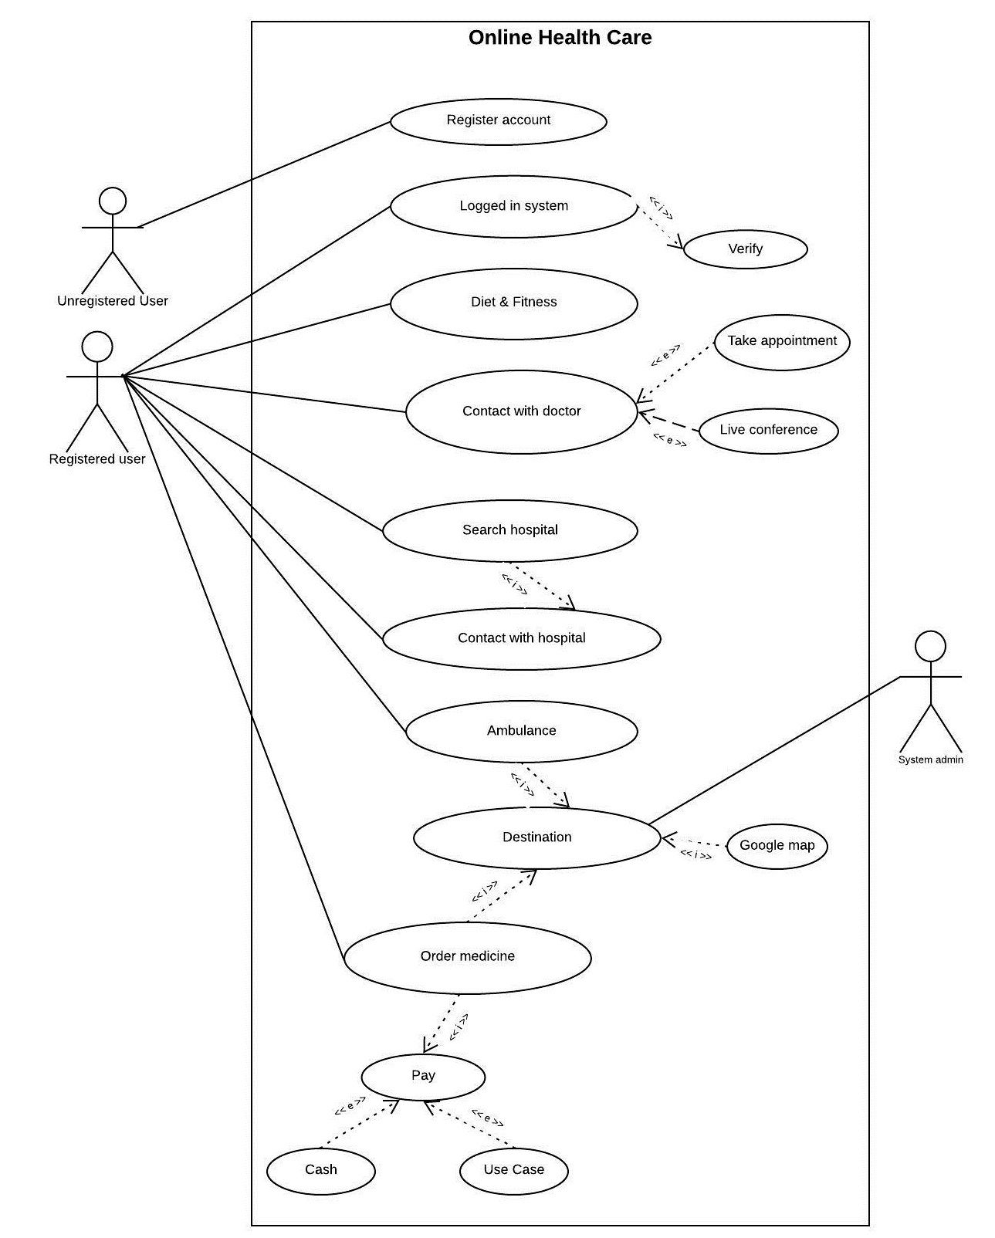

**Activity Scenario**

In an online Health care system, a customer places a request to the system for online health service. After the customer places request for health service he waits for the information. While the customer is waiting the server creates a session object. The system then gets all the available health service names and their time schedule then sent to customer. Then customer selects the desired service from the database and the session object retrieves the available timing of the selected service. The list is then sent to customer. Before displaying the time to the customer each scheduled time of the service is checked in the Booking Database for the availability of the appointments for the service. Only the time schedules in which appointments are available are displayed to the customer. The customer then selects the time he wants to book. The fee of the health service is taken from the Database and the due amount is calculated by the Session object. Then the customer enters his credit card detail for the calculated amount which is verified by a credit card agent. If the card is verified the session object sends a receipt to the customer, writes in the booking database and update the database at the same time. If the card is not verified the customer request is denied. The server finally destroys the session object.

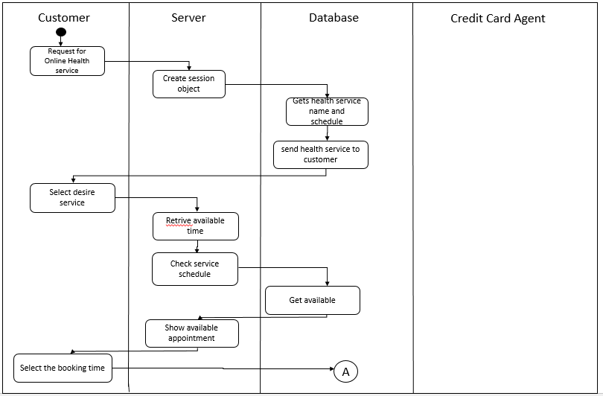

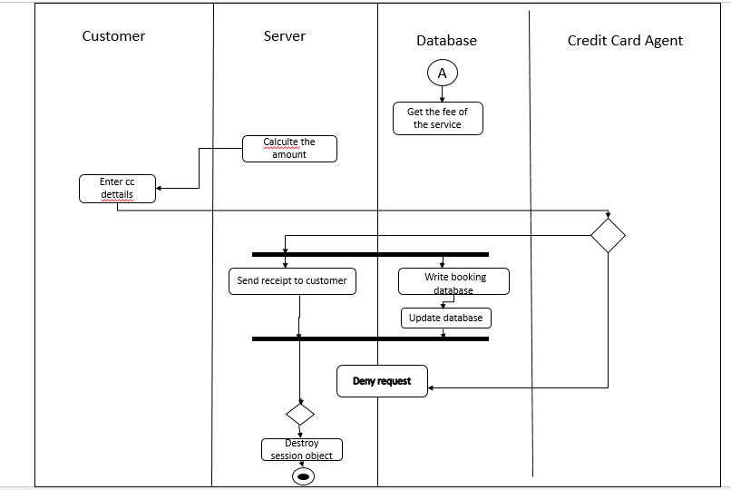

No

Verified

Yes

**Class Diagram Scenario**

* User downloads the Health care app.
* User makes the pay by cash, card for clearance.
* User creates any number of accounts by giving id, password.
* The app contains contact with doctor option which includes name, id, age.
* The app contains appointment option including date and time.
* Appointment option contains live conference option with doctors.
* The app contains order medicine option by name and id.
* The app contains diet and fitness option.
* The app contains ambulance service option by name, location.

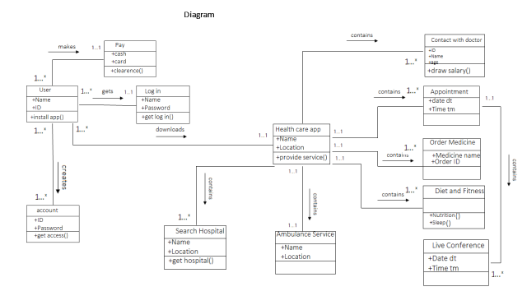

1. **SOFTWARE DEVELOPMENT LIFE CYCLE**
   1. **Process Model**

* Since we have an online based project, we must select the Agile Method. In the Agile Method we will work with the XP model.
* The life cycle of XP consists of five phases:

1. **Exploration -**The customers write out the story cards that they wish to be included in the first release. At the same time the project team familiarize themselves with the tools, technology and practices they will be using in the project.
2. **Planning -**Users stories are written. Estimate the effort of working with the user stories. Release planning creates the release schedule.
3. **Iterations to Release -**Includes several iterations of the systems before the first release. Each take one to four weeks to implement. The customer decides the stories to be selected for each iteration.
4. **Productionizing -**Requires extra testing and checking of the performance of the system before the system can be released to the customer. New changes may still be found and the decision has to be made if they are included in the current release**.**
5. **Maintenance and Death-** When the customer does no longer have any stories to be implemented. System satisfies customer needs also in other respects

* In Agile model, there are several iterative models. We also know in agile model late changes are always welcomed. We have chosen Extreme Programming(XP) because our system is an online based system. And we always need to change data, update data, update the system functions for betterment and we need to update many more things time after time. As it is Online Health Care System, our client may ask for changes even late in the project, which is always welcomed in XP. XP ensures that the client gets exactly what they want. Simplicity is another advantage of Extreme Programming projects. Developers who prefer to use this methodology create extremely simple code that can be improved any time. The most basic advantage of XP is that the whole process is visible and accountable. This is why we are using the XP model among all the other models.
  1. **Project Roll Identification and Responsibilities**
* The roles in the project management activities in software development-
* **Customer**
* **Programmer**
* **Tester**
* **Tracker**
* **Coach**
* **Consultant**
* **Manager**
* The responsibilities of the role in the software development-
* **Customer:** writes the stories and functional tests, and decides when each requirement is   
   satisfied. The customer sets the implementation priority for the requirements
* **Programmer:** keeps the program code as simple and definite as possible
* **Tester:** helps the customer write functional tests, also run functional tests regularly,   
   broadcast test results and maintain testing tools
* **Tracker:** Gives feedback in XP. He traces the estimates made by the team (e.g.   
   effort estimates) and gives feedback on how accurate they are in order to improve future estimations. He also traces the progress of each iteration and evaluates whether the goal is reachable within the given resource and time constraints or if any changes are needed in the process.
* **Coach:** Coach is the person responsible for the process as a whole. A sound   
   understanding of XP is important in this role enabling the coach to guide the other  
   team members in following the process.
* **Consultant:** Consultant is an external member possessing the specific technical   
   knowledge needed.
* **Manager (Big Boss):** Manager makes the decisions.