**Table of Contents**

1. ER Diagram for Library Management System2
2. Database Schema3
3. UML Diagram3

3.1 Use Case Diagram for Library Management System3

3.1.1 Use Case 1: Login4

3.1.2 Use Case 2: Maintain Book4

3.1.3 Use case 3: Issue Book4

* 1. Class Diagram for Library Management System5
  2. Sequence Diagram for Library Management System6

1. UI Design7

4.1 Home Page7

4.2 Registration Page7

4.3 Member Login Page8

* 1. Password Recovery Page8
  2. New Book Entry Page9
  3. Logout Page9

1. E-R Diagram for Library Management System

Books

Manage

Member

Admin

Librarian

Supervise

Borrower

**2. Database Scheme**

Admin ( AdmID, AName, Username, Password)

Librarian (LbnID, LName, Username, Password)

Member (MemID, MName, Username, Password)

Books (BookID, BName, Author)

Supervise (AdmID, LbnID, MemID )

Manage ( LbnID, BookID )

Borrow (MemID ,BookID, IssueDate, ReturnDate )

**3. UML Diagram**

**3.1 Use Case Diagram for Library Management System**

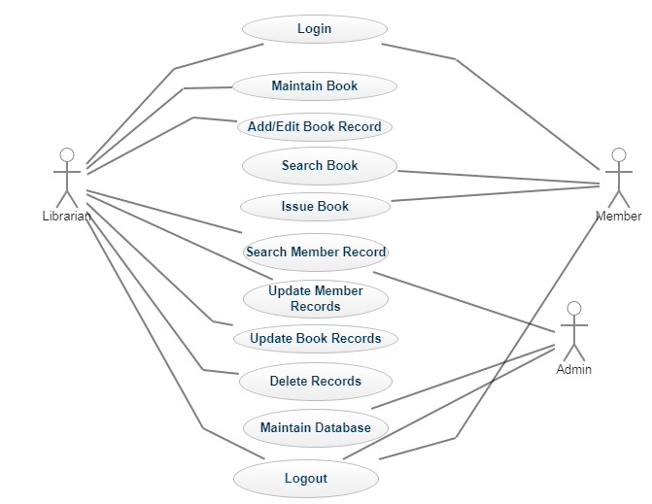

**3.1.1 Use Case 1: Login**

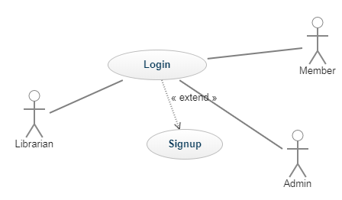

**3.1.2 Use Case 2: Maintain Book**

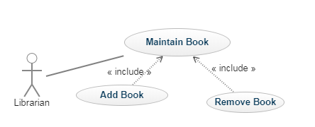

**3.1.3 Use Case 3: Issue Book**

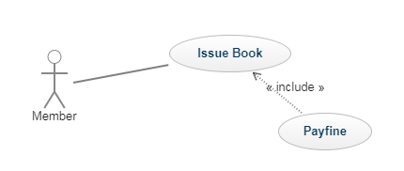

**3.2 Class Diagram for Library Management System**

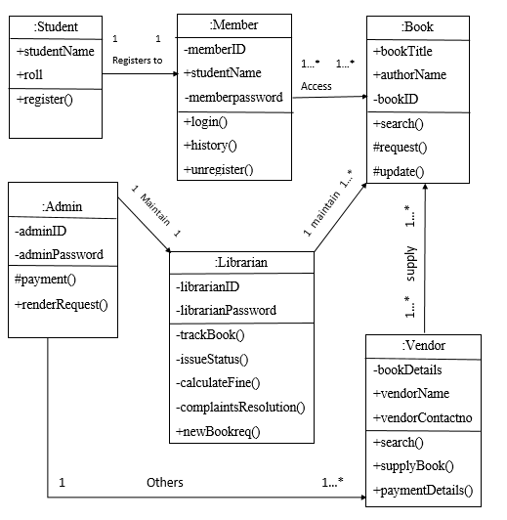

**3.3 Sequence Diagram for Library Management System**

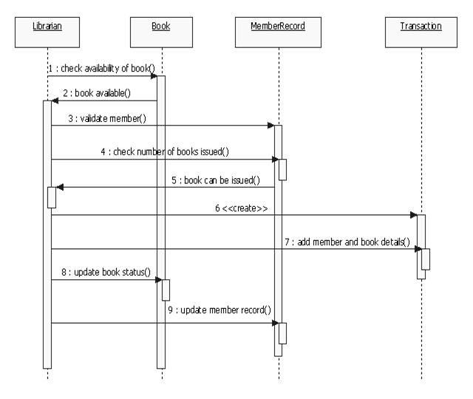

**4. UI Diagram**

**4.1 Home Page**

Library Management System

Login as Member

Exit

Login as member

**4.2 Member Registration Page**

**Name:**

**Username:**

**E-mail Address:**

**Password:**

**Submit**

**Back**

**Exit**

**Member Registration Form**

**Security Question:**

**Answer:**

**2**

**4.3 Member Login Page**

**Member Login Form**

**Username:**

**Trouble Logging In !!!**

**Password:**

**Forgot Password?**

**Exit**

**Back**

**Login**

**4.4 Password Recovery Page**

**Username:**

**Password:**

**Search**

**Retrieve**

**Forgot Password Form**

**Login**

**Security Question:**

**Answer:**

**4. Book Entry Form**

**4.5 New Book Entry Page**

**New Book Entry Form**

**Name:**

**Author:**

**Edition:**

**Publisher:**

**Exit**

**Back**

**Add**

**No. Of Copy:**

**4.6 Logout Page**

Logout