**Cyclistic Bike-Share Analysis Case Study**

**Project Overview**

This project is part of a case study analyzing bike-share data from Cyclistic, a fictional bike-sharing company in Chicago. The goal of this analysis is to understand how different types of riders (annual members vs. casual riders) use the service, with the aim of developing strategies to convert casual riders into annual members.

**Data Sources**

The data for this case study includes two CSV files with bike trip information from 2019 and 2020. Each file contains trip data such as start and end times, station locations, and user type. Data was imported and analyzed using Google BigQuery.

**Key Analysis Questions**

1. How do annual members and casual riders use Cyclistic bikes differently?
2. What are the trends in bike usage over time?
3. Which factors could influence casual riders to convert to annual memberships?

**Queries and Results**

**1. Count of Total Rows in Each Table**

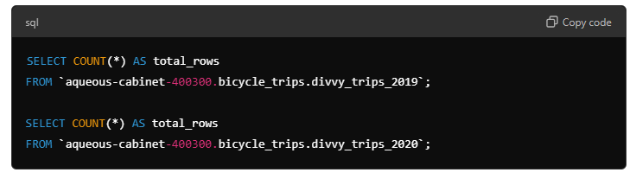

**Explanation**:  
These queries count the total number of rows in the 2019 and 2020 datasets to verify the data volume and ensure that both tables are populated correctly. This step helps us understand the size of the datasets we're working with.

**Results**:  
Each table's row count represents the total number of trips in that year.

**2. Distinct Trip Records**

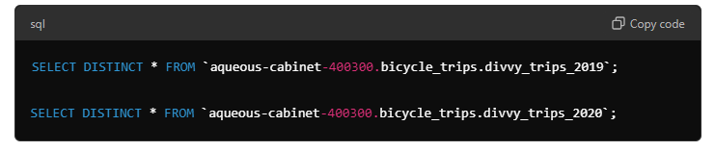

**Explanation:**These queries identify distinct records in each dataset to ensure there are no duplicates and to verify data integrity.

**3. Summary Statistics for Trip Duration**

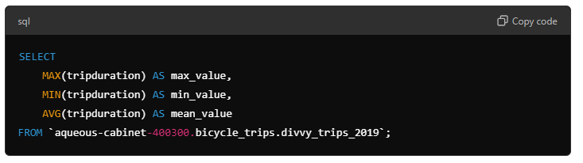

**Explanation**:  
This query calculates the maximum, minimum, and average trip duration for the 2019 dataset. It provides insights into the general range of trip durations, which is helpful for identifying usage patterns.

**Results**:  
This step reveals the longest and shortest trips and the average trip duration, which can indicate how customers are using the service.