Summary
In design document, we laid out a high-level view of our solution design.
Here we will elaborate on implementation and operational steps for this project which includes the dbt models and their purpose, the data validation strategies, some instruction on how to run our pipeline, the potential backfilling strategies, and some next steps to explore.

Snapshot
We need to run this snapshot code every 15 minutes to keep track of the 15-minute changes in our wallets table.
If a user upgrades from Tier 0 to Tier 1, dbt will instantly perform two actions:
- Update the old record: It finds the existing row for that wallet_id where dbt_valid_to is NULL and sets dbt_valid_to to the exact 15-minute execution timestamp.
- Insert the new record: It inserts a brand-new row containing the new Tier 1 information, setting dbt_valid_from to the execution timestamp, and dbt_valid_to to NULL.
If a wallet's updated_at time has not changed since the last 15-minute run, dbt completely ignores that row. It scans only the micro-partitions that contain modifications, keeping Snowflake costs minimal
Find the code in snap_wallets.sql.

Use Case 1: KPI Dashboard
To refresh this dashboard efficiently without scanning billions of rows, we will build a dedicated, pre-aggregated table in our Marts Layer. This table will collapse a billion raw rows into a few thousand summarized rows by grouping data by hour (or even every 15 minutes) and key dimensions.
Before we aggregate, we must solve Challenge A (Point-in-Time KYC tracking). We need to know what a user's KYC tier was at the exact second they paid.

Challenge A
In dbt, an Incremental Model allows us to insert or update only the data that has changed since the last run. Since our source tables update every 15 minutes, our incremental model will run every 15 minutes, processing only the tiny sliver of new or mutated rows.
Find the code in int_payments_enriched.sql.

Challenge B
We have handled this challenge (handling payment status mutations/reversals) across four distinct layers of architecture. Each layer handles a specific part of the problem to ensure that a change in transaction status (e.g., from 'success' to 'reversed') updates correctly without triggering a costly full-table scan on our billion-row dataset.
- In the Base Intermediate Layer (int_payments.sql)
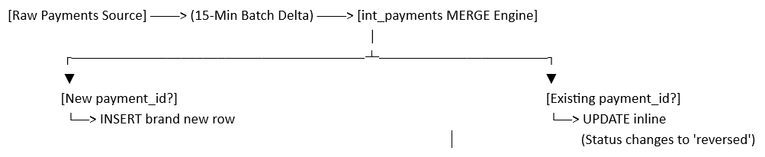
This is the primary engine that absorbs the mutation. Instead of appending data blindly, it uses a Merge Strategy to overwrite old rows with new statuses. When a payment's status changes to 'reversed' in the source table, its updated_at timestamp updates. During the 15-minute run, dbt finds the row via its payment_id and overwrites the old status inline.
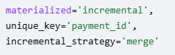
The following filter ensures we only scan the last 15-30 minutes of data. We look back 3 hours as a safe buffer for any late-arriving data or pipeline delays.
The inner SELECT: This tells Snowflake to look at the destination table right before the 15-minute run starts, find the single newest updated_at timestamp currently stored, and return it.
- interval '3 hours': This is standard Snowflake date math. It takes that maximum timestamp and subtracts exactly 3 hours from it to create a rolling cut-off time. It only loads the tiny handful of boxes containing files touched or created within that active 3-hour buffer window. From those few isolated micro-partitions, Snowflake extracts the small batch of rows that arrived or changed in the last 15 minutes.
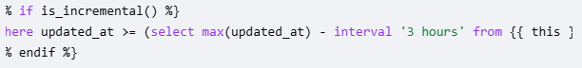
- In the Enriched Intermediate Layer (int_payments_enriched.sql)
This layer ensures that downstream summary tables know an update just happened, prompting them to recalculate their metrics. By tracking the updated_at timestamp down to this layer, we ensure that the newly reversed payment is pulled into the enrichment process, paired with its dimensions, and passed forward to the Marts.

- In the KPI Dashboard Mart (fct_payment_summary_hourly.sql)
This table self-heals the dashboard metrics so executives never see stale, un-reversed totals. Because this model calculates net_volume by strictly summing rows where status = 'success', a mutation to 'reversed' causes that payment's value to instantly drop out of the net calculation. The model then uses its own unique_key='summary_id' to overwrite and correct that specific hour's summary row in the database.
- In the Compliance Mart (fct_wallet_monthly_spending.sql)
This table protects users from false positive compliance alerts by dynamically adjusting their monthly transaction balance. Much like the dashboard mart, this model aggregates monthly spending strictly for successful transactions. When a payment mutates to 'reversed', the 15-minute incremental run recalculates that wallet's total for the current month. The update lowers their running balance, automatically removing them from the active breach alerts view (rpt_kyc_breaches_current) if they fall back under their threshold.

Master Layer
At this step, we can aggregate data to be used by our dashboard. This design ensures that our BI dashboards query a few thousand rows instead of billions of rows with high performance which was our goal.
Find the code in fct_payment_summary_hourly.sql.

Use Case 2: Compliance Alerting Engine
Our goal is to detect any user whose total transaction volume for the current calendar month has breached their wallet’s active KYC limit. This needs to run every 15 minutes, catch changes instantly, and remain highly performant over our billion-row table.
To achieve this, we will build a two-step framework in our Marts layer.

Incremental Mart Table
This table keeps a running, aggregated total of monthly spending per wallet. So instead of recalculating every user's monthly spending from scratch every 15 minutes, this model calculates monthly totals incrementally. If a payment status changes to 'reversed', Snowflake will overwrite and correct that specific user's monthly total during the 15-minute sync. Snowflake will do this under the hood through micro-partitioning mechanisms.
Find the code in fct_wallet_monthly_spending.sql. (The monthly Rolling Aggregation)

Downstream View
This view instantly flags current breaches for our alerting system.

Data Validation
Every pipeline needs to have some level of data quality checks to ensure the decisions made based on processing this information are reliable. We considered several layers of data validation for our pipeline.
- Generic data quality checks have been implemented in marts/schema.yaml.
- We check our intermediate data to ensure no corrupt entries contain negative payment values. (tests/assert_payment_amounts_are_positive.sql)
- We need to ensure that our 15-minute SCD Type 2 wallet snapshots never create corrupt, overlapping historical timelines for a single user's KYC tier. (tests/assert_no_overlapping_kyc_windows.sql)
- We also need to verify that the alerting layer is calculating numbers correctly by confirming that every flagged breach amount is mathematically greater than zero. (tests/assert_breach_amounts_are_valid.sql)

Running Pipeline
When running this in production every 15 minutes, our orchestration engine (like Airflow, Prefect, or dbt Cloud) will execute the commands in this exact sequence to ensure data integrity:
- dbt snapshot — Sweeps the raw wallet data first to capture any immediate KYC tier modifications.
- dbt run --models staging — Pulls in and standardizes the newest raw data points. (We didn’t develop this stage).
- dbt run --models intermediate — Merges payment status changes (reversals) and executes the historical point-in-time joins.
- dbt run --models marts — Refreshes the dashboard aggregates and updates the active monthly compliance logs.
- dbt test — Validates unique keys, null fields, and custom compliance thresholds to guarantee data accuracy before the alerting layer reads it.

Backfilling Pipeline
dbt snapshots cannot natively "replay" historical changes retroactively (they can only track changes from the moment they are turned on). If our upstream system keeps an immutable audit log or historical table of KYC changes (e.g., wallets_history_log), we can manually populate the snapshot table for day one to seed those past records directly into snapshots.snap_wallets.

What’s Next
As much as I’ve enjoyed working on this project and I can keep adding to it, I’m running out of time. Following are some of the steps that we can take to enrich this solution.
- Document columns: Adding data assets, column names, and descriptions in models/marts/schema.yml (and staging/intermediate files)
- Spin up a local web server: By running these two commands in a terminal or orchestration platform:
  - dbt docs generate
  - dbt docs serve
- Data Lineage Diagram: Adding some data flow diagram. Seeing how data flows at a glance can be helpful to understand the flow.
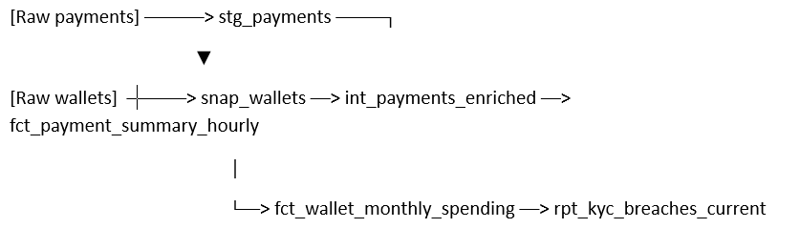
- Run book: Creating an operational document that explains how to run the code. It must explicitly state when and in what order to execute it to maintain the 15-minute sync. Document the execution loop clearly:
  - SLA: 15 minutes.
  - Trigger: Cron expression */15 * * * * (Every 15 minutes).
  - Command Sequence: dbt snapshot -> dbt run -> dbt test.
  - Failure Protocol: If dbt test fails on assert_no_overlapping_kyc_windows, notify the #data-ops Slack channel immediately and do not refresh downstream dashboards.
- Data Retention and Time-Travel Policies:
Because we are running on Snowflake with a billion-row baseline, we need a brief section outlining storage backup settings to ensure costs don't spiral during mutations:
  - Time Travel: We need to configure DATA_RETENTION_TIME_IN_DAYS = 1 (or a number that came in SLA) for the intermediate and mart tables. Keeping 90 days of Time Travel history on a changing billion-row table will cause Snowflake storage costs to balloon unnecessarily.
  - Fail-Safe: We need to confirm that permanent tables fall back to Snowflake's standard 7-day (or a number that came in SLA) automated data recovery window for absolute disaster recovery.

Notes
Disclaimer: Vibe coding has been used. The resulting code has been verified and rectified by me, but it hasn’t been tested against any data.
Note: Although I have used “we-language” in my writing (because I’m used to it) I’m the sole person who worked on this task, came up with the solution, and did the implementation. I have not consulted nor got help from anybody else.

