Table of Contents
Acknowledgment 4
List of Abbreviations 5
CHAPTER ONE: INTRODUCTION 7
1.1 Background and Statement of the Problem 7
1.2 Rationale 10
1.3 Research Questions 11
1.3.1 Main Research Question 11
1.3.2 Specific Research Questions 11
1.4 Objectives 12
1.4.1 Overall Objective 12
1.4.2 Specific Objectives 12
1.5 Significance of the Study 13
1.6 Scope of the Study 14
1.7 Definition of Key Terms 14
CHAPTER TWO: LITERATURE REVIEW 16
2.1 Introduction 16
2.2 Conceptual Review 16
2.2.1 Maternal Health and Maternal Mortality 16
2.2.2 Pregnancy Risk and Danger Signs 17
2.2.3 Antenatal Care and Continuity of Support 18
2.2.4 Low-Resource and Low-Income Settings 18
2.2.5 Mobile Health in Maternal Care 19
2.2.6 Pregnancy Companion Applications 20
2.2.7 Artificial Intelligence and Voice Assistance in Pregnancy Support 20
2.3 Theoretical and Technical Foundations 21
2.3.1 The Three Delays Model 21
2.3.2 Human-Centred Design 22
2.3.3 Mobile-First and Offline-Capable Design (Istepanian and Lacal (2003)) 23
2.3.4 Decision Support and Safety Rules 23
2.3.5 Privacy and Data Security 24
2.3.6 Task Shifting and Health Support Networks 24
2.4 Empirical Review 28
2.4.1 Global Burden of Maternal Mortality and the Need for Timely Support 28
2.4.2 Maternal Mortality in Africa and Cameroon 29
2.4.3 Barriers to Antenatal Care in Sub-Saharan Africa 29
2.4.4 mHealth Interventions for Maternal Care 30
2.4.5 SMS, Voice, and Mobile App Approaches 30
2.4.6 Quality and Safety of Pregnancy Apps 31
2.4.7 Digital Health Guidelines and Implementation Considerations 31
2.4.8 AI Chatbots and Non-Diagnostic Guidance 32
2.4.9 Emergency Response and Location Sharing 32
2.4.10 Mood Tracking and Psychosocial Support 32
2.4.11 Health Support Networks and Professional Guidance 33
2.4.12 User Interface Requirements for Low-Literacy Users 33
2.4.13 Privacy, Trust, and Ethical Concerns 34
2.5 Review of Related Systems and Interventions 34
2.6 Research Gap 35
2.7 Proposed Conceptual Framework for WunAlly 36
2.8 Chapter Summary 38
CHAPTER THREE: MATERIALS AND METHODS 39
3.1 Introduction 39
3.2 Materials and Development Environment 39
3.2.1 Hardware Requirements 39
3.2.2 Software Requirements 40
3.3 Research and Development Methodology 42
3.3.1 Choice of Development Methodology 42
3.4 Requirements Analysis 43
3.4.1 Functional Requirements 43
3.4.2 Non-Functional Requirements 44
3.5 System Analysis and Design 45
3.5.1 Use Case Analysis 45
3.5.2 System Architecture 47
3.5.3 Database Design 48
3.5.4 Process Flow Design 49
3.6 Implementation of Proposed Solution Based on Research Objectives 50
3.6.1 Design and Implementation of the Pregnancy Tracking Module (Objective 1) 50
3.6.2 Design and Implementation of the AI and Voice Guidance Module (Objective 2) 52
3.6.3 Design and Implementation of the SOS Emergency Module (Objective 3) 53
3.6.4 Design and Implementation of the Mood Tracking Feature 55
3.7 System Testing and Evaluation (Objective 4) 55
3.7.1 Testing Approach 56
3.7.2 Evaluation Metrics and Instruments 56
3.7.3 Participants 57
3.8 Chapter Summary 58
REFERENCES 60

Acknowledgment

List of Abbreviations
Abbreviation | Meaning
AI | Artificial Intelligence
ANC | Antenatal care
API | Application Programming Interface
BP | Blood Pressure
CHW | Community Health Worker
GDPR | General Data Protection Regulation
HCD | Human-Centered Design
ICT | Information and Communication Technology
LMICs | Low- and Middle-Income Countries
MMR | Maternal Mortality Ratio
mHealth | Mobile Health
NCD | Non-Communicable Disease
RMC | Respectful Maternity Care
SDG | Sustainable Development Goals
SMS | Short Message Service
SOS | Emergency alert/ save our soul
UI | User interface
UX | User Experience
WHO | World Health Organization
WunAlly | Women Understanding nurture Ally

CHAPTER ONE: INTRODUCTION

1.1 Background and Statement of the Problem
Pregnancy is often described as a normal physiological process, yet it is also one of the most sensitive periods in a woman’s life. Over approximately forty weeks, the mother’s body changes rapidly to support the growth of the fetus. These changes affect blood volume, blood pressure, immunity, glucose regulation, sleep, appetite, mood, mobility, and emotional wellbeing. (National institutes of Health 2024). For many women, pregnancy is therefore a joyful experience and at the same time a period that requires careful monitoring, timely health information, and access to skilled support. A symptom that appears small at the beginning, such as persistent headache, swollen face or hands, dizziness, fever, severe abdominal pain, vaginal bleeding, reduced fetal movement, or difficulty breathing, may become dangerous when it is not recognised early or when action is delayed. (Ye, J., Li, Lin, Y., et al (2024))
Maternal mortality remains one of the clearest indicators of inequality in global health. The World Health Organization (WHO) estimates that about 260,000 women died during and following pregnancy and childbirth in 2023, and that most of these deaths were preventable. The global maternal mortality ratio was estimated at 197 deaths per 100,000 live births in 2023, but the burden is not equally distributed. Low-income countries recorded far higher risk than high-income countries, and sub-Saharan Africa continued to carry the largest share of global maternal deaths (WHO, 2025; UNICEF, 2025). These figures show that pregnancy itself is not the only danger. The greater danger is pregnancy occurring in an environment where warning signs are missed, transport is unavailable, skilled care is delayed, health facilities are overcrowded, and women do not receive respectful and continuous support. (National Library of Medicine, Rev Obstet Gynecol. 2008 Spring)
The leading direct causes of maternal death include haemorrhage, hypertensive disorders such as pre-eclampsia and eclampsia, sepsis, complications of unsafe abortion, and obstructed labour. Indirect causes, including malaria, HIV/AIDS, anaemia, cardiovascular disease, diabetes, and other chronic conditions, may also worsen during pregnancy. (Creswell J, Alexender M, Chong M et al. Global and Regional causes of maternal deaths 2009-20: a WHO systematic analysis) Many of these conditions can be prevented, detected early, managed, or referred if women receive adequate antenatal care and emergency support. Over 80% of maternal deaths are preventable. (Apollo Pharmacy 9 January 2025) However, the reality in many low-resource communities is that care is not continuous. A pregnant woman may attend a clinic only during scheduled antenatal visits, while most symptoms and anxieties occur at home, at work, on the farm, on the road, or at night. Between clinic visits, she may depend on relatives, neighbours, social media, or personal guesses to decide whether a symptom is normal or serious.
In Cameroon, maternal health challenges are shaped by a combination of clinical, social, economic, and infrastructural factors. The World Bank’s modelled estimates place Cameroon’s maternal mortality ratio at 258 deaths per 100,000 live births in 2023. Although this figure is lower than that of several countries with the highest burden in the region, it still represents a serious public health concern and shows that many women remain exposed to preventable pregnancy-related risks (World Bank, 2025). Pregnant women in rural and low-income communities often face long distances to health facilities, high transport costs, limited access to skilled health personnel, and shortages of emergency obstetric services. In urban settings, hospitals may be physically closer, but overcrowding, long waiting times, and limited consultation time can still make care difficult. Some women also report fear of rude treatment, embarrassment, lack of privacy, or being judged by health workers, which may reduce their willingness to seek care early (Budhwani et al., 2024).
These challenges are closely related to the Three Delays Model proposed by Thaddeus and Maine (1994). The first delay occurs when a woman or her household delays deciding to seek care, often because danger signs are not recognised, the seriousness of the condition is underestimated, or previous experiences with health services were negative. The second delay occurs when a woman decides to seek care but cannot reach a facility quickly because of distance, cost, transport, insecurity, or poor roads. The third delay occurs after arrival at the facility, when the woman waits too long to receive appropriate care because of overcrowding, shortage of staff, weak referral systems, or lack of essential supplies. For pregnant women in low-resource settings, these delays do not occur separately; they reinforce one another. A woman who has little knowledge of danger signs may wait too long at home, then struggle to find transport, and finally reach a facility where services are delayed.
Mobile health, commonly known as mHealth, offers an opportunity to reduce some of these delays by bringing health guidance closer to women. mHealth refers to the use of mobile phones, smartphones, tablets, wearable devices, and wireless communication technologies to support healthcare delivery, health education, monitoring, reminders, decision-making, and communication. In maternal health, mHealth interventions have been used to send appointment reminders, provide pregnancy education, support community health workers, collect health data, promote skilled delivery, and connect patients to providers. Systematic reviews show that mHealth interventions can improve antenatal care attendance and maternal health knowledge in low- and middle-income countries, although effectiveness depends on design quality, usability, cultural fit, integration with health services, and the ability to work in real deployment conditions (Rahman et al., 2022; Knop et al., 2024).
Despite the promise of mHealth, many existing pregnancy applications do not adequately meet the needs of women in low-resource settings. Some applications provide general information but do not adapt to the woman’s gestational age, symptoms, language, literacy level, or local realities. Others require continuous internet access, use long text-heavy interfaces, lack emergency response features, or do not provide a clear route to human support. Many applications are designed for users in high-resource contexts where smartphones, data bundles, stable electricity, ambulances, and nearby hospitals can be assumed. Such assumptions do not fit many Cameroonian communities. A useful pregnancy companion for low-resource settings must therefore be simple, culturally appropriate, partially offline, privacy-conscious, and able to support both ordinary self-care and urgent response.
This project proposes WunAlly, meaning Women Understanding Nurture Ally, as a pregnancy companion mobile application designed to mitigate pregnancy-related risks and enable emergency health support. WunAlly is not intended to replace doctors, midwives, nurses, antenatal clinics, or emergency obstetric care. Rather, it is intended to act as a digital companion that helps pregnant women understand their pregnancy, recognise potential danger signs, track key information, receive personalised non-diagnostic guidance, communicate with a health support network, and trigger emergency alerts when urgent help is needed. The proposed application brings together pregnancy tracking, AI-assisted chat and voice support, reminders, low-literacy friendly content, offline access to essential guidance, and an SOS alert with live location sharing.
The central problem addressed by this study is that many pregnant women, especially in low-resource and low-income communities, lack continuous, personalised, and accessible support for recognising pregnancy risks and responding promptly to emergencies. Existing health services are essential, but they are often episodic, facility-based, and constrained by distance, cost, staff shortages, and waiting times. Existing mobile solutions are useful but frequently fragmented, not locally adapted, and weak in emergency response. Consequently, there is a need to develop an integrated pregnancy companion application that supports women before a complication becomes life-threatening, during the decision to seek care, and at the moment when emergency help is required.

1.2 Rationale
The rationale for this study is based on the gap between the needs of pregnant women and the support systems currently available to them outside the health facility. Pregnancy care does not happen only during antenatal visits. It continues daily, through decisions about nutrition, rest, medication, appointments, movement, hygiene, emotional wellbeing, and the interpretation of symptoms. Yet many women do not have immediate access to reliable pregnancy guidance when they need it. The situation is more serious in low-resource settings where health facilities may be far away, transport may be expensive, internet connection may be unstable, and health workers may be too few to provide continuous individual follow-up.
A mobile application is a practical platform for addressing this gap because mobile phones are increasingly common in African communities. Even where smartphone ownership is uneven, shared phone use, family phone access, and growing digital familiarity make mobile-based support more scalable than many facility-only interventions. However, the application must be designed with the realities of low-resource settings in mind. It must not assume constant connectivity, advanced digital literacy, unlimited data, high-end devices, or English-only communication. It must also avoid presenting itself as a diagnostic tool. Instead, it should provide safe guidance, encourage antenatal attendance, support early recognition of danger signs, and direct users to professional care when risk is suspected.
WunAlly is justified because it responds to several practical problems at once. First, it can help reduce the first delay by improving recognition of warning signs through simple symptom check-ins, trimester-specific education, AI-assisted guidance, and voice support for women who may struggle with long written content. Second, it can help reduce the second delay by providing an SOS function that alerts selected contacts and shares live location during emergencies. Third, it can help reduce pressure on health facilities by providing non-diagnostic advice for minor concerns and encouraging referral for serious symptoms. Fourth, it can strengthen adherence to antenatal care by reminding users about appointments, supplements, medications, hydration, rest, and basic monitoring. Fifth, it can create a safer communication space for women who may feel shy, embarrassed, or afraid to ask questions in public clinical settings.
From a computer engineering perspective, the study is also important because it requires more than simply presenting health information on a screen. It involves the design of a secure, user-centred, mobile-first system that combines data collection, personalisation, rule-based risk prompts, AI-assisted interaction, voice interface considerations, offline access, emergency notification, and usability for users with different literacy levels. The project therefore contributes to both maternal health and digital health engineering by demonstrating how context-aware design can make technology more relevant to women in resource-constrained environments.

1.3 Research Questions

1.3.1 Main Research Question
How can WunAlly, a pregnancy companion mobile application, be developed to support pregnant women in managing pregnancy-related risks, monitoring relevant health information, and responding promptly to emergencies in low-resource settings?

1.3.2 Specific Research Questions
- How can WunAlly be designed to record pregnancy progress, gestational age, trimester milestones, allergies, symptoms, reminders, and other relevant health information in a manner that helps women recognize risks early and adhere to antenatal care routines?
- How can AI-powered chat, voice assistance, and a Health Support Network provide safe, personalised, non-diagnostic guidance on nutrition, exercise, sleep, emotional wellbeing, and common pregnancy concerns while encouraging timely referral when warning signs are detected?
- How can an SOS emergency feature with live location sharing, selected-contact alerts, offline guidance, and a simple user interface improve access to immediate help for pregnant women with different literacy levels, income levels, and digital experience in Cameroon?

1.4 Objectives

1.4.1 Overall Objective
The overall objective of this project is to develop WunAlly, a pregnancy companion mobile application that supports pregnant women in managing pregnancy-related risks, tracking pregnancy progress, and accessing emergency health support in low-resource settings.

1.4.2 Specific Objectives
- To design and implement a secure pregnancy tracking module for recording gestational age, trimester milestones, weight, blood pressure, allergies, symptoms, reminders, appointments, and other relevant maternal health information.
- To integrate AI-powered chat, voice-assisted interaction, and a Health Support Network that provide personalised, non-diagnostic guidance on pregnancy self-care, nutrition, exercise, sleep, emotional wellbeing, and common danger signs.
- To develop an SOS emergency support module that alerts pre-selected contacts, shares the user’s live location where possible, provides stored emergency guidance, and remains usable in low-resource or limited-connectivity contexts.
- To evaluate the application’s usability, accessibility, perceived usefulness, privacy considerations, and suitability for pregnant women with varying literacy levels and socio-economic backgrounds.

1.5 Significance of the Study
This study is significant to pregnant women, families, health professionals, healthcare systems, policy actors, and the field of digital health engineering. For pregnant women, WunAlly can improve confidence and self-efficacy by making pregnancy information easier to understand and available at the moment of need. A woman who is unsure about a symptom can use the app to check whether it is a common discomfort, a sign that requires monitoring, or a danger sign that requires immediate care. This does not replace clinical judgement, but it can help the woman make a safer first decision.
For families and caregivers, the application can improve emergency preparedness. In many communities, relatives are the first responders when a pregnant woman feels unwell. The SOS feature can notify selected contacts quickly and share the user’s location, reducing confusion during urgent situations. The application can also encourage households to take danger signs seriously by presenting them in simple language and connecting them to recommended actions.
For health professionals, WunAlly can support earlier care-seeking and better communication. Women who track symptoms, appointments, blood pressure readings, medication use, and allergies may be able to provide clearer information during consultations. The Health Support Network can also create a channel for non-diagnostic guidance from trained midwives or nurses, while serious symptoms are referred to appropriate care. In settings where health workers are few, such triage-like support may help reduce unnecessary visits while encouraging urgent care for high-risk symptoms.
For healthcare systems, the study contributes to the broader effort to reduce preventable maternal and neonatal complications. Digital tools cannot solve all health system problems, but they can support demand-side readiness, appointment adherence, health literacy, and early warning sign recognition. When combined with existing antenatal care services, a context-aware application can improve continuity between clinic visits and home-based self-care.
For digital health research, the study demonstrates how mobile applications can be designed around human-centred and low-resource principles. It emphasises offline access, simple interfaces, voice interaction, privacy, local relevance, emergency response, and integration with human support. These design priorities respond to the weaknesses of many existing pregnancy apps, which often focus on general information without sufficient attention to real-world constraints.

1.6 Scope of the Study
The scope of this project is the development of a mobile pregnancy companion application for risk awareness, self-monitoring, non-diagnostic guidance, reminders, health support communication, and emergency alerting. The application will focus on pregnancy from early gestation to delivery preparation, with content organised by trimester and user-reported needs. It will include features such as profile creation, gestational age tracking, weekly pregnancy information, symptom check-ins, nutrition and lifestyle guidance, mood tracking, appointment and medication reminders, AI-assisted chat, voice support, Health Support Network communication, and an SOS emergency alert.
The project does not aim to replace hospital care, antenatal clinics, clinical diagnosis, laboratory testing, ultrasound, prescription, or emergency obstetric services. The AI component will be framed as a supportive and educational tool, not as a doctor. Any high-risk symptom or emergency condition will be directed toward urgent professional care. The study will primarily consider the Cameroonian low-resource context, although the design principles may be adaptable to other low- and middle-income settings.

1.7 Definition of Key Terms
Maternal mortality refers to the death of a woman while pregnant or within forty-two days of termination of pregnancy from causes related to or aggravated by the pregnancy or its management, but not from accidental or incidental causes.
Pregnancy risk refers to any medical, behavioural, social, environmental, or contextual factor that increases the likelihood of harm to the pregnant woman, the fetus, or the newborn and therefore requires monitoring, guidance, referral, or emergency action.
mHealth refers to the use of mobile and wireless technologies to support healthcare delivery, health education, health monitoring, communication, decision support, and public health interventions.
Low-resource setting refers to an environment where access to skilled healthcare, transport, finance, internet connectivity, electricity, trained personnel, or medical equipment is limited or unreliable.
Artificial intelligence support in this study refers to computer-assisted interaction that provides personalised, non-diagnostic responses based on user input, stored health content, safety rules, and referral prompts.
Emergency health support refers to features and processes that help a pregnant woman obtain immediate assistance during a suspected complication, including SOS alerts, live location sharing, emergency contacts, and referral guidance.
Health Support Network refers to a feature that connects users to trained health personnel such as midwives and nurses for non-diagnostic guidance, reassurance, health education, and referral advice.

CHAPTER TWO: LITERATURE REVIEW

2.1 Introduction
This chapter reviews the literature relevant to the development of WunAlly, a pregnancy companion mobile application designed to mitigate pregnancy-related risk and enable emergency health support in low-resource settings. The review follows a thematic structure rather than a simple author-by-author listing. It begins with conceptual issues in maternal health, pregnancy risk, low-resource care, and mHealth. It then discusses theoretical frameworks that explain why pregnant women experience delays in receiving lifesaving care. The chapter proceeds to examine empirical studies on mHealth interventions, pregnancy apps, AI-supported health guidance, emergency response, usability, privacy, and the Cameroonian context. It ends by identifying the research gap that justifies the proposed application.
The purpose of this literature review is not merely to show that mobile technology exists in maternal healthcare. Its purpose is to position WunAlly within the existing conversation on maternal mortality, digital health, human-centred design, and low-resource deployment. A strong review must define the key concepts, compare what previous studies and systems have achieved, identify their limitations, and show how the proposed project responds to an unresolved problem. For a computer engineering project, this also means discussing system features, technical constraints, usability requirements, safety, privacy, and deployment realities.

2.2 Conceptual Review

2.2.1 Maternal Health and Maternal Mortality
Maternal health refers to the physical, mental, and social wellbeing of women during pregnancy, childbirth, and the postnatal period. It includes antenatal care, skilled birth attendance, emergency obstetric care, respectful maternity care, nutrition, mental health, family support, and postpartum follow-up. Maternal health is therefore broader than the absence of disease. A woman may not have a diagnosed complication and still be unsafe if she lacks information, transport, respectful care, or emergency support.
Maternal mortality is a particularly important concept because it reflects both clinical risk and system performance. Most maternal deaths are not sudden random events. They often develop through a chain of missed opportunities: a danger sign is not recognised, a decision to seek care is delayed, transport is unavailable, a referral is weak, or a health facility is unable to respond quickly(JSTOR collection, 2010 Taylor & Francis). WHO reports that the world has made progress in reducing maternal mortality since 2000, but the rate of progress is still too slow to meet Sustainable Development Goal 3.1, which aims to reduce the global maternal mortality ratio to less than 70 deaths per 100,000 live births by 2030 (WHO, 2025, UNICEF UNFPA).
The global picture also reveals a strong equity problem. Women in low- and lower-middle-income countries account for the overwhelming majority of maternal deaths. The World Bank estimates that in 2023 the global maternal mortality ratio was 197 deaths per 100,000 live births, compared with 346 in low-income countries and 10 in high-income countries (World Bank, 2025). This gap shows that preventable maternal mortality is strongly linked to poverty, weak health systems, low education, gender inequality, distance, conflict, and lack of emergency response capacity.

2.2.2 Pregnancy Risk and Danger Signs
Pregnancy risk can be understood from both clinical and functional perspectives. Clinically, risk refers to conditions that increase the probability of adverse outcomes, such as pre-eclampsia, gestational diabetes, anaemia, infection, malaria, HIV, hypertension, previous caesarean section, multiple pregnancy, adolescent pregnancy, advanced maternal age, and history of obstetric complications. Functionally, risk includes any symptom or context that requires a woman to monitor herself more carefully, seek advice, attend antenatal care, or access emergency services.
Common danger signs during pregnancy include severe headache, blurred vision, convulsions, severe abdominal pain, vaginal bleeding, fever, foul-smelling discharge, swelling of the face or hands, reduced fetal movement, severe vomiting, dizziness, difficulty breathing, and labour before term. The importance of danger signs is that they translate complex medical risk into understandable cues for action. A mobile application cannot diagnose pre-eclampsia, sepsis, obstructed labour, or haemorrhage, but it can help users recognise that certain symptoms should not be ignored. (National Library of Medicine; Counselling for Maternal and Newborn Health Care, WHO 2013)
In WunAlly, pregnancy risk is therefore defined as any symptom, condition, personal factor, or environmental barrier that may increase harm to the mother or baby and requires timely information, monitoring, referral, or emergency response. This broad definition is appropriate because the project is not only concerned with disease detection. It is concerned with risk mitigation, decision support, and timely action in real life.

2.2.3 Antenatal Care and Continuity of Support
Antenatal care is a key strategy for preventing complications and preparing women for safe delivery. It allows health workers to monitor blood pressure, weight, fetal growth, infections, anaemia, malaria, HIV, and other conditions. It also provides education on nutrition, danger signs, birth preparedness, breastfeeding, and postpartum care. However, antenatal care is often delivered through scheduled visits, meaning that support is intermittent. A woman may attend a clinic today and develop symptoms tomorrow. If she cannot interpret those symptoms or reach a provider, the benefit of antenatal care is weakened. (Research Gate: Shelley Grierson, March 2023)
In sub-Saharan Africa, barriers to antenatal care include distance, transport cost, low household income, lack of autonomy, low education, poor service quality, long waiting times, and negative provider attitudes (Ahinkorah et al., 2021). These barriers can lead to late initiation of antenatal care, fewer visits, missed appointments, and poor preparation for emergencies. In Cameroon, similar barriers are reported, including structural constraints, shortage of skilled personnel, weak referral pathways, and socio-cultural concerns (Budhwani et al., 2024).
WunAlly addresses this continuity gap by extending basic support beyond the clinic. It can remind users about appointments, store key pregnancy information, provide week-by-week education, encourage danger sign recognition, and prompt timely referral. This kind of support is most useful when it complements, rather than competing with existing antenatal services.

2.2.4 Low-Resource and Low-Income Settings
Low-resource settings are not defined only by low income. They are environments where essential resources for safe healthcare are limited, unreliable, or unevenly distributed. These resources include skilled personnel, roads, ambulances, electricity, internet connection, medicines, blood supply, diagnostic equipment, privacy, respectful care, and emergency referral systems. A low-resource setting may be rural, peri-urban, conflict-affected, or even urban but overcrowded. (Springer Nature Link: Barriers to timely and adequate antenatal care: a systematic review of socioeconomic, cultural, psychosocial, and health care factors across high and low resource settings; Ali, S.T., Rizvi, S.A., Talat, M. et al)
Digital health systems designed for such contexts must avoid assumptions that are common in high-resource environments. They cannot assume that the user has constant internet access, high literacy, privacy at home, data bundles, a high-end smartphone, or a nearby hospital. They must also consider that women may share phones with relatives, may have limited control over household money, and may not be able to travel without support. Therefore, low-resource design requires simplicity, offline functionality, low data use, privacy protection, and emergency support that works with available social networks.

2.2.5 Mobile Health in Maternal Care
mHealth is the use of mobile and wireless technologies to support health outcomes, health services, and health research. In maternal healthcare, mHealth has been applied through SMS reminders, voice messages, mobile applications, teleconsultation, community health worker tools, mobile data collection, emergency referral systems, and decision support. It is attractive because mobile phones can reach users outside health facilities, including women in remote communities.
Several reviews show that mHealth interventions can improve maternal health knowledge and antenatal care attendance, especially when messages are timely, culturally appropriate, and linked to health services (Rahman et al., 2022; Knop et al., 2024). However, the evidence is not uniformly strong for all outcomes. Some interventions improve appointment attendance but do not significantly improve skilled delivery or clinical outcomes. This means that mHealth should not be treated as magic. Its impact depends on the problem it targets, the quality of the design, the level of user engagement, and the strength of the surrounding health system.
For WunAlly, mHealth is not merely a channel for sending information. It is a platform for personalised self-monitoring, two-way interaction, reminders, support seeking, and emergency response. This broader view reflects the need for integrated support rather than isolated messages.

2.2.6 Pregnancy Companion Applications
Pregnancy companion applications are mobile apps that support pregnant women through information, tracking, reminders, emotional support, community features, and sometimes communication with health professionals. Common features include due date calculation, weekly fetal development updates, contraction timers, kick counters, weight tracking, appointment reminders, nutrition tips, baby size comparisons, and discussion forums. (ScienceDirect; SWA Dona, 2024)
Many women use pregnancy apps because they provide convenient and private access to information. However, the quality of pregnancy apps varies widely. Some apps may not be clinically validated, may present information without sources, may overwhelm users with commercial content, or may fail to address high-risk situations. Recent systematic app analyses have found that existing pregnancy apps often differ in scientific grounding, feature completeness, privacy practices, and user-centred design (Biviji et al., 2024; Musgrave et al., 2023). These findings are important because pregnant women may be vulnerable to anxiety, misinformation, and delayed care if app content is unclear or unsafe.
WunAlly responds to these concerns by adopting a non-diagnostic safety position, presenting simple guidance, prompting referral for danger signs, supporting voice interaction, and prioritising features relevant to low-resource contexts, including offline content and SOS alerts.

2.2.7 Artificial Intelligence and Voice Assistance in Pregnancy Support
Artificial intelligence can support digital health by enabling chat-based interaction, personalisation, pattern recognition, decision support, triage prompts, and automated education. In pregnancy support, AI chatbots may help women ask questions privately and receive immediate guidance. Voice assistance is especially important for users with low literacy, visual difficulty, language barriers, or limited comfort with typing.
However, AI in maternal health must be handled carefully. Pregnancy is a high-stakes domain, and unsafe advice can lead to harm. AI should therefore be constrained by verified content, clear disclaimers, risk escalation rules, and human support pathways. For example, if a woman reports vaginal bleeding, convulsions, severe headache with blurred vision, or reduced fetal movement, the system should not attempt to reassure her casually. It should advise urgent care and activate emergency support options.
In WunAlly, AI and voice assistance are best understood as supportive interaction tools. They help the user understand information and decide when to seek professional care. They do not diagnose, prescribe, or replace clinical consultation.

2.3 Theoretical and Technical Foundations

2.3.1 The Three Delays Model
The Three Delays Model is one of the most useful frameworks for understanding maternal mortality in low-resource settings. Thaddeus and Maine (1994) argued that maternal outcomes are strongly affected by delays between the onset of an obstetric complication and the receipt of adequate care. The first delay is the delay in deciding to seek care. The second delay is the delay in reaching a health facility. The third delay is the delay in receiving adequate care after reaching the facility.
This model is directly relevant to WunAlly. The application can reduce the first delay by improving awareness of danger signs and giving simple prompts when symptoms are serious. It can reduce the second delay by helping users contact selected helpers and share location through the SOS feature. It can indirectly reduce the third delay by encouraging earlier presentation with clearer information, although facility-level delays require broader health system strengthening.

Table 2.1 maps the Three Delays Model to WunAlly’s proposed features.
Table 2.1: Mapping the Three Delays Model to WunAlly
Delay | Typical problem in low-resource settings | WunAlly response
Delay 1: deciding to seek care | Low danger sign awareness, fear, uncertainty, reliance on informal advice | Symptom check-ins, trimester-specific education, AI chat, voice guidance, danger sign prompts
Delay 2: reaching care | Distance, transport cost, poor roads, lack of immediate support | SOS alert, live location sharing, emergency contacts, stored emergency steps
Delay 3: receiving adequate care | Overcrowding, shortage of skilled personnel, weak referral | Health information tracking, referral prompts, Health Support Network for non-diagnostic guidance
Source: Nhonwi Niba, 2026

2.3.2 Human-Centred Design
Human-centred design is a design approach that begins with the needs, abilities, constraints, and lived experiences of users. It was first brought to us by Gould and Lewis (1985). In digital health, it requires developers to understand who the users are, what problems they face, what language they understand, what devices they use, what barriers they experience, and what would make the system trustworthy.
For WunAlly, human-centred design means designing for pregnant women who may be anxious, tired, busy, or unfamiliar with complex applications. The interface should use simple language, large buttons, clear icons, gentle colours, minimal typing, and direct-action prompts. It should avoid medical jargon and long paragraphs. It should also provide privacy and reassurance, because pregnancy concerns can be sensitive.
Human-centred design is also important because low-resource users are not a uniform group. Some women may be highly educated and comfortable with smartphones; others may prefer voice, icons, or assisted use. Some may have internet access; others may be offline for long periods. A usable app must therefore provide multiple pathways to the same support: text, voice, icons, reminders, offline guidance, and emergency contact options.

2.3.3 Mobile-First and Offline-Capable Design (Istepanian and Lacal (2003))
Mobile-first design means that the system is designed primarily for mobile use rather than adapted from a desktop system. This is important because the target users will access WunAlly through a phone, often in environments with small screens, unstable internet, limited battery, and distractions. The app must load quickly, use minimal data, and present essential information without requiring the user to search through many pages.
Offline capability is a major technical requirement for low-resource settings. The app should store basic pregnancy education, danger signs, emergency steps, reminders, and user profile information locally so that essential support remains available when the internet is unavailable. Online features such as AI chat, live location sharing, and nurse chat may depend on connectivity, but the application should still provide offline alternatives such as emergency instructions, saved contacts, and locally stored danger sign guidance.

2.3.4 Decision Support and Safety Rules
Decision support refers to system features that help users make better decisions based on structured information. In WunAlly, decision support may include rule-based prompts such as: if the user reports vaginal bleeding, severe abdominal pain, convulsions, severe headache with blurred vision, difficulty breathing, or reduced fetal movement, the app advises urgent care and displays the SOS option. (European Journal of Obstetrics & Gynecology and Reproductive Biology; Valencia Kabeya, Saba Tariq et al, 2025)
The safety of decision support depends on clear boundaries. The application should classify information into educational guidance, self-care suggestions, monitoring advice, and urgent referral prompts. It should avoid giving a false sense of certainty. For example, instead of saying “you have pre-eclampsia”, it should say that severe headache, swelling, or blurred vision can be dangerous in pregnancy and that the user should seek urgent care. This approach supports safety while respecting the fact that diagnosis belongs to trained health professionals.

2.3.5 Privacy and Data Security
Pregnancy data is sensitive. It may include name, age, location, gestational age, health conditions, blood pressure, symptoms, medication use, mood, emergency contacts, and chat history. If poorly protected, such information could expose users to embarrassment, stigma, discrimination, or household conflict. Privacy is therefore not optional.
A secure pregnancy companion should collect only necessary information, explain why data is collected, protect data stored on the device, secure communication where online features are used, and allow users to control emergency contacts. The design should also consider shared-phone contexts. For example, app notifications should be discreet, and sensitive chat content should not be displayed openly on the lock screen. These choices are important for user trust.

2.3.6 Task Shifting and Health Support Networks
Task shifting refers to the redistribution of certain healthcare tasks from highly specialised professionals to trained health workers such as nurses, midwives, or community health workers. In many low-resource settings, doctors and gynaecologists are too few to provide continuous support to all pregnant women. (World Health Organization (2008)) Midwives and nurses therefore play a central role in antenatal education, danger sign recognition, counselling, and referral.
WunAlly’s Health Support Network aligns with task shifting by allowing trained midwives and nurses to provide non-diagnostic guidance. This does not mean shifting emergency obstetric care to the app. Rather, it means creating a communication bridge for questions, reassurance, health education, and referral advice. When designed properly, this feature can reduce silence, fear, and unnecessary travel while encouraging urgent care when needed.
This table summarizes the main theoretical and technical foundations supporting the development of WunAlly: Women Understanding Nurture Ally. The Three Delays Model is treated as the central theoretical framework because it directly explains why preventable pregnancy complications can become fatal in low-resource settings. The remaining foundations support the app design choices, including usability, personalised guidance, professional support, offline accessibility, and emergency response.
Theory / foundation | First author(s) and year | Place / context | Strengths | Weaknesses / limitations
Three Delays Model | Thaddeus and Maine (1994) | Developed from maternal mortality studies in developing countries and low-resource settings. | Clearly explains maternal mortality as a process shaped by delay in deciding to seek care, delay in reaching care, and delay in receiving adequate care. It is simple, widely cited, and directly linked to emergency obstetric outcomes. | It explains the causes of delay but does not itself provide a technological solution. It also does not fully address modern digital-health issues such as app usability, data privacy, internet access, and AI safety.
Human-Centred Design / User-Centred Design | Gould and Lewis (1985) | Originated in human-computer interaction and software usability research; later formalised in user-centred design standards. | Strong for designing systems around the real needs, literacy levels, language abilities, device limitations, and social context of users. It supports simple interfaces, user testing, feedback, and iterative improvement. | It can be time-consuming because it requires repeated engagement with users. If user testing is limited, the design may still fail to match the realities of low-resource settings.
Task Shifting | World Health Organization (2008) | Global health workforce shortage, especially in low- and middle-income countries. | Supports redistribution of appropriate tasks from doctors to trained nurses, midwives, and community health workers. It is useful where doctors and specialists are few, especially in rural areas. | It may create safety risks if roles are unclear, training is inadequate, or supervision is weak. It must not encourage unqualified workers or AI tools to replace clinical diagnosis.
Adaptive Learning / Personalised Digital Guidance | Brusilovsky (2001) | Adaptive hypermedia and personalised educational systems. | Useful for explaining why one-size-fits-all education is weak. It supports content that changes according to user profile, pregnancy stage, symptoms, risk level, and knowledge needs. | It depends on accurate user input and good content rules. Incorrect or incomplete symptoms can lead to less useful guidance. It also requires strong safety boundaries so that advice remains non-diagnostic.
mHealth Foundation | Istepanian and Lacal (2003) | Use of mobile communication and wireless technologies to support healthcare delivery. | Strong foundation for extending health education, reminders, monitoring, communication, and decision support beyond hospitals. It is especially relevant where mobile phones are more accessible than specialist care. | mHealth can fail where phone ownership, internet access, electricity, digital literacy, trust, and clinical validation are weak. Many pregnancy apps also lack local adaptation and emergency support.
Respectful Maternity Care / Disrespect and Abuse Framework | Bowser and Hill (2010) | Facility-based childbirth and women’s experiences of disrespect, abuse, poor communication, and lack of privacy. | Strong for explaining social and emotional barriers to care-seeking. It shows that women may avoid facilities not only because of distance or money, but also because of fear, embarrassment, judgment, and poor treatment. | It focuses more on facility-based maternity care than mobile application design. It also does not solve infrastructure shortages such as transport, equipment, and staffing.
Source: Nhonwi Niba, 2026

In this study, the Three Delays Model is adopted as the main theoretical framework because it directly explains how maternal complications become fatal when women delay deciding to seek care, delay reaching care, or delay receiving adequate care. The supporting foundations are Human-Centred Design, Task Shifting, Adaptive Digital Guidance, mHealth, and Respectful Maternity Care. Together, these theories justify the major functions of WunAlly: symptom tracking, personalized AI and voice guidance, offline access, midwife/nurse support, reminders, and SOS location alerts.

2.4 Empirical Review

2.4.1 Global Burden of Maternal Mortality and the Need for Timely Support
The empirical literature consistently shows that maternal mortality is largely preventable when women receive timely and quality care. WHO reports that most maternal deaths occur in low- and lower-middle-income countries and that skilled care before, during, and after childbirth can save the lives of women and newborns (WHO, 2025). UNICEF’s report on maternal mortality trends from 2000 to 2023 also highlights that progress has slowed and that sub-Saharan Africa remains the region with the highest burden (UNICEF, 2025).
These findings matter for WunAlly because they show that the problem is not only a lack of medical knowledge. The causes of maternal death are already known. The challenge is ensuring that knowledge, monitoring, referral, and emergency care reach women early enough. A digital pregnancy companion can contribute by improving the timeliness of information and action, especially between clinic visits.

2.4.2 Maternal Mortality in Africa and Cameroon
The WHO African Region continues to face a disproportionate maternal mortality burden. The WHO African Health Observatory fact sheet describes maternal mortality as an urgent issue requiring a systemic and multisectoral response in Africa, where a large share of global maternal deaths occurs (WHO Regional Office for Africa, 2022). The high burden is associated with weak health systems, shortages of skilled personnel, poverty, conflict, poor referral systems, and limited access to emergency obstetric care.
Cameroon reflects many of these regional challenges. Although the country has made progress, the World Bank’s 2023 modelled estimate of 258 maternal deaths per 100,000 live births indicates continued risk (World Bank, 2025). Qualitative research on maternity care barriers in Cameroon identifies structural obstacles including facility limitations, referral challenges, cost, transport difficulties, and health system constraints (Budhwani et al., 2024). These findings support the need for digital solutions that do not depend entirely on immediate facility access.
However, it is important to avoid overclaiming. A mobile app cannot build roads, increase the number of obstetricians, supply blood banks, or solve poverty. Its realistic contribution is to improve awareness, preparedness, communication, tracking, and emergency notification. These functions are important because they target the moments when a woman decides whether to seek help and how quickly her support network responds.

2.4.3 Barriers to Antenatal Care in Sub-Saharan Africa
Studies on antenatal care utilisation in sub-Saharan Africa show that women face multiple barriers to receiving recommended care. Ahinkorah et al. (2021) found that barriers to healthcare access are associated with lower utilisation of antenatal services in selected sub-Saharan African countries. These barriers include distance to health facilities, financial constraints, lack of permission or autonomy, and difficulty obtaining care. Such barriers reduce the likelihood that women will attend enough antenatal visits and receive timely health information.
For low-income women, missed antenatal visits may not be a matter of carelessness. They may result from transport cost, household workload, fear, lack of childcare, poor roads, or previous disrespectful treatment. A pregnancy companion app can support antenatal care by reminding women about appointments and explaining why visits matter. However, the app must also be sensitive to the fact that reminders alone do not remove financial or transport barriers. Therefore, WunAlly’s emergency contact and support network features are important because they involve the household and community response, not only the individual woman.

2.4.4 mHealth Interventions for Maternal Care
mHealth interventions have been studied widely in maternal and newborn health. Rahman et al. (2022) conducted a systematic review and meta-analysis on mHealth interventions for antenatal care visits and skilled delivery care in low- and middle-income countries. The review found that mHealth interventions can improve service utilisation, although effects differ by intervention type and context. Knop et al. (2024) similarly found that mHealth interventions can improve some maternal, newborn, and child health outcomes during the first 1000 days, especially antenatal care attendance and immunisation timeliness, but results are mixed for other outcomes.
These findings support the use of mHealth while also warning against simplistic claims. Digital tools are more effective when they are targeted, understandable, integrated with health services, and designed for the users’ context. WunAlly builds on this evidence by combining reminders and education with interactive guidance, emergency support, and human support links.

2.4.5 SMS, Voice, and Mobile App Approaches
Early mHealth interventions in maternal health often used SMS because basic phones were more common than smartphones. SMS reminders can improve appointment attendance and deliver short health messages, but they have limitations. Text messages may be difficult for women with low literacy, may not support two-way interaction, and may not provide enough detail for complex concerns. Voice interventions can help overcome literacy barriers and make content more personal. Smartphone apps offer richer interaction through icons, images, audio, forms, chat, and location services.
The choice of technology should match user capacity. In some low-resource settings, a smartphone app may not reach every woman, but it can still be useful for those with access to smartphones, family phones, or community support. WunAlly should therefore be designed with low data usage, simple navigation, offline resources, and voice support so that it remains as inclusive as possible.

2.4.6 Quality and Safety of Pregnancy Apps
Pregnancy apps are increasingly popular, but studies warn that not all apps are safe or evidence based. Systematic reviews and app evaluations have raised concerns about content accuracy, lack of clinical validation, weak privacy practices, commercial bias, limited emergency guidance, and inconsistent usability (Biviji et al., 2024; Musgrave et al., 2023). These issues are serious because pregnant women may rely on app advice when deciding whether to seek care.
For WunAlly, the implication is that content quality and safety must be built into the design. The app should cite credible sources, use clear referral language, avoid diagnosis, and provide a safety-first response to danger signs. It should also be tested with users and, where possible, reviewed by maternal health professionals. A beautiful interface is not enough; the content must be clinically responsible and contextually useful.

2.4.7 Digital Health Guidelines and Implementation Considerations
WHO’s guideline on digital interventions for health system strengthening emphasizes that digital tools should be evaluated not only for their technical possibility but also for benefits, harms, acceptability, feasibility, resource use, and equity (WHO, 2019). The guideline includes interventions such as targeted client communication, health worker decision support, telemedicine, and digital tracking. It also warns that multi-component digital interventions require technical and human resource capacity.
This guidance is relevant because WunAlly is a multi-component application. It includes client communication, self-tracking, AI-assisted guidance, health support communication, and emergency alerts. Such a system should therefore be implemented gradually and evaluated carefully. The first version should focus on reliable core features rather than trying to automate all aspects of maternal care. Safety, usability, and trust should be prioritized over feature overload.

2.4.8 AI Chatbots and Non-Diagnostic Guidance
AI chatbots are increasingly used in health applications because they can answer questions quickly and conversationally. In pregnancy care, this can be valuable because women may have questions at night or in private. Chatbots can explain common symptoms, suggest self-care for minor discomforts, remind users about antenatal care, and encourage referral for serious signs.
However, AI chatbots can also produce unsafe or overconfident advice if not constrained. Pregnancy is not a suitable context for unrestricted automated medical decision-making. WunAlly should therefore combine AI with safety rules, verified content, disclaimers, escalation prompts, and human support options. The AI should be designed to say when a situation is beyond the app and requires urgent professional care.

2.4.9 Emergency Response and Location Sharing
Emergency response is a major gap in many pregnancy apps. Many applications provide information and trackers but do not help a woman act quickly during a complication. In low-resource settings, an emergency response feature must recognize the practical reality that the first person contacted is often a spouse, parent, neighbor, friend, community health worker, or motorcycle rider rather than an ambulance. Therefore, an SOS feature should allow the user to alert trusted contacts quickly and share location when connectivity permits.
Location sharing is useful but must be handled carefully. It requires consent, privacy protection, and user control over who receives alerts. It should not expose the woman’s location to unauthorised people. WunAlly should therefore allow users to pre-select emergency contacts and understand when location is shared. Offline emergency guidance should also be available because live location may fail when network coverage is poor.

2.4.10 Mood Tracking and Psychosocial Support
Maternal health includes mental and emotional wellbeing. Pregnancy can bring anxiety, fear, mood changes, stress, low confidence, and relationship concerns. These experiences may be intensified by poverty, unplanned pregnancy, poor support, previous pregnancy loss, intimate partner conflict, or disrespectful care. Mood tracking in WunAlly can help users recognise emotional patterns and seek support early.
The aim of mood tracking is not to diagnose depression or anxiety. Rather, it provides a simple way for women to reflect on how they are feeling and receive supportive tips. If a user repeatedly reports severe sadness, fear, or self-harm thoughts, the app should encourage immediate human support and professional care. This feature makes WunAlly more holistic because it recognises that pregnancy risk is not only physical.

2.4.11 Health Support Networks and Professional Guidance
The literature on maternal health emphasises the importance of skilled providers, especially midwives and nurses. In low-resource settings, women may not always reach doctors, but trained midwives and nurses often provide frontline antenatal support. A digital Health Support Network can make this support more accessible by allowing users to ask questions, receive reassurance, and obtain referral advice.
This feature should be carefully defined. It should not create unrealistic expectations of 24-hour specialist care unless the system can provide it. It should also record boundaries: midwives and nurses can provide education and non-diagnostic guidance, but emergencies require facility care. In future implementation, the network could be linked to local clinics, community health workers, or maternal health programmes.

2.4.12 User Interface Requirements for Low-Literacy Users
A key limitation of many health apps is that they are text-heavy. Low-literacy users may struggle with long explanations, medical vocabulary, forms, and complex menus. User interface design for low-literacy pregnant women should use simple words, icons, audio, pictures, step-by-step guidance, and consistent navigation. Buttons should be large, emergency actions should be easy to find, and the app should avoid overcrowding the screen.
The sample interface concept for WunAlly, with soft colours, mood icons, reminder cards, chat support, and a large SOS button, is appropriate because it makes the app feel friendly rather than clinical. However, friendly design must be combined with serious safety logic. For example, the SOS button should be visually distinct, easy to access, and protected against accidental activation through a confirmation step if appropriate.

2.4.13 Privacy, Trust, and Ethical Concerns
Trust is central to digital maternal health. Pregnant women may not use an app if they fear that their data will be exposed, judged, sold, or misunderstood. Ethical concerns include informed consent, data minimisation, confidentiality, transparency, AI limitations, location privacy, and the risk of overdependence on the app.
WunAlly should include a simple privacy notice written in accessible language. Users should know what information is collected, why it is collected, who can see it, and how emergency sharing works. The app should also make clear that it is a support tool and that urgent symptoms require professional care. This protects users and strengthens the credibility of the project.

2.5 Review of Related Systems and Interventions
Existing maternal mHealth systems can be grouped into four broad categories. The first category is message-based systems, such as SMS or voice reminder programmes. These are useful for appointment reminders and health tips but limited in personalisation and emergency response. The second category is pregnancy information apps, which provide week-by-week education, fetal development updates, and general self-care advice. These are engaging but often designed for high-resource users and may lack clinical validation. The third category is provider-support systems that help health workers collect data, follow up patients, or manage referrals. These strengthen the supply side but may not directly empower the pregnant woman. The fourth category is telehealth and chat systems, which allow remote communication with providers but may require internet access, staffing, and clear protocols.
WunAlly combines elements from these categories but focuses on a specific gap: a low-resource pregnancy companion that integrates personal tracking, AI and voice guidance, health support communication, reminders, mood tracking, offline content, and emergency SOS support in one application.

Table 2.2 summarises the comparison.
Table 2.2: Comparison of Existing mHealth Approaches and WunAlly
Approach | Strength | Limitation | WunAlly’s contribution
SMS reminders | Low cost and broad reach | Limited interaction, text literacy required | Adds interactive app, voice, tracking, and emergency features
General pregnancy apps | Rich content and attractive interface | Often not locally adapted or emergency-focused | Adds low-resource design, danger sign prompts, and SOS alerts
Provider support tools | Strengthen health worker follow-up | May not empower women directly | Gives women a companion while linking to support network
Telehealth/chat systems | Human guidance possible | Requires staffing and connectivity | Combines human support with offline guidance and AI-assisted triage prompts
Source: Nhonwi Niba, 2026

2.6 Research Gap
The reviewed literature shows that maternal mortality remains high in low-resource settings because preventable clinical complications are intensified by delayed decision-making, transport barriers, weak referral systems, and limited access to timely care. It also shows that mHealth can improve maternal knowledge and antenatal care utilisation, but evidence varies and many interventions address only one part of the problem. SMS reminders improve communication but may not provide interactive risk support. General pregnancy apps offer information but often lack local adaptation, offline access, clinical safety, and emergency response. Provider-facing digital tools strengthen health systems but may not give pregnant women direct support between clinic visits.
The main research gap is therefore functional, contextual, and technical. Functionally, many existing tools do not combine pregnancy tracking, personalised guidance, voice interaction, health support communication, mood support, reminders, and emergency alerting in one coherent system. Contextually, many apps are designed for high-resource users and do not sufficiently address low literacy, limited internet, cost, transport, privacy, and social support realities in settings such as Cameroon. Technically, there is a need for a mobile-first, low-data, partially offline, privacy-conscious application that uses AI only within safe non-diagnostic boundaries and escalates danger signs to human or emergency support.
WunAlly addresses this gap by proposing an integrated pregnancy companion application that supports women across the pregnancy journey. Its value lies not in replacing the health system but in strengthening the moments between formal care: understanding symptoms, remembering appointments, tracking relevant information, asking questions, preparing for emergencies, and contacting help quickly when danger signs arise.

2.7 Proposed Conceptual Framework for WunAlly
The conceptual framework for WunAlly links maternal health challenges, digital intervention features, and expected outcomes. The starting point is the problem context: high maternal risk, low-resource barriers, delayed care-seeking, limited continuous support, and emergency response challenges. These problems create a need for a mobile companion that is accessible, personalised, safe, and responsive.
WunAlly’s core inputs include user profile information, gestational age, symptoms, reminders, mood entries, health measurements, emergency contacts, and locally stored maternal health content. The system processes these inputs through pregnancy tracking, personalised content delivery, AI-assisted chat, voice support, risk prompts, reminder logic, and SOS triggering. The outputs include weekly pregnancy guidance, appointment reminders, danger sign alerts, emergency contact notifications, health support communication, and stored pregnancy records. The expected short-term outcomes are improved risk awareness, better adherence to antenatal routines, faster emergency communication, and improved user confidence. The expected long-term contribution is reduced delay in seeking and reaching care, although clinical mortality reduction would require broader evaluation beyond the scope of the initial project.Table 2.3 shows the conceptual Framework for WunAlly.
Table 2.3: Conceptual Framework for WunAlly
Problem context | WunAlly feature | Immediate output | Expected contribution
Low danger sign awareness | Symptom check-ins and AI/voice guidance | Clear action prompts | Reduced delay in deciding to seek care
Missed appointments or supplements | Reminders | Appointment and medication alerts | Better antenatal adherence
Limited professional access | Health Support Network | Non-diagnostic support and referral advice | Improved confidence and earlier referral
Emergency transport and contact delays | SOS and live location sharing | Alerts to selected contacts | Faster mobilisation of help
Low literacy and limited internet | Icons, voice, offline content | Accessible guidance | Better inclusion in low-resource settings
Privacy concerns | Data minimisation and user-controlled contacts | Safer use of sensitive information | Increased trust and adoption
Source: Nhonwi Niba, 2026

2.8 Chapter Summary
This chapter reviewed the concepts, theories, empirical evidence, and gaps that support the development of WunAlly. Maternal mortality remains a major global and African health challenge, with preventable deaths concentrated in low-resource settings. The Three Delays Model explains how lack of information, transport barriers, and facility constraints contribute to poor outcomes. mHealth interventions have shown promise in improving maternal knowledge and antenatal care attendance, but many existing tools are fragmented, text-heavy, internet-dependent, weak in emergency support, or insufficiently adapted to low-resource users.
The literature therefore supports the need for an integrated pregnancy companion application that combines tracking, education, reminders, AI-assisted and voice-supported guidance, human support links, mood support, privacy, offline access, and SOS emergency response. WunAlly is positioned as a context-aware digital ally for pregnant women, especially those in low-resource communities. Its contribution is to strengthen risk awareness, decision-making, and emergency preparedness while reinforcing, not replacing, professional maternal healthcare.

CHAPTER THREE: MATERIALS AND METHODS

3.1 Introduction
This chapter presents the methodology used in the design and development of WunAlly, a pregnancy companion mobile application intended to mitigate pregnancy-related risks and provide emergency health support for pregnant women in low-resource settings. Following the conceptual framework established in Chapter Two, the chapter describes the development environment, system requirements, design methodology, system analysis, implementation of each application module in correspondence with the specific research objectives, and the strategy used to test and evaluate the application.
The design of WunAlly was guided by three principles drawn from the reviewed literature:
- The application must be technically sound and architecturally secure.
- it must be human-centred, serving users with varying literacy and digital experience; and
- it must be responsive to the practical constraints of low-resource settings, including intermittent internet access, limited device capability, and the need for offline functionality. These principles shaped every decision made during requirements analysis, system design, implementation, and evaluation.

3.2 Materials and Development Environment
The development of WunAlly required both hardware and software resources. The selection of tools was guided by the need for cross-platform mobile development, efficient backend API management, reliable data storage, and collaboration support.

3.2.1 Hardware Requirements
The following hardware resources were used throughout the development process:
- Laptop or development computer with a minimum of 8 GB RAM and 256 GB storage, used to write, compile, and test application code.
- Android smartphones for mobile device testing, enabling direct assessment of user interface behavior, performance, and feature responsiveness under realistic conditions.
- Internet connectivity for package installation, API testing, version control operations, and cloud service interaction.

3.2.2 Software Requirements
The software environment for WunAlly was selected to support mobile-first development, REST-based communication, and relational data management. Table 3.1 summarizes the tools used.

Table 3.1: Summary of software tools used in WunAlly development
Tool | Category | Purpose
Visual Studio Code | IDE | Primary code editor for frontend and backend development
Android Studio | IDE / Emulator | Android device emulation and testing of React Native components
React Native | Frontend Framework | Cross-platform mobile application development for Android and iOS
Django REST Framework | Backend Framework | Development of RESTful API endpoints for all application modules
PostgreSQL | Database | Structured storage of user profiles, health records, and application data
Git / GitHub | Version Control | Source code management, version tracking, and collaborative development
Postman | API Testing | Manual testing and validation of API endpoints during backend development
Source: Nhonwi Niba, 2026

React Native was selected because it supports the development of a single application codebase deployable on both Android and iOS platforms, reducing development time and broadening potential user reach. Django REST Framework was chosen because of its maturity, security features, and well-documented support for token-based authentication, which is essential for protecting sensitive health data. PostgreSQL was selected for its robustness in managing relational data and its compatibility with Django's Object Relational Mapper (ORM). These tools together provide an architecture that can be maintained, extended, and deployed in resource-constrained settings.

3.3 Research and Development Methodology

3.3.1 Choice of Development Methodology
WunAlly was developed using the Agile Software Development Model. Agile methodology was selected because it emphasizes iterative development, early and continuous delivery of working software, and ongoing stakeholder feedback, qualities that are particularly suited to mHealth application development in low-resource contexts (Banos et al., 2015; Abaza and Marschollek, 2017). In comparison to the traditional waterfall model, which relies on rigid sequential phases and complete specification before development begins, Agile allows requirements to emerge and be refined throughout the process (Erreyes et al., 2015; Dutta and Das, 2025).
For a project such as WunAlly, where the application must be responsive to the lived experiences of pregnant women in Cameroon, Agile's iterative approach provided the flexibility to adjust features, rethink interface components, and incorporate early feedback before finalizing the system. This aligns with findings from the SMARThealth study, which demonstrated that an agile development process combined with user-centred design produces mHealth tools that better fit end-user requirements and deployment environments in resource-constrained settings (Peiris et al., 2015).
3.3.2 Agile Development Phases
The development of WunAlly proceeded through the following iterative phases:
- Requirement Gathering: Systematic identification of user needs, system constraints, and research objectives through review of maternal health literature and analysis of existing mHealth tools.
- System Design: Translation of identified requirements into use case diagrams, system architecture, database schema, and process flow models.
- Development: Iterative implementation of application modules, beginning with core features (user registration, pregnancy tracking) and progressing to more complex modules (AI chat, SOS emergency alerts).
- Testing: Unit testing of individual components and integration testing of module interactions, conducted alongside development in each iteration.
- User Feedback: Structured feedback sessions with representative participants, used to identify usability issues and improve interface design.
- Iterative Improvement: Refinement of features and interface based on testing results and feedback, repeated across development cycles until evaluation criteria were met.

3.4 Requirements Analysis
Requirements analysis was conducted to identify the functional and non-functional specifications that WunAlly must satisfy in order to address the research problem and objectives defined in Chapter One. The requirements were derived from the literature review, the conceptual framework, and the specific research questions.

3.4.1 Functional Requirements
The functional requirements define the core behaviours that WunAlly must support. These were organised in correspondence with the specific research objectives:
- User registration and login: Secure creation of a personal user account, including entry of name, gestational age, expected due date, blood type, known allergies, and emergency contacts.
- Pregnancy tracking: Recording and displaying gestational age, trimester progress, weight, blood pressure, fetal kick counts, and week-by-week information about fetal development and maternal health changes.
- Symptom recording: A structured check-in system allowing users to report symptoms and receive clear guidance on whether the symptom is a normal pregnancy experience, a condition to monitor, or a potential danger sign requiring urgent care.
- Reminder management: Configurable reminders for antenatal clinic appointments, medications, supplements, hydration, and routine self-monitoring activities.
- AI-assisted chat: A conversational interface that provides personalised, non-diagnostic guidance on nutrition, exercise, sleep, emotional wellbeing, and common pregnancy concerns, with safety escalation for high-risk symptom reports.
- Voice support: Audio output for application guidance and chat responses, supporting users with low literacy or difficulty reading on a small screen.
- Health Support Network: A communication channel connecting the user to trained midwives or nurses for non-diagnostic guidance, reassurance, and referral advice.
- SOS emergency alerts: A dedicated emergency feature that, upon activation, notifies pre-selected contacts, shares the user's live location where network connectivity allows, and provides stored step-by-step emergency guidance for offline scenarios.
- Mood tracking: A simple daily mood check-in with supportive tips and referral prompts when repeated negative entries are detected.

3.4.2 Non-Functional Requirements
Non-functional requirements define the quality attributes the system must maintain across all its operations:
- Security: User data must be protected through token-based authentication (JSON Web Token, JWT), encrypted data transmission using HTTPS/TLS, and role-based access control at the API level.
- Privacy: The application must collect only necessary information, provide a clear privacy notice, and allow users to control who receives emergency alerts and location data.
- Reliability: Core features, including symptom guidance, reminders, and emergency contact storage, must function consistently and without failure.
- Offline capability: Essential content including danger sign information, emergency guidance steps, stored reminders, and the user's health profile must remain accessible when internet connectivity is unavailable.
- Ease of use: The interface must be navigable by users with varying literacy levels, using simple language, large buttons, intuitive icons, and minimal typing requirements.

3.5 System Analysis and Design

3.5.1 Use Case Analysis
Use case analysis was carried out to identify the interactions between the application and its two primary actors: the pregnant woman (primary user) and the health support provider (midwife or nurse connected through the Health Support Network). A third actor, the emergency contact, interacts with the system passively by receiving SOS notifications. The use cases identified for each module are presented in Table 3.2.

Table 3.2: Summary of use cases by module
Module | Actor(s) | Use Cases
User Authentication | Pregnant Woman | Register account, login, update profile, reset password
Pregnancy Tracking | Pregnant Woman | Record weight and blood pressure, log symptoms, view weekly pregnancy content, set reminders
AI Chat and Voice | Pregnant Woman | Send text or voice query, receive guided response, receive escalation prompt for danger signs
Health Support Network | Pregnant Woman, Health Provider | Send message to nurse or midwife, receive non-diagnostic guidance, receive referral advice
SOS Emergency | Pregnant Woman, Emergency Contact | Activate SOS alert, share live location, notify selected contacts, access offline emergency steps
Mood Tracking | Pregnant Woman | Log daily mood, receive supportive tips, receive referral prompt on persistent low mood
Source: Nhonwi Niba, 2026

Figure 3.1 below presents the overall use case diagram for WunAlly, showing the relationships between actors and the main application functions.

[Screenshot: Figure 3.1 – WunAlly Use Case Diagram showing all actors and primary interactions]
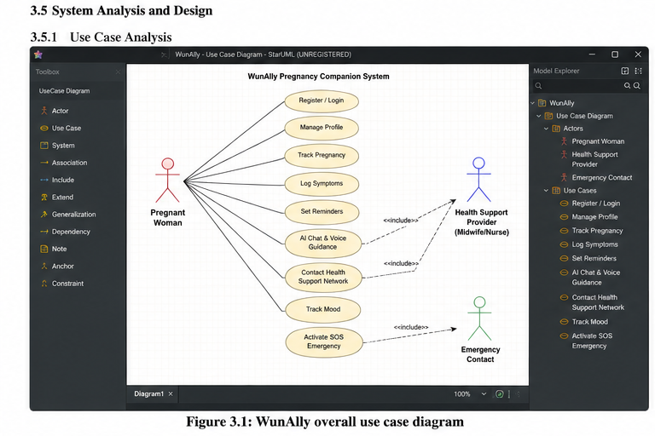

3.5.2 System Architecture
WunAlly employs a client-server architecture comprising three primary layers: the mobile frontend, the backend API server, and the database layer. This architecture is illustrated in Figure 3.2.
The mobile frontend, developed using React Native, presents the user interface and manages client-side logic including local data storage for offline access. It communicates with the backend through a RESTful API. The backend, implemented using Django REST Framework, handles business logic, data validation, safety rule processing, AI chat integration, push notification dispatch, and emergency alert triggers. The database layer, powered by PostgreSQL, stores all structured data including user profiles, health records, symptom entries, chat histories, mood logs, reminders, and emergency contact information.
Data transmitted between the frontend and backend is secured using HTTPS with TLS encryption. User authentication is managed through JWT tokens, which are issued upon successful login and required for every protected API request. This approach ensures that health data is not accessible without valid authentication, reducing the risk of unauthorized access even in shared-phone environments (Abaze and Marschollek, 2017).

[Screenshot: Figure 3.2 – WunAlly System Architecture Diagram: Mobile Client, REST API (Django), PostgreSQL Database]
Figure 3.2: WunAlly three-layer system architecture

3.5.3 Database Design
The database was designed to store all data required by WunAlly's modules while minimising the collection of unnecessary personal information in line with privacy requirements. The core tables and their relationships are described in Table 3.3.

Table 3.3: Core database tables and their primary fields
Table | Primary Fields
Users | user_id, name, phone, hashed_password, date_created, is_active
Profiles | profile_id, user_id, gestational_age, expected_due_date, blood_type, allergies, trimester, last_updated
HealthRecords | record_id, user_id, date, weight_kg, blood_pressure_systolic, blood_pressure_diastolic, fetal_kicks, notes
Symptoms | symptom_id, user_id, date, symptom_description, severity_level, ai_guidance_given, referral_triggered
Reminders | reminder_id, user_id, type (appointment/medication/supplement), scheduled_time, is_recurring, is_acknowledged
ChatLogs | chat_id, user_id, timestamp, user_message, ai_response, escalation_flag
MoodLogs | mood_id, user_id, date, mood_score, mood_label, support_tip_delivered, referral_flag
EmergencyContacts | contact_id, user_id, contact_name, phone_number, relationship, is_primary
SOSEvents | sos_id, user_id, timestamp, location_lat, location_lng, contacts_notified, offline_mode
HealthProviders | provider_id, name, role (midwife/nurse), phone, assigned_users
Source: Nhonwi Niba, 2026

Foreign key constraints ensure referential integrity across tables. The user_id field links all health and activity records to the corresponding user account. Sensitive fields, including passwords, are hashed before storage. Location coordinates stored in SOSEvents are treated as temporary data and are not retained beyond their immediate operational purpose.

[Screenshot: Figure 3.3 – Entity Relationship Diagram (ERD) for WunAlly database schema]
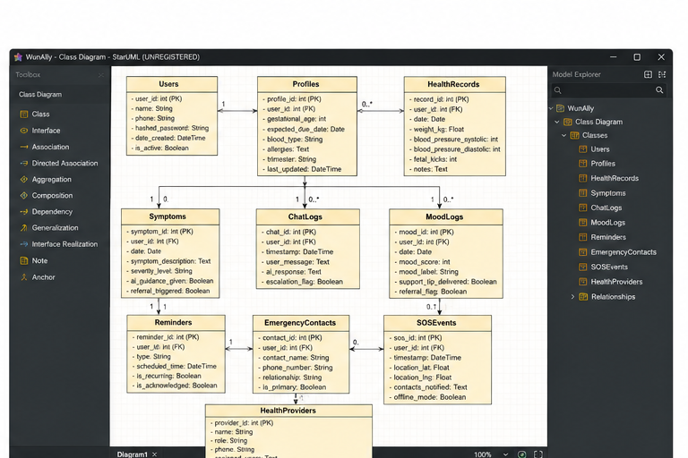
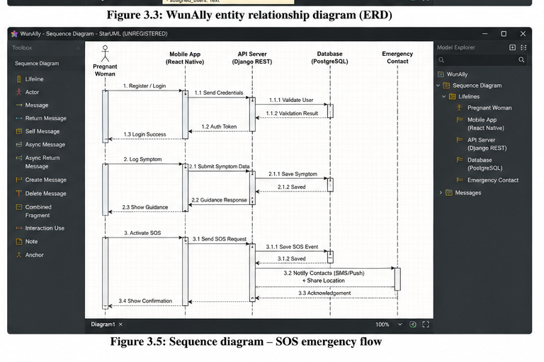

3.5.4 Process Flow Design
Process flow diagrams were developed to model the logic and sequence of operations for each major module. Figure 3.4 illustrates the overall user journey from registration through daily use and emergency activation.
On first launch, the user is prompted to create a profile by entering personal health information including gestational age, expected due date, blood type, known allergies, and emergency contacts. After successful registration, the application generates a personalised dashboard displaying the current trimester, gestational week, upcoming reminders, and a daily mood prompt. During routine use, the user may log symptoms, review weekly pregnancy content, chat with the AI assistant, or contact a health support provider. If the user activates the SOS function, the application immediately notifies pre-selected emergency contacts, attempts to share live location data, and, if offline, presents stored emergency guidance steps. The symptom module applies rule-based logic to classify reported symptoms as routine, watchful, or urgent, and triggers appropriate guidance or escalation responses accordingly.

[Screenshot: Figure 3.4 – WunAlly Process Flow Diagram: Registration, Daily Use, and SOS Activation]
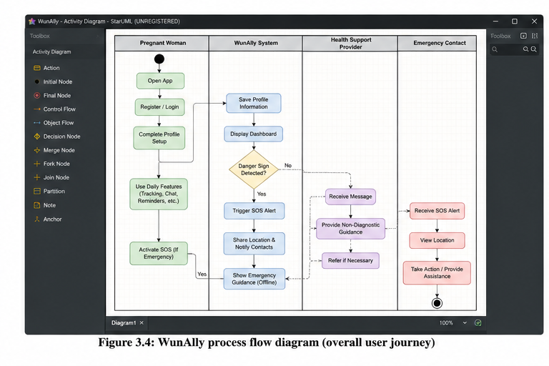
Figure 3.4: WunAlly overall process flow

3.6 Implementation of Proposed Solution Based on Research Objectives
The implementation of WunAlly was structured in correspondence with the four specific research objectives. Each module addresses one or more objectives and was developed iteratively, with testing and review conducted at the end of each development cycle.

3.6.1 Design and Implementation of the Pregnancy Tracking Module (Objective 1)
The pregnancy tracking module was designed to address the first specific objective: to design and implement a secure pregnancy tracking module for recording gestational age, trimester milestones, weight, blood pressure, allergies, symptoms, reminders, appointments, and other relevant maternal health information.
Upon registration, the user enters key profile information that serves as the foundation for all personalised content. Gestational age is calculated from the last menstrual period date or from the estimated due date, and is updated automatically with each session. The module then delivers week-by-week pregnancy information aligned with the user's current gestational week, describing fetal development, expected physical changes in the mother, nutrition recommendations, and relevant self-care guidance for that period.
The health record entry screen allows the user to log weight and blood pressure readings at any time. These records are stored with timestamps in the HealthRecords table and displayed in a simple longitudinal view, enabling the user to observe trends over time. The symptom check-in screen presents a structured list of common pregnancy symptoms alongside a free-text entry option. Each symptom entry is processed through a rule-based classification engine that assigns it one of three severity levels: (i) normal, accompanied by reassurance and self-care advice; (ii) watchful, accompanied by monitoring instructions and advice to inform a health worker; or (iii) urgent, accompanied by a danger sign prompt and a direct link to the SOS function and the Health Support Network.
The reminder system allows users to create, edit, and delete reminders for antenatal clinic appointments, iron and folic acid supplementation, medications, hydration schedules, and self-monitoring activities. Reminders are stored locally on the device to ensure they are triggered reliably even when the device is offline. Push notifications are used to deliver reminders when the device is connected to a network.
The frontend for the tracking module was built using React Native components including FlatList for displaying health records, custom input forms for data entry, and local AsyncStorage for offline caching of profile and reminder data. The backend API exposes endpoints for creating, reading, updating, and deleting records in the Profiles, HealthRecords, Symptoms, and Reminders tables. Figures 3.5 and 3.6 illustrate the pregnancy tracking dashboard and the symptom entry screen respectively.

[Screenshot: Figure 3.5 – Pregnancy Tracking Dashboard showing gestational week, trimester progress bar, recent health record entries, and upcoming reminders]
Figure 3.5: Pregnancy tracking dashboard

[Screenshot: Figure 3.6 – Symptom Check-In Screen showing structured symptom list, severity classification result, and guidance response]
Figure 3.6: Symptom check-in screen with rule-based classification feedback
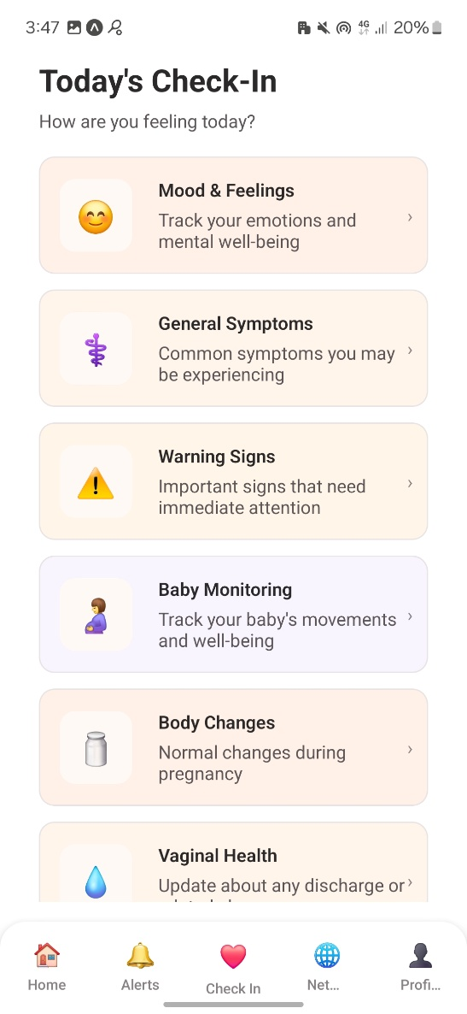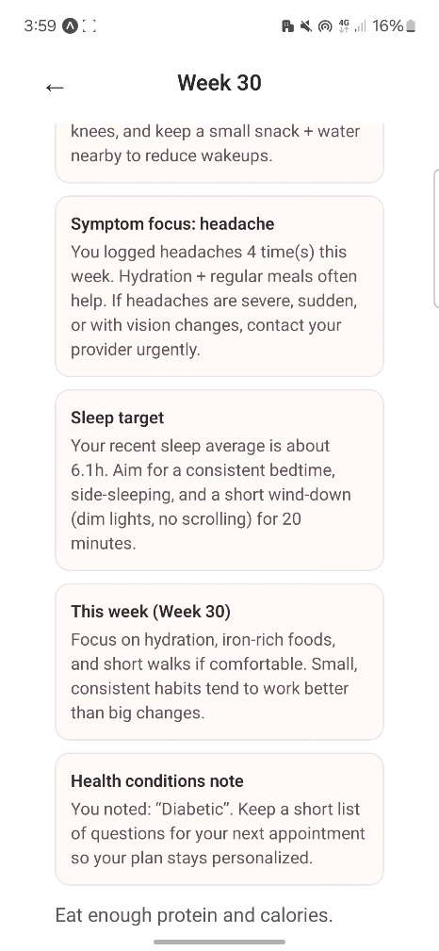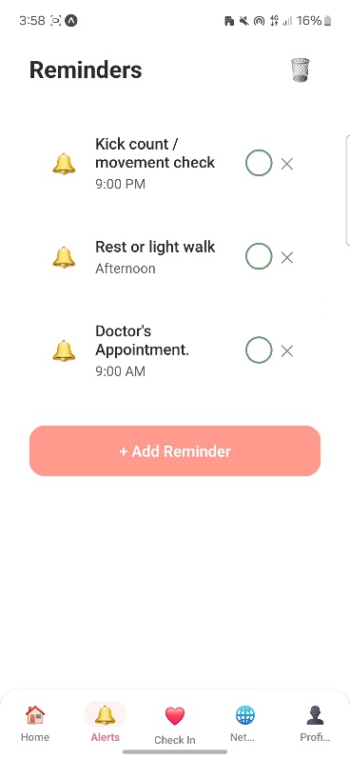

3.6.2 Design and Implementation of the AI and Voice Guidance Module (Objective 2)
The AI and voice guidance module was designed to address the second specific objective: to integrate AI-powered chat, voice-assisted interaction, and a Health Support Network that provide personalised, non-diagnostic guidance on pregnancy self-care, nutrition, exercise, sleep, emotional wellbeing, and common danger signs.
The AI chat interface allows the user to type or speak a question and receive a conversational response. The underlying model is accessed through a secure API call from the Django backend, which acts as a middleware layer between the mobile client and the AI service. This architecture ensures that the AI service credentials are never exposed to the client, and that all queries pass through the backend's safety filter before being forwarded.
The backend safety filter applies a set of pre-defined rules before each AI response is delivered to the user. These rules check for keywords associated with danger signs, including vaginal bleeding, reduced fetal movement, severe headache with blurred vision, convulsions, fever with chills, difficulty breathing, and severe abdominal pain. When such keywords are detected in either the user's query or the AI's draft response, the system overrides the AI output with a standardised safety escalation message advising the user to seek urgent professional care immediately and presenting the SOS option. This approach is consistent with the recommendation that AI in maternal health must be constrained by verified content, clear disclaimers, and human support pathways (Biviji et al., 2024; Musgrave et al., 2023).
For topics that do not trigger safety escalation, the AI assistant provides personalised, non-diagnostic responses based on the user's gestational week and previous symptom entries stored in the session context. Topics covered include nutrition by trimester, safe physical activity, sleep positioning, managing nausea and heartburn, interpreting common discomforts, preparing for antenatal visits, and emotional wellbeing strategies. All responses include a standard disclaimer reminding the user that the guidance provided is educational and does not replace clinical assessment.
Voice support was implemented using the device's built-in text-to-speech capability, invoked through the React Native Speech library. When voice output is enabled by the user, all AI responses are read aloud in addition to being displayed on screen. Voice input was implemented using the React Native Voice library, converting spoken queries into text before submission to the backend. This feature is particularly valuable for users who struggle with reading on a small screen, have low literacy, or prefer audio interaction, as identified as a priority design criterion for low-resource settings (Ahinkorah et al., 2021).
The Health Support Network feature connects the user to a registered midwife or nurse through an in-app messaging interface. Messages are delivered through the backend to the provider's dashboard, where the health worker can review the query and respond with non-diagnostic guidance or a referral recommendation. The network is clearly framed to users as a channel for education and reassurance, not emergency response. Figure 3.7 shows the AI chat interface, and Figure 3.8 shows the Health Support Network messaging screen.

[Screenshot: Figure 3.7 – AI Chat Interface showing a user query, the AI response, a safety escalation example, and the voice output toggle]
Figure 3.7: AI-assisted chat interface with voice support and safety escalation

[Screenshot: Figure 3.8 – Health Support Network Screen showing the messaging interface between the user and a registered midwife]
Figure 3.8: Health Support Network messaging interface

3.6.3 Design and Implementation of the SOS Emergency Module (Objective 3)
The SOS emergency module was designed to address the third specific objective: to develop an SOS emergency support module that alerts pre-selected contacts, shares the user's live location where possible, provides stored emergency guidance, and remains usable in low-resource or limited-connectivity contexts.
The SOS button is displayed persistently on the application's main navigation bar, ensuring it remains visible and accessible regardless of which screen the user is viewing. Its visual design uses a high-contrast red color against the application's background palette, making it immediately identifiable even under stress or poor lighting conditions. To prevent accidental activation, the SOS function requires a simple two-step confirmation before executing.
Upon confirmation, the module executes the following sequence: it retrieves the device's GPS coordinates using the React Native Geolocation API; it composes an alert message including the user's name, gestational week, and current location coordinates; it dispatches this message via the backend to all pre-selected emergency contacts through SMS and push notification channels; and it logs the SOS event in the SOS Events database table with timestamp, location data, and the list of contacts notified.
When the device is offline or location services are unavailable, the module degrades gracefully. In offline mode, it displays a stored emergency guidance screen presenting step-by-step instructions for common obstetric emergencies, including uncontrolled bleeding, loss of consciousness, difficulty breathing, and onset of labor. These instructions are stored locally during application installation and are accessible without network connection. Emergency contact phone numbers are also stored locally so that the user or a nearby helper can initiate a direct phone call without requiring app connectivity.
This design directly addresses the second delay in the Three Delays Model by reducing the time needed to mobilise emergency support, particularly in communities where ambulance services may be unavailable and the first responders are family members, neighbours, or community health workers (Thaddeus and Maine, 1994; WHO, 2025). Figure 3.9 illustrates the SOS activation screen, and Figure 3.10 shows the offline emergency guidance display.

[Screenshot: Figure 3.9 – SOS Activation Screen showing the confirmation step, contact list to be notified, and location sharing status indicator]
Figure 3.9: SOS emergency activation screen

[Screenshot: Figure 3.10 – Offline Emergency Guidance Screen showing stored step-by-step instructions and direct call buttons for emergency contacts]
Figure 3.10: Offline emergency guidance screen

3.6.4 Design and Implementation of the Mood Tracking Feature
A mood tracking feature was incorporated as part of the holistic design of WunAlly, recognising that pregnancy risk includes psychosocial dimensions alongside clinical ones. The feature presents a simple daily check-in prompt in which the user selects from a set of five illustrated mood icons ranging from very positive to very distressed. Each selection is stored in the MoodLogs table and associated with a supportive tip displayed immediately after the entry.
The system monitors patterns in mood logs over consecutive days. If a user records severe distress, persistent sadness, or selects the lowest mood category across three or more consecutive days, the application generates a prompt encouraging the user to speak with a trusted person or health provider and offering to connect to the Health Support Network. This feature does not diagnose depression or anxiety; it serves as a supportive reflection tool that prompts timely human connection when emotional distress is detected.

[Screenshot: Figure 3.11 – Mood Tracking Screen showing the daily check-in prompt with illustrated mood icons and the supportive tip display]
Figure 3.11: Daily mood tracking check-in

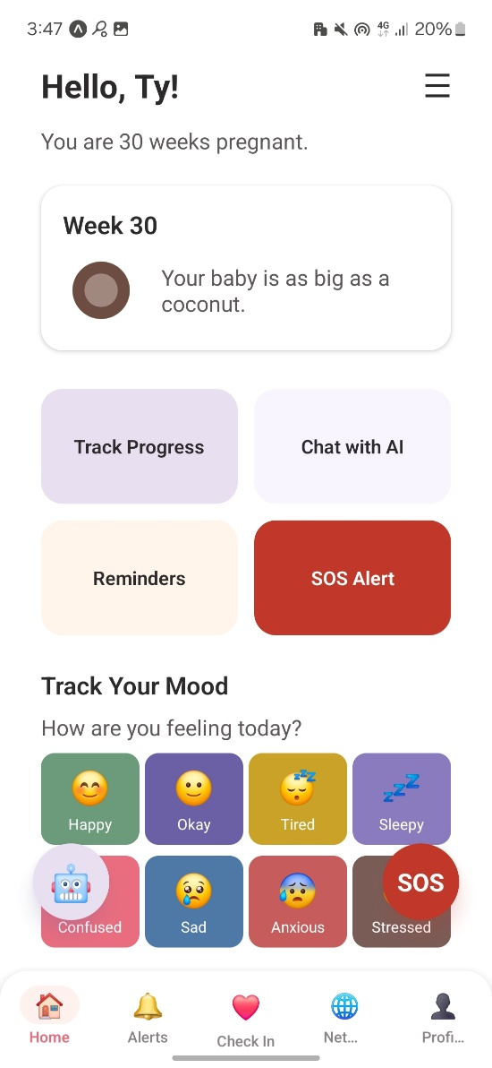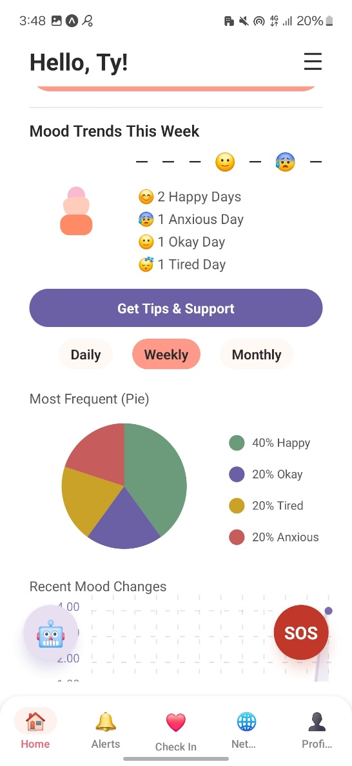

3.7 System Testing and Evaluation (Objective 4)
System testing and evaluation were conducted to address the fourth specific objective: to evaluate the application's usability, accessibility, perceived usefulness, privacy considerations, and suitability for pregnant women with varying literacy levels and socio-economic backgrounds.

3.7.1 Testing Approach
Testing was carried out at three levels throughout the development process:
Unit Testing: Each backend API endpoint was tested individually using Postman to verify correct data input, output, authentication behavior, and error handling. Frontend components were tested in isolation using React Native's built-in test utilities to verify rendering, state management, and event handling.
Integration Testing: After individual modules were developed, integration tests were conducted to verify correct communication between the React Native frontend and the Django REST API. Test scenarios included user registration, symptom submission with rule-based classification, AI chat safety escalation, SOS alert dispatch, and reminder notification delivery.
User Testing: Structured user testing sessions were conducted with a representative sample of participants. Participants were asked to complete a series of tasks within the application while thinking aloud, followed by completion of a standardized usability questionnaire. Observations from sessions were recorded and used to identify interface improvements.

3.7.2 Evaluation Metrics and Instruments
The evaluation of WunAlly was guided by four primary dimensions, consistent with the World Health Organization's recommended framework for assessing digital health interventions (WHO, 2019) and the literature on mHealth usability assessment (Hussain et al., 2018; Galavi et al., 2024):
- Usability: Assessed using the System Usability Scale (SUS), a validated ten-item questionnaire that produces a composite score between 0 and 100. A score of 70 or above is generally considered acceptable for digital health applications (Hyzy et al., 2022). Participants completed the SUS after performing standardized tasks across all major modules.
- Accessibility: Evaluated through observation during testing sessions, focusing on whether participants with limited smartphone experience or low literacy were able to navigate core features without assistance, and whether voice support and icon-based navigation provided adequate alternative pathways.
- Perceived Usefulness: Assessed through a short post-testing interview and a five-item Likert scale questionnaire asking participants to rate the usefulness of each module for their pregnancy experience and emergency preparedness.
- Privacy and Trust: Assessed through a structured discussion exploring participants' understanding of data use, comfort with location sharing during SOS activation, and confidence that their health information was protected.

3.7.3 Participants
Participants were recruited from two groups representative of WunAlly's intended user population:
- Pregnant Women: Women in the second and third trimester of pregnancy, recruited from antenatal clinics and community settings in the study area. Participants were selected to include a range of educational backgrounds, smartphone experience levels, and income brackets, reflecting the socio-economic diversity of the target population.
- Healthcare Support Staff: Registered nurses and certified midwives working in antenatal care settings, recruited to evaluate the Health Support Network features and provide professional input on the clinical safety of AI chat responses and danger sign escalation logic.

All participants provided informed consent prior to participation. Personal information collected during testing sessions was used solely for research purposes and was not linked to participants' identities in any published output. Ethical principles including voluntary participation, confidentiality, and the right to withdraw at any time were observed throughout the evaluation process.
Table 3.4 summarizes the testing instruments and the module or objective each instrument was used to evaluate.

Table 3.4: Summary of evaluation instruments and their application
Instrument | Dimension Assessed | Module(s) Evaluated
System Usability Scale (SUS) | Usability | All modules
Task completion observation | Usability, Accessibility | Registration, Tracking, Chat, SOS
Perceived usefulness Likert scale | Perceived Usefulness | All modules
Post-testing interview | Privacy, Trust, Accessibility | SOS, AI Chat, Health Support Network
Clinical safety review checklist | Clinical Safety of AI Responses | AI Chat, Symptom Classification
Source: Nhonwi Niba, 2026

3.8 Chapter Summary
This chapter described the methodology, system design, implementation, and evaluation strategy used in the development of WunAlly. The Agile development model was adopted to enable iterative, feedback-driven progress suited to mHealth application development in resource-constrained contexts. The development environment combined React Native for mobile frontend development, Django REST Framework for backend API management, and PostgreSQL for structured data storage, providing technically sound and extensible architecture.
Requirements analysis identified the functional and non-functional specifications for four core modules: the pregnancy tracking module, the AI and voice guidance module, the SOS emergency module, and the Health Support Network. Each module was implemented in direct correspondence with the specific research objectives, with safety rules, offline fallbacks, and privacy protections built into the design of every component. The symptom classification engine, AI safety filter, and SOS graceful degradation for offline use reflect the application's commitment to operating safely and reliably under the real conditions faced by pregnant women in low-resource settings.
System testing was conducted at unit, integration, and user levels. Evaluation of the completed system used validated instruments including the System Usability Scale, task observation, Likert-scale perceived usefulness rating, and structured post-testing interviews. Participants were drawn from two groups: pregnant women with varying literacy and digital experience, and healthcare support staff. The results of this evaluation are presented and discussed in Chapter Four.

REFERENCES
Ahinkorah, B. O., Ameyaw, E. K., Seidu, A.-A., Odusina, E. K., Keetile, M., & Yaya, S. (2021). Examining barriers to healthcare access and utilization of antenatal care services: Evidence from demographic health surveys in sub-Saharan Africa. BMC Health Services Research, 21, 125. https://doi.org/10.1186/s12913-021-06129-5
Biviji, R., Williams, K. S., & Kvedar, J. C. (2024). Smartphone pregnancy apps: Systematic analysis of features, scientific rationales, and user perceptions. JMIR mHealth and uHealth. https://pmc.ncbi.nlm.nih.gov/articles/PMC11587608/
Budhwani, H., Turan, J. M., Szychowski, J. M., Carlo, W. A., Ambe, L. N., Halle-Ekane, G., Muffih, P. T., Tita, A. T. N., & others. (2024). Structural barriers to maternity care in Cameroon: A qualitative study. Reproductive Health, 21, 100. https://doi.org/10.1186/s12978-024-01834-w
Knop, M. R., Nagashima-Hayashi, M., Lin, R., Saing, C. H., Ung, M., Oy, S., Yam, E. L. Y., Zahari, M., & Yi, S. (2024). Impact of mHealth interventions on maternal, newborn, and child health from conception to 24 months postpartum in low- and middle-income countries: A systematic review. BMC Medicine, 22, 196. https://doi.org/10.1186/s12916-024-03417-9
Kusyanti, T., Wirakusumah, F. F., Rinawan, F. R., Muhith, A., Purbasari, A., Mawardi, F., Puspitasari, I. W., Faza, A., & Stellata, A. G. (2022). Technology-based (mHealth) and standard/traditional maternal care for pregnant woman: A systematic literature review. Healthcare, 10(7), 1287. https://doi.org/10.3390/healthcare10071287
Musgrave, L. M., Kizirian, N., Homer, C. S. E., & Gordon, A. (2023). Safety considerations for assessing the quality of apps used during pregnancy: A scoping review. Digital Health, 9. https://pmc.ncbi.nlm.nih.gov/articles/PMC10478559/
Rahman, M. O., Yamaji, N., Nagamatsu, Y., & Ota, E. (2022). Effects of mHealth interventions on improving antenatal care visits and skilled delivery care in low- and middle-income countries: Systematic review and meta-analysis. Journal of Medical Internet Research, 24(4), e34061. https://doi.org/10.2196/34061
Thaddeus, S., & Maine, D. (1994). Too far to walk: Maternal mortality in context. Social Science & Medicine, 38(8), 1091-1110. https://doi.org/10.1016/0277-9536(94)90226-7
UNICEF. (2025). Trends in maternal mortality 2000 to 2023. UNICEF Data. https://data.unicef.org/resources/trends-in-maternal-mortality-2000-to-2023/
World Bank. (2025). Maternal mortality ratio (modeled estimate, per 100,000 live births) - Cameroon. World Bank Data. https://data.worldbank.org/indicator/SH.STA.MMRT?locations=CM
World Health Organization. (2019). WHO guideline: Recommendations on digital interventions for health system strengthening. World Health Organization. https://www.who.int/publications/i/item/WHO-RHR-19.10
World Health Organization. (2025). Maternal mortality. World Health Organization. https://www.who.int/news-room/fact-sheets/detail/maternal-mortality
World Health Organization Regional Office for Africa. (2022). Maternal mortality: The urgency of a systemic and multisectoral approach in mitigating maternal deaths in Africa. WHO African Health Observatory. https://files.aho.afro.who.int/afahobckpcontainer/production/files/iAHO_Maternal_Mortality_Regional_Factsheet.pdf
Bowser, D., & Hill, K. (2010). Exploring evidence for disrespect and abuse in facility-based childbirth: Report of a landscape analysis. USAID-TRAction Project.
Brusilovsky, P. (2001). Adaptive hypermedia. User Modeling and User-Adapted Interaction, 11, 87-110.
Gould, J. D., & Lewis, C. (1985). Designing for usability: Key principles and what designers think. Communications of the ACM, 28(3), 300-311.
Istepanian, R. S. H., & Lacal, J. C. (2003). Emerging mobile communication technologies for health: Some imperative notes on m-health. Proceedings of the 25th Annual International Conference of the IEEE Engineering in Medicine and Biology Society.
World Health Organization. (2008). Task shifting: Rational redistribution of tasks among health workforce teams: Global recommendations and guidelines.
Abaza, H., & Marschollek, M. (2017). mHealth application areas and technology combinations: A comparison of literature from high and low/middle income countries. Methods of Information in Medicine, 56(7), e105–e122. https://doi.org/10.3414/ME17-05-0003
Ahinkorah, B. O., Ameyaw, E. K., Seidu, A.-A., Odusina, E. K., Keetile, M., & Yaya, S. (2021). Examining barriers to healthcare access and utilization of antenatal care services: Evidence from demographic health surveys in sub-Saharan Africa. BMC Health Services Research, 21, 125. https://doi.org/10.1186/s12913-021-06129-5
Banos, O., Villalonga, C., Garcia, R., Saez, A., Damas, M., Holgado-Terriza, J. A., Lee, S., Pomares, H., & Rojas, I. (2015). Design, implementation and validation of a novel open framework for agile development of mobile health applications. BioMedical Engineering OnLine, 14(S2), S6. https://doi.org/10.1186/1475-925X-14-S2-S6
Biviji, R., Williams, K. S., & Kvedar, J. C. (2024). Smartphone pregnancy apps: Systematic analysis of features, scientific rationales, and user perceptions. JMIR mHealth and uHealth. https://pmc.ncbi.nlm.nih.gov/articles/PMC11587608/
Budhwani, H., Turan, J. M., Szychowski, J. M., Carlo, W. A., Ambe, L. N., Halle-Ekane, G., Muffih, P. T., & Tita, A. T. N. (2024). Structural barriers to maternity care in Cameroon: A qualitative study. Reproductive Health, 21, 100. https://doi.org/10.1186/s12978-024-01834-w
Dutta, P. K., & Mensah, G. B. (2025). Implementing agile healthcare frameworks in the context of low income countries: Proposed framework and review. arXiv. https://arxiv.org/abs/2502.10403
Erreyes, E. M. L., Perez Mayorga, D., & Menendez Vera, N. (2015). A comparison between agile and traditional software development methodologies. Universidad Politecnica Salesiana Ecuador.
Galavi, Z., Montazeri, M., & Khajouei, R. (2024). Which criteria are important in usability evaluation of mHealth applications: An umbrella review. BMC Medical Informatics and Decision Making, 24(1), 365.
Hussain, A., Mkpojiogu, E. O. C., Fadzil, N., Hassan, N., & Zaaba, Z. F. (2018). A mobile usability evaluation of a pregnancy app. Journal of Telecommunication, Electronic and Computer Engineering, 10(1-11), 13–18.
Hyzy, M., Bond, R., Mulvenna, M., Bai, L., Dix, A., Daly, R., Frey, A., & Leigh, S. (2022). System Usability Scale benchmarking for digital health apps: Meta-analysis. JMIR mHealth and uHealth, 10(8), e37290. https://doi.org/10.2196/37290
Knop, M. R., Nagashima-Hayashi, M., Lin, R., Saing, C. H., Ung, M., Oy, S., Yam, E. L. Y., Zahari, M., & Yi, S. (2024). Impact of mHealth interventions on maternal, newborn, and child health from conception to 24 months postpartum in low- and middle-income countries: A systematic review. BMC Medicine, 22, 196. https://doi.org/10.1186/s12916-024-03417-9
Musgrave, L. M., Kizirian, N., Homer, C. S. E., & Gordon, A. (2023). Safety considerations for assessing the quality of apps used during pregnancy: A scoping review. Digital Health, 9. https://pmc.ncbi.nlm.nih.gov/articles/PMC10478559/
Peiris, D., Praveen, D., Johnson, C., & Mogulluru, K. (2015). Engineering a mobile health tool for resource-poor settings to assess and manage cardiovascular disease risk: SMARThealth study. BMC Medical Informatics and Decision Making, 15, 36. https://doi.org/10.1186/s12911-015-0148-4
Rahman, M. O., Yamaji, N., Nagamatsu, Y., & Ota, E. (2022). Effects of mHealth interventions on improving antenatal care visits and skilled delivery care in low- and middle-income countries: Systematic review and meta-analysis. Journal of Medical Internet Research, 24(4), e34061. https://doi.org/10.2196/34061
Thaddeus, S., & Maine, D. (1994). Too far to walk: Maternal mortality in context. Social Science & Medicine, 38(8), 1091–1110. https://doi.org/10.1016/0277-9536(94)90226-7
World Health Organization. (2019). WHO guideline: Recommendations on digital interventions for health system strengthening. World Health Organization.
World Health Organization. (2025). Maternal mortality. World Health Organization. https://www.who.int/news-room/fact-sheets/detail/maternal-mortality
Ye, J., Li, J., Lin, Y., Wang, Y., Wu, J., & Zhou, Z. (2024). Pregnancy: A comprehensive review. In Public Health. IntechOpen. https://doi.org/10.5772/intechopen.1007951

