

DEPARTMENT OF COMPUTING & AI

OBJECT ORIENTED PROGRAMMING-LAB
BSIT-2A
ASSIGNMENT No. 01
SUBMITTED BY: MAHNOOR TANVEER
ROLL No.2504497
SUBMITTED TO: MA’AM SARA IBRAHIM
DATE: 02/24/2026

- PART 01: Analysis & Identification
- Selected Entity: Book
A book represents a product available in a book shop. The system stores information about each book and allows the shopkeeper to add, search, view and update book records.
- Attributes of Book
Attributes | Data Type | Description
BookID | int | Unique identification number of a book
Title | string | Name of the book
Author | string | Writer of the book
Price | float | Cost of the book
- Behaviors / Functions
The Book object will perform:
- Add record
- View records
- Search record
- Update record
- Entity Description
The Book entity stores complete information of books available in the shop. Each book has a unique ID. The user can insert a new book, view all books, search for a specific book, and update book details.

- PART 02: C++ Implementation
- Program:
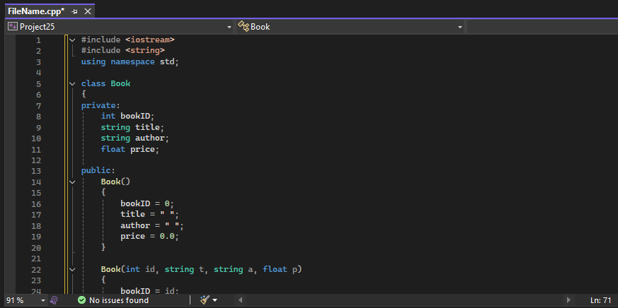
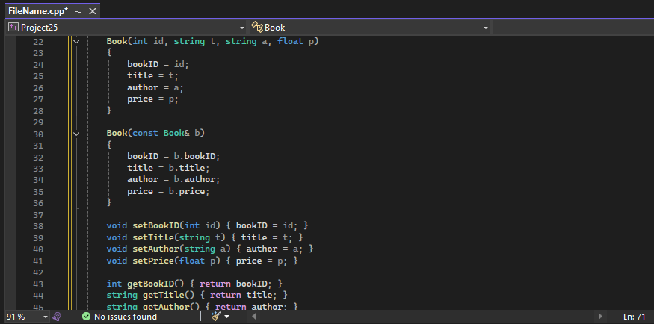
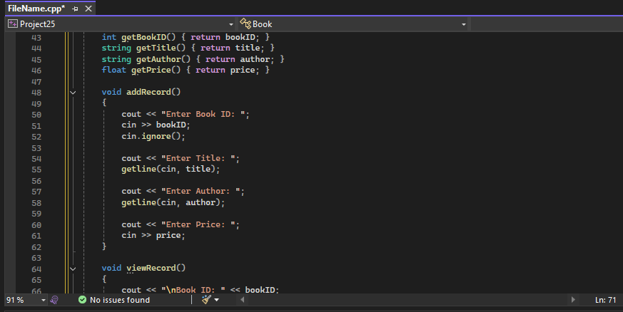
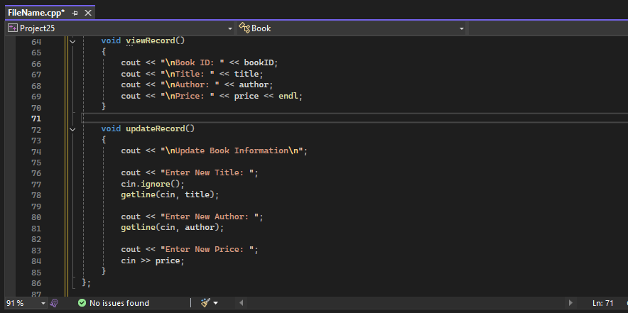
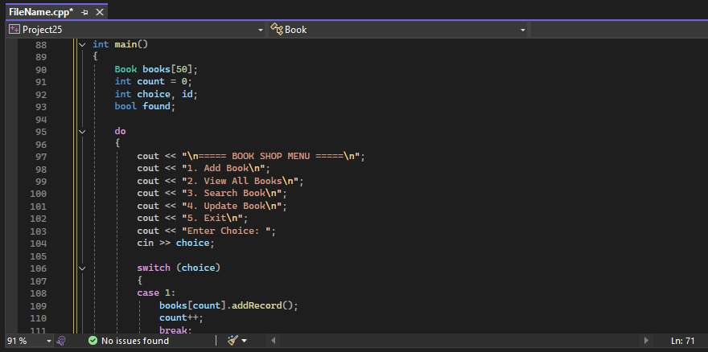
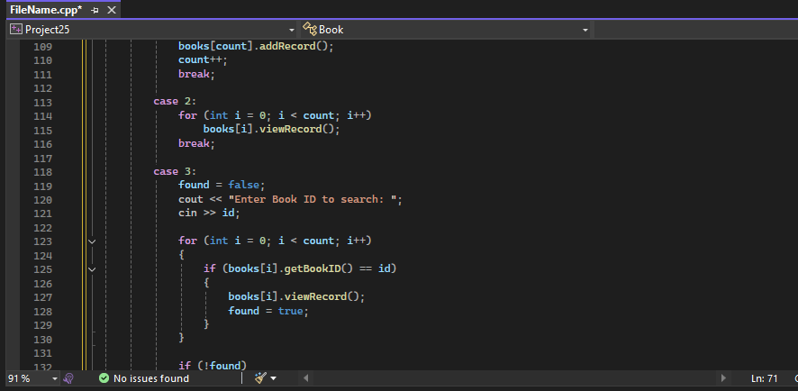
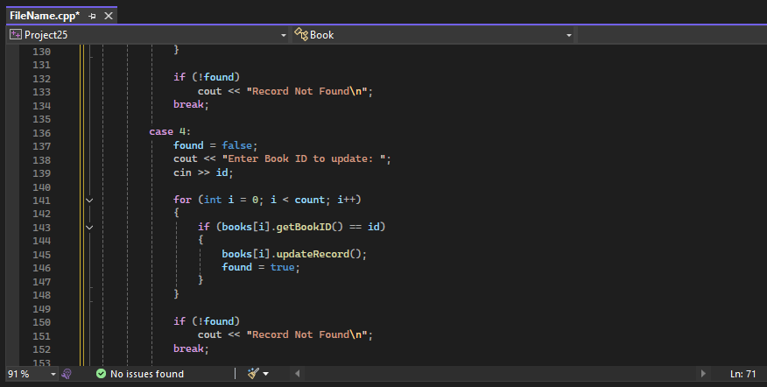
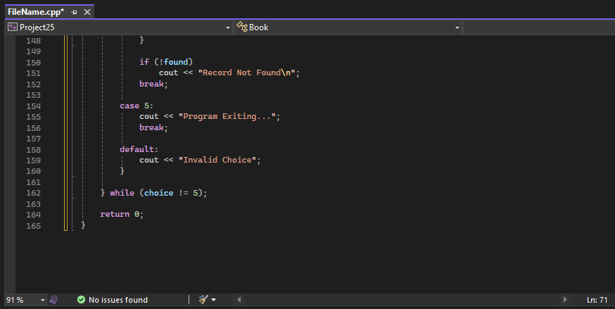

- Output:
- Menu:
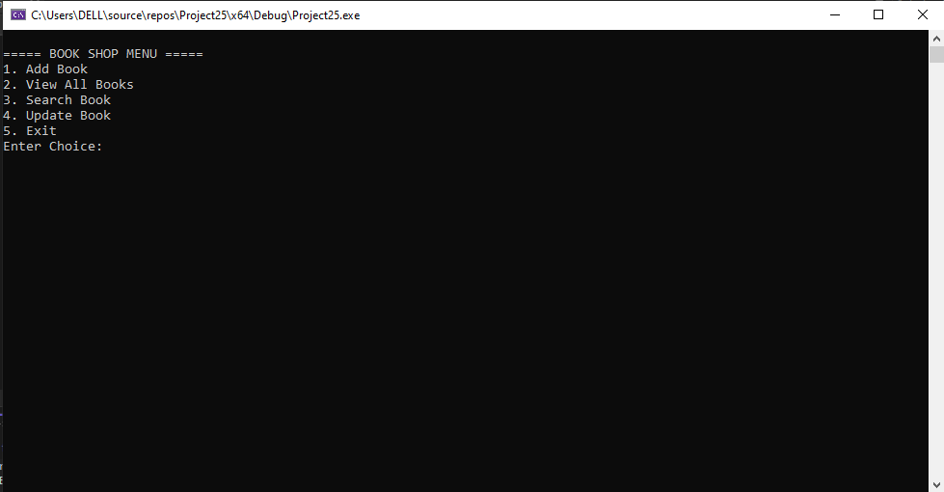
- Add record:
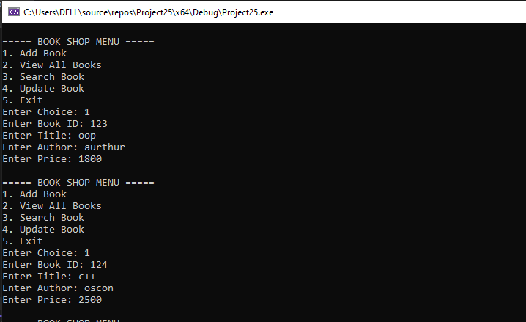

- View record:
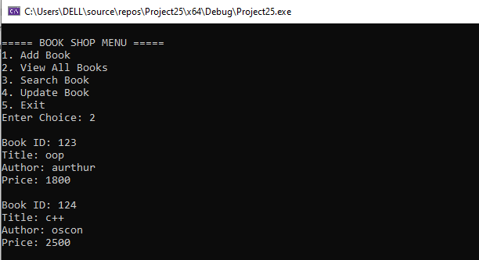
- Search record:
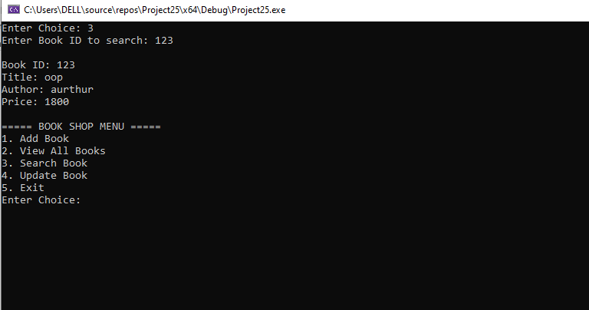

- Update record:
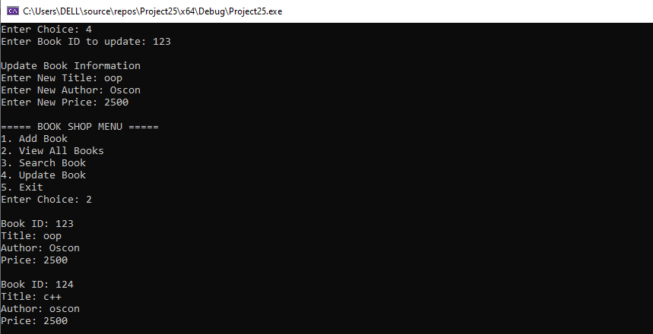
- Exit:
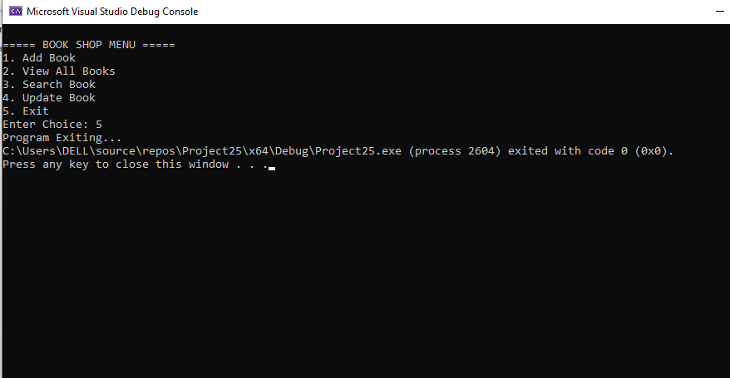

- PART 03: Testing
- Test for adding a record:
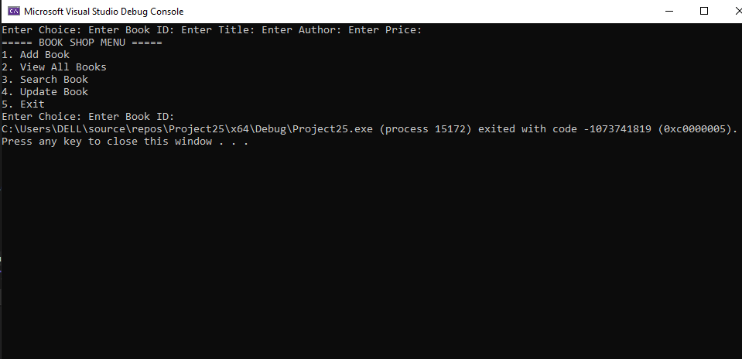
- Test for searching a record:
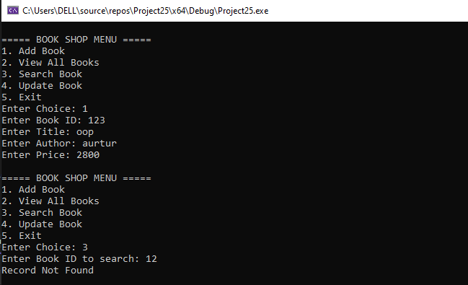

- Test for updating a record:
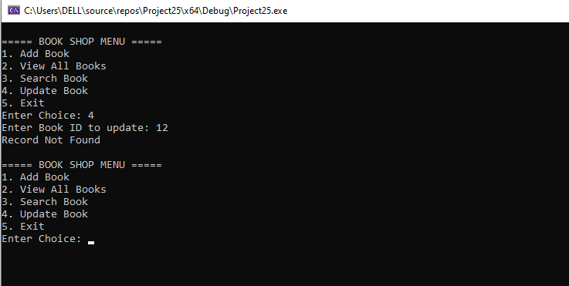
- Input & expected Output:
INPUT | EXPECTED OUTPUT
(After entering choice#1)  Enter Choice: | Enter Book ID:  Enter Title:  Enter Author:  Enter Price:
(After entering choice#2)  Enter Choice: | Book ID: 123  Title: oop  Author: aurtur  Price: 2800
(After entering choice#3)  Enter Choice: | Enter Book ID to search: 123  Book ID: 123  Title: oop  Author: aurtur  Price: 2800
(After entering choice#4)  Enter Choice: | Enter Book ID to update: 123  Update Book Information  Enter New Title: c++  Enter New Author: oscon  Enter New Price: 3500
(After entering choice#4)  Enter Choice: | Program Exiting...

