**NAME: MAHNOOR QAZI**

**R.NO: FA21-BSE-020**

**SECTION: BSE 4A**

**SUBJECT: WEB TECHNOLOGIES**

**SUBMITTED TO: SIR MUHAMMAD ALI**

**LAB ASIGNMENT: 1**

**QUESTION:**

Make a website in HTML and CSS. Your website should have 3 pages with proper content and menu.

**ANSWER:**

**HTML FILE:**

**Doctype html:**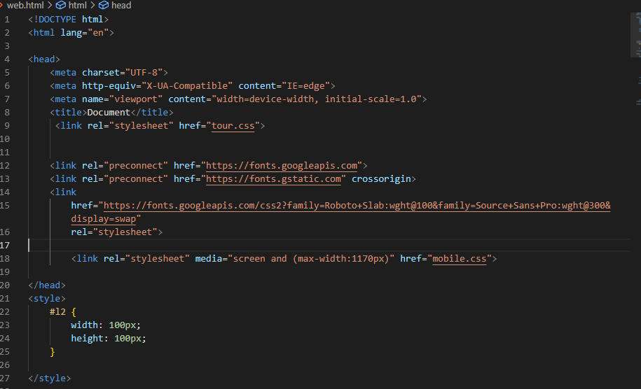

**BODY:**

**Navigation bar:**

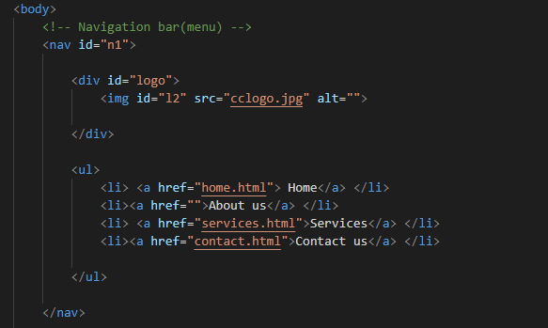

**Home:**

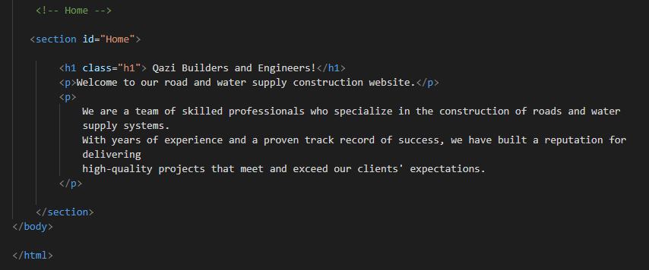

**CSS FILE:**

**For navigation bar:**

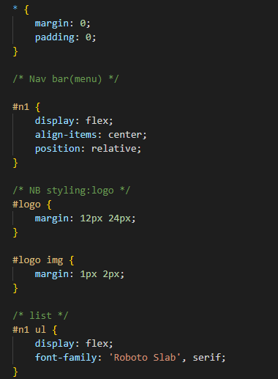

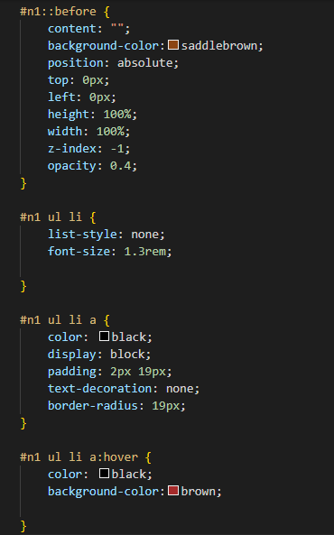

**CSS FOR HOME:**

