Lab-04: Draw CFG by defining its paths and checking the whole code by white box testing.

**Example to reverse the number in Java**

public class ReverseNumber {

public static void main(String[] args) {

int number = 12345;

System.out.println("Original number: " + number);

int reversed = 0;

int temp = number;

while (temp != 0) {

int digit = temp % 10;

reversed = reversed * 10 + digit;

temp /= 10;

}

System.out.println("Reversed number: " + reversed);

}

}

**Control Flow Graph**

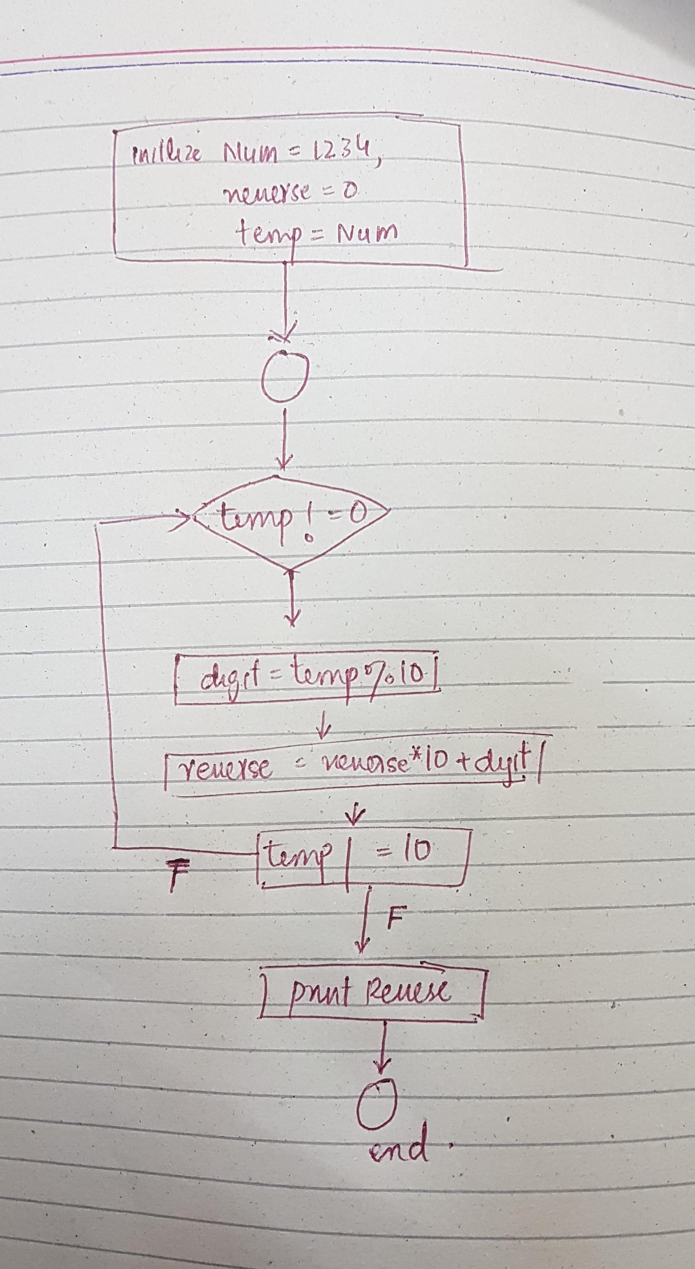

1. **Path 1**: The while loop condition **temp != 0** is true initially.
   * 1-2 (Initialization)
   * 3-4-5 (Loop)
   * 6 (Exit Loop)
2. **Path 2**: The while loop condition **temp != 0** is false initially.
   * 1-2 (Initialization)
   * 3 (Loop Condition False)

Therefore, we have two paths in this code:

1. Path 1: 1-2-3-4-5-6
2. Path 2: 1-2-3