

AI Driven Software Development
Name: Aqsa Abbas(55493)
Submitted To: Sir Zia Ul Murtaza
BSCS:6B

Installation Command:
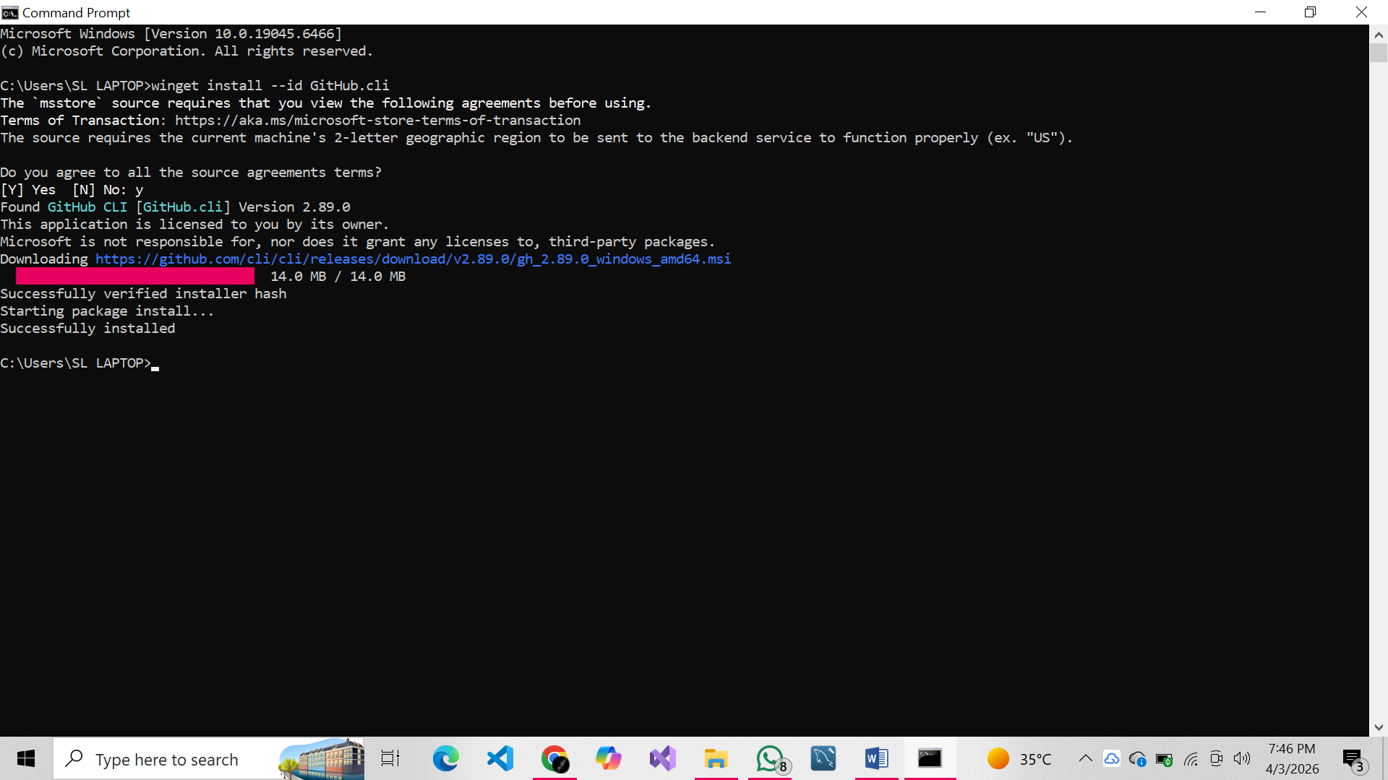
Verification:
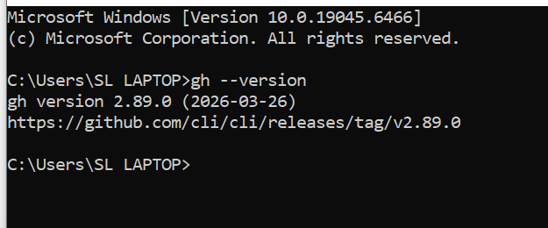
Authentication:
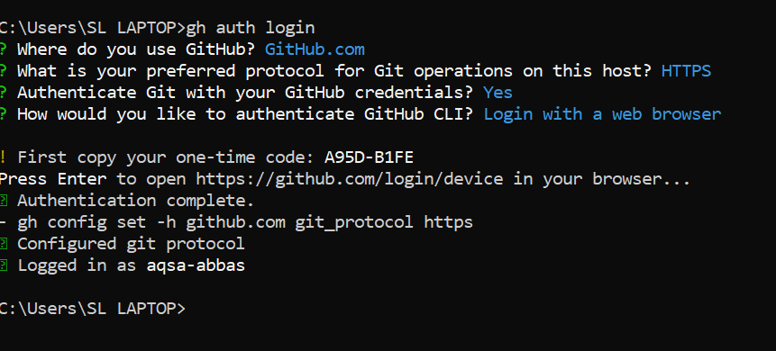
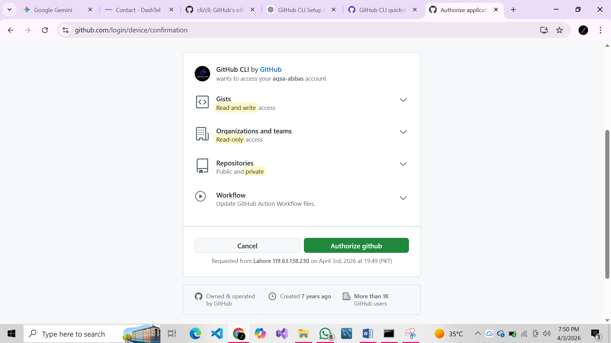
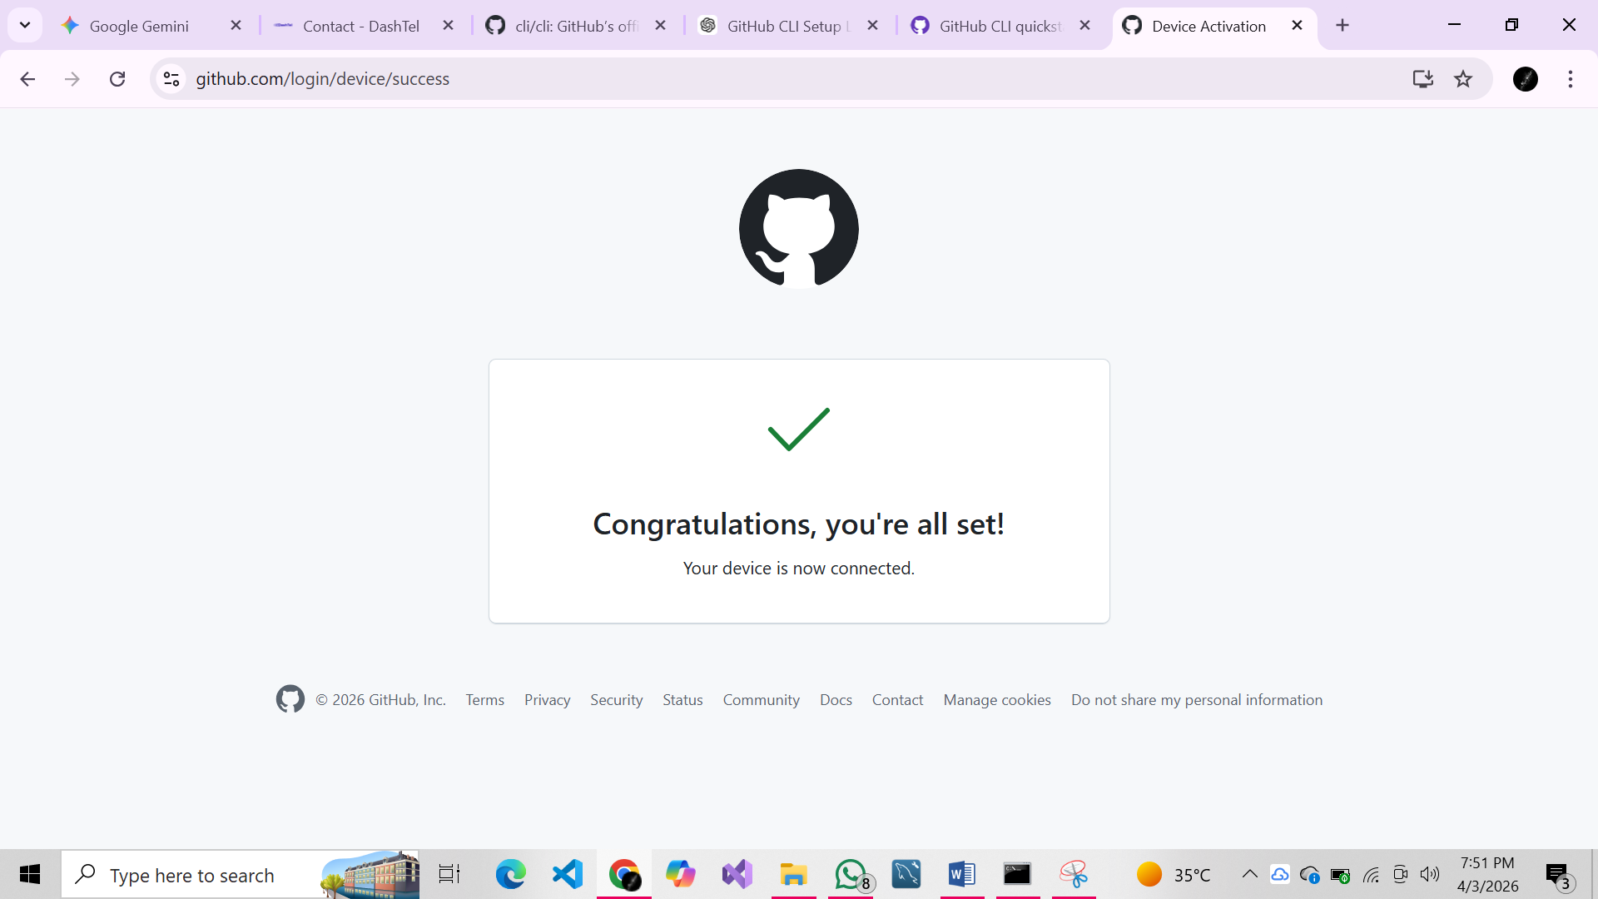
Check Status:
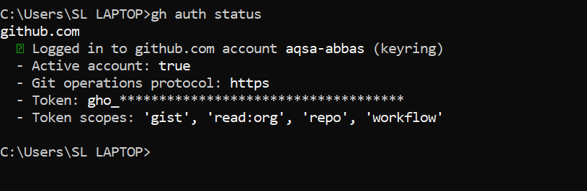
Show list of repos:
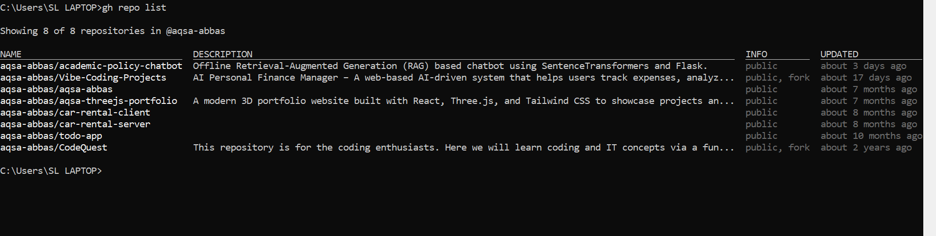
To view your profile information:
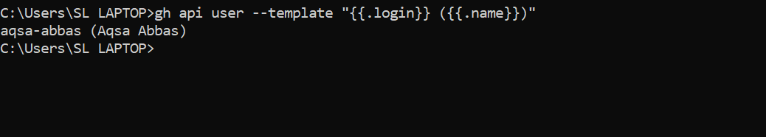
Make folder in project:
