***COURIER MANAGEMENT SYSTEM.***

|  |  |  |
| --- | --- | --- |
| **SUPERVISOR** | **SIR HASSAN NAEEM.** | |
| **BATCH** | 2206A. | |
| **GROUP** | COURIER MANAGEMENT SYSTEM. | |
| **SERIAL NO** | **ENROLLMENT NO.** | **STUDENT NAME** |
| 1 | Student1414991 | MAHNOOR |
| 2 | Student1395292 | SHAYAN |
| 3 | Student1396107 | FAIQ |
| 4 | Student1386806 | IMRAN KHAN |
| 5 | Student1414903 | JAWAD |

***ACKNOWLEDGEMENT***

The first, we would like to express my special thanks of gratitude to my teacher << **SIR** **HASSAN NAEEM** >>, who helped us a lot in finalizing this project with in the limited time frame, valuable counseling and assistance for the accomplishment of this project. Secondly we would also like to thank the e-Project team at Aptech HeadOﬃce, who gave us the golden opportunity to do this wonderful project about Aura Watch. Thirdly, we also thank the e-Project team, some of the benefits are as under: Re-enforcement of skills happens in the experiential learning process.Amentor, ensuring that we do not get drifted, constantly guides us. It gives us a lot of confidence to face an interview as we have worked on a project. We can explain virtually everything on the subject we have learnt.

***SYNOPSIS***

[A courier management system (**CMS**) is a software that simplifies courier management and routing](https://www.bing.com/ck/a?!&&p=63a44f0dfb3891f8JmltdHM9MTY4ODYwMTYwMCZpZ3VpZD0zZDYwZjVlNS0wNDdlLTY0ODUtMWM1NC1lNzczMDVhNTY1MzkmaW5zaWQ9NTY4MQ&ptn=3&hsh=3&fclid=3d60f5e5-047e-6485-1c54-e77305a56539&psq=courier+management+system+synopsis&u=a1aHR0cHM6Ly9vcHRpbW9yb3V0ZS5jb20vY291cmllci1tYW5hZ2VtZW50Lw&ntb=1). [It handles the end-to-end process of a courier business, from initiating a courier order to driver pickup and delivery](https://www.bing.com/ck/a?!&&p=57d8e857cdf399fbJmltdHM9MTY4ODYwMTYwMCZpZ3VpZD0zZDYwZjVlNS0wNDdlLTY0ODUtMWM1NC1lNzczMDVhNTY1MzkmaW5zaWQ9NTY4NA&ptn=3&hsh=3&fclid=3d60f5e5-047e-6485-1c54-e77305a56539&psq=courier+management+system+synopsis&u=a1aHR0cHM6Ly93d3cubG92ZWx5Y29kaW5nLm9yZy9jb3VyaWVyLW1hbmFnZW1lbnQtc3lzdGVtLw&ntb=1). [A CMS streamlines tasks such as planning and optimizing delivery routes, courier tracking and scheduling, and analyzing courier performance](https://www.bing.com/ck/a?!&&p=7b828219a30eed7eJmltdHM9MTY4ODYwMTYwMCZpZ3VpZD0zZDYwZjVlNS0wNDdlLTY0ODUtMWM1NC1lNzczMDVhNTY1MzkmaW5zaWQ9NTY4Ng&ptn=3&hsh=3&fclid=3d60f5e5-047e-6485-1c54-e77305a56539&psq=courier+management+system+synopsis&u=a1aHR0cHM6Ly9vcHRpbW9yb3V0ZS5jb20vY291cmllci1tYW5hZ2VtZW50Lw&ntb=1). [The system also keeps track of employee information, details about day-to-day courier senders and receivers, hub details, prices, and products sent using courier services](https://www.bing.com/ck/a?!&&p=df95d615e51bfa1aJmltdHM9MTY4ODYwMTYwMCZpZ3VpZD0zZDYwZjVlNS0wNDdlLTY0ODUtMWM1NC1lNzczMDVhNTY1MzkmaW5zaWQ9NTY4OA&ptn=3&hsh=3&fclid=3d60f5e5-047e-6485-1c54-e77305a56539&psq=courier+management+system+synopsis&u=a1aHR0cHM6Ly9wcm9qZWN0c2dlZWsuY29tLzIwMTYvMDQvY291cmllci1tYW5hZ2VtZW50LXN5c3RlbS5odG1s&ntb=1). [The database is stored on the system's server with a backup](https://www.bing.com/ck/a?!&&p=facd8da09d6d2b19JmltdHM9MTY4ODYwMTYwMCZpZ3VpZD0zZDYwZjVlNS0wNDdlLTY0ODUtMWM1NC1lNzczMDVhNTY1MzkmaW5zaWQ9NTY5MA&ptn=3&hsh=3&fclid=3d60f5e5-047e-6485-1c54-e77305a56539&psq=courier+management+system+synopsis&u=a1aHR0cHM6Ly9wcm9qZWN0c2dlZWsuY29tLzIwMTYvMDQvY291cmllci1tYW5hZ2VtZW50LXN5c3RlbS5odG1s&ntb=1). In-house courier delivery can be extremely beneficial if you do it well. You’d be hard-pressed to find a third-party courier service that cares more about your products and your customers than you do. But there’s a lot to consider when running your own delivery operation.  
To conquer courier management, you need a solid understanding of the basics, a handy guide for spotting areas that need improvement, and easy-to-use software—a robust courier management system.

***PROBLEMS DEFINITION***

This Courier Management System Project will provide information recipient with following details:- where the current consignment is, till when it will reached its final destination, if any delay then reason of the delay, the route of current consignment, date of placing consignment, final date to reach its destination.

People when transfer their products using any courier service wants to know whether their product has been shifted to their right place or not, if not then by what time it will be shifted and where it is now. Taking all this information manually is very difficult and time taking process. To handle all these activities include various processes and paper work from the management side also. The courier company has number of branches, which are spread over the country or the world. So that when person wants to send things then he has to contact at nearest courier service branch. The courier company creates the schedule & gives internal/external services. The courier service work as destination office or source office. The source office branch receives the order means consignments & sends it to the destination courier branch. The company has certain rules according to the weight. Using the courier service person can easily send his/her parcel to other person in the particular destination within the time. Now days, 50% of companies of the world uses the services of various courier company.

***CUSTOMER REQUIREMENT***

***SPECIFICATION (CRS)***

**Requirements management** is the process of documenting, [analyzing](https://en.wikipedia.org/wiki/Requirements_analysis), [tracing](https://en.wikipedia.org/wiki/Requirements_traceability), [prioritizing](https://en.wikipedia.org/wiki/Requirement_prioritization) and agreeing on requirements and then controlling change and communicating to relevant stakeholders. It is a continuous process throughout a project. A requirement is a capability to which a project outcome (product or service) should conform. The purpose of requirements management is to ensure that an organization documents, verifies, and meets the needs and expectations of its customers and internal or external stakeholders. Requirements management begins with the analysis and elicitation of the objectives and constraints of the organization. Requirements management further includes supporting planning for requirements, integrating requirements and the organization for working with them (attributes for requirements), as well as relationships with other information delivering against requirements, and changes for these.

The traceability thus established is used in managing requirements to report back fulfilment of company and stakeholder interests in terms of compliance, completeness, coverage, and consistency. Traceabilities also support change management as part of requirements management in understanding the impacts of changes through requirements or other related elements (e.g., functional impacts through relations to functional architecture), and facilitating introducing these changes.

Requirements management involves communication between the project team members and stakeholders, and adjustment to requirements changes throughout the course of the project. To prevent one class of requirements from overriding another, constant communication among members of the development team is critical.

***Scope Of The Work***

***(Briefly)***

A **courier** is a person or organization that delivers a message, package or letter from one place or person to another place or person. Typically, a courier provides their courier service on a commercial contract basis; however, some couriers are government or state agency employees (for example: a [diplomatic courier](https://en.wikipedia.org/wiki/Diplomatic_courier)).Couriers are distinguished from ordinary [mail](https://en.wikipedia.org/wiki/Mail) services by features such as speed, security, tracking, signature, specialization and individualization of express services, and swift delivery times, which are optional for most everyday mail services. As a premium service, couriers are usually more expensive than standard mail services, and their use is normally limited to packages where one or more of these features are considered important enough to warrant the cost.

Courier services operate on all scales, from within specific towns or cities, to regional, national and global services. Large courier companies include [DHL](https://en.wikipedia.org/wiki/DHL_Express), [DTDC](https://en.wikipedia.org/wiki/DTDC), [FedEx](https://en.wikipedia.org/wiki/FedEx), [EMS International](https://en.wikipedia.org/wiki/EMS_International), [TNT](https://en.wikipedia.org/wiki/TNT_Express), [UPS](https://en.wikipedia.org/wiki/United_Parcel_Service), [India Post](https://en.wikipedia.org/wiki/India_Post), [J&T Express](https://en.wikipedia.org/wiki/J%26T_Express) and [Aramex](https://en.wikipedia.org/wiki/Aramex" \o "Aramex). These offer services worldwide, typically via a [hub and spoke](https://en.wikipedia.org/wiki/Hub_and_spoke) model.

Couriers services utilizing [courier software](https://en.wikipedia.org/w/index.php?title=Courier_software&action=edit&redlink=1) provide electronic [proof of delivery](https://en.wikipedia.org/wiki/Proof_of_delivery) and electronic tracking details. In ancient history, messages were hand-delivered using a variety of methods, including [runners](https://en.wikipedia.org/wiki/Runner_(soldier)), [homing pigeons](https://en.wikipedia.org/wiki/Pigeon_post) and riders on horseback. Before the introduction of mechanized courier services, foot messengers physically ran miles to their destinations. [Xenophon](https://en.wikipedia.org/wiki/Xenophon) attributed the first use of couriers to the [Persian](https://en.wikipedia.org/wiki/Achaemenid_Empire) prince [Cyrus the Younger](https://en.wikipedia.org/wiki/Cyrus_the_Younger).

***Wireframes***

LAYOUT

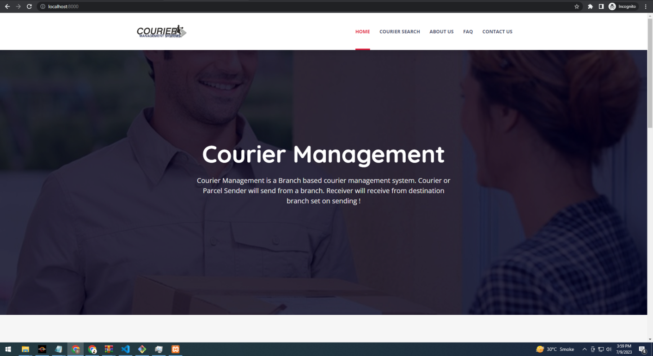

ADMIN DASHBOARD

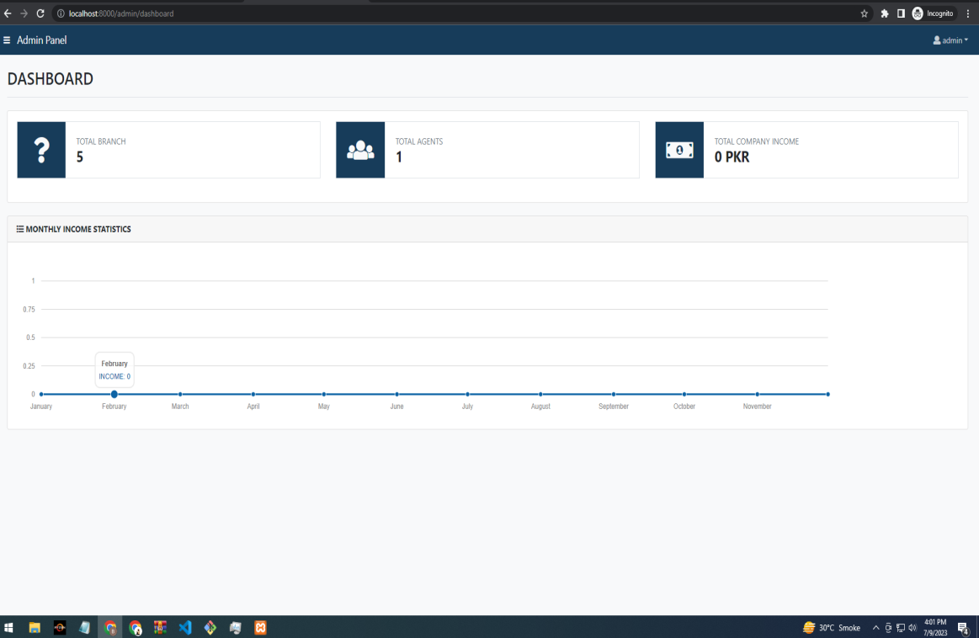

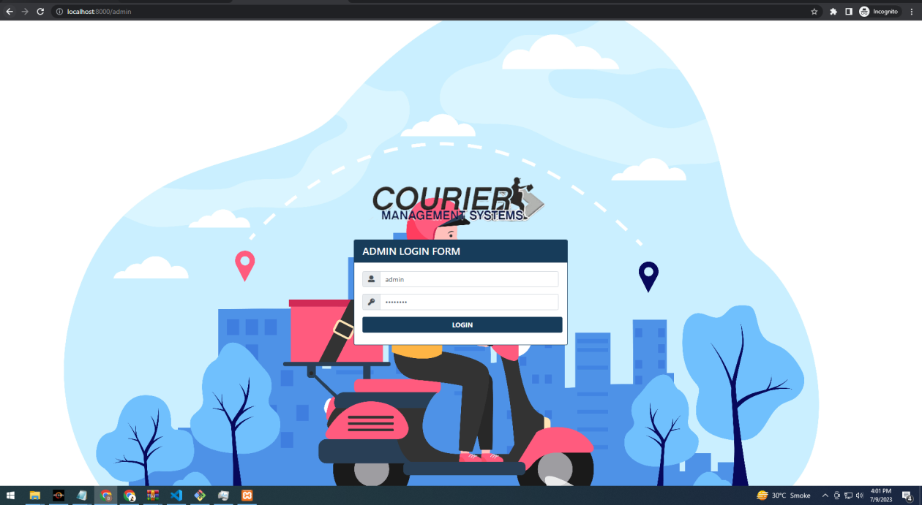

LOGIN FORM

SEARCHING COURIER

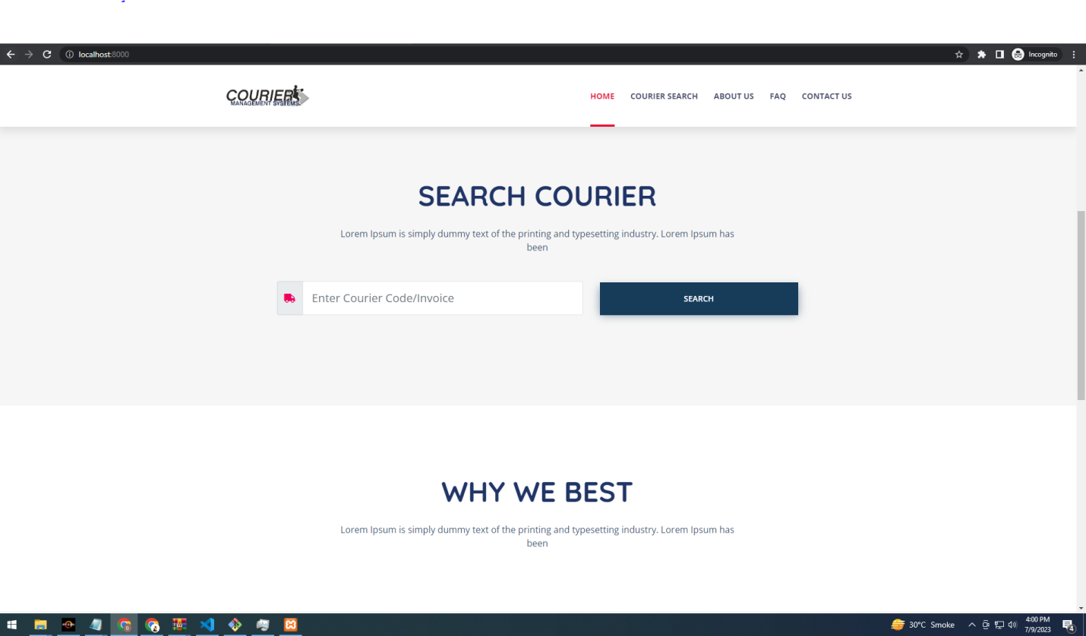

CREATE COURIER

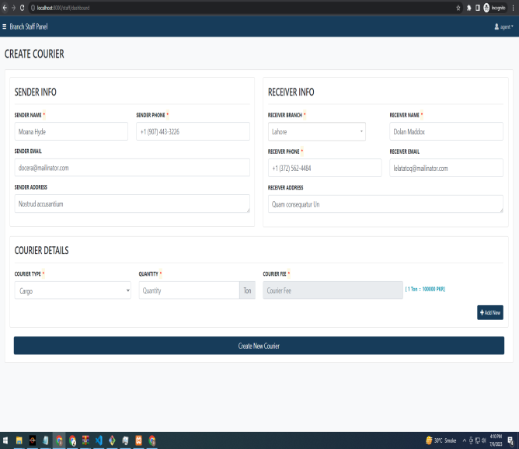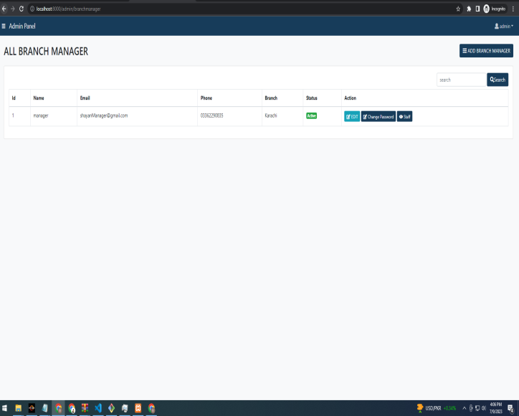

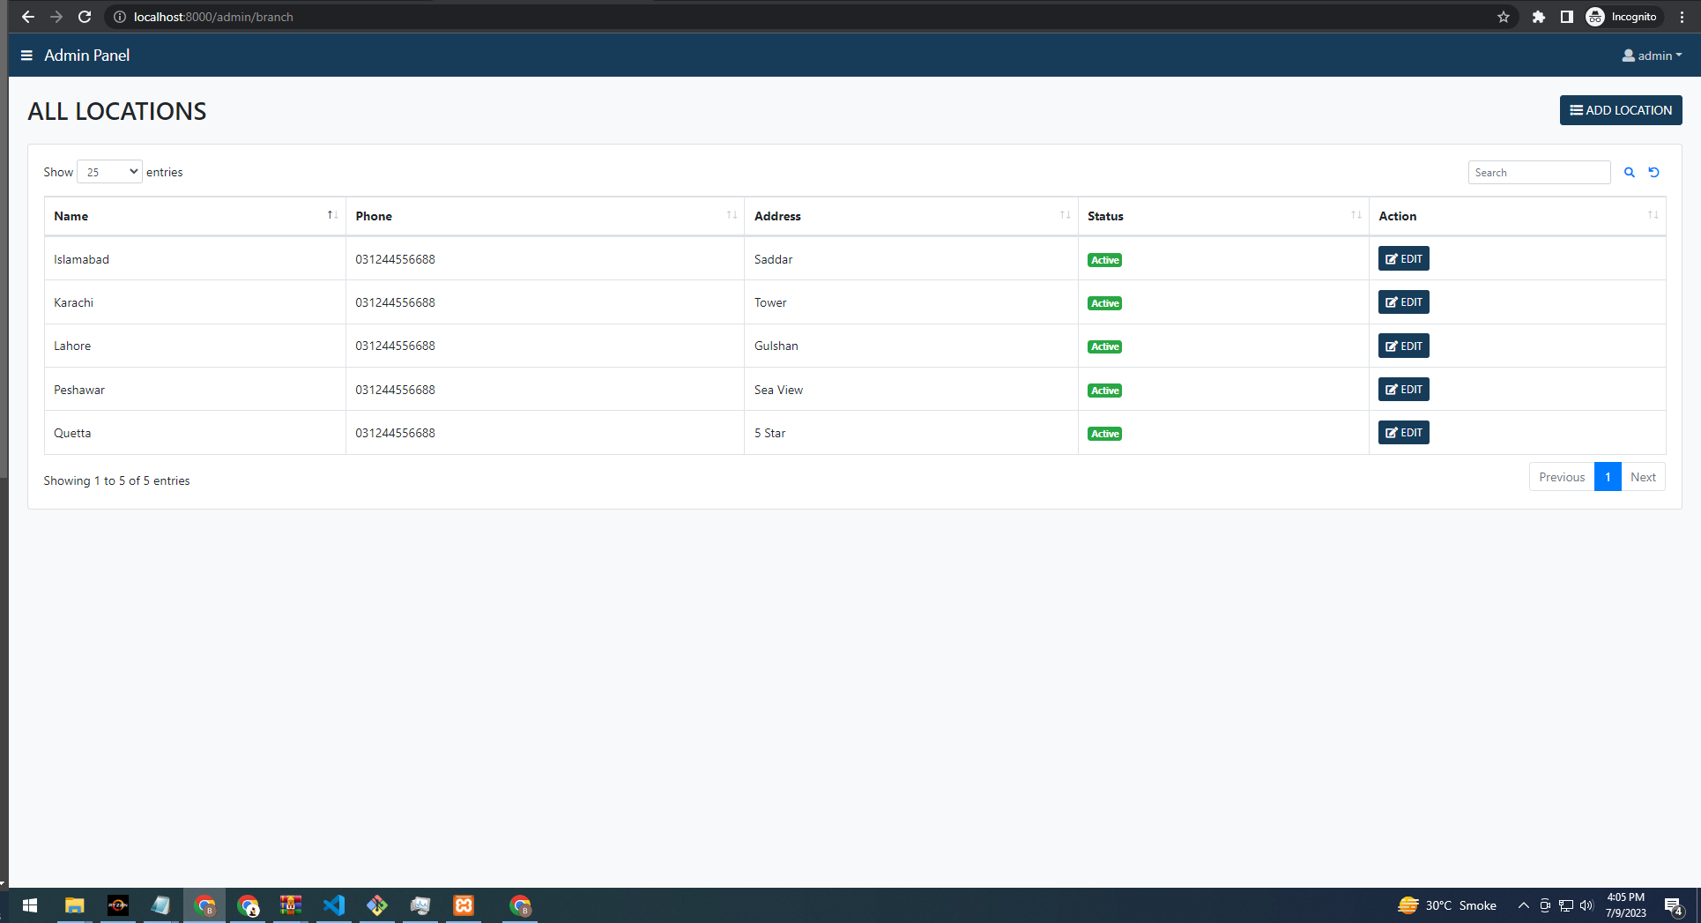

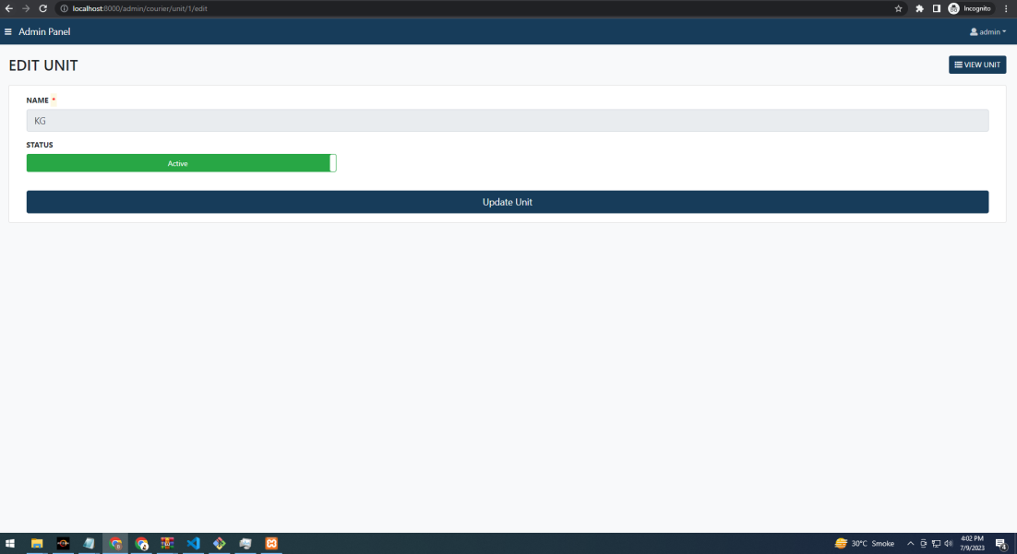

CREATE LOCATION

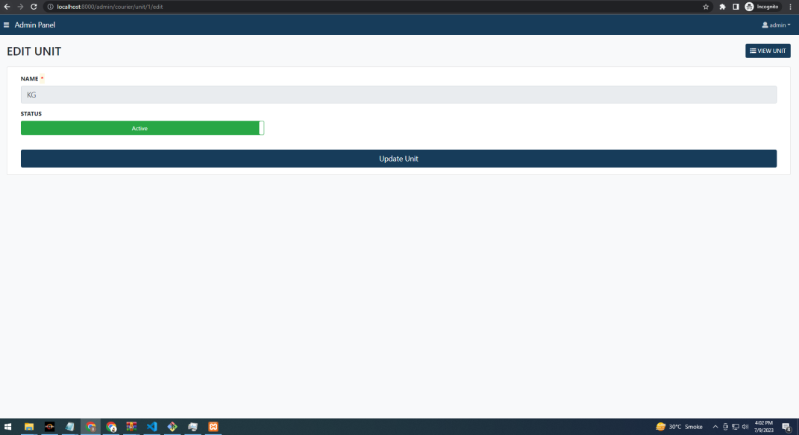

***TASK SHEET***

|  |  |  |  |  |  |  |
| --- | --- | --- | --- | --- | --- | --- |
| **Project Ref.No:Ep/Advertisement**  **Portal Management System /01** | | **Project**  **Title** | **Date Of preparation Of Activity Plan** | | | |
| **No.** | **Task** | **c**  **O**  **U**  **R**  **I**  **E**  **R**  **M**  **A**  **N**  **A**  **G**  **M**  **E**  **N**  **T**  **S**  **Y**  **S**  **T**  **E**  **M** | **Actual**  **Start**  **Date** | **Actual Days** | **Team-Mate**  **Name** | **Status** |
| 01 | HOME PAGE | **05**  **-**  **J**  **U**  **N**  **E**  **-**  **2**  **0**  **2**  **3** | **30**  **-**  **D**  **A**  **Y**  **S**  **-** | Mahnoor&  shayan | pass |
| 02 | OUR SERVICES | Mahnoor&  shayan | pass |
| 03 | FIND US | Mahnoor&  shayan | pass |
| 04 | CONTACT US | Mahnoor&  shayan | pass |
| 05 | TRACKING | Mahnoor&  shayan | pass |
| 06 | LOGIN/  REGISTERED | Mahnoor&  shayan | pass |
| 07 | DOCUMENTATION |  |  | Mahnoor&  shayan | pass |