**Punjab University**

**College of Information Technology**

**Lecture 7**

**MODULE:**

**Mobile Computing**

**SUBMITTED BY:**

**Mahnoor Abid (Mcsf19a030)**

**SUBMITTED TO:**

**Sir Haq Nawaz**

**Text View:**

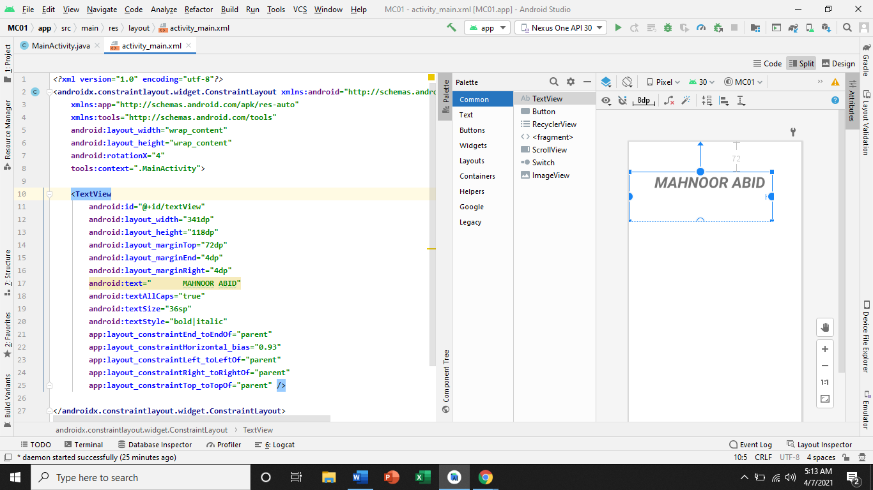

**Insert Button:**

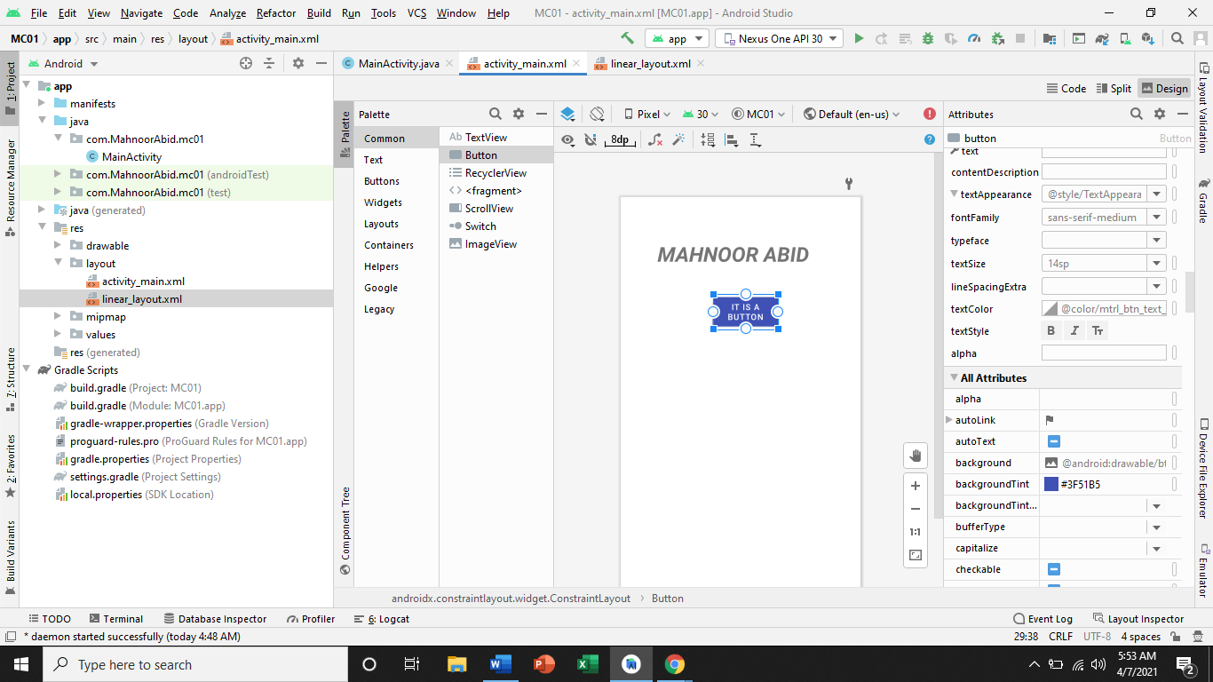

**Insert Image:**

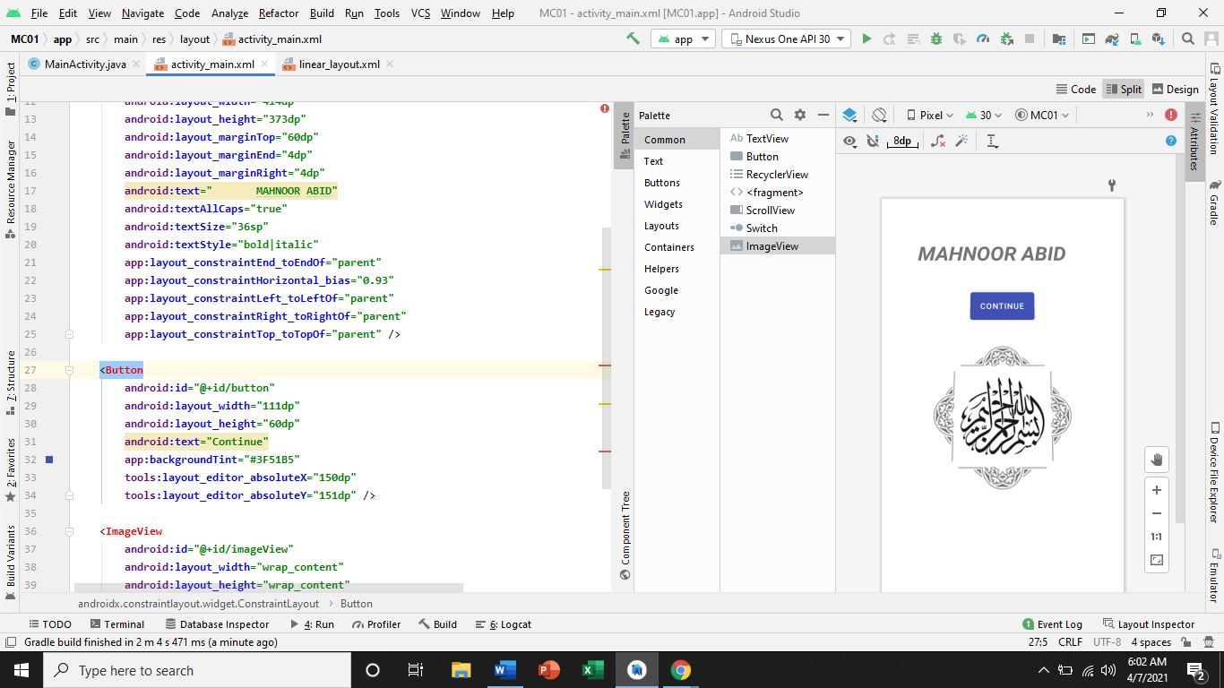**Linear Layout.xml:**

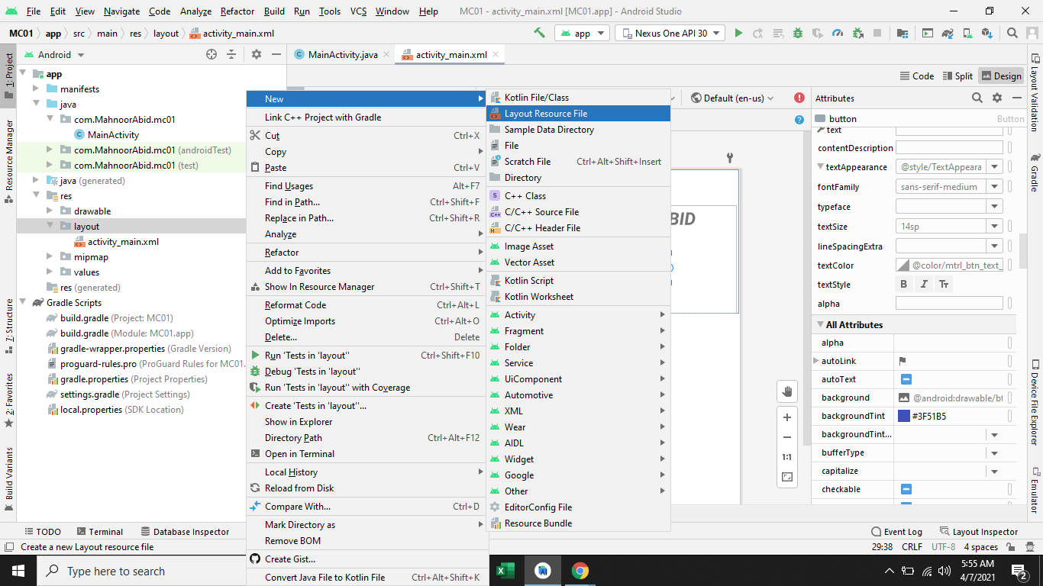

**In Linear Layout:**

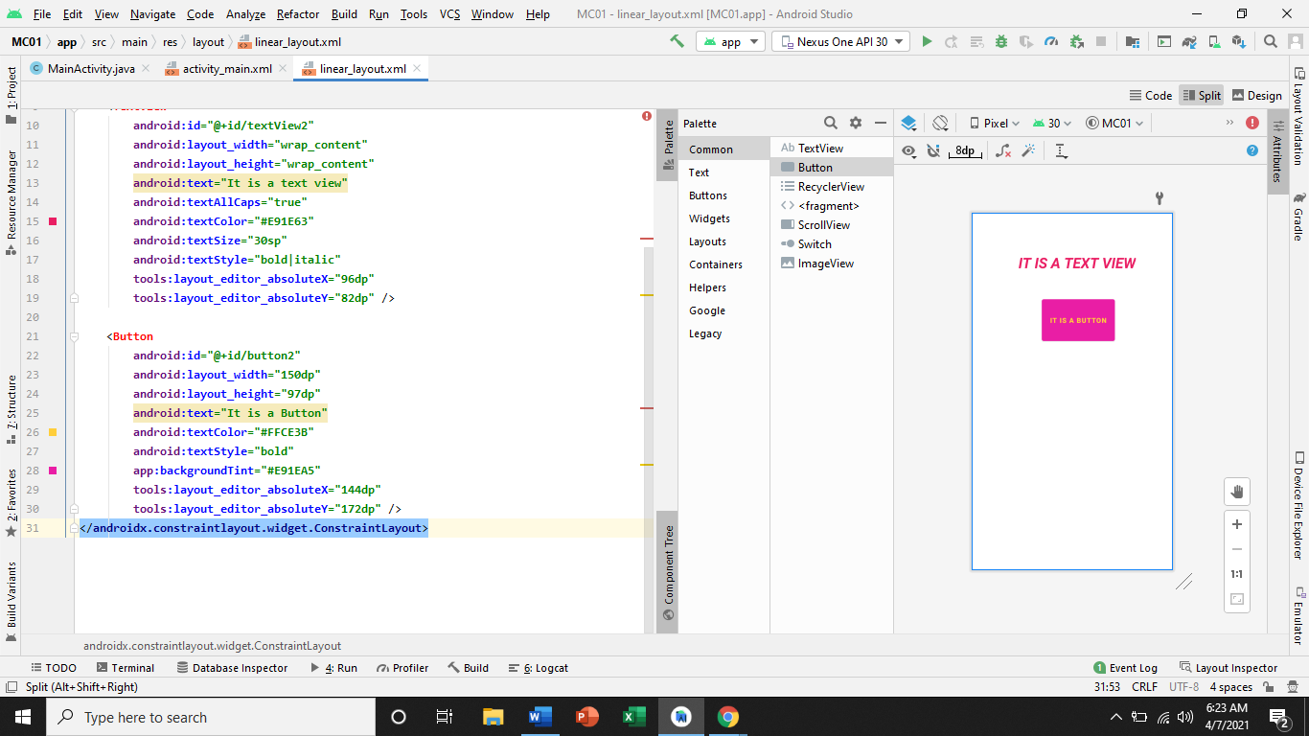

**Linear Constraint:**

