**Punjab University**

**College of Information Technology**

**Lecture 8(Intent)**

**MODULE:**

**Mobile Computing**

**SUBMITTED BY:**

**Mahnoor Abid (Mcsf19a030)**

**SUBMITTED TO:**

**Sir Haq Nawaz**

**Intents:**

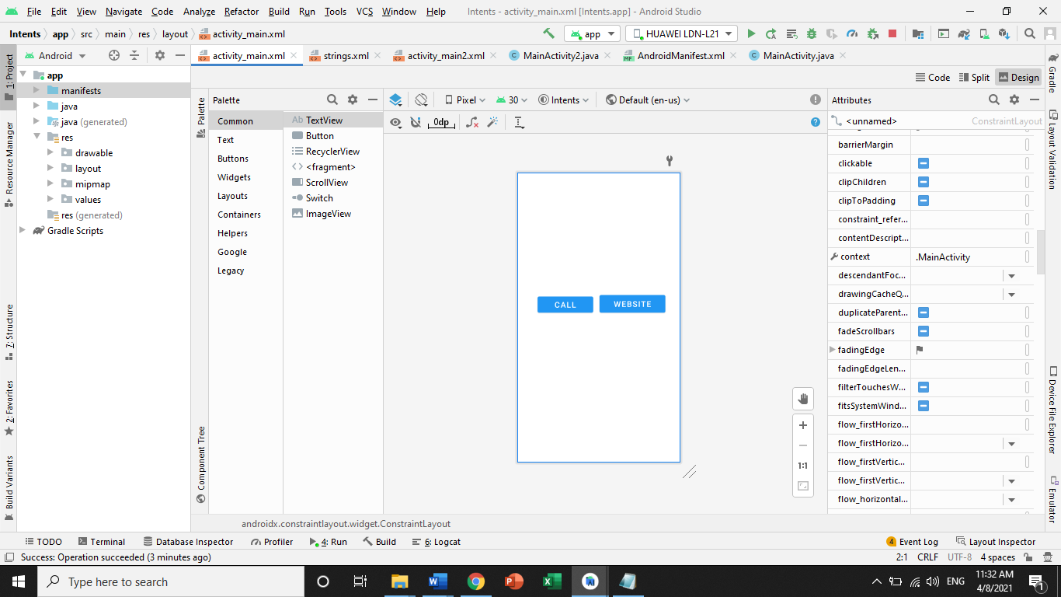

Insert Call And Website:

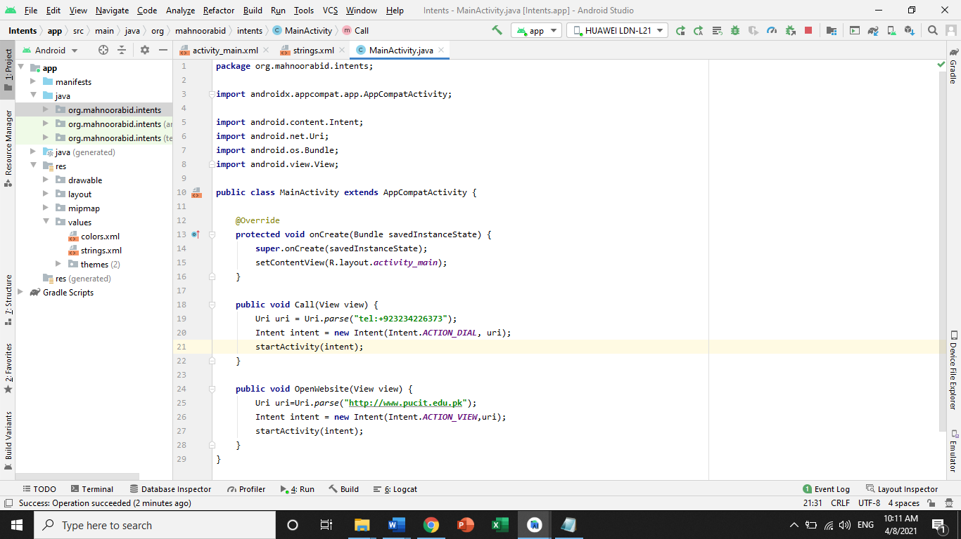

**Strings:**

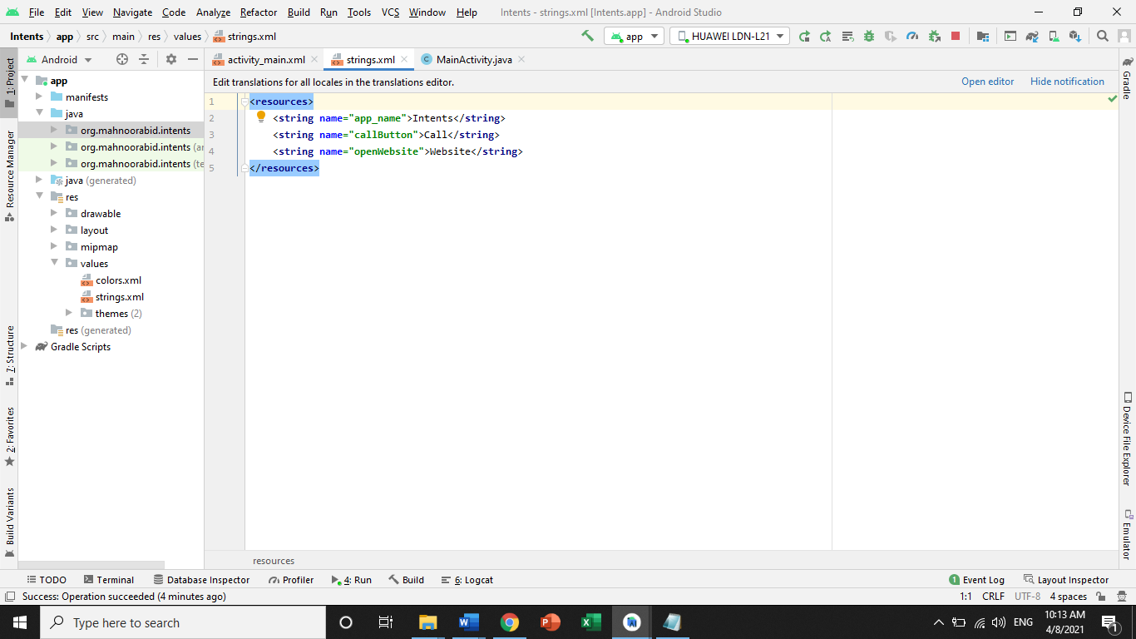

**Add Main Activity2:**

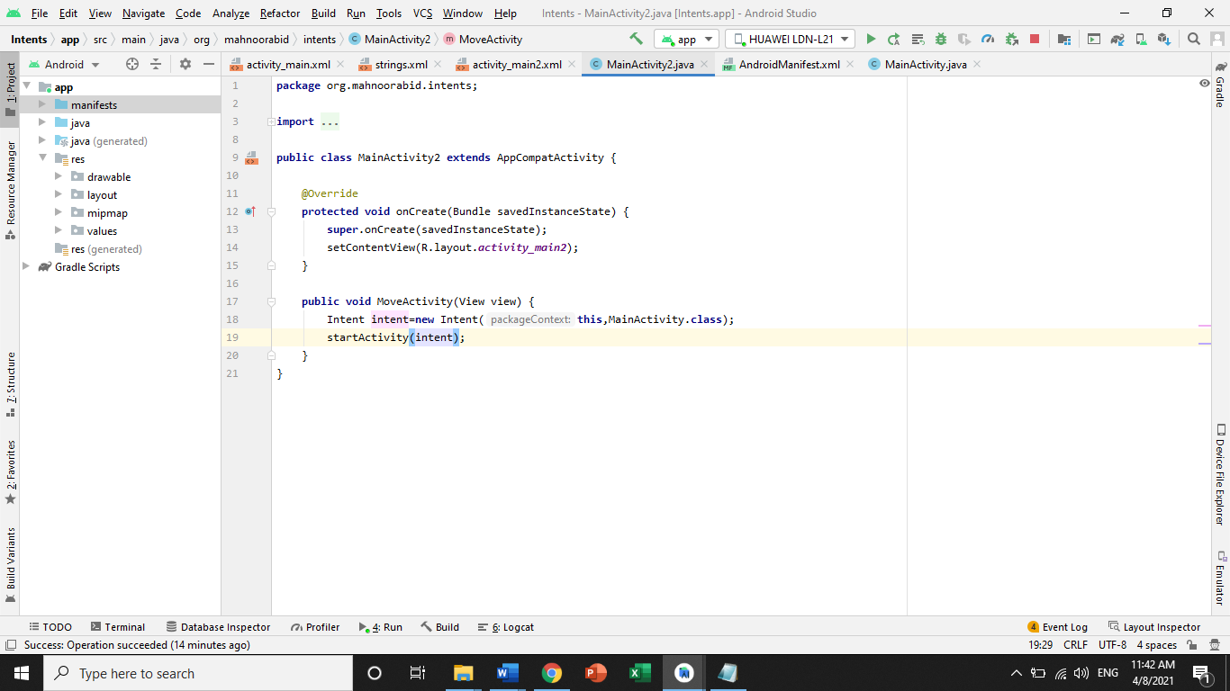

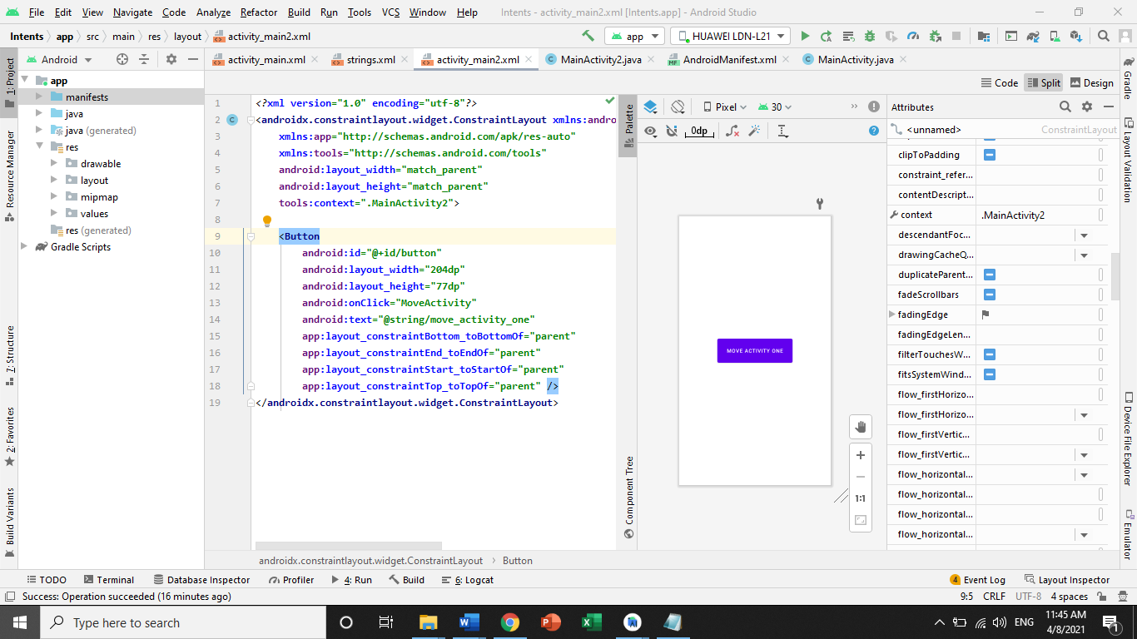

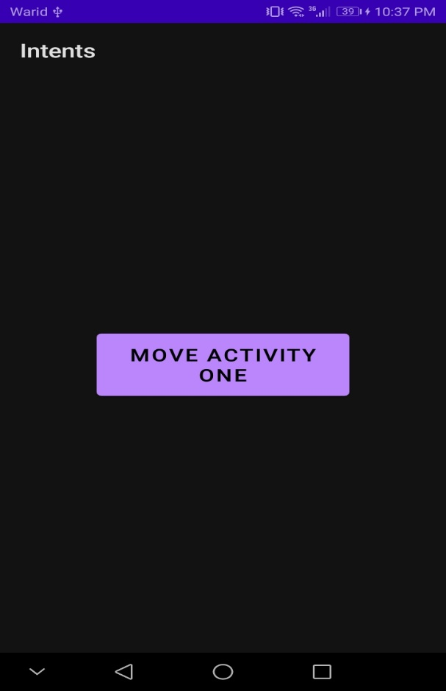

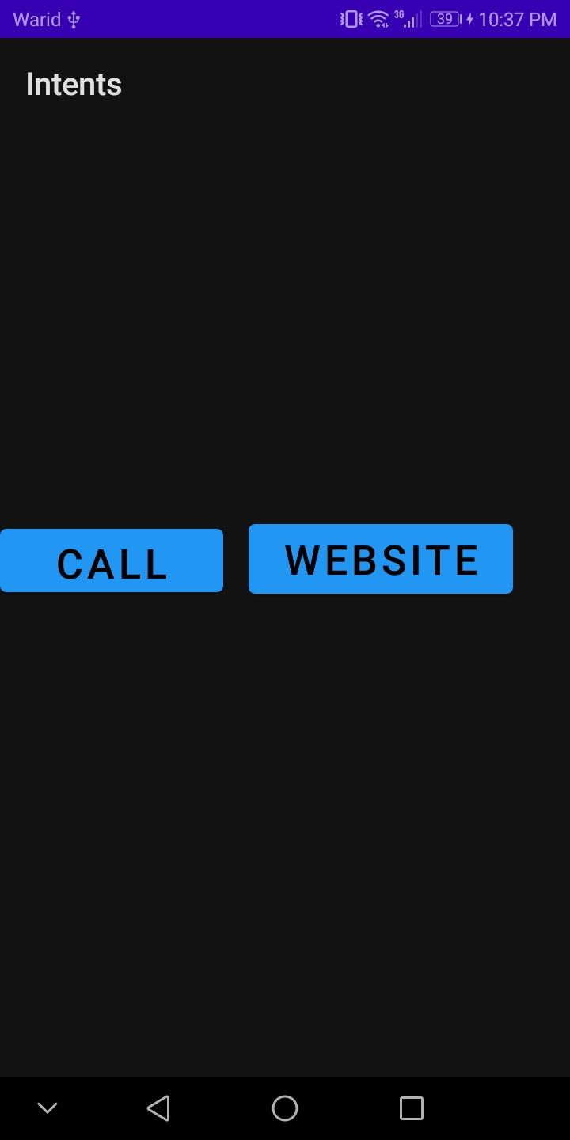

**Press Call:**

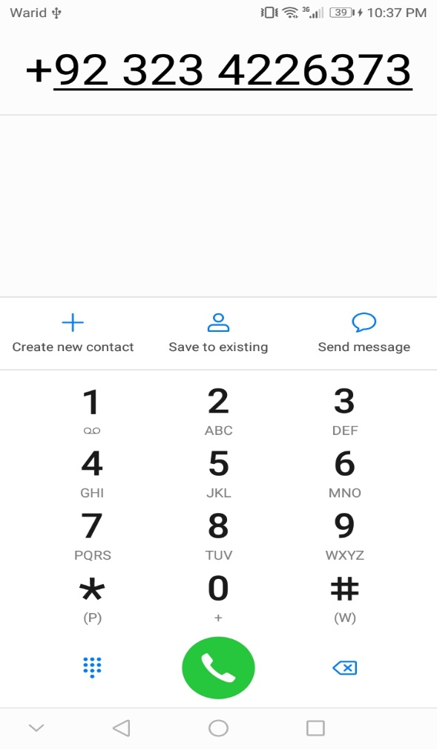

**Press Website:**

**‘**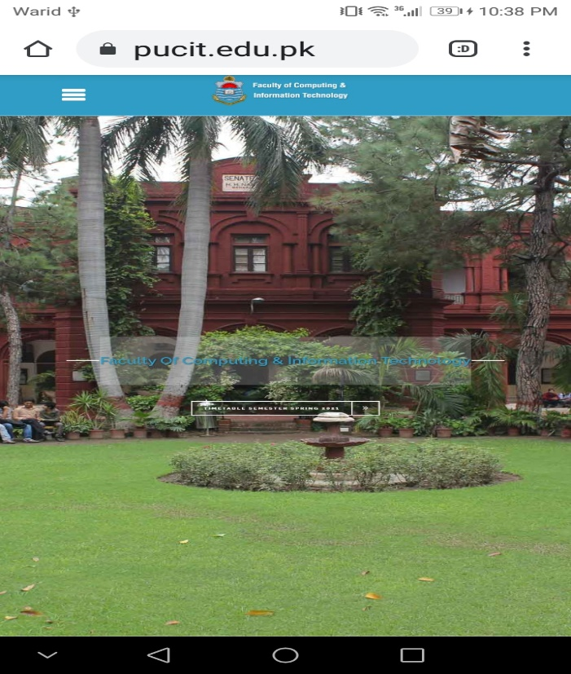

**Android Manifest:**

