NLP Assignment 2
Project Phase 2: Word Representations (Word Vectors)
Course: Introduction to Natural Language Processing
Project Title: Job Skill NLP
University: University of Central Punjab
Submitted To: Numan Aslam
Submitted By:
Emaan Abbas L1F23BSCS0255
Mahnoor Bhatti L1F23BSCS0926
GitHub Repository: https://github.com/MahnoorB6/Job_Skill_NLP
Submission Date: 14-11-26
1. Introduction
The purpose of this assignment is to transform cleaned job-description text into numerical representations suitable for Natural Language Processing and machine learning tasks.
The project investigates two categories of word representations: count-based methods and learned word embeddings. Count-based methods include Bag of Words (BoW), TF-IDF and N-grams, while learned embeddings include Word2Vec CBOW, Word2Vec Skip-gram and fastText.
The same cleaned dataset from Assignment 1 is used throughout the experiments to maintain consistency and allow meaningful comparisons.
2. Dataset Overview
The project uses a job-description dataset prepared during Assignment 1. The cleaned descriptions are stored in cleaned_job_skill_dataset.parquet.
The dataset contains job-related text covering different professional roles and skill requirements. The cleaned_description column is used as the input corpus for all word-representation techniques.
Number of documents: 1,167
Total tokens: 613,180
Unique words: 26,485
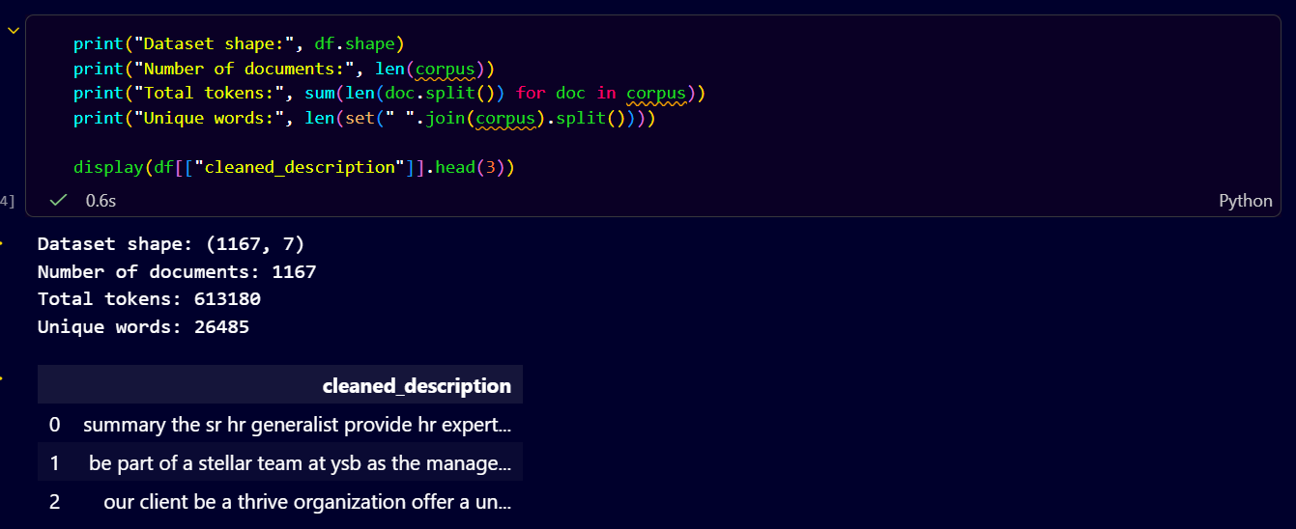
Preprocessing: The cleaning pipeline from Assignment 1 is reused to maintain consistent text normalization across project phases.
3.1 Bag of Words (BoW)
Bag of Words is a count-based text representation technique that converts documents into numerical vectors based on word frequencies. It ignores word order and focuses on how often each vocabulary word appears.
In this project, CountVectorizer from scikit-learn was applied to the cleaned job-description corpus. A document-term matrix was generated, where each row represents a job description and each column represents a vocabulary term.
Results:
- Matrix shape: (1167, 18635)
- Vocabulary size: 18635
- Sparsity: 98.60%
The resulting matrix is sparse because each job description contains only a small portion of the total vocabulary.
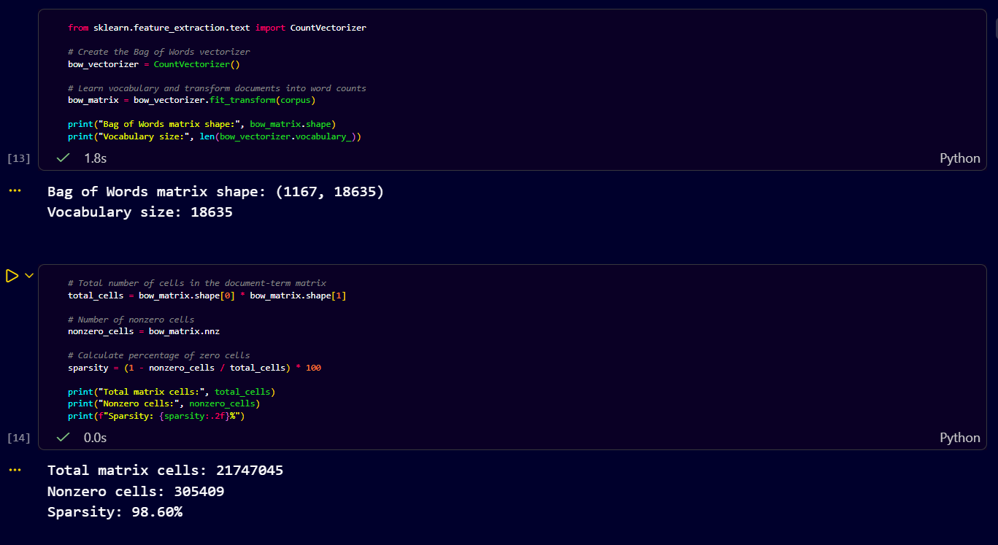
3.2 TF-IDF Representation
Term Frequency–Inverse Document Frequency (TF-IDF) assigns weights to words based on their frequency within a document and their frequency across the entire corpus.
Unlike BoW, which uses raw counts, TF-IDF reduces the relative importance of words that occur in many documents and highlights words that are more distinctive to individual documents.
The TfidfVectorizer from scikit-learn was used to construct the TF-IDF matrix.
Results:
- Matrix shape: (1167, 18635)
- Sparsity: 98.60%
High-weight terms:
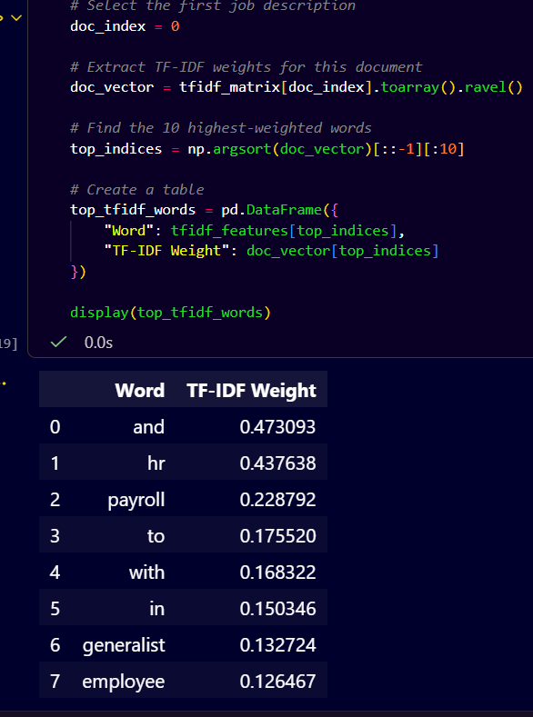
Low-weight terms:
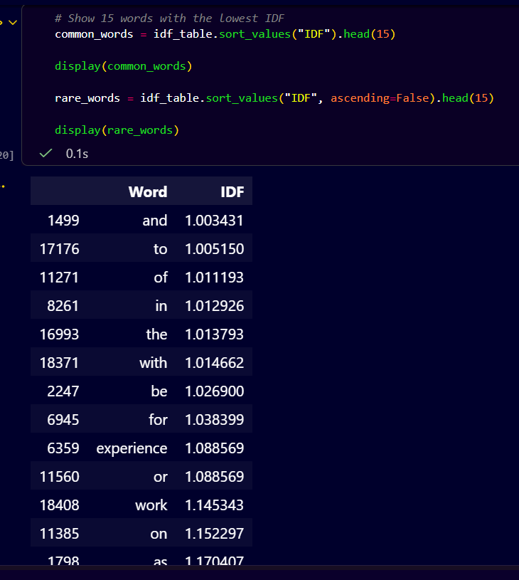
High-weight terms are relatively distinctive within the selected document, while common terms tend to receive lower weights. The results demonstrate how TF-IDF differs from simple frequency counting.
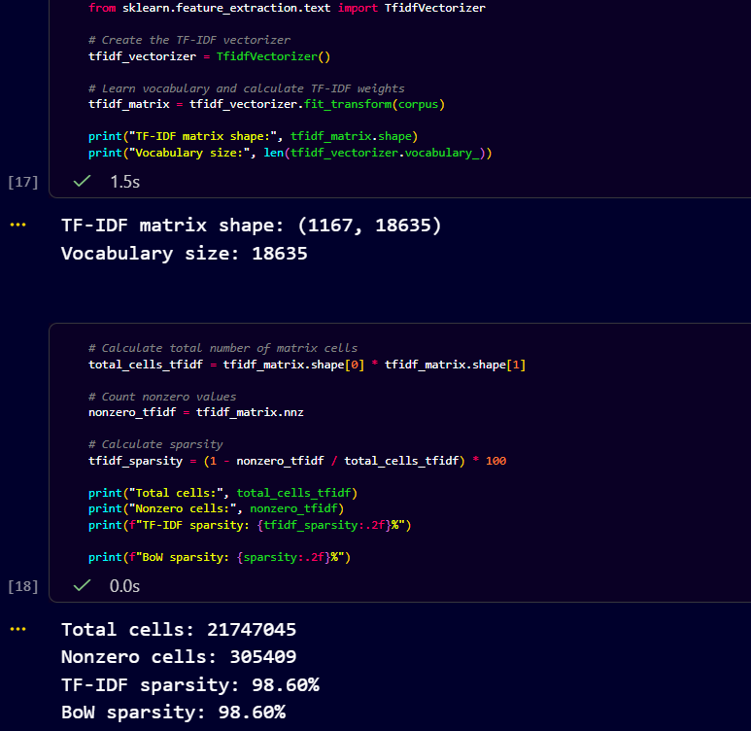
3.3 N-gram Analysis
N-grams represent sequences of consecutive words. A unigram contains one word, a bigram contains two consecutive words, and a trigram contains three consecutive words.
In this experiment, unigram, unigram–bigram and unigram–trigram feature configurations were evaluated using the cleaned job-description corpus.
The results were compared based on vocabulary size and matrix sparsity.
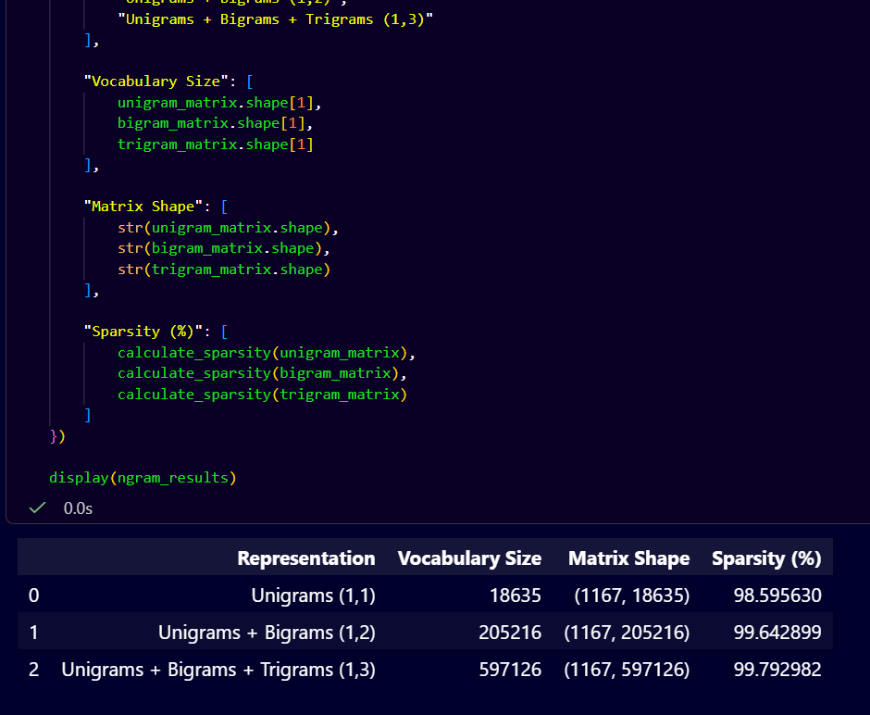
Adding longer N-grams generally increases the number of features because the representation captures more word combinations. However, many combinations appear in relatively few documents, increasing storage requirements and potentially making the representation sparser.
3.4 Hand-Worked TF-IDF and Bigram Calculation
A small toy corpus consisting of four documents was used to demonstrate the manual calculation of TF-IDF and bigram frequency.
The manual calculation was compared with scikit-learn output to verify correctness.
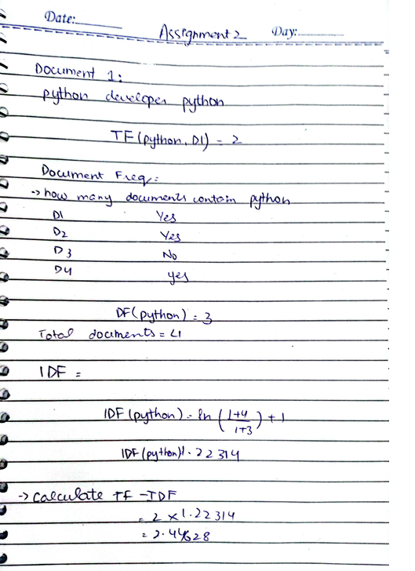
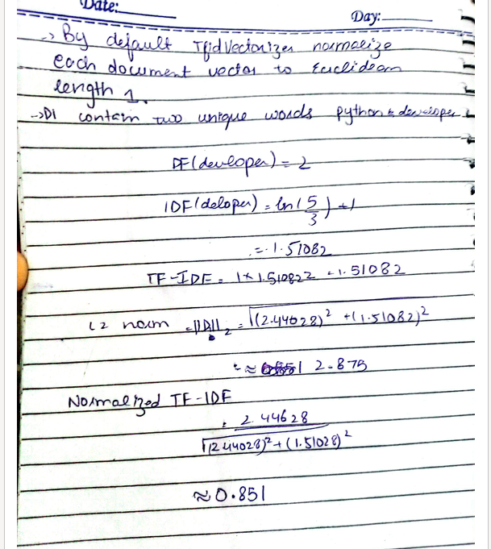
For the term python, the toy corpus contained four documents, of which three included the term. The first document contained the term twice.
The final normalized TF-IDF weight was compared against the library result.
For the bigram data analyst, the total frequency in the toy corpus was 2.
The calculations were performed manually and verified using Python.
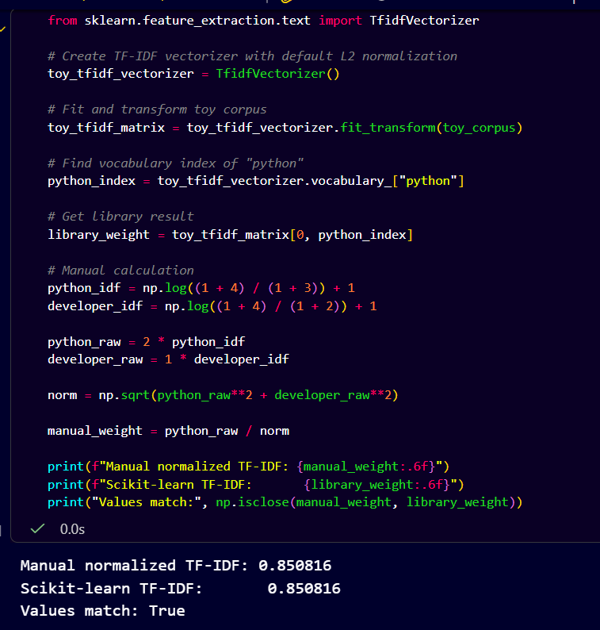
4.1 Word2Vec — Continuous Bag of Words (CBOW)
Word2Vec is a neural word-embedding technique that learns dense numerical representations from the contexts in which words appear.
The CBOW model predicts a centre word using its surrounding context words.
The model was trained using Gensim on the cleaned job-description corpus.
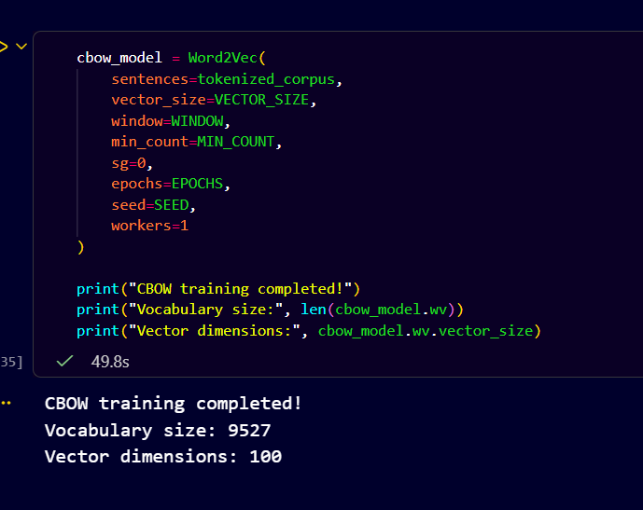
4.2 Word2Vec — Skip-gram
The Skip-gram model works in the opposite direction to CBOW. It uses a centre word to predict the surrounding context words.
Both models were trained using the same hyperparameters so that the training objectives could be compared fairly.
Hyperparameter | CBOW | Skip-gram
Vector size | 100 | 100
Window size | 5 | 5
Minimum count | 2 | 2
Epochs | 20 | 20
Training mode | sg=0 | sg=1
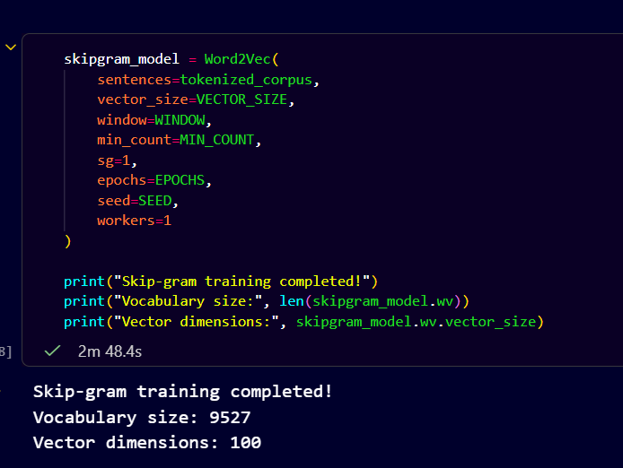
4.3 CBOW vs Skip-gram
CBOW learns by predicting a target word from its context and is generally computationally efficient.
Skip-gram learns by predicting context words from a target word and may be useful for learning representations of less frequent terms.
For a job-description corpus, Skip-gram might capture relationships involving specialized technical skills. However, this expectation must be evaluated using the similarity experiments rather than assumed to be correct.
Both models produce dense word vectors with 100 dimensions.
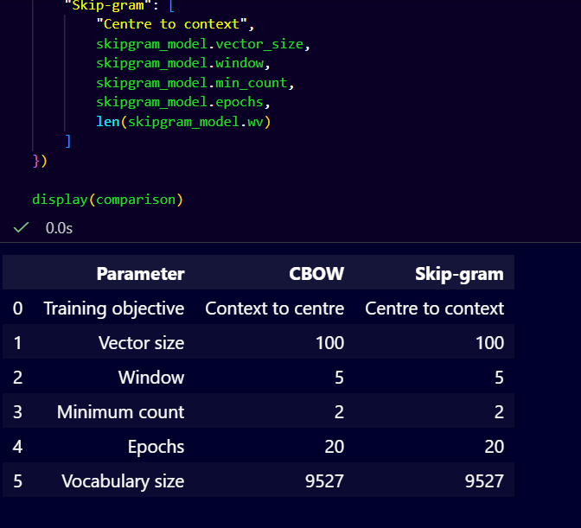
4.4 fastText Embeddings
fastText extends Word2Vec by incorporating character-level subword information.
Instead of relying exclusively on complete words, fastText learns representations from character n-grams. This allows the model to construct vectors for many words that were not observed as complete words during training.
The fastText model was trained using Gensim on the same cleaned job-description corpus.
Hyperparameters:
- Vector size: 100
- Window size: 5
- Minimum count: 2
- Epochs: 20
- Character n-gram lengths: 3–6
- Training architecture: Skip-gram
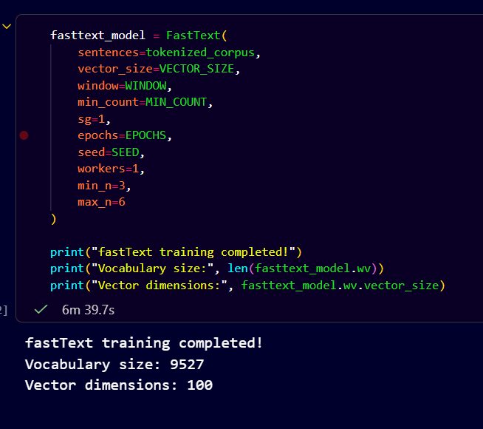
4.5 Out-of-Vocabulary Demonstration
To investigate OOV handling, the misspelled word developper was tested.
Standard Word2Vec cannot return a vector for a word that is absent from its learned vocabulary.
In contrast, fastText can construct a vector using character n-grams learned during training.
The similarity between developer and developper was also calculated using fastText.

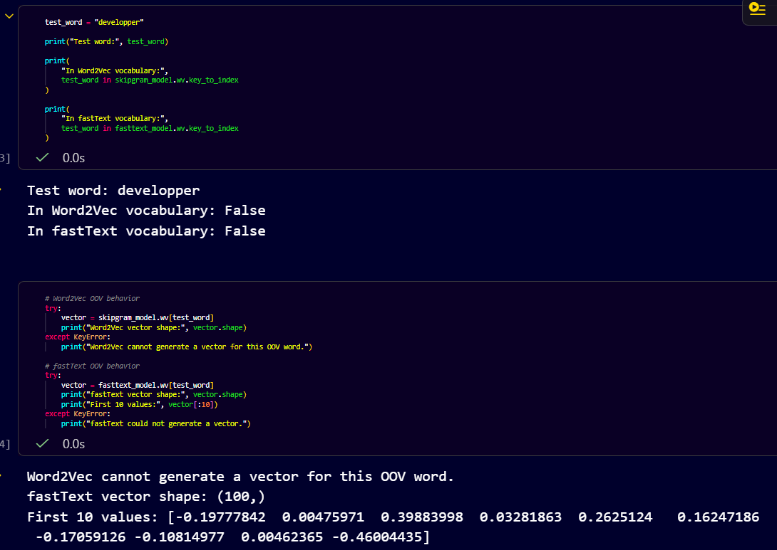
This experiment demonstrates the practical effect of subword representations. However, generating a vector for an unseen word does not guarantee that the vector accurately captures its meaning.
5. Probing and Comparison
5.1 Most Similar Words
The trained CBOW, Skip-gram and fastText models were evaluated by retrieving the five most similar words for selected job-related query terms.
The query terms included python, developer, data, analyst and software, where available in the model vocabularies.
The nearest neighbours were examined to determine whether the models captured meaningful contextual relationships.
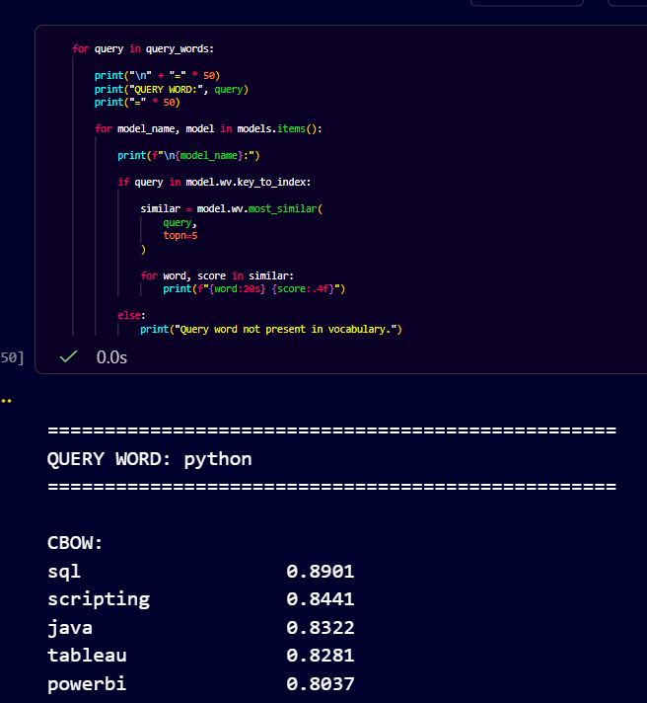
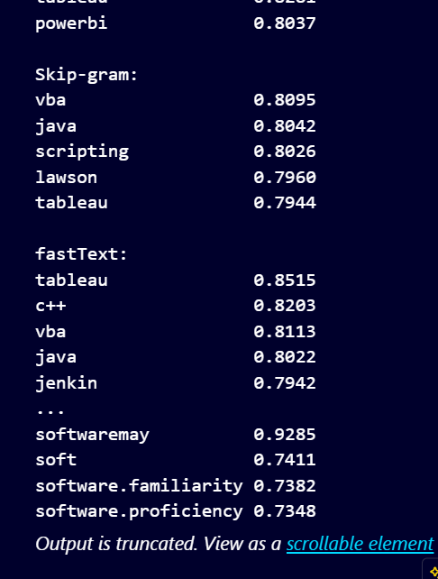
5.2 Cosine Similarity
Cosine similarity was used to compare selected pairs of word vectors.
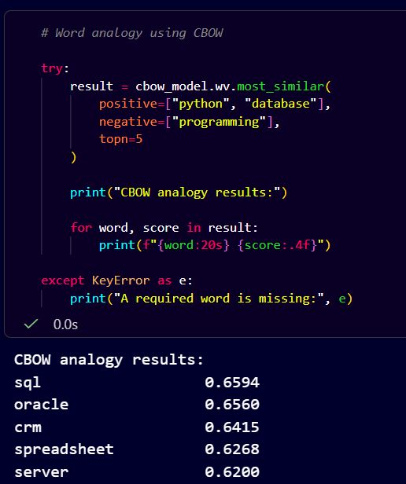
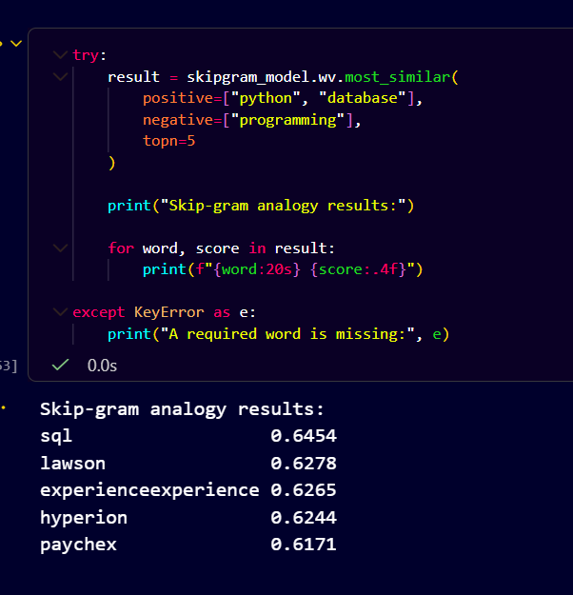
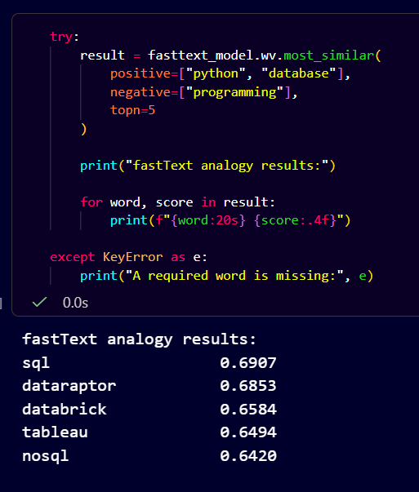
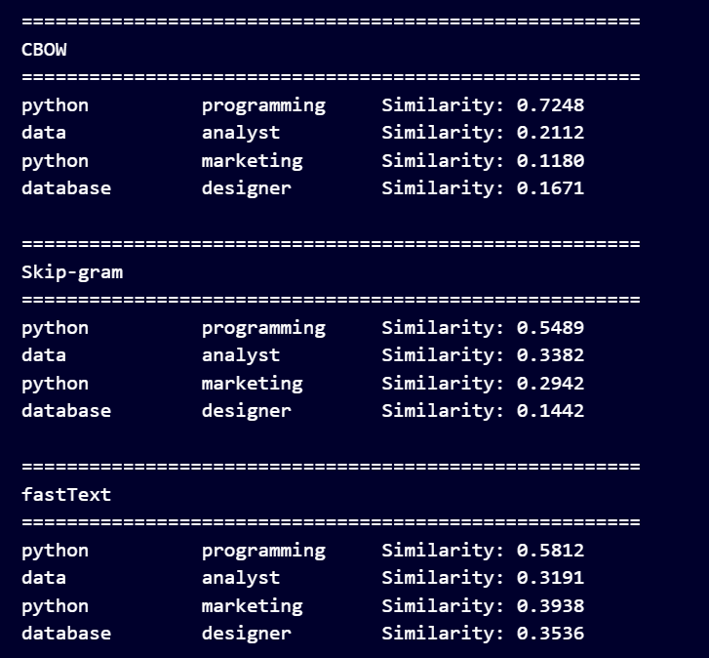
The scores were examined to determine whether expected relationships were reflected in the learned vector spaces.
The analogy experiment returned sql as the highest-ranked result for CBOW, Skip-gram, and fastText. This suggests that all three models learned a contextual association between Python, programming, and database-related terminology. However, the result does not establish that the models learned a precise linguistic analogy, because the selected terms are not a strict relational analogy.
5.3 Word Analogy
A word analogy was attempted using vector arithmetic:
Python − Programming + Database ≈ ?
The experiment was performed using CBOW, Skip-gram and fastText.
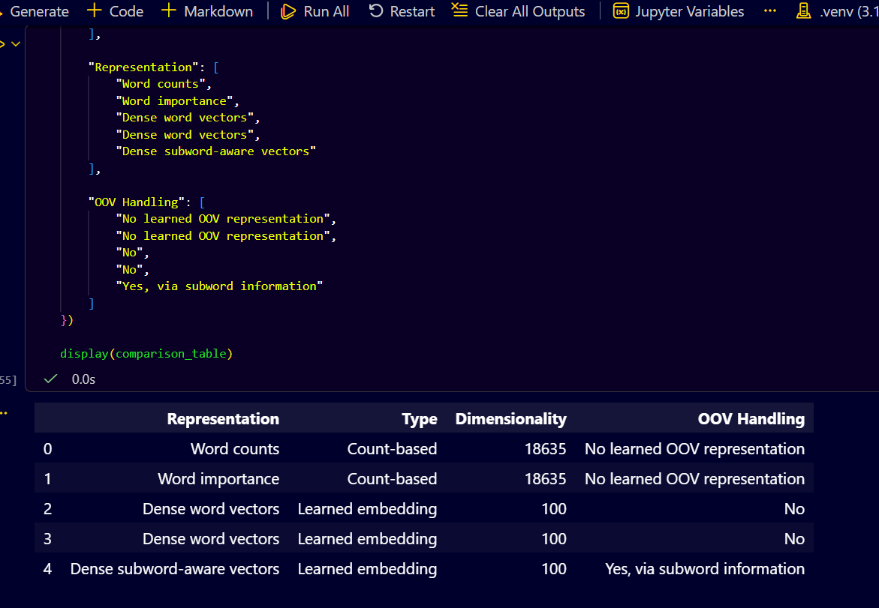
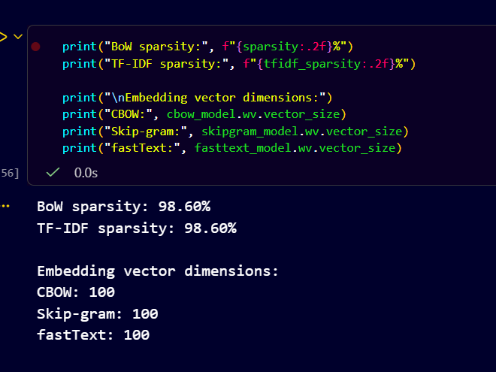
The results were assessed based on whether the returned words represented a meaningful relationship. Unexpected results were retained because they demonstrate the limitations of embeddings trained on a relatively small, domain-specific corpus.
5.4 Count-Based vs Learned Representations
The count-based and learned representations were compared in terms of dimensionality, sparsity, vocabulary handling and the information captured.
Representation | Dimensionality | Sparsity | OOV Handling
BoW | 18635 | High | Unseen terms ignored
TF-IDF | 18635 | High | Unseen terms ignored
CBOW | 100 | Dense | No
Skip-gram | 100 | Dense | No
fastText | 100 | Dense | Subword-based vectors
BoW captures raw word frequencies, while TF-IDF emphasizes relatively distinctive terms. Both produce high-dimensional sparse document representations.
Word2Vec learns dense word representations based on contextual information. fastText additionally uses character n-grams, allowing it to handle many unseen word forms.
6. Model Saving and Reusable Vectorization
All trained representations were saved to disk for reuse in the next project phase.
The saved files include:
- tfidf_vectorizer.pkl
- word2vec_cbow.model
- word2vec_skipgram.model
- fasttext.model
A reusable DocumentVectorizer class was implemented in src/vectorizer.py.
Its vectorize_document() method accepts a raw job description and a selected representation.
For TF-IDF, the function returns a sparse document vector. For Word2Vec and fastText, it averages the available word vectors to produce a dense document representation.
The saved models are loaded directly from disk, so retraining is not required during document vectorization.
7. Reproducibility
The implementation was developed using Python, scikit-learn, Gensim, pandas and spaCy.
The project repository contains the notebook, preprocessing scripts, reusable vectorization module and dependency requirements.
The implementation can be reproduced by following these steps:
- Clone the GitHub repository.
- Create and activate a Python virtual environment.
- Install the dependencies from requirements.txt.
- Install the required spaCy English model.
- Generate or provide the cleaned dataset from Assignment 1.
- Run the Assignment 2 notebook in sequence.
- Save the trained models and verify the document-vectorization interface.
GitHub repository: https://github.com/MahnoorB6/Job_Skill_NLP
Submission tag: assignment-2
8. Conclusion
This project implemented and compared count-based word representations and learned word embeddings on a cleaned job-description corpus.
BoW and TF-IDF represented documents using vocabulary-based features, while Word2Vec CBOW, Skip-gram and fastText learned dense word vectors from contextual information.
The experiments investigated vocabulary growth, sparsity, word similarity, analogies and out-of-vocabulary handling.
The trained models were saved and a reusable document-vectorization interface was developed for the next phase of the NLP project.
9. Team Contribution Statement
Team Member | Contribution
Emaan Abbas: | Implemented Bag of Words, TF-IDF, and N-gram representations. Performed manual TF-IDF and bigram calculations, analyzed vocabulary size and sparsity, saved the TF-IDF vectorizer, and prepared the corresponding report sections and screenshots.
Mahnoor Bhatti: | Trained Word2Vec CBOW, Word2Vec Skip-gram, and fastText models. Performed word similarity, cosine similarity, analogy, and out-of-vocabulary experiments. Saved the embedding models and prepared the corresponding report sections and screenshots.
Joint Contribution: Both members contributed to the representation comparison, reusable document-vectorization interface, integration testing, GitHub repository management, report review, and final submission.
Work Distribution: Approximately 50% contribution from each team member.

