# Functional Diagram:

# 

# Sequence Diagram:

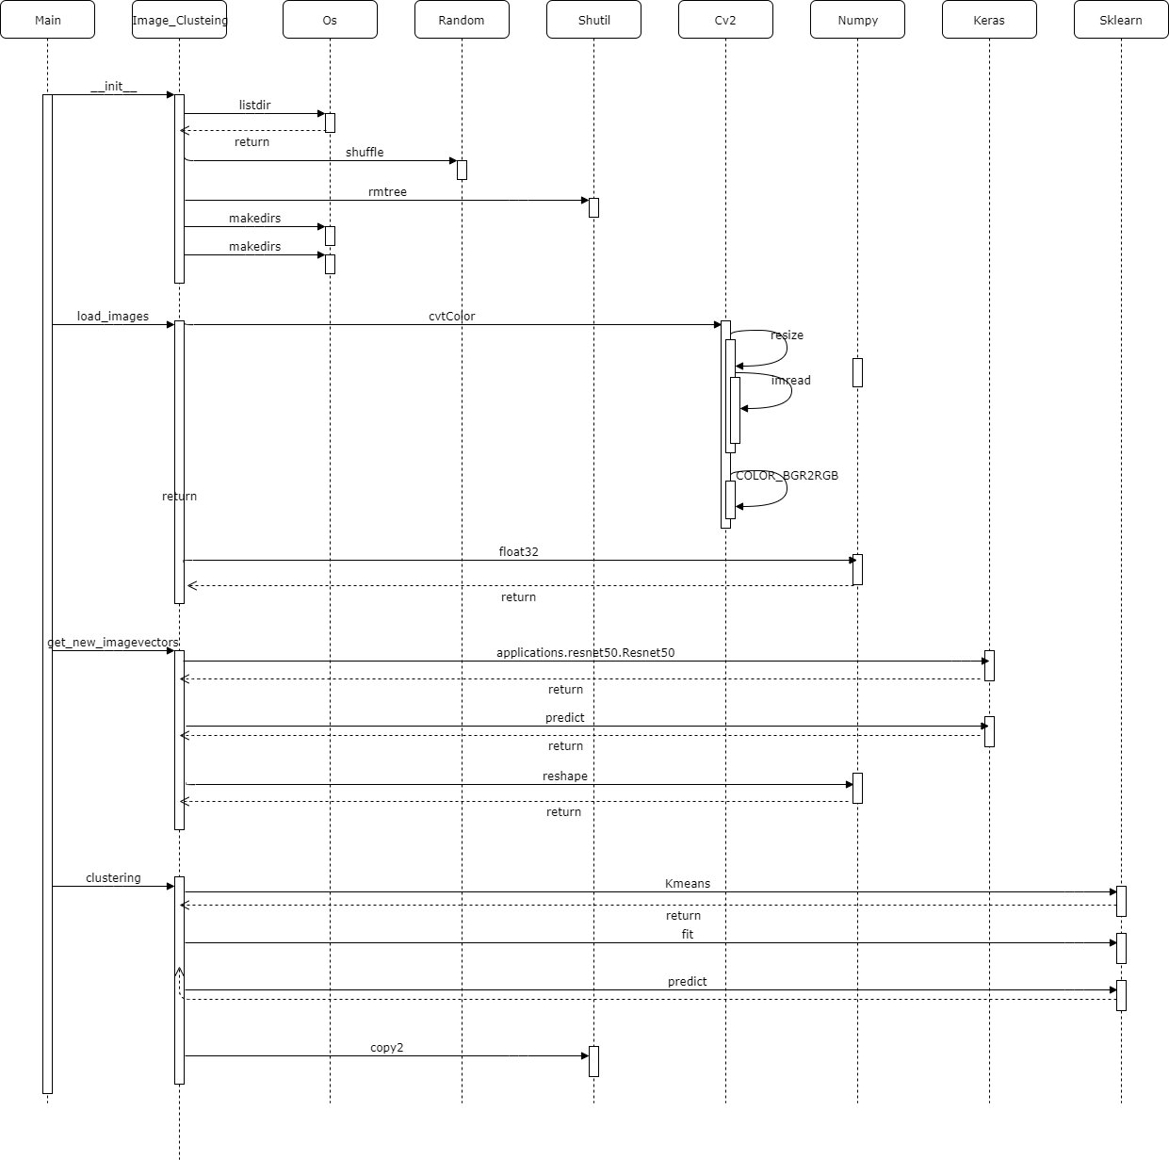

# Class Diagram:

