**Doctor Appointment App   
Report by 20sw059**

**Introduction:**

In an era of digital transformation, healthcare services are rapidly embracing technology to improve accessibility and efficiency. The Doctor Appointment Flutter App is a pioneering solution designed to facilitate the interaction between healthcare providers (doctors) and patients in an easy, convenient, and user-friendly manner.

**Problem Statement:**

Patients struggle to find and book appointments with suitable healthcare providers, while doctors face challenges in managing their schedules efficiently and attracting new patients, resulting in a less-than-optimal healthcare experience for both parties.

**Patient's Problem:**

* Difficulty in finding available doctors, especially specialists.
* Extended wait times for appointments, leading to delayed healthcare services.
* Inability to access comprehensive information about doctors' category, specialties, and experience.
* Cumbersome appointment booking processes, including phone calls and paper forms.

**Doctor's Problem:**

* Difficulty in managing appointments efficiently, leading to overbooking or underutilization of time slots.
* Administrative Overhead: Time-consuming administrative tasks, such as appointment confirmation calls.

**Proposed Solution:**

The Doctor Appointment Flutter App presents a comprehensive solution to address the challenges faced by both patients and doctors in the healthcare appointment booking process. By leveraging modern technology and user-friendly design, this app offers several key features to streamline and enhance the healthcare experience:

**For Patients:**

* Patients can effortlessly search for available doctors, view their schedules, and book appointments within a few taps on their mobile devices.
* Doctor Profiles: Comprehensive profiles provide patients with detailed information about doctors, including their specialties, services, experience, and working timings.
* Patients will let know by app that their appointment is accepted or rejected.

**For Doctors:**

* Doctors can manage their schedules efficiently, reducing the risk of overbooking and optimizing time slots to enhance productivity.
* Doctors can showcase their credentials, specialties, and availability, making it easier for patients to discover and choose them as their healthcare providers.
* The app minimizes administrative overhead by automating appointment confirmations and reminders, freeing up more time for patient care.

**User Interface:**

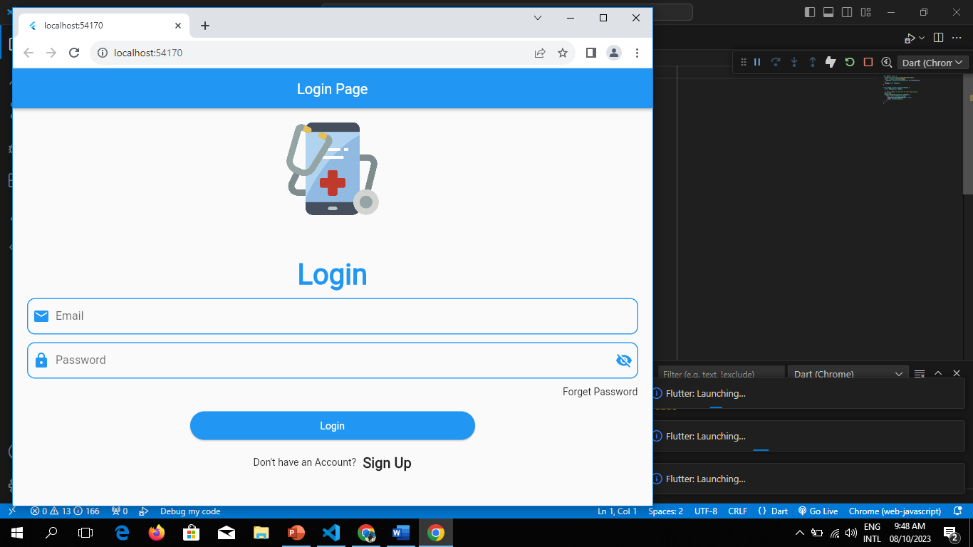

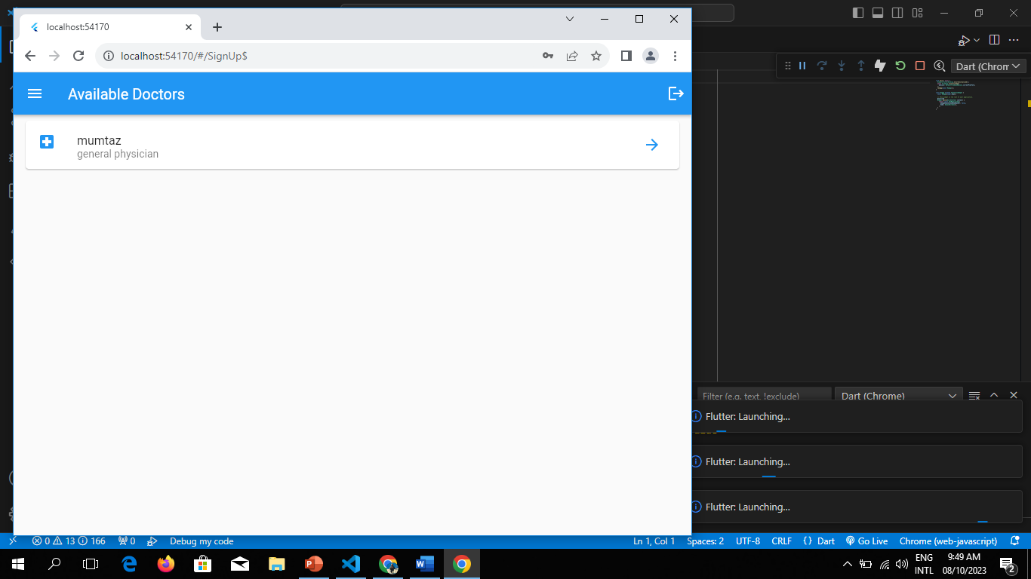

**Firebase Integration:**

**Authentication:**

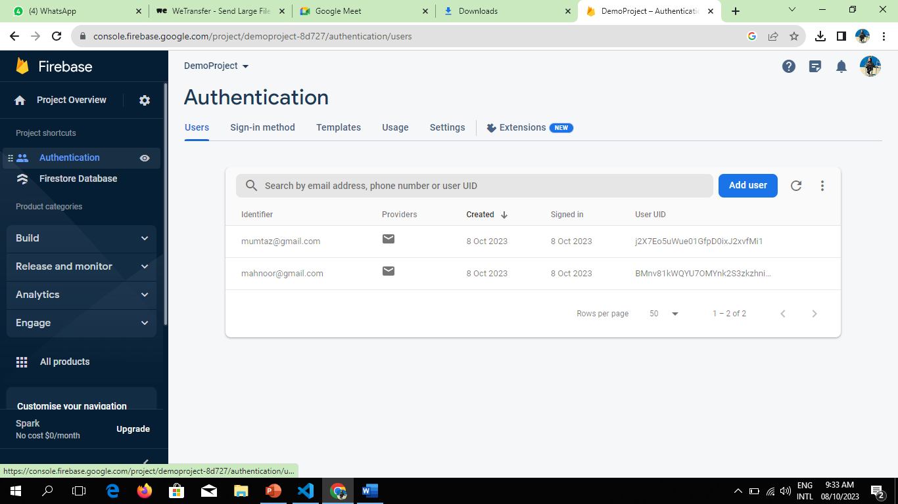

**Firestore Database:**

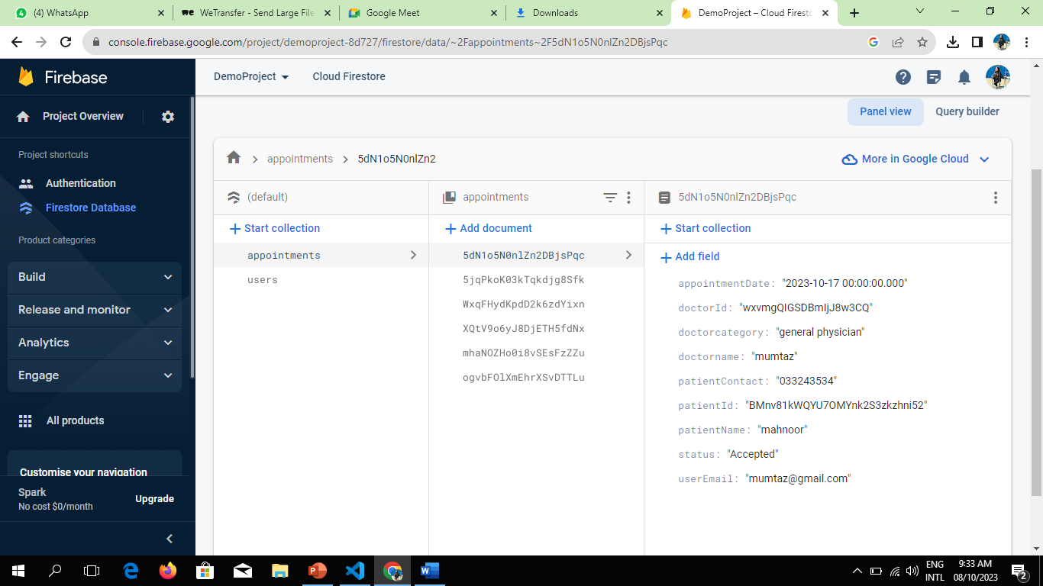

**TECHNOLOGIES USED**

Doctor Appointment app is powered by cutting-edge technologies to ensure a seamless and secure experience:

• **Flutter:** A cross-platform framework for building natively compiled applications.

• **Firebase:** A comprehensive platform for mobile and web app development, including user authentication and real-time database functionality.

• **Cloud Firestore:** A NoSQL cloud database for storing and syncing data.

**• Firebase Storage:** Securely store and retrieve user-uploaded images.

**ERRORS WE ENCOUNTERED DURING THE DEVELOPMENT**

