**DBAS 1001**

**Introduction to Database Management**

**Assignment # 7**

**Background:**

**The Sample Database** –

* You have been provided with a sample database called **appt_sched_master.accdb,** its ERD and Data Dictionary via the shared drive.
* Copy this database to your local drive, as many of your future assignments will require you to construct and save application objects, to load and manipulate data, and to run functional demonstrations using the sample database.
* Ensure you keep a regularly updated backup copy of the database along with your working copy. If you wreck your working copy, the master copy on the shared drive will not contain any of your changes.

**Retrieving Data from the Database –**

* Via a DBMS-supplied GUI interface
  + Any DBMS will generally provide some GUI interface, often referred to as a “query wizard” to facilitate the construction of an underlying SQL SELECT statement.
  + The MS Access implementation of this is called the Query Wizard.
  + Users, through such a wizard, can have the ability to:
    - Name which of the tables in the database will serve as the source of the data for the query;
    - Specify which rows of the table(s) will be copied to the query for processing;
    - Specify which field(s) from the rows copied to the query for processing will be output by the query;
    - Specify grouping level(s) and group function(s) to be applied to the rows copied to the query for processing;
    - Sort the rows of query output; and
    - Save the query in the DBMS so that it can be re-executed on user demand as a dynamically updated “view” of information derived from table data.
* Via the SQL SELECT statement
  + The SQL SELECT statement uses a SELECT clause to format the output of the SELECT statement.
  + It uses a FROM clause to the name the database table(s) that will source data to the query.
  + It uses an optional WHERE clause to limit the number of rows from the source table(s) that are copied to the query for processing.
  + It uses an optional ORDER BY clause to impose a sort order on the rows output by the query.
  + It uses an optional GROUP BY clause to apply grouping levels to the rows that have been copied to the query for processing.
  + It uses an optional HAVING clause to limit the number of groups output by the query.
  + For sample code, examples, and deeper syntax guidelines I suggest you have a look online or peruse an excellent reference like the O’Reilly SQL Pocket Guide.
* Via an application interface
  + Programming platforms ranging from the object-oriented languages such as Java to the scripting platforms like PHP give developers the ability to create widely deployed user-friendly GUI interfaces so that end users can manipulate data in an environment that closely simulates how they actually do business.
  + One such interface is MS Access Forms.
  + The MS Access Form Wizard gives the developer the ability to quickly create a form that is **bound** to a single database table, specifically designed to give the end user the ability to view data from that table.
  + The form, in its design view, can then be “modified” to include a “subform object” that sources data from a query (an SQL SELECT statement) that could be based on several tables other than the one bound to the original form. As long as the query includes a field that can be used to link to a field on the original form, the subform data can be “coordinated” with the data on the original form.

**Your Work:**

1. Copy your post-assg6 version of **appt_sched_master.accdb** to your backup location. Rename it appropriately.
2. Code, test and save a Query using an SQL statement for each of the following scenarios:
   1. List all of the person names
   2. List all of the fields from the appointment table
   3. List the names of all the services that cost more than 100 dollars
3. Code, test and save a Query using the Query Wizard for the same scenarios.
4. Code, test and save an Access form as per this storyboard:

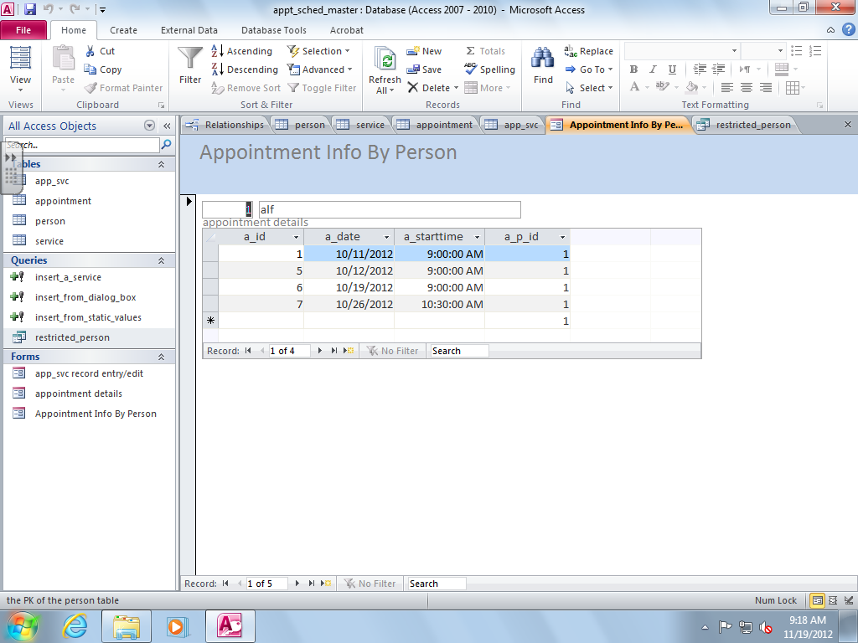

that displays information from the person table across the top, and as you scroll through the person data, displays information from the appointment table that is synchronized with the data currently viewable in the “person area” of the form.

1. Make a memo with:
   1. Existing system – The Appointment Scheduling System Design documentation from Assg4 and the **appt_sched_master.accdb** from the shared drive;
   2. Requirement – to complete each of the tasks listed in the “Your Work section of this assignment;
   3. Analysis –
      1. Supply the ERD and reference the Data Dictionary;
      2. Supply the three SELECT statements you made earlier in this assignment. For each, explain all of the syntax you used and how it relates to the requirements stated in YOUR WORK section 2. Supply the SQL view of the queries you made with the query wizard. Explain the differences between this syntax and the syntax you coded by hand, if any; and
      3. Supply a screenshot of the form you made, accompanied by an explanation, for each object visible on the form,
         1. what it is;
         2. what it is for; and
         3. what, if any, functionality is associated with it.
   4. Recommendation – Please accept the demonstration as evidence of the per-specification functionality of the data entry application.
2. Demonstrate the functionality of your database application by:
   1. Running each of the SQL queries and explaining what each column of output means;
   2. Running the form, displaying the synchronization of data between the two areas of the form, and explaining how the form knows how to synchronize the data.

DBAS 1001

ASSIGNMENT SEVEN MARKING RUBRIC

|  |  |  |  |
| --- | --- | --- | --- |
| MARKING POINTS | 0 | 1 | 2 |
| Memo Format | Not used | incomplete | Complete |
| Professionalism | Illegible spelling; poor paragraph structure; poor grammar: affecting user acceptance of the finished work | Errors exist that do not affect user acceptance of finished work | Finished work has a level of professionalism acceptable to standards as negotiated with the client or his/her representative |
| Existing system details | Not present | incomplete | As applicable, enough details regarding existing system to form conclusions regarding requirements |
| Requirements | Not stated | Incomplete or inaccurate | Clear, measurable requirements for deliverables, including stage of development required i.e. design, prototype, implementation, testing |
| Analysis | Not present | Incomplete or inaccurate | complete as per the list in Assg7 Your Work Section 5c. |
|  | 0 | 1..9 | 10 |
| Recommendation | Not present | -1 point for each omission from the specs and -5 points for not matching analysis | successful demo as per specs in Assg7 Your Work Section 6. |
| Totals | 0 | 1..19 | 20 |