**DBAS 1001**

**Introduction to Database Management**

**Assignment # 9**

**Background:**

**The Sample Database** –

* You have been provided with a sample database called **appt_sched_master.accdb,** its ERD and Data Dictionary via the shared drive.
* Copy this database to your local drive, as many of your future assignments will require you to construct and save application objects, to load and manipulate data, and to run functional demonstrations using the sample database.
* Ensure you keep a regularly updated backup copy of the database along with your working copy. If you wreck your working copy, the master copy on the shared drive will not contain any of your changes.

**Provision of an End-User Friendly Application Navigation Interface –**

* It is a given that the data model underlying a database application system is comprehensive in that it is capable of storing all the data, and retrieving all of the information necessary to support business function(s). Provision of end-user friendly GUI application interfaces like forms and reports places this interactive capability into the hands of the end users.
* The issue that can arise is that as the number of supported business functions increases, so does the number of application interfaces to the point where end users may find it difficult to find, much less access, the interface(s) they require to perform their business functions.
* A solution to the issue of application complexity can be the provision of a logically (according to business function) structured menu system that allows end users quick access to/exit from the objects with which they need to interact.

**Steps in Design and Implementation of an End-User Friendly Application Navigation Interface –**

1. Gather Requirements. Management may wish to impose design/functionality requirements, for instance, on the number of submenu levels, application object groupings, security, platform, etc.
2. Logically group the application objects by business function, for instance, all the forms that have to do with data entry/edit, all the forms/reports that have to do with viewing summarized data, all the objects used by the accounting department, etc.
3. Storyboard the menu system as a tree, including the application objects as leaf nodes, the functional groupings as a submenu level, and the application entry/exit point as a main menu. More than these three levels will tend to frustrate the end users as they find navigation through the menu system becoming labour intensive. Ensure your tree diagram depicts the application flow from one object to another. A magic word often used to describe such a diagram is a Functional Hierarchy Diagram.
4. Choose a programming platform that interacts well with your database platform, and implement your FHD. MS Access provides three directions for the implementation of menu objects:
   1. Plain blank forms with titles and buttons;
   2. Use of the Switchboard Manager; and
   3. Use of the new set of Navigation Forms.

Ensure that you test every navigation possible in your menu system.

**Your Work:**

1. Copy your post-assg8 version of **appt_sched_master.accdb** to your backup location. Rename it appropriately.
2. Consider the following Functional Hierarchy Diagram:

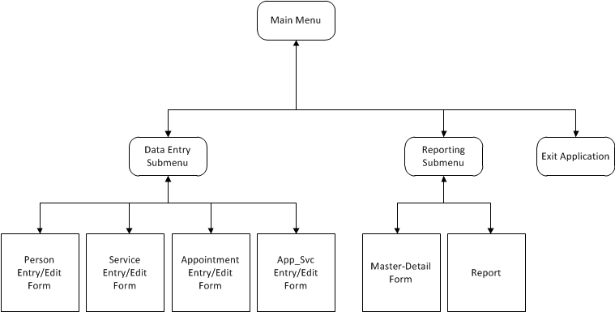

Using the MS Access Switchboard Manager, or blank MS Access Forms with Navigation Buttons, implement the above diagram as an application system in your copy of appt_sched_master.accdb. Ensure the labels used on the diagram above end up as Form Titles and Button Labels. Ensure the functional flow indicated by the arrows on the diagram is implemented in your application system; for instance, closing the Person Entry/Edit Form should return you to the Data Entry Submenu; closing the Data Entry Submenu should return you to the Main Menu.

1. Make a memo with:
   1. Existing system – The Appointment Scheduling System Design documentation from Assg4 and the **appt_sched_master.accdb** from the shared drive;
   2. Requirement – to complete each of the tasks listed in the “Your Work section of this assignment;
   3. Analysis –
      1. Supply the ERD and reference the Data Dictionary;
      2. Supply the Functional Hierarchy Diagram from this assignment;
      3. Supply Storyboards with accompanying explanations for the Main Menu, the Data Entry Submenu, and the Reports Submenu; and
      4. Reference your existing storyboards from previously submitted assignments for the report, the master-detail form, and the four Data Entry forms.
   4. Recommendation – Please accept the demonstration as evidence of the per-specification functionality of the report application.
2. Demonstrate the functionality of your database application system by:
   1. Running the Main Menu;
   2. Using your FHD as a roadmap, return trip every process flow from the main menu to each leaf node (application object). End your demo by exiting the application from your main menu.

DBAS 1001

ASSIGNMENT NINE MARKING RUBRIC

|  |  |  |  |
| --- | --- | --- | --- |
| MARKING POINTS | 0 | 1 | 2 |
| Memo Format | Not used | incomplete | Complete |
| Professionalism | Illegible spelling; poor paragraph structure; poor grammar: affecting user acceptance of the finished work | Errors exist that do not affect user acceptance of finished work | Finished work has a level of professionalism acceptable to standards as negotiated with the client or his/her representative |
| Existing system details | Not present | incomplete | As applicable, enough details regarding existing system to form conclusions regarding requirements |
| Requirements | Not stated | Incomplete or inaccurate | Clear, measurable requirements for deliverables, including stage of development required i.e. design, prototype, implementation, testing |
| Analysis | Not present | Incomplete or inaccurate | complete as per the list in Assg9 Your Work Section 3c. |
|  | 0 | 1..9 | 10 |
| Recommendation | Not present | -1 point for each omission from the specs and -5 points for not matching analysis | successful demo as per specs in Assg9 Your Work Section 4. |
| Totals | 0 | 1..19 | 20 |