DBAS 1001
Introduction to Database Management
Assignment # 5

Background:

Database-Related Job Roles –

- Database Application Developer, Database Programmer
  - Design, code, test of complex SQL statements
  - Design, code, test of transactional code for server and client applications such as stored procedures and functions
  - responsible for SME in an application platform’s data-handling capabilities such as database drivers, in-application CRUD
  - See Annex 1: Database Programming Job

- Database Administrator
  - Planning and implementation of the DBMS
  - Ongoing maintenance and performance tuning of the DBMS
  - Planning and implementation of DBMS security measures
  - Planning and implementation of Backup and Recovery procedures
  - See Annex 2: Database Administration Job

- Database Architect, Database Specialist, Data Modeler, Data Analyst
  - Does it all, often at a management/supervisory level
  - Expert skills in Data Warehousing, Data Mining, Business Intelligence
  - See Annex 3: Database Management Job

Database Skills are In Demand in EVERY IT Job role -
- Here are some current (as of 11 Sept 2013) IT job opportunities from careerbeacon.com:
  - For a Junior Java Developer job with CGI in Stratford, Ontario see Annex 4 - note specific requirements for Database Development in Oracle
  - For a Web Developer job using ASP.NET through the headhunter Randstad Technologies, job location in HRM – see Annex 5 - note specific requirements for SQL Server 2005 and Oracle PL/SQL
  - For a System Administrator (CS03) job with the province (Nova Scotia Pension Services) in Halifax –see Annex 6 - note specific requirements for MySQL, MS SQL Server and Oracle

Your Work:

- Find a cool job ad for a job that meets what you would like to be able to do after you graduate – see if it contains any database job roles.
- Find a database-related job ad – see if it contains any elements of the job roles you would like to do after you graduate.
- Make a memo with:
  - Existing system - you need to find a job that will not kill you
  - Requirement – to analyze two job ads to determine what job roles they require
  - Analysis – show the content of the job ads and your conclusions regarding what job roles they include
  - Recommendation – Tell which of the two analyzed jobs you would apply for and why.

DBAS 1001
ASSIGNMENT FIVE MARKING RUBRIC
MARKING POINTS | 0 | 1 | 2
Memo Format | Not used | incomplete | Complete
Professionalism | Illegible spelling; poor paragraph structure; poor grammar: affecting user acceptance | Errors exist that do not affect user acceptance of finished work | Finished work has a level of professionalism acceptable to the client
Existing system details | Not present | incomplete | As applicable, enough detail to form conclusions regarding requirements
Requirements | Not stated | Incomplete or inaccurate | Clear, measurable requirements
Analysis | Not present | Incomplete or inaccurate | both jobs ads present, along with job role description for each
 | 0 | 1..9 | 10
Recommendation | Not present | -1 point for each omission from the specs and -5 points for not matching analysis | clear statement of which job you would prefer and why
Totals | 0 | 1..19 | 20

Annex One: Database Programming Job

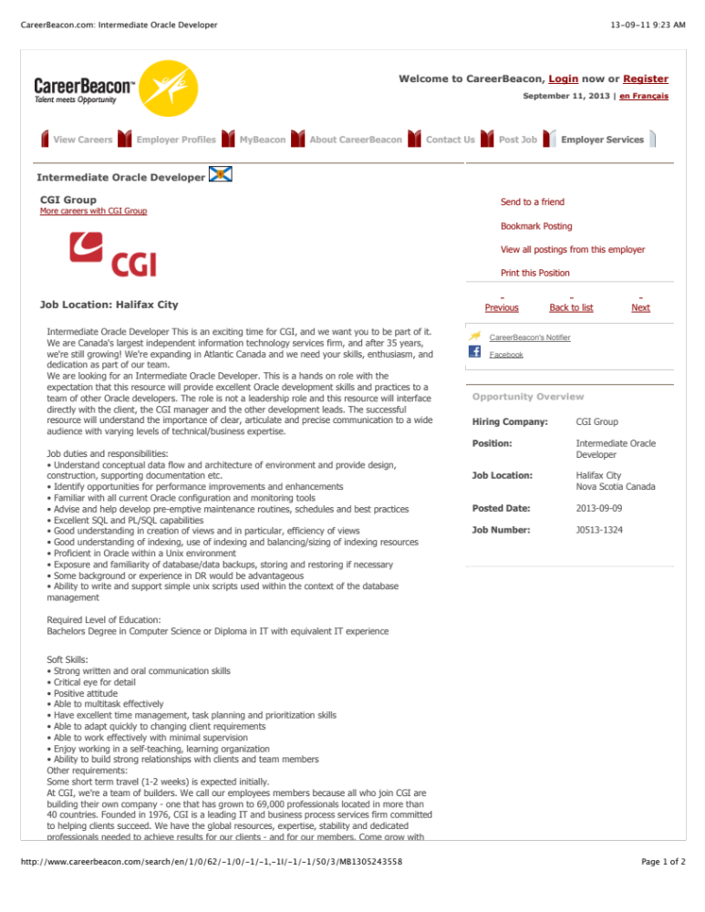

Annex 2: Database Administration Job

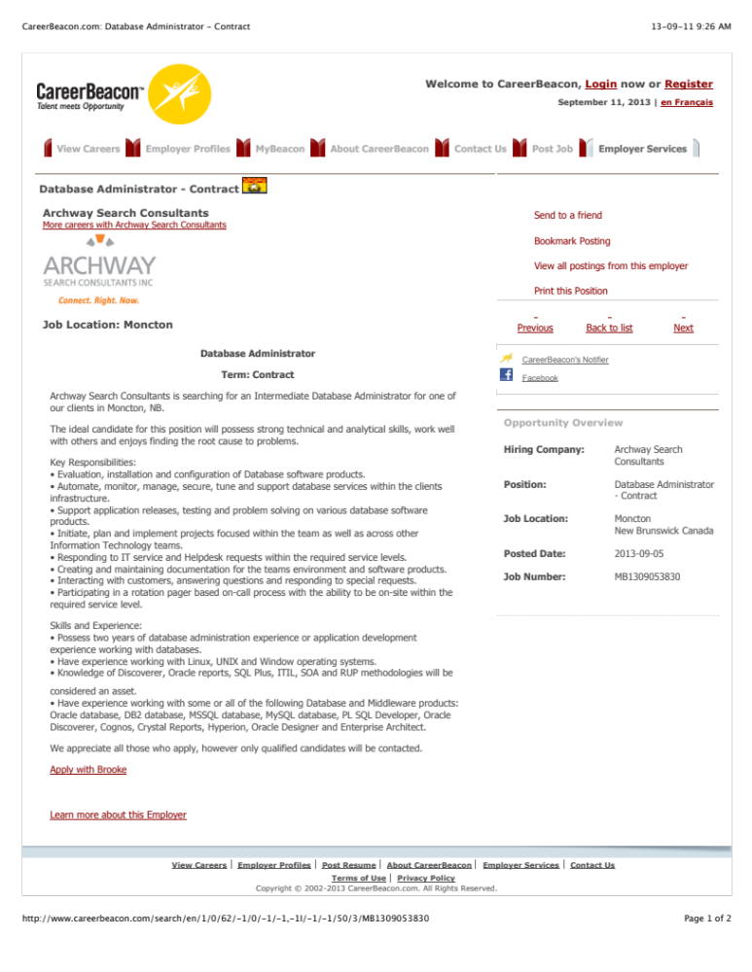

Annex 3: Database Management Job

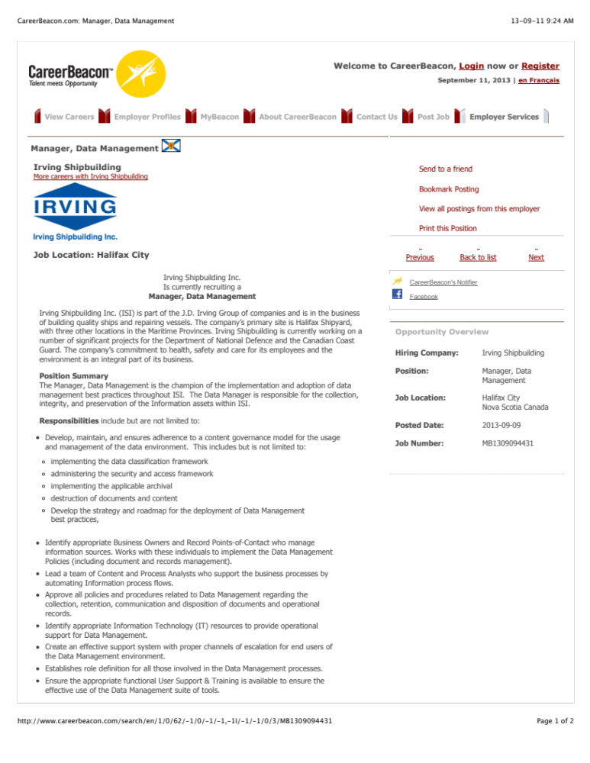

Annex 4: Entry Level Programming Job

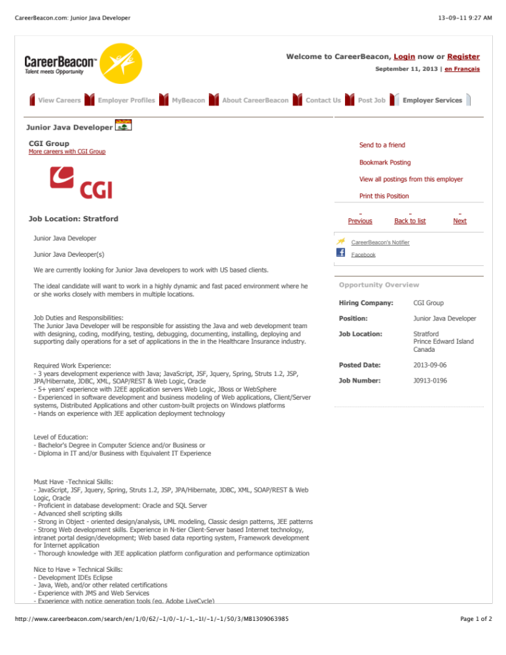

Annex 5: Web Developer Job

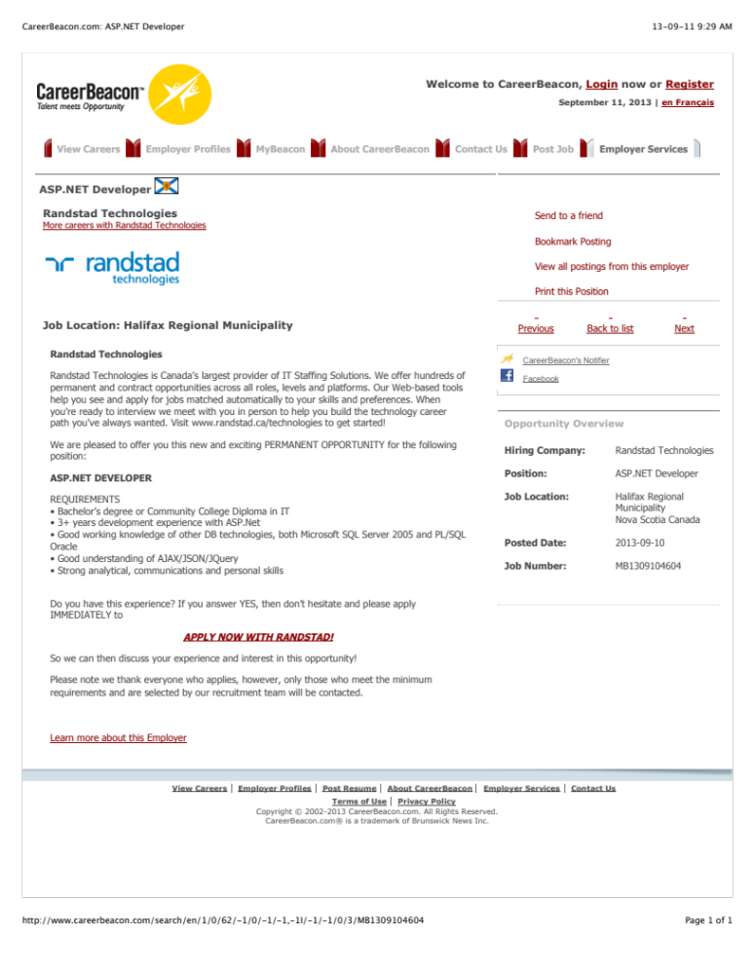

Annex 6: System Administrator Job

