**UNSW Streams – Planning for the Future**

**Table of Contents**

1. **Requirements** 
   1. Elicitations
   2. Analysis & Specification – Use Cases
   3. Validation
2. **Design**
   1. Interface Design
   2. Conceptual Modelling (State)

**1. Requirements**

* 1. **Elicitation**

**Target Users:**

User 1:

* Name: Harsh Vachhani
* Email Address: harshvachhani4@gmail.com

User 2

* Name: Wendy Lu
* Email Address: [wendylu1358@gmail.com](mailto:wendylu1358@gmail.com)

User 3:

* Name: Juan Francisco Puyó
* Email Address: [juanfran.puyo@gmail.com](mailto:juanfran.puyo@gmail.com)

**Questions for target users:**

1. What are some other platforms that you currently use and how do you use them? (e.g., Microsoft teams, discord, Zoom)
2. *Give demo of frontend
3. What are some problems you are finding while using the UNSW Streams platform?
4. What are the downsides of using teamwork driven communication tools over in person meetings?
5. What are the most challenging aspects of working together in online communication apps?
6. Do you like the look of the UNSW Streams platform?
7. What is your preferred device(s) for this type of communication app?
8. How intuitive is the app to use?

**User answers transcript**

User 1: Harsh Vachhani

**Q. What are some other platforms that you currently use and how do you use them? (e.g., Microsoft teams, discord, Zoom)**

A. I mainly use discord and reddit.

**Q. what are some problems you are finding while using the UNSW Streams platform?**

A. User interface could be better. Those red errors popping is very annoying. Like discord, I would like to have been anonymous and have different usernames for different channels. Also, there is no option for screen sharing, which is very important for group projects.

**Q. What are the downsides of using teamwork driven communication tools over in person meetings?**

A. In person meetings are more engaging and you can know how people react to what you say, rather than staring at chats or shared screens.

**Q. What are the most challenging aspects of working together in online communication apps?**

A. communicating what you are working on and showing your work, especially if two people need to work together on some part of the project.

**Q. Do you like the look of the UNSW Streams platform?**

A. It is okay I guess; my main concern would be if people I want to interact with are using this platform or not.

**Q. What are your preferred devices for this type of communication app?**

A. I mainly use a laptop for this type of communication.

**Q. How intuitive is the app to use?**

A. not very much.

User 2: Wendy Lu

**Q. What are some other platforms that you currently use and how do you use them? (e.g., Microsoft teams, discord, Zoom)**

A. Messenger mostly, sometimes discord

**Q. What are some problems you are finding while using the UNSW Streams platform?**

A. Poor aesthetics, private channels that you cannot access. There is no way for me to communicate with teammates in mediums other text. Image sharing and sending links would be nice.

**Q. What are the downsides of using teamwork driven communication tools over in person meetings?**

A. You can choose to ignore people’s messages, people might not reply until later and it is harder to connect with your teammates on a more personal level.

**Q. What are the most challenging aspects of working together in online communication apps?**

A. There is less incentive for team bonding due to the disconnect. There is also not as much initiative to be a leader or reach out to your team members

**Q. Do you like the look of the UNSW Streams platform?**

A. No. Channels and dms can be confused with one another because they look very similar. A dark mode should be an option. However, the simple design makes it easy to use.

**Q. What are your preferred devices for this type of communication app?**

A. I prefer the phone as it is convenient, easier to download, and I can get popup notifications

**Q. How intuitive is the app to use?**

A. Intuitive, like other common messaging apps.

User 3: Juan Francisco Puyó

**Q:** What are some other platforms that you currently use?

**A:** I use Zoom for education and Discord to communicate with my friends.

**Q:** What are some problems you are finding while using the UNSW Streams platform?

**A:** UNSW Streams doesn’t allow me to communicate with smaller groups inside a channel so that I can create different teams and work or play on separate issues or games.

**Q:** What are the downsides of using teamwork driven communication tools over in person meetings?

**A:** Teamwork driven communication makes it daunting to participate during class which wasn’t hard with in person meetings. Also, it is hard to have discussions with many people at a time.

**Q:** What are the most challenging aspects of working together in online communication apps?

**A:** The most challenging part is maintaining myself organized and achieving my group or class goals. This was easier in person since I felt more responsibility when I was assigned work.

**Q:** Do you like the look of the UNSW Streams platform?

**A:** It looks good, but it burned my eyes when I opened it at night.

**Q:** What is your preferred device(s) for this type of communication app?

**A:** I mostly use this type of app in my laptop but definitely use my phone occasionally.

**Q:**  How intuitive is the app to use?

**A:** I think the buttons are placed at the right places, but I can’t see a list for my friends or contacts to send them dm’s.

**Q:** Thanks!

**Proposed Solutions**

**Problem**: The page is too bright to view at night and is uncomfortable to look at.

**Solution**: Create a dark-mode toggle that changes the entire app to a darker theme.

**Problem**: Meetings and group projects do not feel personal enough because there are no forms of vocal communication.

**Solution**: Create a call feature for channels and dms.

**Problem**: Cannot share images, videos, or clickable links through messages.

**Solution**: Implement an upload file feature for channels and dms which takes in a file that is present in a list of valid file types (e.g., jpg, mp4, gif) and stores it in the database. This file is downloadable within the channel or dm that it is sent in, and it can be viewed as a message sent by the user who made the upload.

**Problem**: Cannot schedule meetings and tasks.

**Solution**: Implement a calendar widget inside channels that shows a small calendar graphic with colored pins on desired dates. It is expandable to show a full calendar that has event/task messages on different dates. Tasks/events can be added, removed, and edited.

**Problem**: Different channels can’t have different usernames.

**Solution:** Add a feature for changing usernames in each channel.

**Problem:** No way of sharing your work with your teammates

**Solution**: Create a screen sharing feature.

* 1. **Analysis & Specification – Use Cases**

**User stories and acceptance criteria**

*As a team member communicating in their group project using UNSW Streams, I want a form of vocal communication so that meetings and interactions feel more personal.*

**Scenario:** User wants to host a voice meeting with team members

**Given:** The user has navigated to their desired channel

**When:** The user clicks the call button

**Then:** The app sends a repeated call notification to everyone in the channel

**Given:** Channel users receive the call notification

**When:** Channel users click on the join call button

**Then:** They are connected to the group call

**Given:** All members of the group call leave the call

**Then:** The group call ends

**And:** Users cannot join back into the call unless a new call is made

*As a student and a night-time user of UNSW Streams, I want to have an option for a darker theme, so it is more comfortable to look at the page at night.*

**Scenario:** User wants a darker theme at night  
**Given:** The user has navigated to the settings page  
**When:** The user toggles on dark mode   
**And:** Was previously on light mode.  
**Given:** The user’s interface changes to a dark theme.   
**When:** The user navigates through channels, dm’s and other parts of the system, these will have a dark theme.

*As a team member communicating in their group project using UNSW Streams, I want to share links and files with other team members so that I can easily communicate information through mediums other than only* plain text.

* The upload file icon is placed in line with other message options eg. React, share, pin within a channel/dm
* User’s system file manager pops up when clicking on upload file icon
* The file exists as a downloadable link inside the channel/dm that it was uploaded in
* User can only upload files that adhere to a predetermined list of file type options
* User’s file size cannot exceed a certain limit

*As a team member communicating in their group project using UNSW Streams, I want to have a way where my team can schedule and keep track of tasks so that my team stays organized.*

* A calendar widget exists in the top left corner of each channel
* The calendar is in minimized view by default and shows a calendar graphic with coloured pins on different dates
* Users can click on the expand calendar button to show expanded view
* Users can add, delete and edit notices to different dates

**Use cases**

**File Upload – Use Case:**

Main Success Scenario

1. User clicks on upload icon located in the row of other message options (react, share, pin)
2. User’s system file manager pops up
3. User selects a file to upload
4. System shows the file that the user has selected to confirm upload
5. System checks the file type to make sure it is in the list of valid file types
6. System downloads the file to the server
7. System generates a download link for the file
8. User’s file download link is sent as a message in the channel
9. Other users can click on the download link to download file from server.

**Themes – Use Case:**

Main Success Scenario:

1. User clicks on profile tab located at the top bar of UNSW Streams.
2. Profile window pops up and shows a toggle called themes.
3. The user clicks on the themes toggles and is shown various colors to personalize his UNSW Streams.
4. This would include dark theme.
5. The user selects a theme and a save button pops up.
6. When the user clicks a color all of the routes of UNSW Streams would have the selected theme.

**Calendar – Use Case:**

Add Event Success Scenario:

1. User clicks on calendar tab below channels and dm’s in UNSW Streams.
2. Calendar window pops up with expand calendar, add event, remove event and edit event.
3. User clicks add event and the add event button expands and shows a window with a textbox for name, due date and a save button.
4. User inputs name, picks a date and clicks save.
5. The event now shows as a bar on the specified date on the calendar.
6. There is an upcoming events list with the closest events on the right.

Remove Event Success Scenario:

1. User clicks on calendar tab below channels and dm’s in UNSW Streams.
2. Calendar window pops up with expand calendar, add event, remove event and edit event.
3. User clicks remove event and the remove event button expands and shows a window with all the events in the calendar and a remove button.
4. If there are no events, there will be a “no events” message.
5. User picks an event and clicks the remove button
6. The event now doesn’t show on the specified date on the calendar.
7. The event is also deleted from the upcoming events list with the closest events on the right.

Edit Event Success Scenario:

1. User clicks on calendar tab below channels and dm’s in UNSW Streams.
2. Calendar window pops up with expand calendar, add event, remove event and edit event.
3. User clicks edit event and the edit event button expands and shows a window with all the events in the calendar and a edit button.
4. If there are no events, there will be a “no events” message.
5. User picks an event and a window shows a window with a textbox for name, due date and a save button.
6. User inputs name, picks a date and clicks save.
7. The edited event now shows as an bar on the new specified date and the new given name on the calendar.

Expand Calendar Scenario:

1. User clicks on calendar tab below channels and dm’s in UNSW Streams.
2. Calendar window pops up with expand calendar, add event, remove event and edit event.
3. User clicks expand calendar and a window with the calendar opens up.
4. This shows the calendar for the whole month and the user can click and go to previous and upcoming months.
   1. **Validation**

User 2: Wendy Lu

**Q:** To what extent do these use cases describe and tackle the problems of being *“hard to connect on a personal level to teammates”* and *“not being able to communicate and share information in other mediums”.*

**A:** I think having voice calls is an essential part of communication apps and it’s a great solution to breaking the disconnect between a working team. Uploading files is also a neat feature so word docs and pictures can be very easily exchanged between users.

User 3: Juan Francisco Puyó

**Q:** To what extent do these use cases describe and tackle the problems of “*maintaining [yourself] organized and achieving [your] group or class goals”* and “*burning [your] eyes at night.”*

**A:** I really liked the solution for me burning my eyes as you added more theme options than dark theme. I also liked the calendar solution, but it would be useful to also have the app send you notifications when an event is coming.

**2. Design**

**2.1 Interface Design**

|  |  |  |  |
| --- | --- | --- | --- |
| **Name & Description** | **HTTP Method** | **Data Types** | **Exceptions** |
| message/fileuploadchannel/v1  Given an active token and a filename, send a message with a download link for the given file to the channel specified by channel_id. | POST | **Parameters:** { token, channel_id, filename }  **Return Type:** { message_id } | **Input Error** when any of:   * channel_id does not refer to a valid channel. * Filename does not refer to a valid file * File type is invalid.   **Access Error** when:   * channel_id is valid and the authorised user is not a member of the channel they are trying to post to |
| message/fileuploaddm/v1  Given an active token and a filename, send a message with a download link for the given file to the dm specified by dm_id. | POST | **Parameters:** { token, dm_id, filename }  **Return Type:** { message_id } | **Input Error** when any of:   * dm_id does not refer to a valid DM. * Filename does not refer to a valid file * File type is invalid.   **Access Error** when:   * dm_id is valid and the authorised user is not a member of the DM they are trying to post to |
| user/profile/settheme/v1  Update the authorised user’s background colour to the given “theme”. | PUT | **Parameters:** { token, theme_id}  **Return Type:** {} | **Input Error** when:   * theme_id does not refer to a valid theme. * the theme already contains given theme_id |
| calendar/addevent/v1  Given a name, and date and list of u_ids, create an event in the calendar. | POST | **Parameters:** { token, name, date, u_ids}  **Return Type:** {event_id} | **Input Error** when any of:   * length of name is less than 1 or more than 20 characters. * date is not of type datetime. * any u_id in u_ids does not refer to a valid user. |
| calendar/editevent/v1  Given an event_id, change the event’s name, date and list of u_ids to the given information. | PUT | **Parameters:** { token, event_id, name, date, u_ids}  **Return Type:** {} | **Input Error** when any of:   * length of name is less than 1 or more than 20 characters. * date is not of type datetime. * any u_id in u_ids does not refer to a valid user. * Invalid event_id   **Access Error** when:   * Authorised user not creator of given event_id |
| calendar/removeevent/v1  Given an event_id, change the event’s name, date and list of u_ids to the given information. | DELETE | **Parameters:** { token, event_id }  **Return Type:** {} | **Input Error** when any of:   * Invalid event_id   **Access Error** when:   * Authorised user not creator of given event_id |
| calendar/expandcalendar/v1  Given an event_id, change the event’s name, date and list of u_ids to the given information. | GET | **Parameters:** { token }  **Return Type:** {} |  |

**2.2 Conceptual Modelling (State)**

**Calendar – State diagram:**

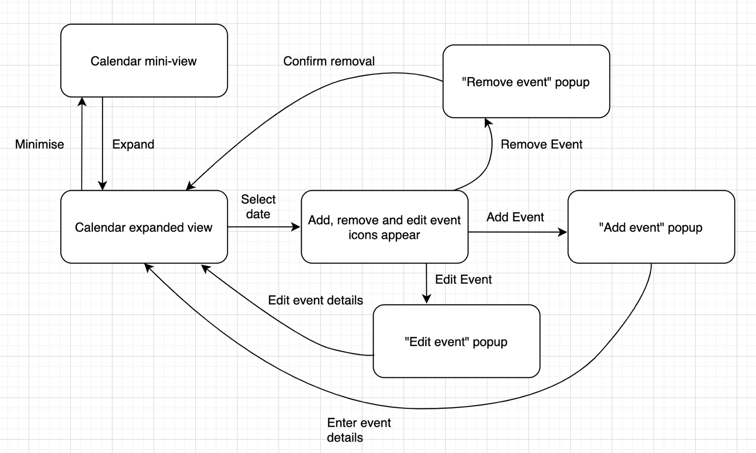

**Upload File– State diagram:**

