Guide To Making Your Robot Helicopter
By
Soham Naik and Dr.AlberCook
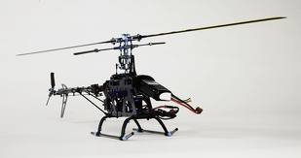

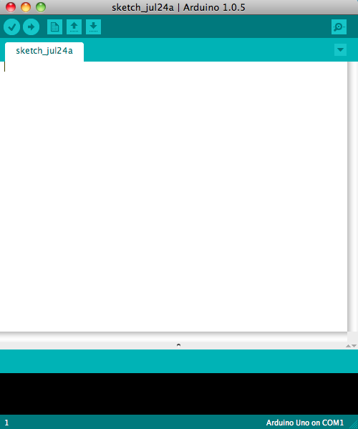



Table of Contents

I. Parts and software need
DigiSpark
<Digi.keyboard>
Arduino Software
Helicopter Parts

II. Installing Your Software
Arduino
DigiSpark
<Digi.keyboard>

III. Assembling Your Helicopter

IV. Basics of Programming
BareMinimum
Blink
digitalRead()
digitalWrite()
Analog Write()
Analog Read()
long()
short()

V. Programming and understanding you Helicopter

VI. Finishing you Helicopter

VII. Possible errors (If you are encountering an error please see this page)
Ports
Indentation issues
etc.

Parts and Software needed

Software:

Arduino

Digistump > library

Parts:

1 Dr.G Board

1 Down sensor

1 Forward sensor

2 Motors

1 Helicopter

Wires

Plastic parts

1 Battery

1 Battery socket

Installing Your Software

Arduino:

Go to “http://www.arduino.cc/” and press the Downloads button in the top right of

the Arduino page. Once on the Arduino/Downloads page go down till you see the

newest version of Arduino for your computer operating system.

Download Arduino unzip the file and put the File name “Arduino” somewhere

easily accessed as the file is what you use to launch the Arduino IDE. To launch

Arduino double click on the file named “Arduino”.
Congrats you have installed Arduino!

Go to the Basics of Programming page or Programming and understanding you

Helicopter page to learn more about Arduino.

DigiStump (Library):

Go to “http://digistump.com/”

Assembling Your Helicopter

I. Gather and Sort your parts in neat piles.
Make sure you have all the parts

II. Start taking apart the Helicopter keep every piece as they might come in handy later!

III.

Basics of Programming

If you already know how to program you can skip this part and move onto “Programming and understanding you Helicopter”.

Start by opening your Arduino IDE that you installed in “Installing Your Software”.
This is your programming Window where you will be doing all your coding.

If you ever encounter problems go to the ”Possible Errors” Page.

This is the Bare Minimum:
text after the // is ignored by the computer.

void setup() {
// put your setup code here, to run once:

}

void loop() {
// put your main code here, to run repeatedly:

}

You can open this program by going to Open (Up Arrow) > 01.Basics > BareMinimum

You are probably wondering how to upload programs to your helicopter. Once you type you code connect the Copter with the computer via usb cable and press the Check button (Check mark) to check if the program is correct and then press the Upload button(Left arrow) to upload the program to the Bot. If successful the Arduino window will print transfer complete in the bottom black window.

Obviously the Bare Minimum program won't do anything. Now lets do something more interesting! Lets make one of the helicopters led’s blink!

When you upload your program make sure there are no objects in the field of vision of the front sensor as we have found it can diserupt the uploading process.

int led = 13;
//Sets the variable integer “led” to pin “13”

void setup() {
// pinMode(led, OUTPUT) says the pin 13 should OUTPUT data.
pinMode(led, OUTPUT);
}

// the loop routine runs over and over again forever:
void loop() {
digitalWrite(led, HIGH); // turn the LED on (HIGH is the voltage level) (ON)
delay(1000); // wait for a second
digitalWrite(led, LOW); // turn the LED off by making the voltage LOW (OFF)
delay(1000); // wait for a second
}
Check the program and upload it. If the program does not work try a different Pin number for the int “led”.
If you are successful you should see one of the led’s in the Helicopter blink on and of each once a second.
Good Job! you completed your first working Arduino program!
Now try out some of the other program found in the

Open > 01.Baisics folder

you can go to “http://arduino.cc/en/Reference/HomePage” to find out what some syntaxes of code meen.
Some more basic syntaxes:

AnalogWrite() //Writes a value to a pin
AnalogWrite(Value, Pin)
example:

int motor = 1;
AnalogWrite(100, 1); //makes motor spin at value of 100

AnalogRead() //Reads a value from a pin
example:

int Pin = 1;
AnalogRead(Pin) = x
serial.println(x)
//Prints values from AnalogWrite() to view values press the eyeglass in the top right of the page! To start serial.println() type serial.begin(9600) in the void setup()

Now int can only get you so far when declaring a variable to a value.
If you use a very large or low number then the int Data type won't be able to handle the amount of bytes.
To fix this problem we can use the Data types of long and short.
Long and short data types allow for larger and smaller numbers respectively.
example:
int PIN = 13;
long PIN = 13;
short PIN = 13;
you can also use long() short() or int() to convert data types to different data types.
example:
int PIN = 13;
long(PIN) = PIN //now int PIN is a long
When you upload your program make sure there are no objects in the field of vision of the front sensor as we have found it can diserupt the uploading process

Programming and understanding you Helicopter

If you ever encounter problems go to the ”Possible Errors” Page.

These are the links to the programs used in your helicopter:

See GitHub for source code:

Once downloaded upload them to your helicopter and try and understand how the code makes the helicopter act the way it does.

Finishing Your Helicopter

Now that you have finished the programing and the Helicopter itself it is time for testing!
Try your helicopter and try to fine tune it even more. If you need to make any major changes to the code make sure you understand what section you are editing so you can understand fully what you are doing what is the best solution and why.

Have fun using your helicopter!

Possible Errors

