Reproducible Machine Learning Pipeline using Dagster

Introduction
In many data science projects, Jupyter or Colab notebooks often become difficult to maintain. When we rerun notebooks after making small changes, they frequently break because of hidden states or incorrect execution order. Even a minor modification, such as changing one model, requires rerunning the entire notebook from the beginning. This wastes time and reduces reliability.
To solve this problem, I built a reproducible Machine Learning pipeline using Dagster, executed inside Google Colab. Dagster allows each step of the workflow to be separated, tracked, and executed independently. This makes the project modular, reliable, and easy to rerun.

Dataset
For this project, I used the Wine Quality dataset (WineQT.csv).
The dataset contains several chemical properties of wine such as acidity, sugar, alcohol content, sulphates, etc., and the goal is to predict the wine’s quality score.
This is treated as a classification problem.

Pipeline Design
Instead of writing everything inside a single notebook, the workflow was divided into multiple stages using Dagster ops. Each stage performs one specific task.
First, the dataset is loaded.
Then, exploratory data analysis (EDA) is performed to understand correlations between features. A heatmap is generated and saved for visualization.
After that, the data is preprocessed by separating features and labels and splitting into training and testing sets.
Next, four different models are trained: Decision Tree, Random Forest, Gradient Boosting, and Logistic Regression.
Finally, the models are compared using accuracy and the best-performing model is selected. A report is saved for reference.
Because each step is independent, Dagster automatically tracks dependencies between them.

Why Dagster was Used
In a normal notebook workflow, if I change one model or modify preprocessing, I must rerun the entire notebook from start to finish. This is slow and inefficient.
With Dagster, only the affected step runs. For example:
- If I modify a model → only that model retrains
- If I modify EDA → only EDA runs
- If I change data → only dependent steps rerun
This selective execution saves a significant amount of time and makes experimentation faster.

Results
The pipeline successfully:
- Loads the dataset
- Generates correlation heatmaps for EDA
- Trains four machine learning models
- Compares accuracy
- Saves reports and plots
- Shows the complete dependency graph in Dagster UI
The workflow is clean, reproducible, and easy to debug.

Time Comparison
In testing, running the full notebook manually took around 5–7 minutes.
With Dagster, rerunning only changed steps took around 20–30 seconds.
This resulted in approximately 70–80% time savings.

Tools Used
The project was implemented using:
- Dagster for orchestration
- Google Colab for execution
- Pandas and Scikit-learn for data processing and models
- Matplotlib and Seaborn for visualization
- GitHub for version control

Conclusion
This project demonstrates how Dagster can convert a traditional notebook-based workflow into a structured and reproducible pipeline. By separating tasks into independent steps and automatically managing dependencies, Dagster improves reliability, saves time, and makes the workflow production-ready.
Overall, the pipeline is easier to maintain, faster to rerun, and more professional compared to a standard notebook approach.
Github: https://github.com/Mahroof10/DS_DevOP_A025

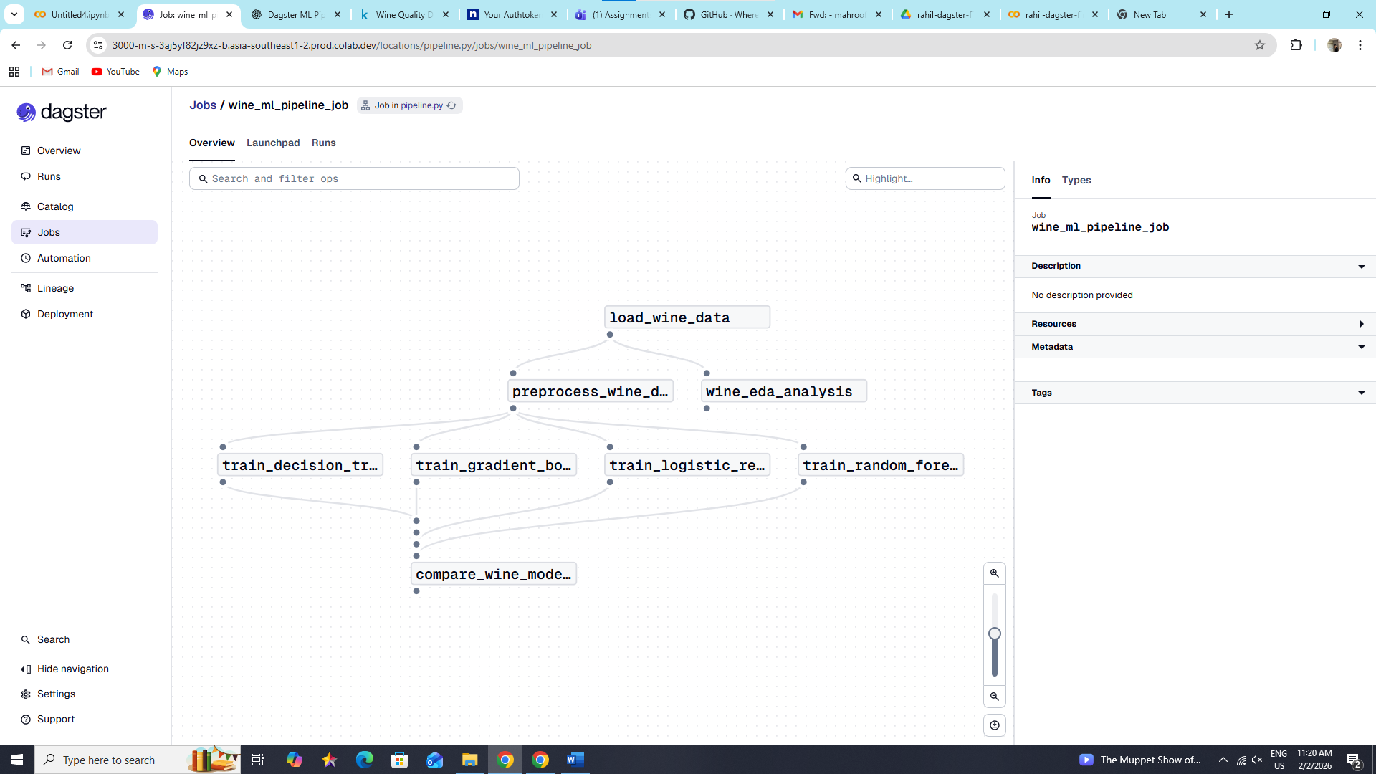

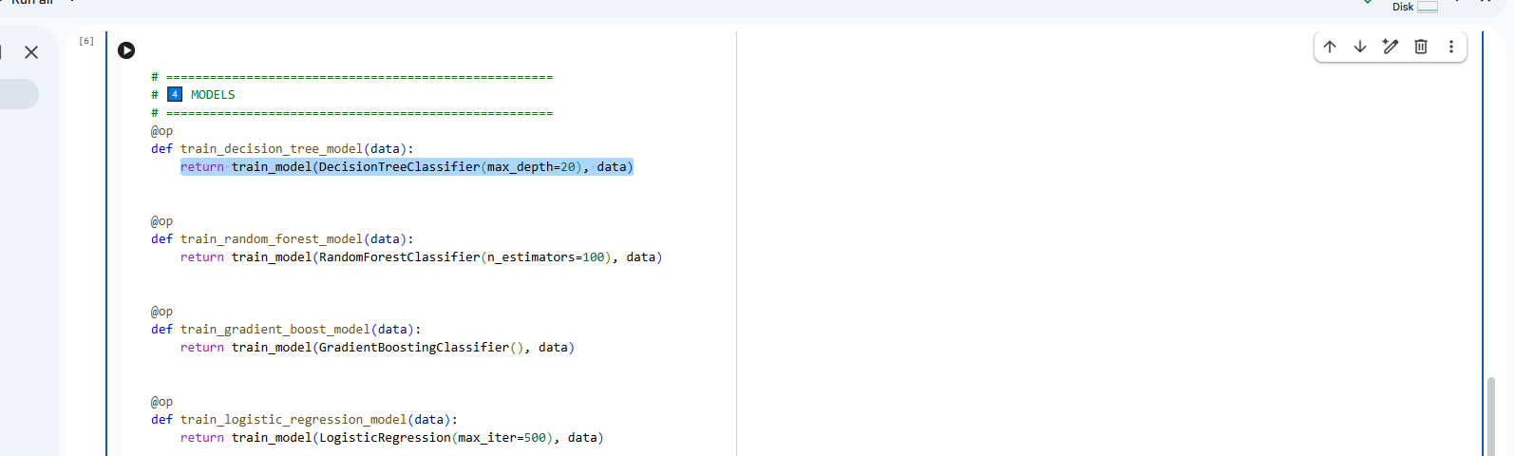

- Changing the max depth from 5 to 20.

