SQ26 — ISIC Rev.5 Classification Report
Repository 1: Zenodo · 39,405 projects
Student ID: 23692652 · FAU Erlangen-Nürnberg · SQ26 Project · July 2026
1. Primary ISIC Section Distribution
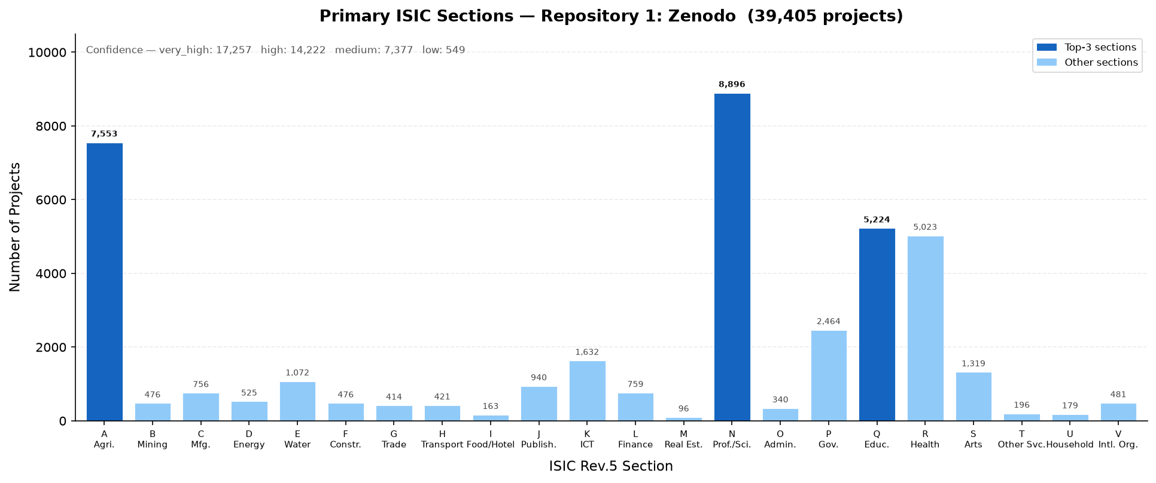

Section Distribution
Section | Name | Projects | %
N | Professional, scientific and technical activities | 8,896 | 22.6%
A | Agriculture, forestry and fishing | 7,553 | 19.2%
Q | Education | 5,224 | 13.3%
R | Human health and social work activities | 5,023 | 12.7%
P | Public administration and defence; compulsory social security | 2,464 | 6.3%
K | Telecommunications, computer programming, consultancy, computing infrastructure, and other information service activities | 1,632 | 4.1%
S | Arts, sports and recreation | 1,319 | 3.3%
E | Water supply; sewerage, waste management and remediation activities | 1,072 | 2.7%
J | Publishing, broadcasting, and content production and distribution activities | 940 | 2.4%
L | Financial and insurance activities | 759 | 1.9%
C | Manufacturing | 756 | 1.9%
D | Electricity, gas, steam and air conditioning supply | 525 | 1.3%
V | Activities of extraterritorial organizations and bodies | 481 | 1.2%
F | Construction | 476 | 1.2%
B | Mining and quarrying | 476 | 1.2%
H | Transportation and storage | 421 | 1.1%
G | Wholesale and retail trade | 414 | 1.1%
O | Administrative and support service activities | 340 | 0.9%
T | Other service activities | 196 | 0.5%
U | Activities of households as employers; undifferentiated goods- and services-producing activities of households for own use | 179 | 0.5%
I | Accommodation and food service activities | 163 | 0.4%
M | Real estate activities | 96 | 0.2%

2. Top-20 ISIC Classes (Section + Division)
Rank | Sec. | Division | Class Name | Count | %
1 | N | 72 | 72 — Scientific research and development | 6,085 | 15.4%
2 | Q | 85 | 85 — Education | 3,839 | 9.7%
3 | R | 86 | 86 — Human health activities | 3,827 | 9.7%
4 | A | 72 | 72 — Scientific research and development | 3,490 | 8.9%
5 | A | 01 | 01 — Crop and animal production, hunting and related service activities | 1,890 | 4.8%
6 | P | 84 | 84 — Public administration and defence; compulsory social security | 1,765 | 4.5%
7 | E | 36 | 36 — Water collection, treatment and supply | 944 | 2.4%
8 | A | 36 | 36 — Water collection, treatment and supply | 815 | 2.1%
9 | K | 62 | 62 — Computer programming, consultancy and related activities | 763 | 1.9%
10 | N | 74 | 74 — Other professional, scientific and technical activities | 751 | 1.9%
11 | K | 63 | 63 — Computing infrastructure, data processing, hosting, and other information s | 599 | 1.5%
12 | R | 88 | 88 — Social work activities without accommodation | 563 | 1.4%
13 | L | 64 | 64 — Financial service activities, except insurance and pension funding | 547 | 1.4%
14 | A | 93 | 93 — Sports activities and amusement and recreation activities | 535 | 1.4%
15 | S | 91 | 91 — Library, archives, museum and other cultural activities | 491 | 1.2%
16 | S | 90 | 90 — Arts creation and performing arts activities | 478 | 1.2%
17 | V | 99 | 99 — Activities of extraterritorial organizations and bodies | 471 | 1.2%
18 | A | 03 | 03 — Fishing and aquaculture | 451 | 1.1%
19 | N | 62 | 62 — Computer programming, consultancy and related activities | 445 | 1.1%
20 | D | 35 | 35 — Electricity, gas, steam and air conditioning supply | 381 | 1.0%

3. Comments on Findings
- Repository 1 (Zenodo) contains 39,405 classified projects across 22 ISIC Rev.5 sections (A, B, C, D, E, F, G, H, I, J, K, L, M, N, O, P, Q, R, S, T, U, V).
- Project types present: QD_PROJECT (27,655); OTHER_PROJECT (10,180); NOT_A_PROJECT (1,528); QDA_PROJECT (42).
- The dominant ISIC section is N — Professional, scientific and technical activities, accounting for 8,896 projects (22.6% of the repository).
- Classification confidence: 31,479 projects (79.9%) classified at high or very-high confidence by the voting ensemble.
- Section N (Professional, scientific and technical activities) dominates. This is expected for general-purpose academic repositories — many datasets describe scientific research processes. Division 72 (Scientific research and development) is typically the most frequent sub-class.
- The distribution spans 22 of 22 ISIC sections, indicating high thematic diversity. No single field monopolises the repository.

4. Top-15 ISIC Divisions (Secondary Classes)
