SQ26 — ISIC Rev.5 Classification Report
Repository 10: Harvard Dataverse · 13,650 projects
Student ID: 23692652 · FAU Erlangen-Nürnberg · SQ26 Project · July 2026
1. Primary ISIC Section Distribution
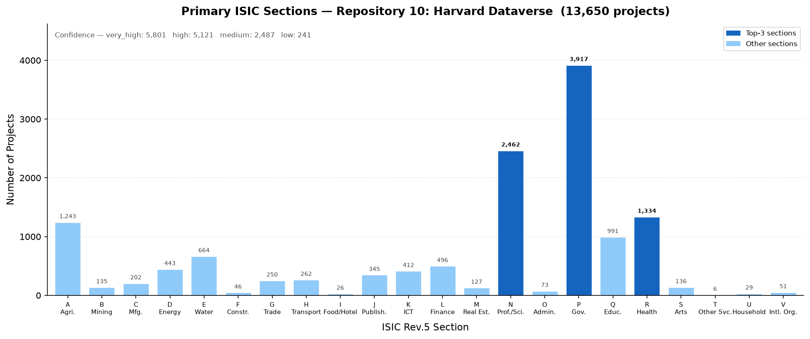

Section Distribution
Section | Name | Projects | %
P | Public administration and defence; compulsory social security | 3,917 | 28.7%
N | Professional, scientific and technical activities | 2,462 | 18.0%
R | Human health and social work activities | 1,334 | 9.8%
A | Agriculture, forestry and fishing | 1,243 | 9.1%
Q | Education | 991 | 7.3%
E | Water supply; sewerage, waste management and remediation activities | 664 | 4.9%
L | Financial and insurance activities | 496 | 3.6%
D | Electricity, gas, steam and air conditioning supply | 443 | 3.2%
K | Telecommunications, computer programming, consultancy, computing infrastructure, and other information service activities | 412 | 3.0%
J | Publishing, broadcasting, and content production and distribution activities | 345 | 2.5%
H | Transportation and storage | 262 | 1.9%
G | Wholesale and retail trade | 250 | 1.8%
C | Manufacturing | 202 | 1.5%
S | Arts, sports and recreation | 136 | 1.0%
B | Mining and quarrying | 135 | 1.0%
M | Real estate activities | 127 | 0.9%
O | Administrative and support service activities | 73 | 0.5%
V | Activities of extraterritorial organizations and bodies | 51 | 0.4%
F | Construction | 46 | 0.3%
U | Activities of households as employers; undifferentiated goods- and services-producing activities of households for own use | 29 | 0.2%
I | Accommodation and food service activities | 26 | 0.2%
T | Other service activities | 6 | 0.0%

2. Top-20 ISIC Classes (Section + Division)
Rank | Sec. | Division | Class Name | Count | %
1 | P | 84 | 84 — Public administration and defence; compulsory social security | 2,285 | 16.7%
2 | R | 86 | 86 — Human health activities | 1,029 | 7.5%
3 | N | 72 | 72 — Scientific research and development | 932 | 6.8%
4 | A | 01 | 01 — Crop and animal production, hunting and related service activities | 542 | 4.0%
5 | E | 36 | 36 — Water collection, treatment and supply | 456 | 3.3%
6 | P | 99 | 99 — Activities of extraterritorial organizations and bodies | 445 | 3.3%
7 | Q | 85 | 85 — Education | 430 | 3.2%
8 | A | 36 | 36 — Water collection, treatment and supply | 294 | 2.2%
9 | D | 35 | 35 — Electricity, gas, steam and air conditioning supply | 286 | 2.1%
10 | P | 88 | 88 — Social work activities without accommodation | 271 | 2.0%
11 | L | 64 | 64 — Financial service activities, except insurance and pension funding | 270 | 2.0%
12 | N | 35 | 35 — Electricity, gas, steam and air conditioning supply | 246 | 1.8%
13 | P | 68 | 68 — Real estate activities | 178 | 1.3%
14 | N | 74 | 74 — Other professional, scientific and technical activities | 168 | 1.2%
15 | Q | 88 | 88 — Social work activities without accommodation | 164 | 1.2%
16 | J | 60 | 60 — Programming, broadcasting, news agency and other content distribution activ | 158 | 1.2%
17 | A | 03 | 03 — Fishing and aquaculture | 150 | 1.1%
18 | N | 86 | 86 — Human health activities | 147 | 1.1%
19 | N | 62 | 62 — Computer programming, consultancy and related activities | 146 | 1.1%
20 | Q | 86 | 86 — Human health activities | 134 | 1.0%

3. Comments on Findings
- Repository 10 (Harvard Dataverse) contains 13,650 classified projects across 22 ISIC Rev.5 sections (A, B, C, D, E, F, G, H, I, J, K, L, M, N, O, P, Q, R, S, T, U, V).
- Project types present: QD_PROJECT (7,634); OTHER_PROJECT (5,735); NOT_A_PROJECT (256); QDA_PROJECT (25).
- The dominant ISIC section is P — Public administration and defence, accounting for 3,917 projects (28.7% of the repository).
- Classification confidence: 10,922 projects (80.0%) classified at high or very-high confidence by the voting ensemble.
- Section P (Public administration and defence) dominates, reflecting a large share of political-science, governance, and survey datasets typical of social science repositories.
- The distribution spans 22 of 22 ISIC sections, indicating high thematic diversity. No single field monopolises the repository.

4. Top-15 ISIC Divisions (Secondary Classes)
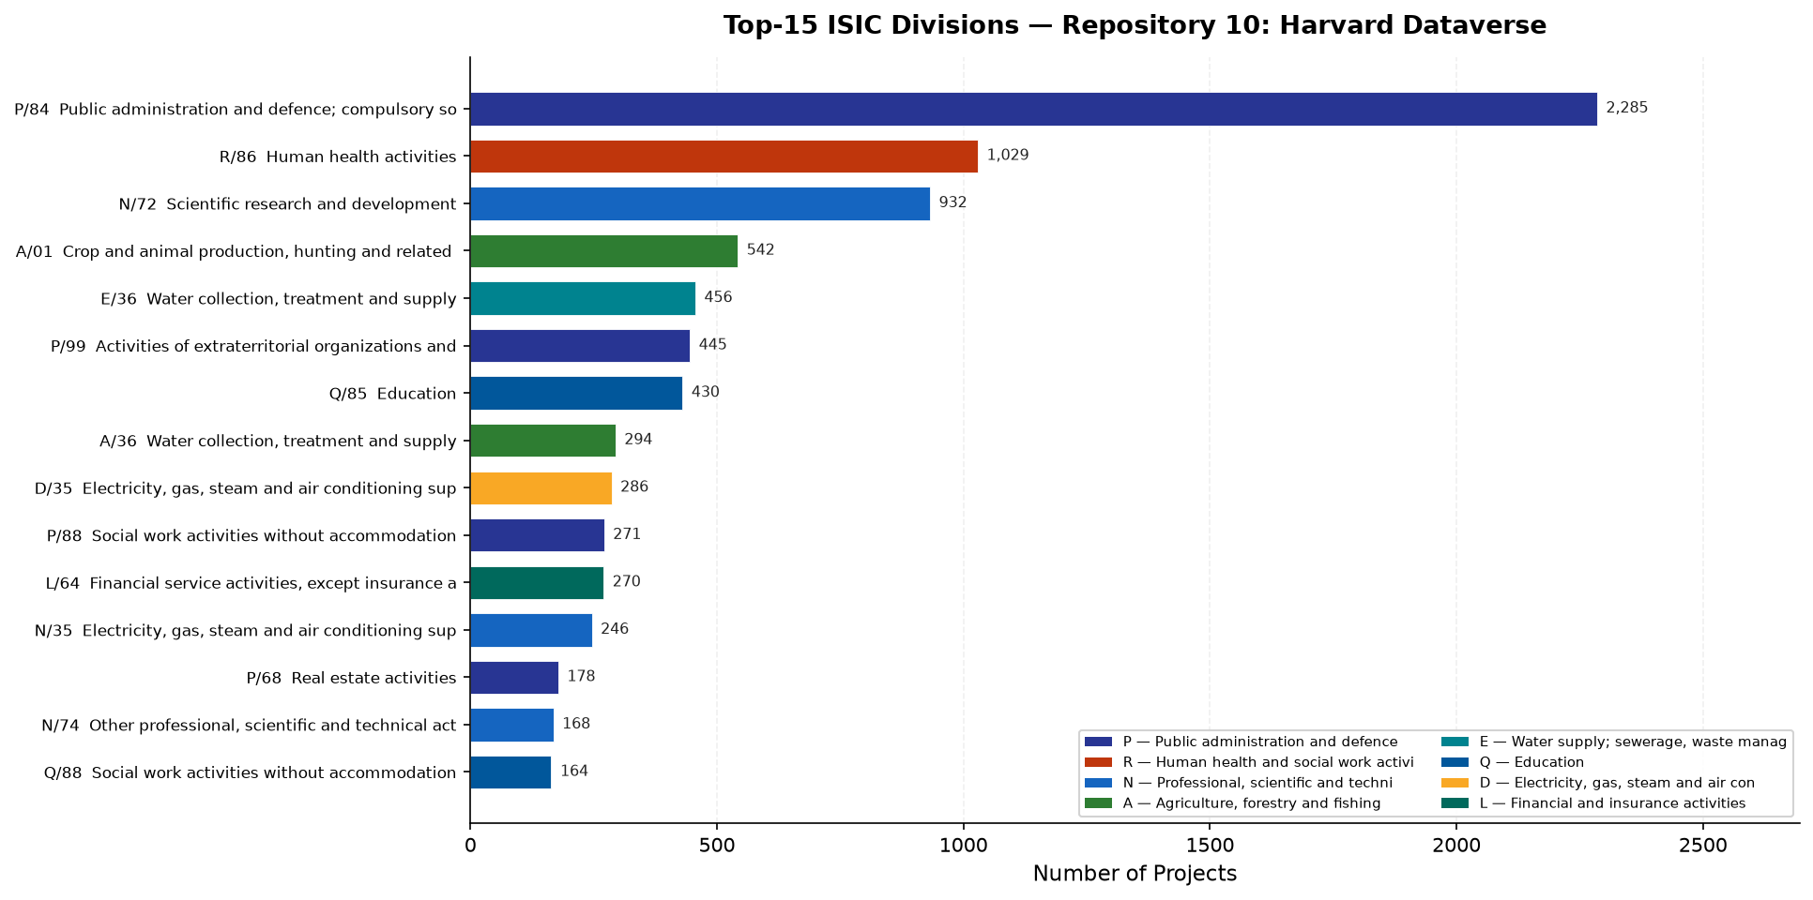
5. File-Level ISIC Classification
Individual files within QDA_PROJECT and QD_PROJECT were classified using the fine-tuned bert-base-uncased model (bert_base_isic_v1). Text was constructed from the parent project title, description, keywords, file name, and the stored file text snippet. Repository 10 contributed 2,787 classified files.
Confidence distribution:
Confidence | Files | %
very_high | 1,886 | 67.7%
high | 452 | 16.2%
medium | 358 | 12.8%
low | 91 | 3.3%

Top ISIC sections across classified files:
Sec | Name | Files | %
A | Agriculture, forestry and fishing | 527 | 18.9%
P | Public administration and defence; compulsory social | 512 | 18.4%
E | Water supply; sewerage, waste management and remedia | 426 | 15.3%
R | Human health and social work activities | 257 | 9.2%
N | Professional, scientific and technical activities | 226 | 8.1%
Q | Education | 205 | 7.4%
H | Transportation and storage | 169 | 6.1%
D | Electricity, gas, steam and air conditioning supply | 133 | 4.8%
B | Mining and quarrying | 80 | 2.9%
K | Telecommunications, computer programming, consultanc | 49 | 1.8%

