SQ26 — ISIC Rev.5 Classification Report
Repository 19: Columbia University Libraries · 25 projects
Student ID: 23692652 · FAU Erlangen-Nürnberg · SQ26 Project · July 2026
1. Primary ISIC Section Distribution
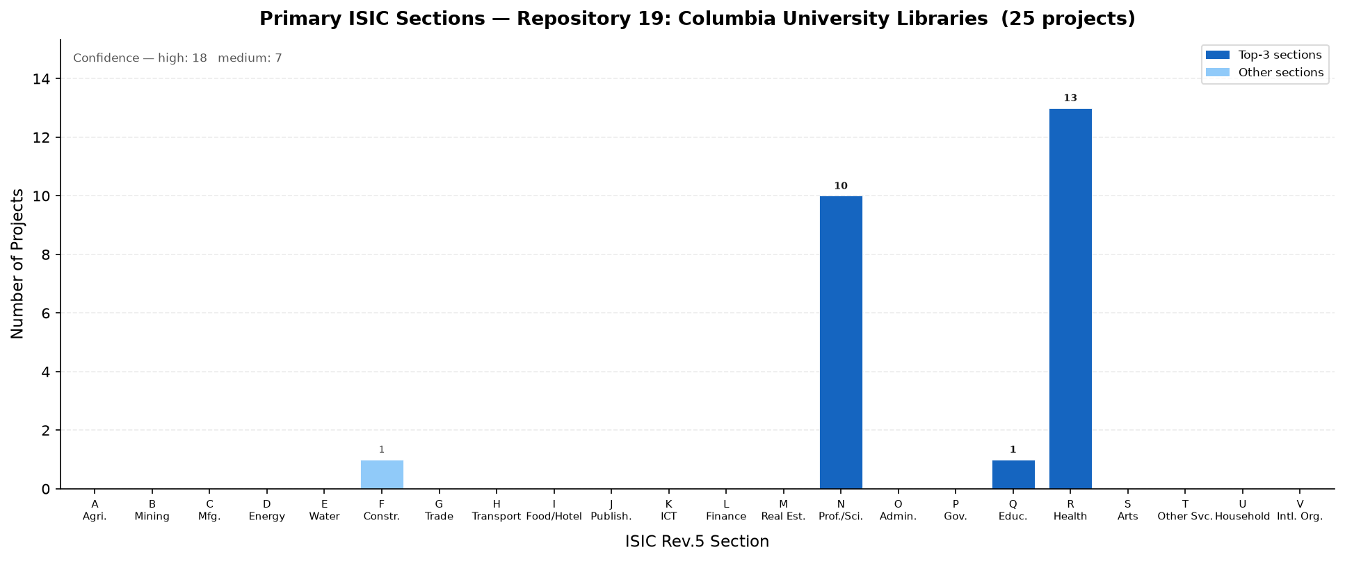

Section Distribution
Section | Name | Projects | %
R | Human health and social work activities | 13 | 52.0%
N | Professional, scientific and technical activities | 10 | 40.0%
Q | Education | 1 | 4.0%
F | Construction | 1 | 4.0%

2. Top-20 ISIC Classes (Section + Division)
Rank | Sec. | Division | Class Name | Count | %
1 | R | 86 | 86 — Human health activities | 11 | 44.0%
2 | N | 74 | 74 — Other professional, scientific and technical activities | 7 | 28.0%
3 | N | 73 | 73 — Activities of advertising, market research and public opinion polling | 3 | 12.0%
4 | R | 42 | 42 — Civil engineering | 2 | 8.0%
5 | F | 41 | 41 — Construction of residential and non-residential buildings | 1 | 4.0%
6 | Q | 85 | 85 — Education | 1 | 4.0%

3. Comments on Findings
- Repository 19 (Columbia University Libraries) contains 25 classified projects across 4 ISIC Rev.5 sections (F, N, Q, R).
- Project types present: NOT_A_PROJECT (25).
- The dominant ISIC section is R — Human health and social work activities, accounting for 13 projects (52.0% of the repository).
- Classification confidence: 18 projects (72.0%) classified at high or very-high confidence by the voting ensemble.
- Section R (Human health and social work activities) is the dominant class, reflecting the repository's focus on medical, clinical, and social datasets.
- With only 4 sections represented, the repository has a narrow thematic focus. Future curation may benefit from broadening the scope.

4. Top-15 ISIC Divisions (Secondary Classes)
