**CRIME REPORTING & INVESTIGATION SYSTEM**

**Design Document**

**Version 1.0**



**Student Id: bc170404767**

**Supervisor Name: Fizzah (**fizzah@vu.edu.pk)

**Revision History**

|  |  |  |  |
| --- | --- | --- | --- |
| **Date (dd/mm/yyyy)** | **Version** | **Description** | **Author** |
| Sun 7 Aug, 2022 | 1.0 | **Introduction of the project**  In this document, we will create; entity relationship diagram, sequence diagrams, architecture design diagram, class diagram, database design, interface design diagram and test cases. | BC170404767 |
|  |  |  |  |
|  |  |  |  |
|  |  |  |  |

**Table of Contents**

1. Introduction of Design Document
2. Entity Relationship Diagram (ERD)
3. Sequence Diagrams
4. Architecture Design Diagram
5. Class Diagram
6. Database Design
7. Interface Design
8. Test Cases

**DESIGN DOCUMENT**

1. **Introduction of Design Document:**

Software Design Document (SDD) is important phase without which the development of software application is not just hard but more time consuming. It surely needs more effort. Therefore, we are working on SDD before the development of our project “Crime Reporting & Investigation System”. What we include in SDD is Entity Relationship Diagram (ERD), Sequence Diagram, Architecture Design Diagram, Class Diagram, Database Design, Interface Design and Test Cases. All these diagrams have important purposes and indicates depth knowledge. In other words, The Software Design Document (SDD) includes a detailed plan for developing piece of software. Apart from this, it includes numerous benefits like programmers other than developers can understand all aspects of the system, assists in user training as well as improves overall software quality. SDD helps grasp the working of a whole system and it forces you to think about the entire system architecture. Also, it helps to face the challenges and roadblocks that might come during the actual development and hence fills the gap. SDD is a kind of goal-oriented or understanding-oriented discussion which is needed for the easy implementation of software. The major purpose of the SDD is to transform the user requirements into a suitable form which assist the programmers or developers in software coding. That is why, it is extremely important to work on this phase before the development of software code.

1. **Entity Relationship Diagram (ERD):**

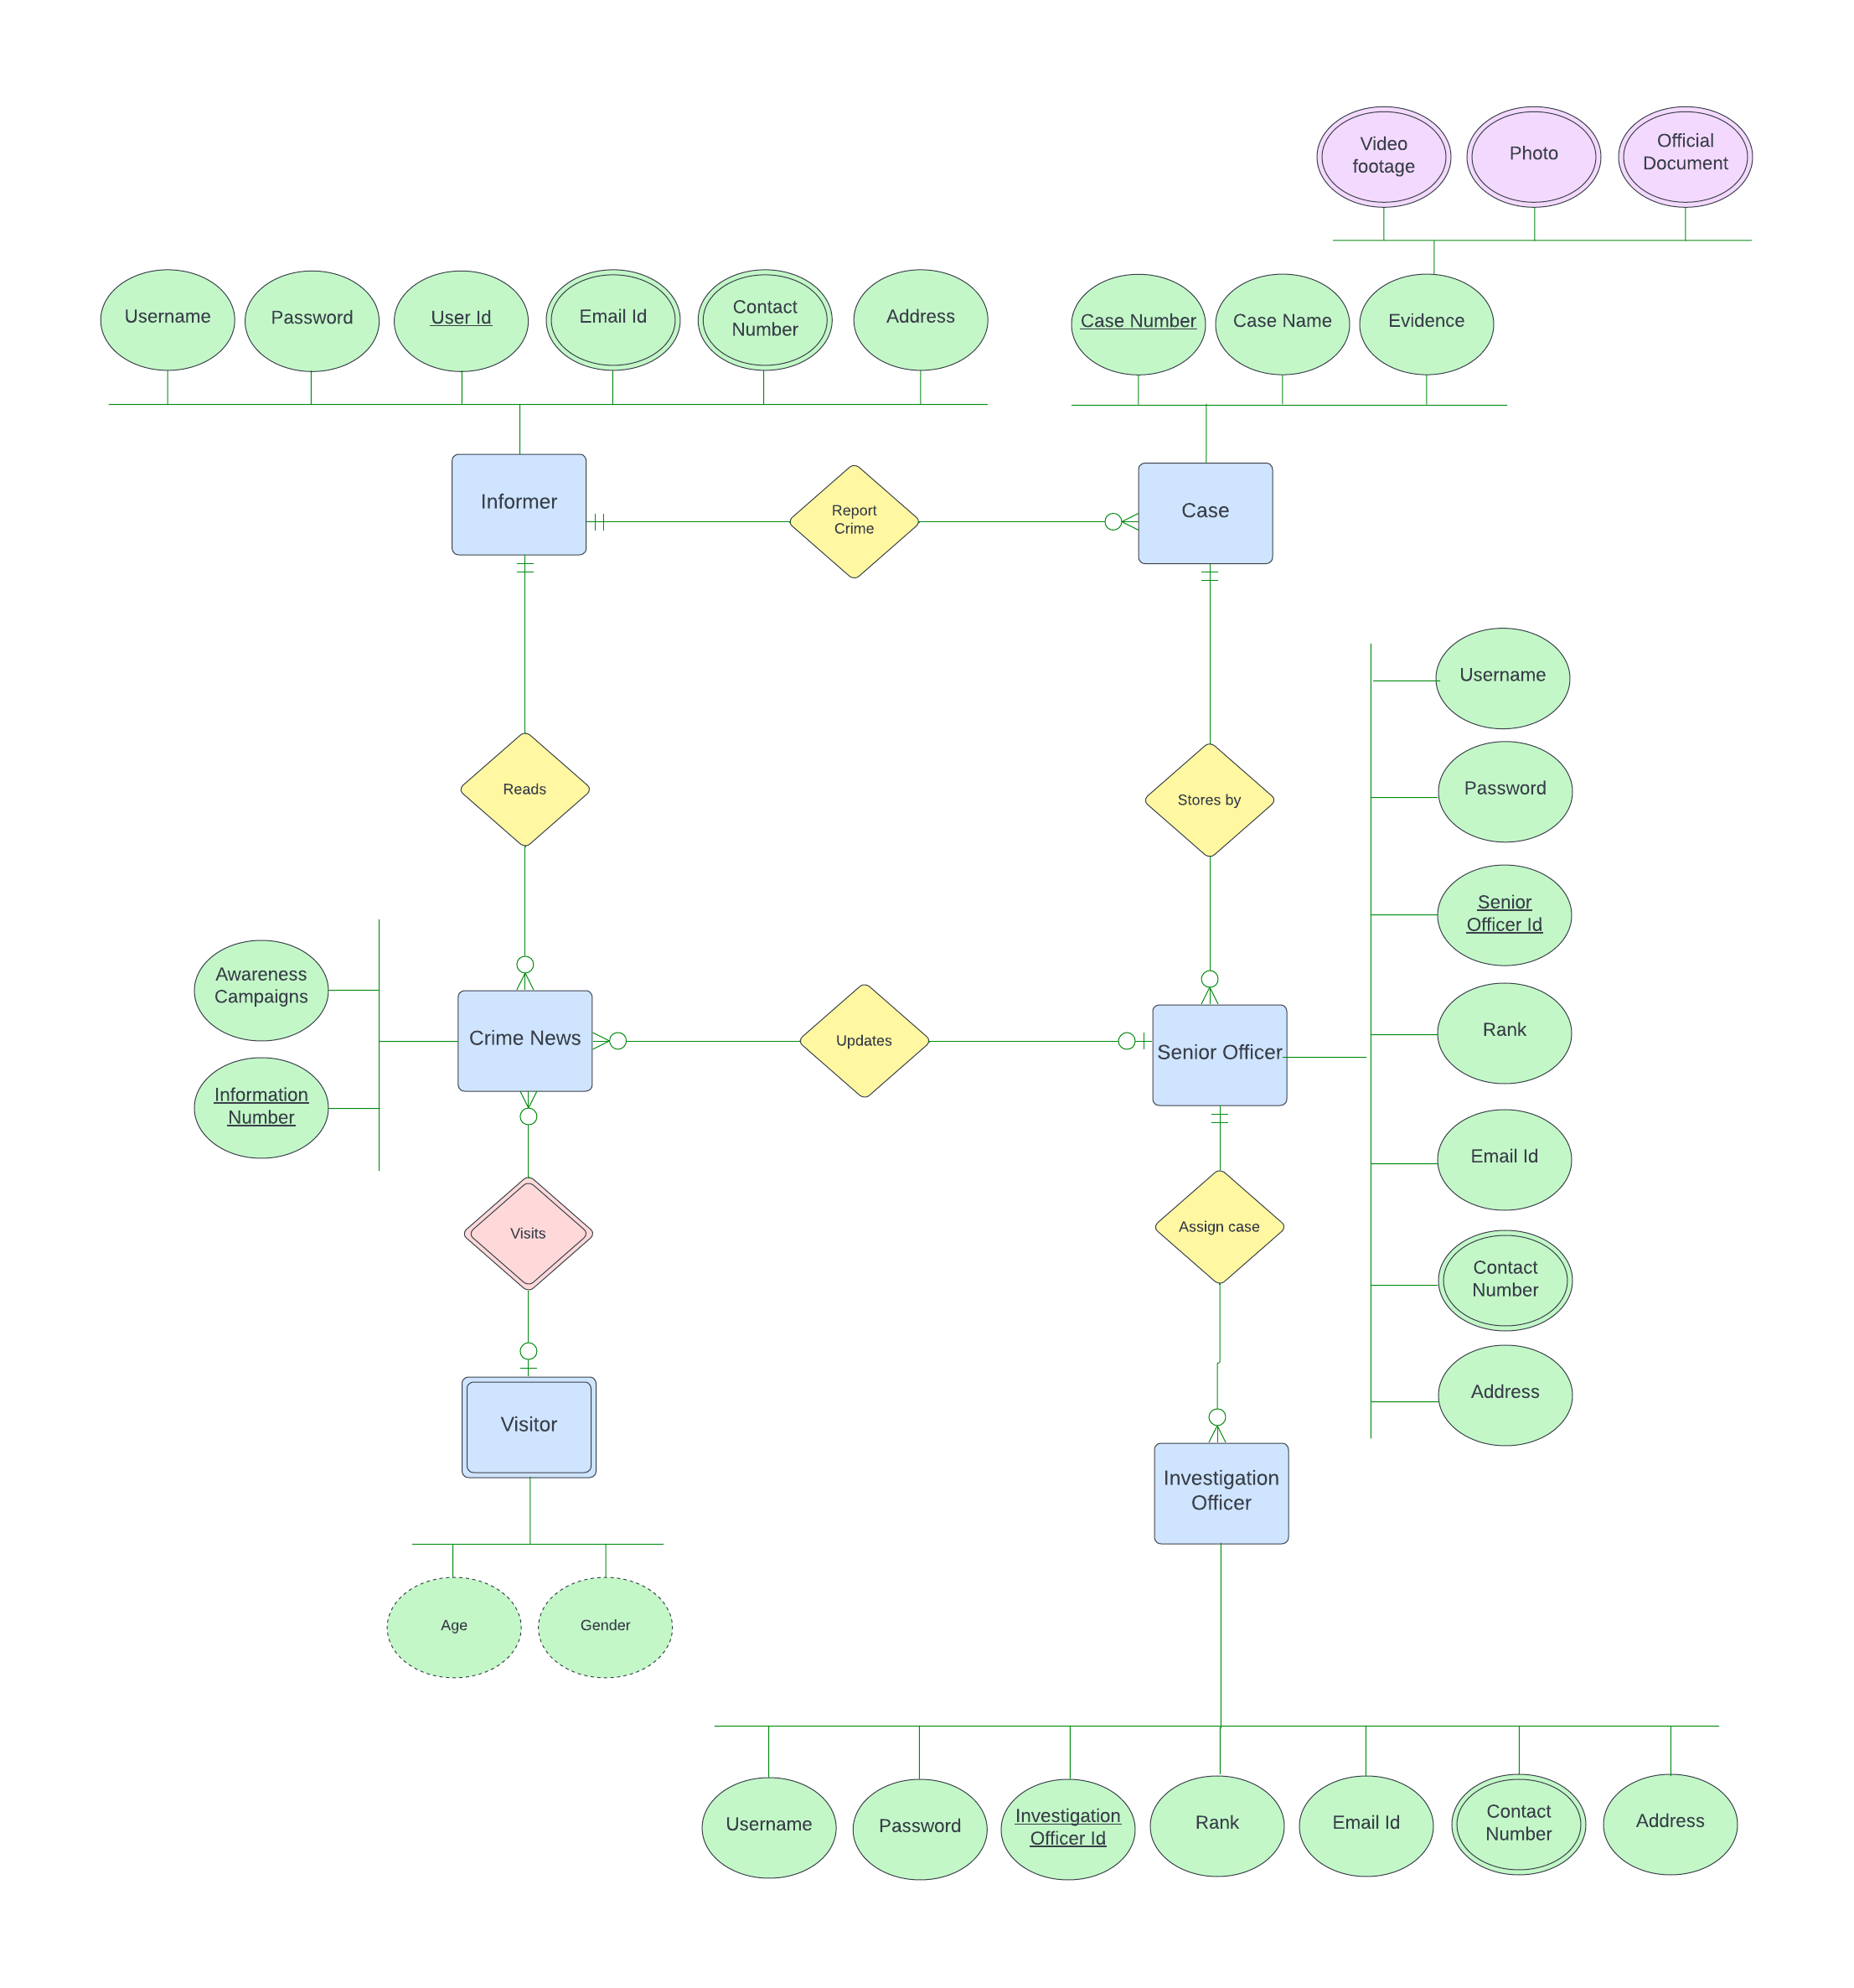

1. **Sequence Diagrams:**

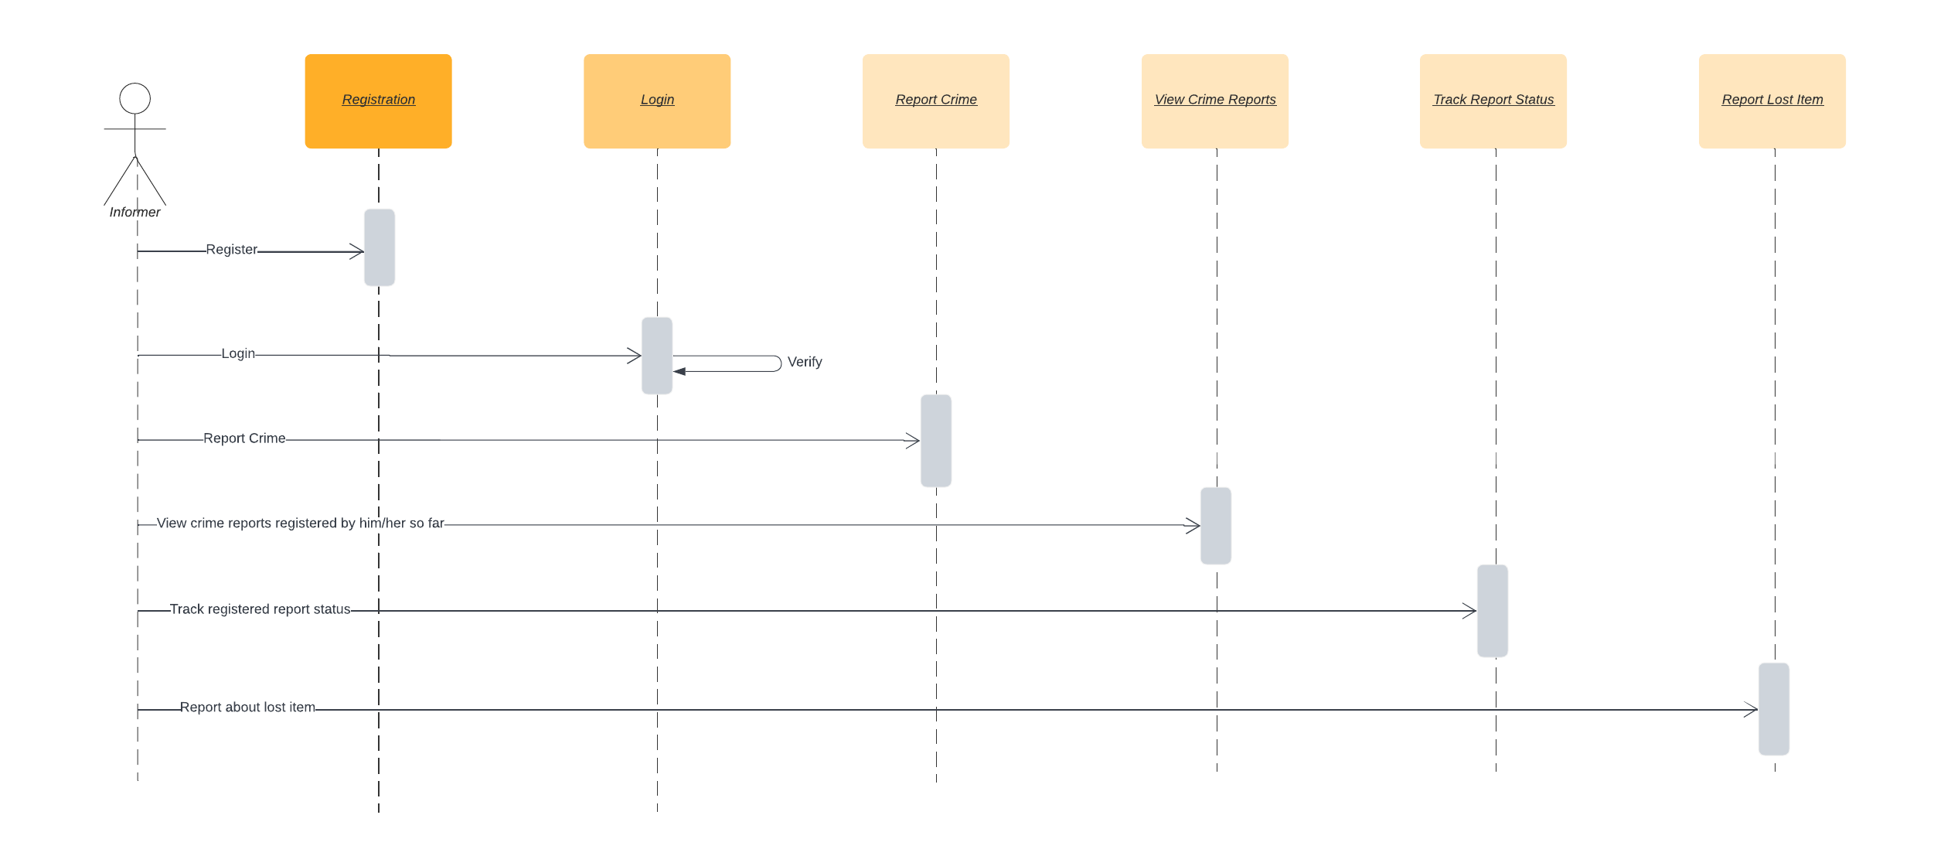

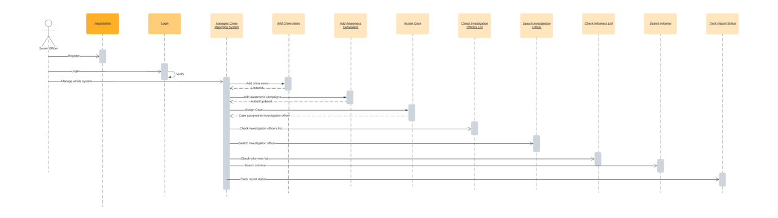

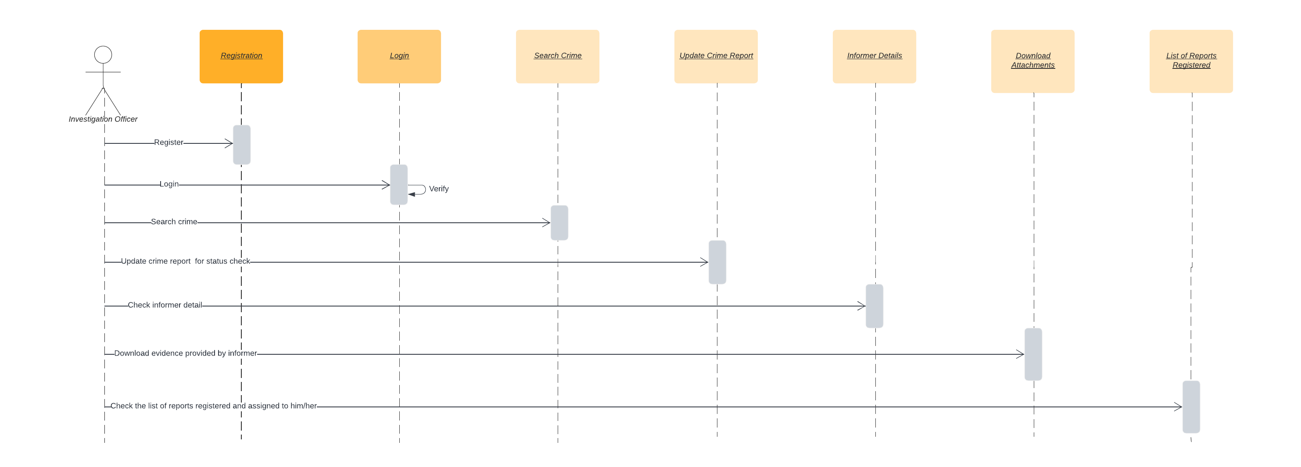

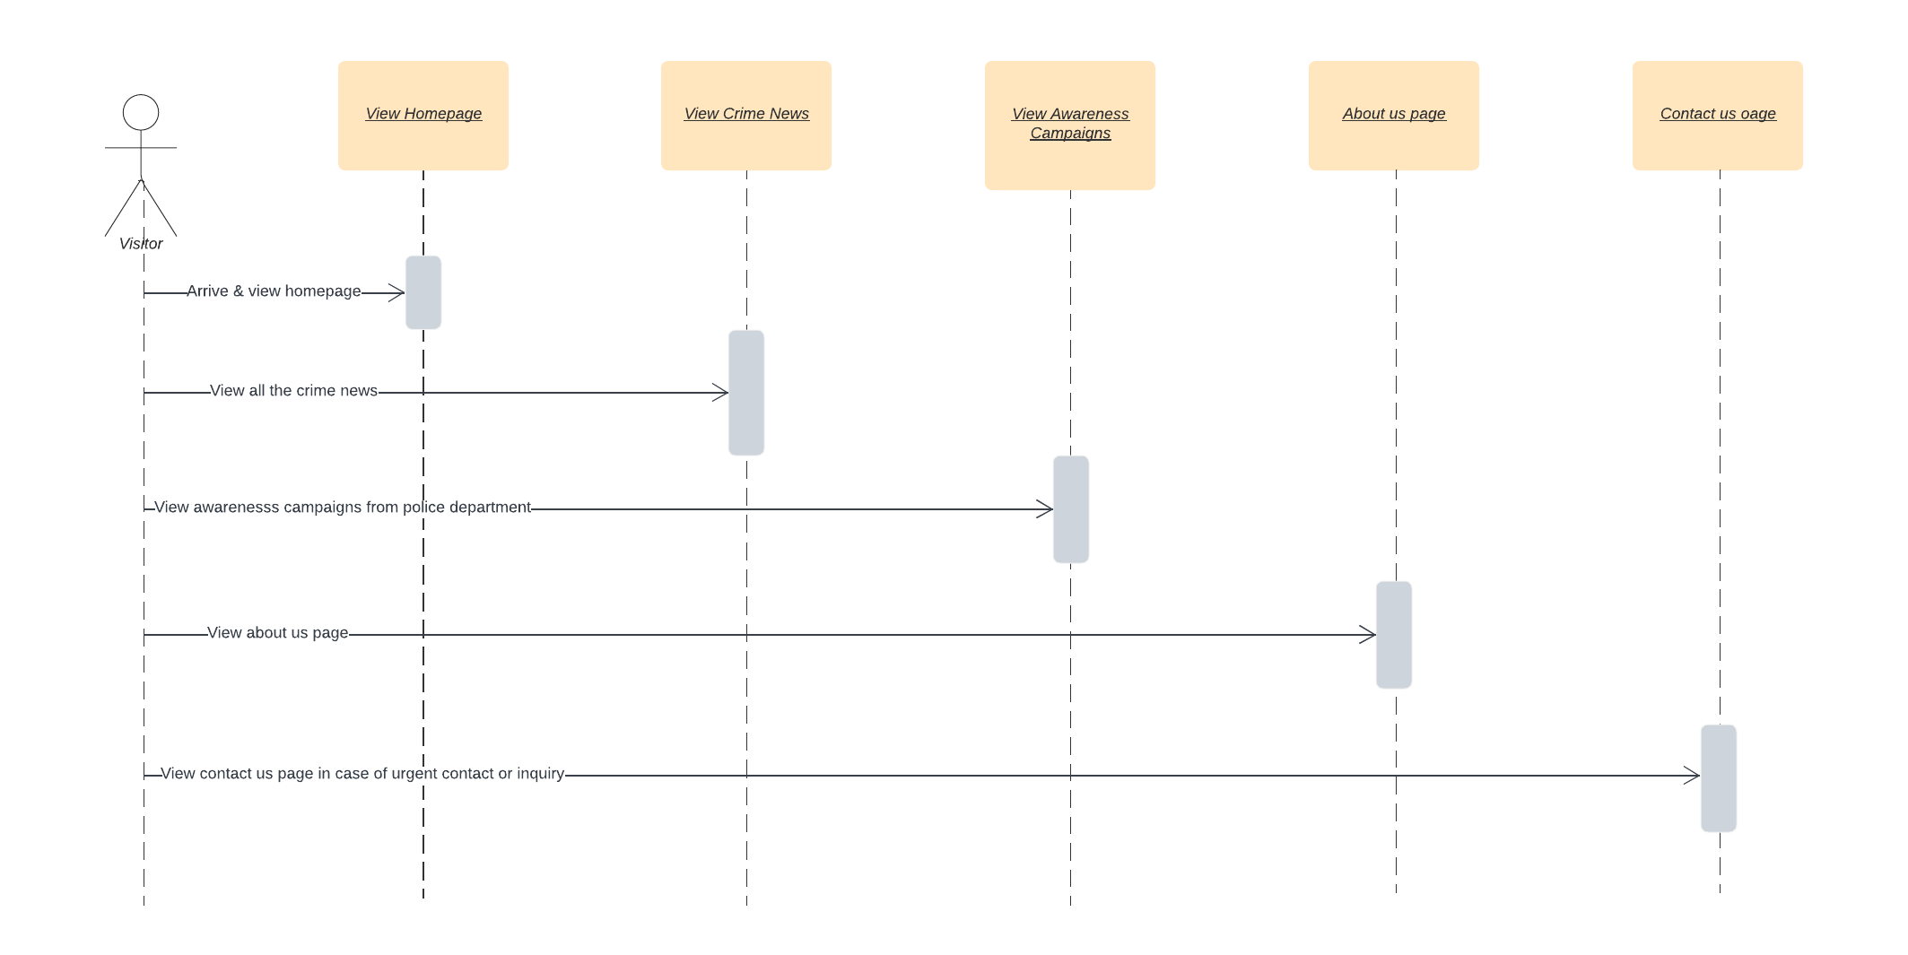

1. **Architecture Design Diagram:**

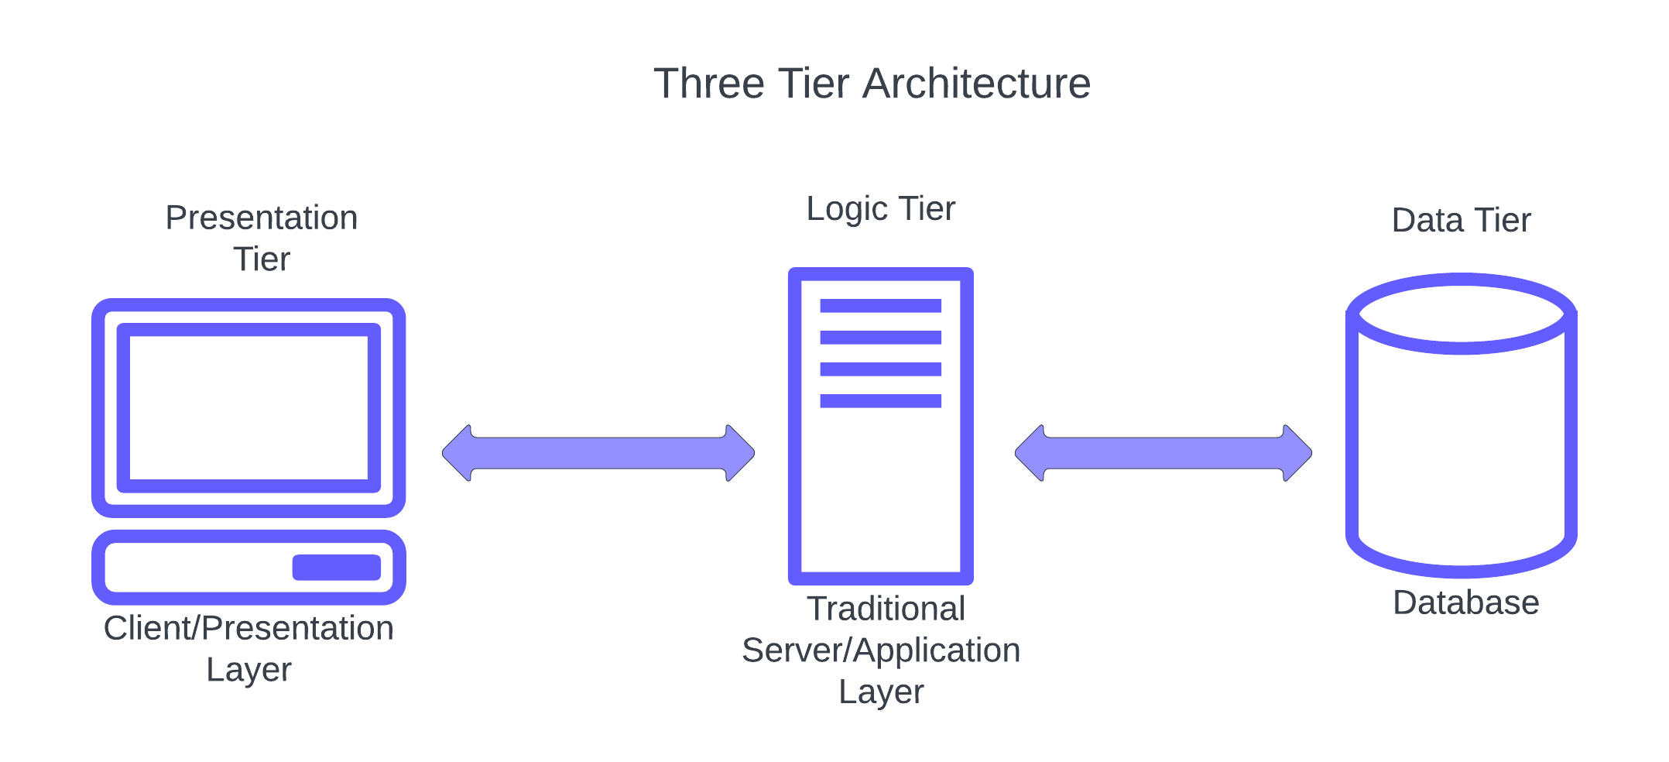

1. **Class Diagram:**

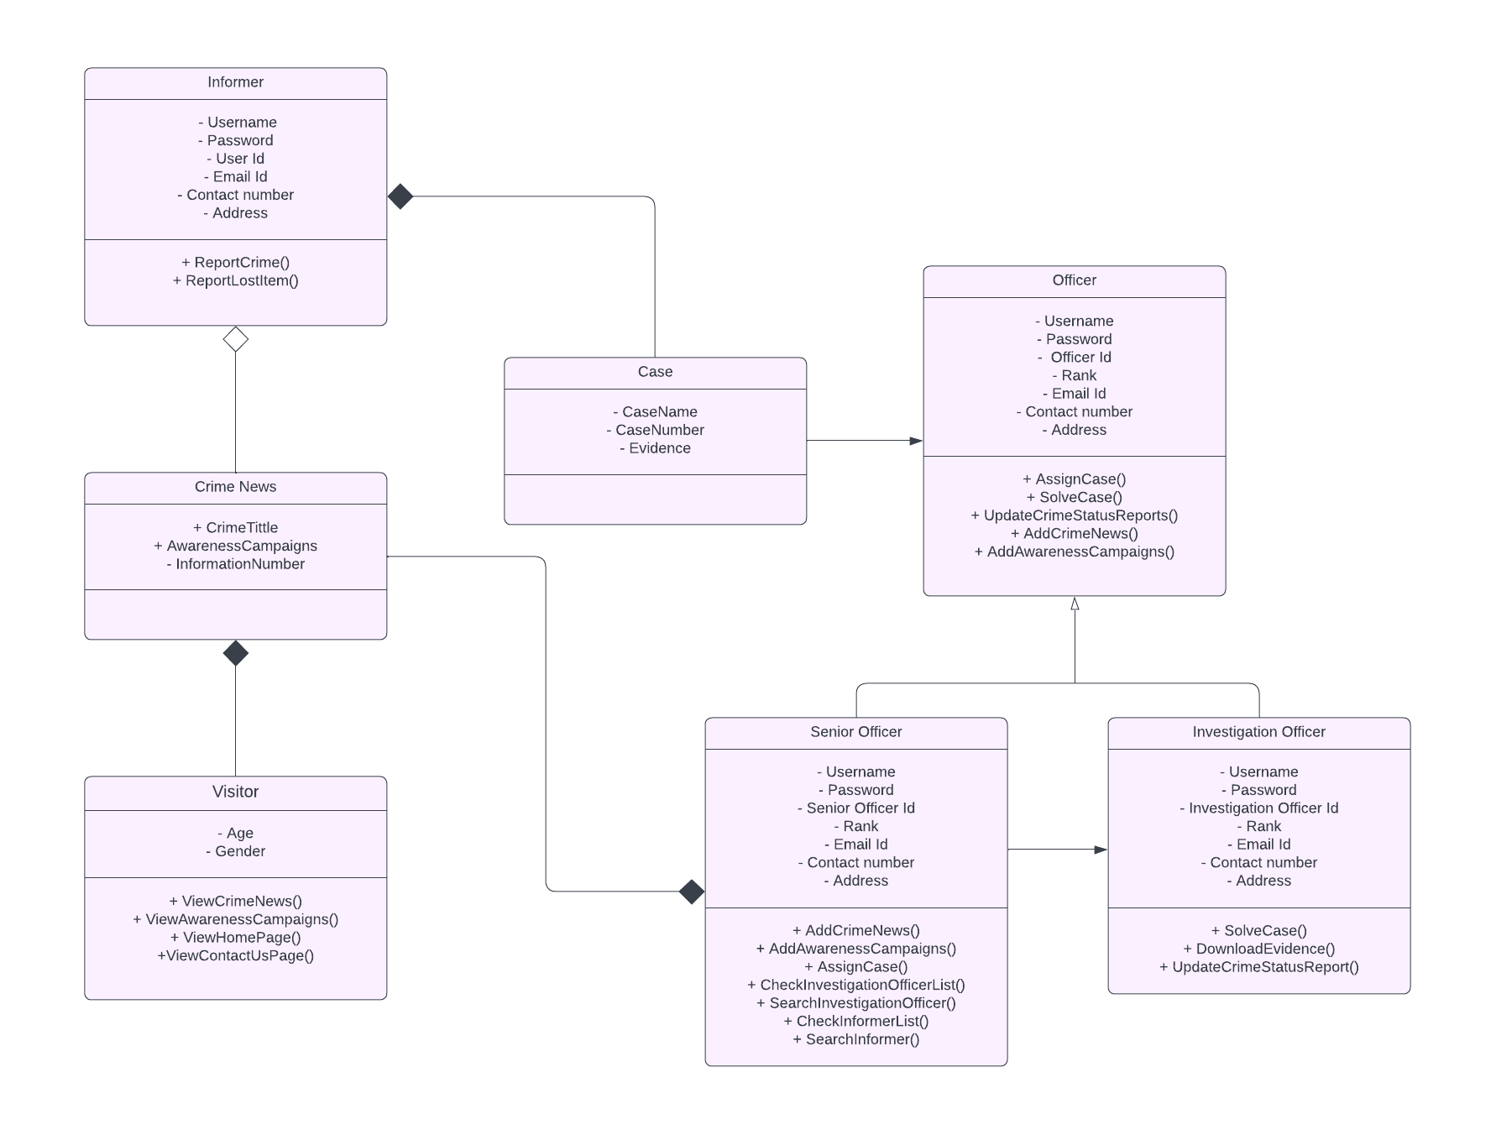

1. **Database Design:**

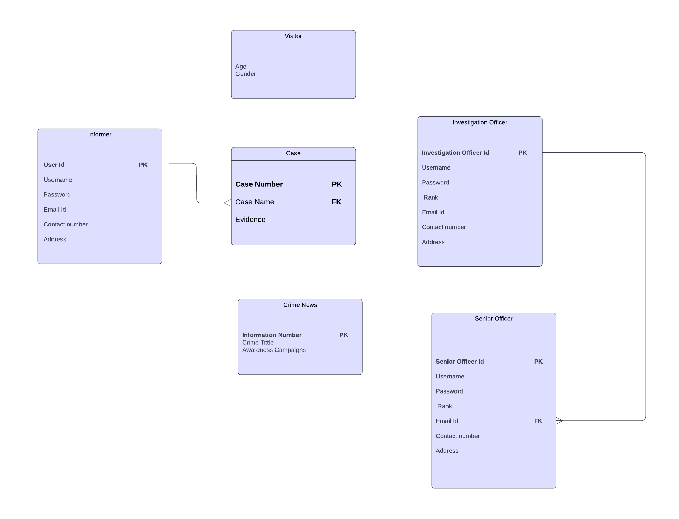

1. **Interface Design:**

This is Homepage:

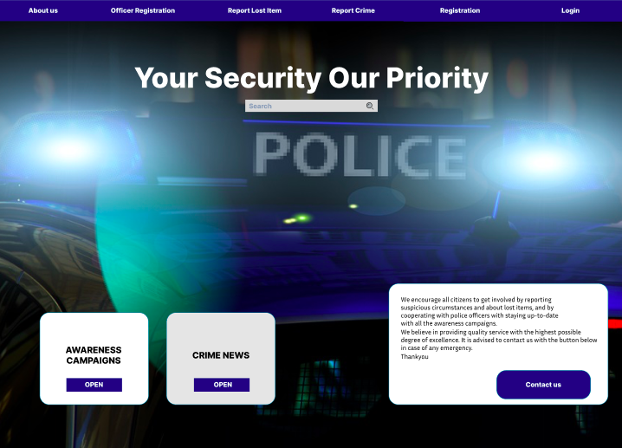

This is Login page:

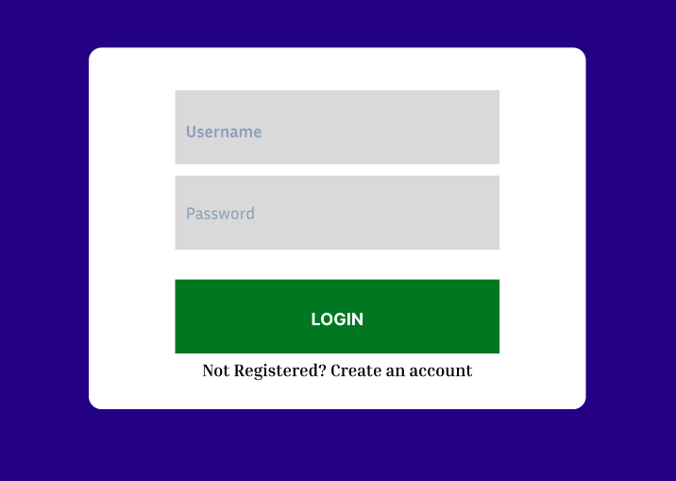

This is Crime News page:

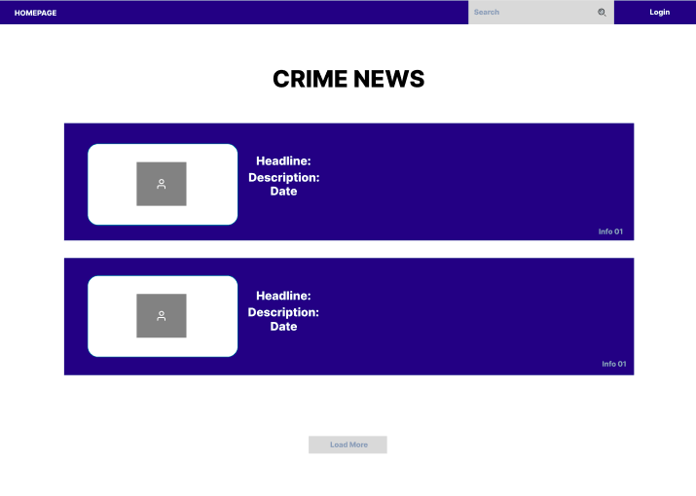

This is Senior Officer page:

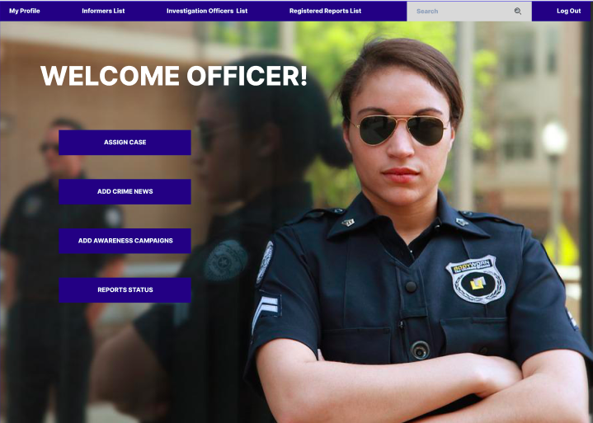

1. **Test Cases:**

**Test Case Title: Registration**

|  |  |
| --- | --- |
| **Preconditions** | 1. Must be click on registration button. 2. Internet connection is strong. |
| **Test case steps** | 1. User click on registration button. 2. Then fill the form correctly. 3. Click on submit button. 4. System verify data. 5. User has registered. |
| **Expected Result** | 1. User successfully registered in system if data is correct. 2. User has not registered if data is invalid or any field is missing. |
| **Test Result** | Successful |
| **Result by** | bc170404767 |

**Test Case Title: Login**

|  |  |
| --- | --- |
| **Precondition** | User must have already registered and then click on login button. |
| **Test case steps** | 1. User click on login button 2. Then enter username and password. 3. Then press login button 4. System verify data 5. Finally, user has login in his/her account. |
| **Expected Result** | 1. If username and password is invalid then user cannot login in the system 2. If user data is valid then user enters in the account. |
| **Test Result** | Successful |
| **Result by** | bc170404767 |

**Test Case Title: Report Crime**

|  |  |
| --- | --- |
| **Precondition** | User must be login in his/her account. |
| **Test case steps** | 1. User login in the system. 2. Then press “Report Crime” button. 3. User write down about crime. 4. Click on submit button. |
| **Expected Result** | 1. If user tries to submit without writing anything, submit button won’t work. 2. If user properly mentions and reports crime, crime report will be submitted. |
| **Test Result** | Successful. |
| **Result by** | bc170404767 |

**Test Case Title: Report Lost Item**

|  |  |
| --- | --- |
| **Precondition** | User must be login in his/her account. |
| **Test case steps** | 1. User login in the system. 2. Then press “Report Lost Item” button. 3. User write down about the lost item. 4. Click on submit button. |
| **Expected Result** | 1. If user tries to submit without writing anything, submit button won’t work. 2. If user properly mentions about lost item, report will be submitted. |
| **Test Result** | Successful. |
| **Result by** | bc170404767 |

**Test Case Title: View Crime Reports**

|  |  |
| --- | --- |
| **Precondition** | User must have view option. |
| **Test case steps** | 1. User must login. 2. User press “View Registered Reports” button. |
| **Expected Result** | 1. If user clicks on “View Registered Reports” button, system shows list of registered reports which this user registered till that date. 2. If user has not reported anything, then “View Registered Reports” page will be empty. |
| **Test Result** | Successful |
| **Result by** | bc170404767 |

**Test Case Title: Track Report Status**

|  |  |
| --- | --- |
| **Precondition** | User must have already reported any crime or about lost item. |
| **Test case steps** | 1. User login into the system. 2. User press “View Registered Reports” buttons. 3. Scroll down the report and press “Current Report Status” button. |
| **Expected Result** | Current status will be shown. |
| **Test Result** | Successful. |
| **Result by** | bc170404767 |

**Test Case Title: Manages Crime Reporting System**

|  |  |
| --- | --- |
| **Preconditions** | 1. User must be registered. 2. User must be login in the system. 3. User must be login as senior officer. |
| **Test case steps** | 1. User login if already registered. 2. User can manage system once entered in his/her account. |
| **Expected Result** | User will be managing the whole crime reporting & investigation system. |
| **Test Result** | Successful. |
| **Result by** | bc170404767 |

**Test Case Title: Add Crime News**

|  |  |
| --- | --- |
| **Precondition** | User has registered and login already. |
| **Test case steps** | 1. User login in the system. 2. User Press button “ADD CRIME NEWS”. 3. Mention Tittle, date and write down latest crime news. 4. Press “DONE” to share on Crime News page. |
| **Expected Result** | 1. DONE cannot be pressed until something is written. 2. It works when user write down news paragraphs. |
| **Test Result** | Successful. |
| **Result by** | bc170404767 |

**Test Case Title: Add Awareness Campaigns**

|  |  |
| --- | --- |
| **Precondition** | User has registered and login already. |
| **Test case steps** | 1. User login in the system. 2. User Press button “ADD AWARENESS CAMPAIGNS”. 3. Mention Tittle, date and write down awareness campaigns. 4. Press “DONE” to share on awareness campaigns page. |
| **Expected Result** | 1. DONE cannot be pressed until something is written. 2. It works when user write down news paragraphs. |
| **Test Result** | Successful. |
| **Result by** | bc170404767 |

**Test Case Title: Assign Case**

|  |  |
| --- | --- |
| **Preconditions** | 1. Already login in the system. 2. Must be friendly with user-interface to avoid mistake. |
| **Test case steps** | 1. User login into the system after registration. 2. Click on “ASSIGN CASE” button. 3. Then user fill the fields which are “Investigation Officer Name", “Investigation Officer Id” and “Case Number”. 4. Press DONE. |
| **Expected Result** | 1. If fields are filled with correct data, button “DONE” will be working 2. If any field is not filled, button “DONE” won’t work. 3. If fields are filled with valid data, case will be assigned to specific ‘Investigation Officer’. |
| **Test Result** | Successful. |
| **Result by** | bc170404767 |

**Test Case Title: Check Investigation Officers List**

|  |  |
| --- | --- |
| **Precondition** | User must be login. |
| **Test case steps** | 1. Open an application. 2. Login into the system. 3. Press button “Investigation Officers List”. |
| **Expected Result** | 1. User will see list of investigation officers which are already registered in system. 2. In case, no investigation officer is registered, then it will be empty page. |
| **Test Result** | Successful. |
| **Result by** | bc170404767 |

**Test Case Title: Search Investigation Officer**

|  |  |
| --- | --- |
| **Precondition** | User must be login in the system and app should be in working condition. |
| **Test case steps** | 1. Open an app and login. 2. Then user press button on “Search”. 3. Write down investigation Id or name to find that particular investigation officer. |
| **Expected Result** | User will be shown desired results if investigation officer list is not empty and searched name or Id is valid. |
| **Test Result** | Successful. |
| **Result by** | bc170404767 |

**Test Case Title: Check Informers List**

|  |  |
| --- | --- |
| **Precondition** | User must be login. |
| **Test case steps** | 1. Open an application. 2. Login into the system. 3. Press button “Informers List”. |
| **Expected Result** | 1. User will see list of informers which are already registered in system. 2. In case, no informer is registered, then it will be an empty page. |
| **Test Result** | Successful. |
| **Result by** | bc170404767 |

**Test Case Title: Search Informer**

|  |  |
| --- | --- |
| **Precondition** | User must be login in the senior officer account. |
| **Test case steps** | 1. Open an app and login. 2. Then user press button on “Search”. 3. Write down informer’s user Id or name to find that particular informer. |
| **Expected Result** | User will be shown results if informer list is not empty and searched name or Id is valid. |
| **Test Result** | Successful. |
| **Result by** | bc170404767 |

**Test Case Title: List of Reports Registered**

|  |  |
| --- | --- |
| **Precondition** | User must have login |
| **Test case steps** | * Login in the system. * User needs to press button “Registered Reports List”. |
| **Expected Result** | If no report has registered yet then it will be empty page else show list page. |
| **Test Result** | Successful. |
| **Result by** | bc170404767 |

**Test Case Title: Informer Details**

|  |  |
| --- | --- |
| **Precondition** | User must login in the system |
| **Test case steps** | 1. User must login. 2. User press button “Registered Reports List”. 3. Open required report. 4. Scroll down, at the end of report there will be informer detail. |
| **Expected Result** | 1. In case of no report registered in the system, User has no way to find informer detail as there will be no informer existence for investigation officer. 2. User can easily find required informer detail for solving case in reports list when there will be registered reports. |
| **Test Result** | Successful. |
| **Result by** | bc170404767 |

**Test Case Title: Download Attachments**

|  |  |
| --- | --- |
| **Precondition** | User must login in the system |
| **Test case steps** | 1. User must login. 2. User press button “Registered Reports List”. 3. Open required report. 4. Press button “Download Attachments”. |
| **Expected Result** | If informer provides evidence, then user can download them else Download attachment button will not work as there will be nothing to download. |
| **Test Result** | Successful. |
| **Result by** | bc170404767 |

**Test Case Title: Search Crime**

|  |  |
| --- | --- |
| **Precondition** | This feature must be added in the system. |
| **Test case steps** | 1. User should be Logged in the system. 2. Press button “Search” to search any crime by name. |
| **Expected Result** | System shows crime reports with those crimes names if user writes crime name in it like kidnapping. |
| **Test Result** | Successful. |
| **Result by** | bc170404767 |

**Test Case Title: Update Report Status**

|  |  |
| --- | --- |
| **Precondition** | Must be login as investigation officer. |
| **Test case steps** | 1. Login in application. 2. Click on “Registered Reports List”. 3. Open the required report. 4. Inside report, there’s a button “Update Report Status” which user must press to update. |
| **Expected Result** | If there is no registered report, then there is no way as well as no need to update report. |
| **Test Result** | Successful. |
| **Result by** | bc170404767 |

**Test Case Title: Homepage**

|  |  |
| --- | --- |
| **Precondition** | User need to have internet connection. |
| **Test case steps** | 1. Open on application.   User has reached on homepage! |
| **Expected Result** | The first page user will land on an application will be homepage. |
| **Test Result** | Successful. |
| **Result by** | bc170404767 |

**Test Case Title: View Awareness Campaigns**

|  |  |
| --- | --- |
| **Preconditions** | 1. User can click on this button only while being at homepage. 2. App should be in running state. |
| **Test case steps** | 1. User open an app 2. On homepage, click on button “AWARENESS CAMPAIGNS”. |
| **Expected Result** | If Senior officer has added number of awareness campaigns, only then it will show else page will be empty. |
| **Test Result** | Successful. |
| **Result by** | bc170404767 |

**Test Case Title: View Crime News**

|  |  |
| --- | --- |
| **Precondition** | User must be present on homepage to open crime news. |
| **Test case steps** | 1. Open an app. 2. Click on “CRIME NEWS” button. 3. User click on required news to open. |
| **Expected Result** | Crime news page will show news with title, description and date. If no news added by senior officer, this page will be shown empty. |
| **Test Result** | Successful. |
| **Result by** | bc170404767 |

**Test Case Title: About us**

|  |  |
| --- | --- |
| **Precondition** | User must have ‘about us’ page. |
| **Test case steps** | 1. Open an app. 2. Click on “About us” button. |
| **Expected Result** | “About us” button will always contain some details of the police department like the purpose of an application and locational information. |
| **Test Result** | Successful. |
| **Result by** | bc170404767 |

**Test Case Title: Contact us**

|  |  |
| --- | --- |
| **Precondition** | User must have internet connection. |
| **Test case steps** | 1. User must open app. 2. Then click on “Contact us” button. |
| **Expected Result** | This page will contain all the immediate contact details like local numbers and email address. |
| **Test Result** | Successful. |
| **Result by** | bc170404767 |