**Crime Reporting & Investigation System**

**Software Requirements Specification**

Version 1.0



**Group Id: bc170404767**

**Supervisor Name : Fizzah (**fizzah@vu.edu.pk)

**Revision History**

|  |  |  |  |
| --- | --- | --- | --- |
| **Date (dd/mm/yyyy)** | **Version** | **Description** | **Author** |
| Sun 19 June, 2022 | 1.0 | **Introduction of the project** | BC170404767 |
|  |  | In this document we will discuss project scope, functional and non-functional requirements, use case diagrams, usage scenarios, adopted methodology and work plan. |  |
|  |  |  |  |
|  |  |  |  |

**Table of Contents**

1. Scope (of the project)
2. Functional Requirements & Non-Functional Requirements
3. Use Case Diagram
4. Usage Scenarios
5. Adopted Methodology
6. Work Plan (Use MS project to create schedule/work plan)

**SRS DOCUMENT**

1. **Scope of Project:**

The speed of the crime is increasing day by day in almost every part of the world. There are many causes behind it but so far, no particular step has been taken for the reduction of crimes. What usually happens is that people avoid helping police department due to their own concerns like they are scared to reveal their identity or would not prefer involving in the matter. Similarly, large number of crimes go unreported due to factors like lack of evidence and no law enforcement in the region and some other barriers. But it is not just people’s fault every time. Sometimes, the police department ignores the complaint or show lack of interest or seriousness in it. There’s no doubt that when people do not play their role of sharing information with police or the important information does not get transferred to the police station early, the investigation case takes more time and effort. To resolve this important issue, I am working on a project “Crime Reporting & Investigation System” which is a web-based application. The scope of my project is huge as it tries to overcome the above-mentioned problems. This application helps the informer to come and report the crime anonymously means with proper secrecy and security. As far as police is concerned, their manual work will be decreased. Another plus point is that senior officer of the police department can log in into the system and assign the specific crime case to the particular investigation officer, add awareness campaigns, crime news, list all the investigation officers as well as reporters and check the status report of the crime. Apart from that, visitors can come to check crime news and awareness campaigns on this application. As I mentioned earlier, the scope of this project is on a great level. This project acts as a significant step in saving humans life and reduction of crime.

1. **Functional Requirements & Non-Functional Requirements:**

**Functional Requirements:**

* Informer/Reporter needs to be registered in the crime reporting system to use the system. The system provides fields for the Reporter’s name, Email ID, Contact number, Address, and password.
* Informer/Reporter can log in to the system before accessing any system functionality. The system provides the interface with fields for username and password.
* Informers/Reporters can report a crime happening around them. They can attach evidence in the form of files such as an image, audio, video, or document. But for the time being, we are restricting the reporter to only attach the evidence in the form of an image or a document. The reporter can report the crime according to the type of crime i.e., Assault, False Imprisonment, Kidnapping, Robbery/Theft, Murder, Rape, Drug Crimes, Harassments, or defamation.
* Informers/Reporters can view all the crimes they have reported so far.
* Reporter can track the changing status of the reports as updated by the investigation officer working on the incidence.
* Informer/Reporter can report any lost item remotely.
* Investigation Officers can register in the system. The system provides the interface with fields for Officer’s name, Email ID, Contact number, Rank, Department, Address, and password.
* Investigation Officers can log in to the system before accessing any system functionality.
* The system provides the interface with fields for username and password.
* Investigation Officers can search for a crime or the incidence based on the type of crime.
* Investigation Officers can make progress updates on the case from time to time as they work on it.
* Investigation Officer can check the details of the reporter/informer.
* Investigation Officer can see the list of all reports registered in the system.
* Investigation Officer can download the attachments with the reports.
* Senior Officer can register in the system.
* Senior Officer can log in to the system.
* Senior Officer assign the crime reports/case to Investigation officer.
* Senior Officer can add the news regarding crimes.
* Senior Officer can add the awareness campaign.
* Senior Officer can see the list of all reporters.
* Senior Officer can search the reporter.
* Senior Officer can see the list of all investigation officers/police.
* Senior Officer can search the investigation officers/police.
* Senior Officer can see the list of all the crime reports.
* Senior Officer can see the status report of all the crime reports registered in the system i.e., status can be pending, assigned to an officer, complete, incomplete, in progress.
* Senior Officer can manage the crime reporting system.
* Visitors can view the crime news.
* Visitors can View the awareness campaign.
* Visitors can view the Home, about us, and contact us page

**Non-Functional Requirements:**

* **Performance:** Application should be designed and developed in such a way that it should not utilize too many resources.
* **Usability:** Usability defines how well the application meets the requirements of the user and consumer by being intuitive, easy to localize and globalize, providing good access for disabled users, and resulting in a good overall user experience.
* **Secure:** login system should be safe and secure
* **User Friendly Interface:** Software design or system should be simple and user-friendly so that user can perform all functions easily.

1. **Use Case Diagram:**

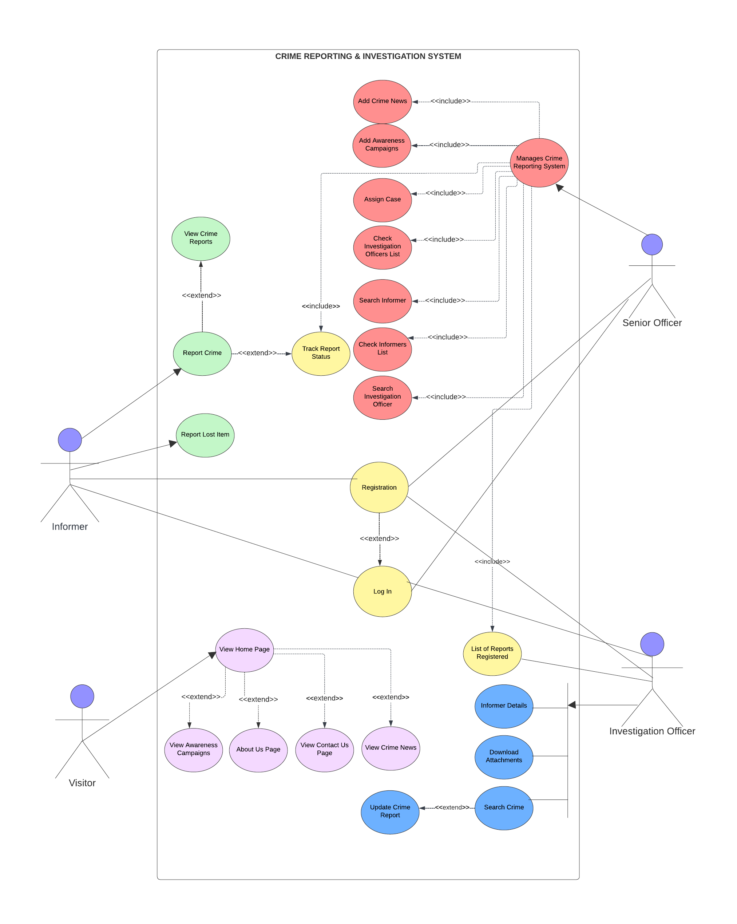

1. **Usage Scenarios:**

Let us refer to **Case Title: 1** as follows:

|  |  |  |
| --- | --- | --- |
| Use Case Title | Registration-FR-1 | |
| Use Case Id | CRAIS-Reg-01 | |
| Action: Firstly, Informer needs to open an app and then click on “sign up for free” for registration. After that informer fills the form which includes; Informer’s name, Email ID, Contact number, Address, and password. This way informer/reporter gets registered.  Investigation officer and senior officer can register themselves too in a similar way. Their form includes officer’s name, Email ID, Contact number, Rank, Department, Address, and password. | | |
| Description: Informer needs to be registered before reporting any crime. Investigation officer or senior officer can get register with their own will in order to perform their tasks. | | |
| Pre-Condition: System should be accessible to internet. | | |
| Alternative Paths:   * In case of some privacy concerns, Informer can use anonymous mode instead of registration. * N/A | | Exceptions:   * User already registered. * Password is weak. * Error message generates if informer or officers miss filling any question in the form. |
| Post Conditions:   * Informer has successfully registered an account in the system. * Informer does not need to register again. | | |
| Modification History: 1.0 | | |
| Author: BC170404767 | | |

Let us refer to **Case Title: 2** as follows:

|  |  |  |
| --- | --- | --- |
| Use Case Title | Login-FR-2 | |
| Use Case Id | CRAIS-Login-02 | |
| Action: Informer first needs to open an app and then click on “Login” button. Then informer needs to write his/her username and password to proceed further. Senior officer and investigation Officers can log in to the system before accessing any system functionality. The system provides the interface for them with fields for username and password. | | |
| Description: Login process is about entering into registered account. Informer can enter and report more crimes, report lost items and even check status of crime report. Senior officer and Investigation officer can login to perform their jobs | | |
| Pre-Conditions:   * App should be connected to internet. * User must remember his/her username and password | | |
| Alternative Paths:   * In case of not being able to remember password, click on “Forgotten Password” to recover password. * If unable to recall username and password both, then register new account with different email address. | | Exceptions:   * Username or password is invalid. * User has not pressed login button to move ahead. |
| Post Conditions:   * User has successfully login in the system. * Informer has recovered the password in case forgotten password. * Informer has reported crime, lost item and checked report status. * Investigation officer and senior officer have accessed to their accounts. | | |
| Modification History: 1.0 | | |
| Author: BC170404767 | | |

Let us refer to **Case Title: 3** as follows:

|  |  |  |
| --- | --- | --- |
| Use Case Title | Report Crime-FR-3 | |
| Use Case Id | CRAIS-Report Crime-03 | |
| Action: Firstly, informer opens an app. Then login into the system. Then finally informer can click on “Report Crime” button and write down all the details of crime including attaching any necessary file as evidence. | | |
| Description: The process of reporting the crime where the report gets into the “Crime Reporting and Investigation System” and receives to the investigation officer for solving the case. | | |
| Pre-Conditions:   * The app should be in running state. * Informer must be able to login into the system | | |
| Alternative Paths:   * If informer forgets how to login, then informer must follow “Forgotten Password” procedure. * N/A | | Exceptions:   * Login is required. * User-interface is less friendly to informer. |
| Post Condition:   * Informer has successfully reported the crime. | | |
| Modification History: 1.0 | | |
| Author: BC170404767 | | |

Let us refer to **Case Title: 4** as follows:

|  |  |  |
| --- | --- | --- |
| Use Case Title | View Crime Reports-FR-4 | |
| Use Case Id | CRAIS-View Crime Reports-04 | |
| Action: Firstly, informer opens an app. On second step, login into the system. On third step, informer clicks on “View Crime Reports” where informer can read all the reports informer has mentioned till that date. | | |
| Description: Steps to see all the crime reports previously reported. | | |
| Pre-Conditions:   * App should be in running state. * Informer must be able to login in the system. | | |
| Alternative Paths:   * Informer can use “forgotten Password” method on forgot password problem to login. * N/A | | Exceptions:   * Invalid username or password. * App gets slow due to load. * “View Crime Reports” section is empty because informer is newly registered. |
| Post Condition:   * Informer has seen the record of all the previous reports. | | |
| Modification History: 1.0 | | |
| Author: BC170404767 | | |

Let us refer to **Case Title: 5** as follows:

|  |  |  |
| --- | --- | --- |
| Use Case Title | Track Report Status-FR-5 | |
| Use Case Id | CRAIS-Track Report Status-05 | |
| Action: First step for informer is to open an app. Secondly, login into the system. Thirdly, press the button “View Crime Reports”. Fourth step is to click on the last reported crime (the report informer wants to check status of) by the informer. Fifth and the last step, scroll down and click “Current Report Status” to see the current status of the reported crime. The same steps are followed by senior officer but on step third, senior officer clicks on “Reports List” to enter in the case report and then scroll down and click “Current Report Status” button to track the case report. | | |
| Description: Tracking process of the reported crime to see the current status of the case. | | |
| Pre-Conditions:   * informer or senior officer must be able to login * App should have access to internet. * Informer should be familiar with app. | | |
| Alternative Paths:   * In case informer does not know the procedure for checking current report status, then informer can email for help by going on “contact us page” on an app. * If Informer or senior officer is unable to login, then must follow “Forgotten Password” procedure. | | Exceptions:   * Login is required. * Connection issues. * No change of status in reported crime. |
| Post Conditions:   * Informer has seen the current status of report. * Senior officer has checked the status of the case. | | |
| Modification History: 1.0 | | |
| Author: BC170404767 | | |

Let us refer to **Case Title: 6** as follows:

|  |  |  |
| --- | --- | --- |
| Use Case Title | Report Lost Item-FR-6 | |
| Use Case Id | CRAIS-Report Lost Item-06 | |
| Action: Firstly, informer needs to access an app. Then informer must login in an app. Third step is to click on “Report Lost Item”, where informer needs to write down all about lost item and attach the photo if possible. | | |
| Description: Reporting process of lost item. Similar method like crime reporting. Here the informer needs to write and submit about lost items details. | | |
| Pre-Conditions:   * App should be in running state. * The informer must login | | |
| Alternative Paths:   * Informer can use “forgotten Password” procedure in case of any login problem. * N/A | | Exceptions:   * Login is required. * Submitting lost item report on report crime section. |
| Post Condition:   * Informer has successfully reported about the lost item remotely. | | |
| Modification History: 1.0 | | |
| Author: BC170404767 | | |

Let us refer to **Case Title: 7** as follows:

|  |  |  |
| --- | --- | --- |
| Use Case Title | Search Crime-FR-7 | |
| Use Case Id | CRAIS-Search Crime-07 | |
| Action: Firstly, investigation officer will open an app or a system. Then login into the system. Once investigation officer has done login procedure, he/she will click on search bar and search for a particular crime or the incidence based on the type of crime. | | |
| Description: The procedure to search for the particular crime or search for specific incidence through the crime name like murder, rape etc. | | |
| Pre-Conditions:   * App in running state. * Investigation officer has successfully login in the system. | | |
| Alternative Paths:   * In case investigation officer cannot find particular crime report, he/she can search that with crime name keywords. * In case investigation officer forgets crime name of particular report, he/she can find that report with using case keywords to find that report in order to confirm the crime name. | | Exceptions:   * Invalid username or password. * Searching for particular incidence based on crime is time consuming especially when crime list is too long. |
| Post Conditions:   * Investigation officer has accessed to all crime reports. | | |
| Modification History: 1.0 | | |
| Author: BC170404767 | | |

Let us refer to **Case Title: 8** as follows:

|  |  |  |
| --- | --- | --- |
| Use Case Title | Update Crime Report-FR-8 | |
| Use Case Id | CRAIS-Update Crime Report-08 | |
| Action: Investigation officer will open an app. Then login in the system by putting username and password details. Then search for crime on search bar, finally click on crime report needed to update. Lastly, press “Update Crime Report”. Here investigation officer will keep posting about case updates from time to time. | | |
| Description: The process for investigation officer to update crime report for senior officer and informer in order to see case updates or track report status. | | |
| Pre-Condition:   * Investigation officer must be login in the system. | | |
| Alternative Paths:   * Investigation officer can find the particular crime report in the list instead of searching in search bar. * N/A | | Exceptions:   * Error in the system * Login is required. |
| Post Conditions:   * Investigation officer has updated crime report status for informers to stay informed. * Investigation officer has updated senior officer with the case progress through updated crime report. | | |
| Modification History: 1.0 | | |
| Author: BC170404767 | | |

Let us refer to **Case Title: 9** as follows:

|  |  |  |
| --- | --- | --- |
| Use Case Title | Informer Details-FR-9 | |
| Use Case Id | CRAIS-Informer Details-9 | |
| Action: Step one is open the app and login in the system for investigation officer. Step two is open the crime report through finding in reports list by pressing “Reports List” button. Once investigation enters in the crime report page, Then the third and final step is investigation officer can find the informers entire detail at the end of the page. | | |
| Description: The procedure to find out the details of the informer by investigation officer. | | |
| Pre-Conditions:   * App should be connected with internet. * The entire system functionality is available after login. | | |
| Alternative Paths:   * If it takes lot of time to find particular report in reports list then searching crime name by clicking on search bar can help find the report more quickly. * N/A | | Exceptions:   * Connection fails with internet. * Pressing on “Reports List” button does not work due to load on app. |
| Post Condition:   * Investigation officer has information of all the informers/reporters who have reported crimes. | | |
| Modification History: 1.0 | | |
| Author: BC170404767 | | |

Let us refer to **Case Title: 10** as follows:

|  |  |  |
| --- | --- | --- |
| Use Case Title | List of Reports Registered-FR-10 | |
| Use Case Id | CRAIS- List of Reports Registered-10 | |
| Action: Investigation officer or Senior Officer firstly must open an app. Then he must login in the system if he/she is already registered. Once officer login into the system, he/she can click on the “Reports List” to have an access to all the reports/cases reported till that date. | | |
| Description: Steps to access the list of all the reported cases or reports registered in the “Crime Reporting and Investigation System”. | | |
| Pre-Condition: App should be in running state. | | |
| Alternative Paths:   * If investigation officer has not registered, then the officer can immediately and easily make registration at that time to have an access inside the system. * In case of login problem, the investigation officer can follow “Forgotten Password” rules to have an access of system functionalities. * In case of report list being too long, investigation officer can search for particular crime report with its crime name in search bar to gain little quick access. | | Exceptions:   * “Reports List” section is empty as system is newly made. * Officer’s registration and login are required. |
| Post Condition:   * Investigation officer or senior officer has gained access to all the cases or reports registered in the system. | | |
| Modification History: 1.0 | | |
| Author: BC170404767 | | |

Let us refer to **Case Title: 11** as follows:

|  |  |  |
| --- | --- | --- |
| Use Case Title | Download Attachments-FR-11 | |
| Use Case Id | CRAIS-Download Attachment-11 | |
| Action: The very first step for the investigation officer is to open an app and login. Second step is to click on “Reports List” button. Once inside the list page, investigation officer will click on desire crime report or case by pressing on it. There will be file attach inside the crime report. Investigation officer will do right click on it and start to download. | | |
| Description: The quite simple process to download the evidence provided by the informer to the investigation officer in order to solve the case. | | |
| Pre-Conditions:   * Memory space in investigation officer’s device. * High speed internet to download the attached files | | |
| Alternative Paths:   * Investigation officer can find the crime report by searching crime name in search bar. * N/A | | Exceptions:   * Sudden connection fail will stop the downloading. * No file attached with the crime report. |
| Post Conditions:   * Investigation officer receives evidence or important attachments for the case. | | |
| Modification History: 1.0 | | |
| Author: BC170404767 | | |

Let us refer to **Case Title: 12** as follows:

|  |  |  |
| --- | --- | --- |
| Use Case Title | Assign Case-FR-12 | |
| Use Case Id | CRAIS-Assign Case-12 | |
| Action: Step-one is open the web-based application. Step-two is login into the system. Step-three is click on the button “ASSIGN CASE”. Step-four has interface with two fields i.e “Investigation officer name” and “Case number” so senior officer has to fill it and press button “enter” in the end to assign the case to investigation officer. | | |
| Description: The process for senior officer to choose the investigation officer and assign the crime case to that investigation officer. One of the most important functionalities of the “Crime Reporting & Investigation System”. | | |
| Pre-Conditions:   * Senior officer must be login in the system. * App must be connected to internet. | | |
| Alternative Paths:   * Another way to assign case to investigation officer is when new crime report/case comes in the list of reports and senior officer can read it and then assign it from there to the investigation officer. There will be option for senior officer to assign case during reading the case. * One more way to assign case is from in investigation officers list where senior officer can choose investigation officer and assign him/her case by crime report/case number. | | Exceptions:   * Connection fail * Login is required. * Invalid case number. * No investigation officer exists with this name. |
| Post Conditions:   * Specific case has assigned to particular investigation officer by the senior officer of the police department. | | |
| Modification History: 1.0 | | |
| Author: BC170404767 | | |

Let us refer to **Case Title: 13** as follows:

|  |  |  |
| --- | --- | --- |
| Use Case Title | Add Crime News-FR-13 | |
| Use Case Id | CRAIS-Add Crime News-13 | |
| Action: The senior officer firstly needs to open an app and login if already registered. Then click on “Add Crime News” button to add all the crime news one by one. In the end, press “Ready to share” button to upload on the app. | | |
| Description: The process of adding crime news for the visitors and informers by senior officer of the police department. | | |
| Pre-Conditions:   * Senior officer must be present. * App should be connected to high-speed internet. | | |
| Alternative Paths:   * If senior officer has registered but unable to login, then senior officer can follow “forgotten password” rules to resolve the issue. * N/A | | Exceptions:   * Constant fail to upload news due to connection issue. * N/A |
| Post Conditions:   * All the updated crime news has added on the application by senior officer of the police department. * Visitors can read the latest crime news. | | |
| Modification History: 1.0 | | |
| Author: BC170404767 | | |

Let us refer to **Case Title: 14** as follows:

|  |  |  |
| --- | --- | --- |
| Use Case Title | Add Awareness Campaigns-FR-14 | |
| Use Case Id | CRAIS-Add Awareness Campaigns-14 | |
| Action: The senior officer follows the steps in which step one is to open an application and step two is to login into the system. Step three is click on “Add Awareness Campaigns” button where senior officer can actually add awareness campaign essay to upload on app. Step four is to press “Ready to Share” button to upload on the app. This is the final step. | | |
| Description: Operations to upload an awareness campaigns like crime prevention campaigns to secure people from becoming a victim of crime. | | |
| Pre-Conditions:   * App should be in running state. * Presence of senior officer is must. * Strategically planned awareness campaigns should be ready to upload. | | |
| Alternative Paths:   * Small public awareness messages can be added under the latest crime news in order to make unintentional awareness. * N/A | | Exceptions:   * Error occurs during uploading. * Awareness campaign paragraph is too short to upload. |
| Post Conditions:   * New Awareness campaigns page has uploaded in order to create awareness in coming visitors. * The targeted audience is informed and police department attempts to change people’s attitude. | | |
| Modification History: 1.0 | | |
| Author: BC170404767 | | |

Let us refer to **Case Title: 15** as follows:

|  |  |  |
| --- | --- | --- |
| Use Case Title | Check Informers List-FR-15 | |
| Use Case Id | CRAIS- Check Informers List-15 | |
| Action: Senior officer must follow these steps; Step-one is open the app. Step-two is login in the system. Step-three is to click the button “Informers List”. | | |
| Description: Simple method to see the details of informers that have reported the crimes or cases in the application. It is compulsory that system already have reported cases to have informers/reporters. | | |
| Pre-Conditions:   * App should be in running state. * Senior officer must login in the system. * System must have already reported cases. | | |
| Alternative Paths:   * The other way to have informer details is through reported case files. Senior officer can go there through pressing “Reports List” button. * N/A | | Exceptions:   * Informers list is empty as no case reported. * Shows missing information of informers. |
| Post Conditions:   * Senior officer knows number of informers who reported exactly one crime like murder or rape. * Senior officer has accessed of informers’ all contact details. | | |
| Modification History: 1.0 | | |
| Author: BC170404767 | | |

Let us refer to **Case Title: 16** as follows:

|  |  |  |
| --- | --- | --- |
| Use Case Title | Search Informer-FR-16 | |
| Use Case Id | CRAIS-Search Informer-16 | |
| Action: Here Initially senior officer needs to login. Then senior officer needs to enter in informers list by pressing button “Informers List”. Then senior officer can simply press the button “Search” where senior officer needs to write down informer’s name and press enter. Finally, app will show the most matched informer on screen from the informers list. | | |
| Description: Very similar method like “Search Investigation Officer”. It is a procedure to search the specific informer in informers list to find out particular informer details in the application system. | | |
| Pre-Conditions:   * App should be in running state. * Senior officer must know the informer’s name. | | |
| Alternative Paths:   * Another way to reach on the informer detail is through finding in informers list one by one via scrolling down. * N/A | | Exceptions:   * Search bar shows no match in result. * Error occurs in system. |
| Post Condition:   * Senior officer has complete detail of the informer who reported the crime. | | |
| Modification History: 1.0 | | |
| Author: BC170404767 | | |

Let us refer to **Case Title: 17** as follows:

|  |  |  |
| --- | --- | --- |
| Use Case Title | Check Investigation Officers List-FR-17 | |
| Use Case Id | CRAIS-Check Investigation Officers List-17 | |
| Action: The very first step in this procedure is that senior officer needs to open an application system and login into the system. Second-step right after login is to click button “Investigation Officer’s List”. After entering, all investigation officers list will be there with their names. Third-step, Senior officer can further click on any investigation officer name to go next page where entire detail of investigation officer will be present. | | |
| Description: The method in “Crime Reporting and Investigation System” application to check the list of investigations officers registered in the system of web-based application. | | |
| Pre-Conditions:   * Application must be working. * Investigations officers must be registered in the system. | | |
| Alternative Paths:   * Senior officer can find investigation officer in reported cases reports/files apart from the list. * N/A | | Exceptions:   * Investigation officers list is empty. * Two or more officers have the exact same name in list. |
| Post Conditions:   * Senior officer knows all the investigation officers and their important information including their departments. * The total number of investigation officers are defined to senior officer. | | |
| Modification History: 1.0 | | |
| Author: BC170404767 | | |

Let us refer to **Case Title: 18** as follows:

|  |  |  |
| --- | --- | --- |
| Use Case Title | Search Investigation Officer-FR-18 | |
| Use Case Id | CRAIS-Search Investigation Officer-18 | |
| Action: Initially senior officer needs to login after opening an app. After the login procedure is completed and senior officer has entered in the account, senior officer needs to enter in investigation officers list by pressing button “Investigation Officers List”. Then senior officer can simply press the button “Search” where senior officer needs to write down investigation officer’s name and press enter. Then app will show most matched investigation officer on screen from the investigation officers list. | | |
| Description: This is a quite simple way for senior officer to search out or quickly find investigation officer with his/her complete details by using search bar in the application. | | |
| Pre-Conditions:   * Senior officer must be login in the system. * Search bar option should be available in the system. | | |
| Alternative Paths:   * Incase search bar does not work properly or system shows error, Senior officer can find the specific investigation officer in the Investigation officers list by scrolling down. * N/A | | Exceptions:   * App shows no match with searched request. * Application takes too much time in showing result. |
| Post Condition:   * Senior officer has found particular requested investigation officer with his/her complete details. | | |
| Modification History: 1.0 | | |
| Author: BC170404767 | | |

Let us refer to **Case Title: 19** as follows:

|  |  |  |
| --- | --- | --- |
| Use Case Title | Manages Crime Reporting System-FR-19 | |
| Use Case Id | CRAIS-Manages Crime Reporting System-19 | |
| Action: Firstly, senior officer needs to open an app and login into the system by filling username and password details. Once the senior officer has successfully login, he/she can see buttons like “Add Crime News”, “Add Awareness Campaigns”, “Crime Report Status”, “Assign Case”, “Informers List”, “Investigation Officers List”, “Reports List”. Any clicked button will perform or show the required task or information. | | |
| Description: The process to manage crime reporting system by senior officer. | | |
| Pre-Conditions:   * Senior officer must be login in the system. * System should be connected to internet. | | |
| Alternative Paths:   * In case of any problem, case current status and reports list will be available to investigation officer as well. * If informers list shows error, senior officer can see any informer detail through going inside case report. | | Exceptions:   * Registration and login are required. * Connection fail. * Pressed button takes lot of time to move ahead due to load. |
| Post Conditions:   * Senior officer has seen informers list, investigation officers list and reports list. * Case is assigned to investigation officer and checked report status of other cases. * New crime news and campaigns are added on the web-based application by senior officer. | | |
| Modification History: 1.0 | | |
| Author: BC170404767 | | |

Let us refer to **Case Title: 20** as follows:

|  |  |  |
| --- | --- | --- |
| Use Case Title | View Crime News-FR-20 | |
| Use Case Id | CRAIS-View Crime News-20 | |
| Action: Initial step for the visitor is to open an application. Then visitor will arrive on the homepage of the application. Third and final step is to click “CRIME NEWS” button. This will take the visitor to the crime news section where senior officer will keep updating with new criminal news. | | |
| Description: This is a procedure to read and know the current crime news in an application by the police department. | | |
| Pre-Conditions:   * Visitor must be able to read and understand English language. * A clear user-interface that is visually appealing and easy to learn. | | |
| Alternative Paths:   * The other simpler way to reach on crime news is through homepage but by clicking on the center picture on homepage instead of pressing button. * N/A | | Exceptions:   * Internet problem. * No new crime news. |
| Post Conditions:   * Visitor knows all the latest crime news around the city/country. * This will help visitors understand criminal minds, and let visitors think how to save themselves from becoming potential victims. | | |
| Modification History: 1.0 | | |
| Author: BC170404767 | | |

Let us refer to **Case Title: 21** as follows:

|  |  |  |
| --- | --- | --- |
| Use Case Title | View Awareness Campaigns-FR-21 | |
| Use Case Id | CRAIS-View Awareness Campaigns-21 | |
| Action: Step-one is to open an app. This will automatically bring on homepage. Step-two is to click “AWARENESS CAMPAIGNS” button. This will take the visitor to another page where visitor can read all the awareness campaigns. | | |
| Description: This is a process to create awareness among app visitors about crimes happening around them. This will help visitors learn and understand how to be save from criminal minds. | | |
| Pre-Conditions:   * Strategy should be ready to how to launch awareness campaign which can impact more on visitors. * Internet connect is must. | | |
| Alternative Paths:   * Just like alternative way of reaching on crime news, visitor can come to ‘awareness campaigns’ page through homepage but by clicking on the center picture on homepage instead of pressing button. * One more way to come is while reading crimes news on the app, visitor can see the button “AWARENESS CAMPAIGNS” above all the news, clicking on it will take it there. | | Exceptions:   * System shows error. * Causes more harm than doing good. |
| Post Conditions:   * This will bring change in society and let visitors learn how to save themselves and prevent crime. * Visitor will discover and analyze the crimes and work for the reduction for them and their families, which leads to the safety for everyone. | | |
| Modification History: 1.0 | | |
| Author: BC170404767 | | |

Let us refer to **Case Title: 22** as follows:

|  |  |  |
| --- | --- | --- |
| Use Case Title | View Home Page-FR-22 | |
| Use Case Id | CRAIS- View Home Page-22 | |
| Action: Visitor firstly needs to open an application. Then application will show homepage to the visitor. This homepage will show few buttons like “CRIME NEWS”, “AWARENESS CAMPAIGNS” to visit and get informative and helpful material. | | |
| Description: The is a simple procedure to visit the “Crime Reporting and Investigation System” application’s main page to see all the updates. | | |
| Pre-Conditions:   * App should be in connected to internet or in running state. * Visitor must be fluent in English language to read and understand. | | |
| Alternative Paths:   * Another way to get to the homepage is shortcut keys, that will directly bring the visitor to the homepage. * If visitor copies the link of the homepage and put that link every time on browser, then browser will automatically bring the visitor to the homepage. | | Exceptions:   * App has crashed. * App gets slow due to load. * A weak internet connection. |
| Post Conditions:   * Visitor receives all the criminal updates nearby. * Visitor will also get user-friendly with an app. | | |
| Modification History: 1.0 | | |
| Author: BC170404767 | | |

Let us refer to **Case Title: 23** as follows:

|  |  |  |
| --- | --- | --- |
| Use Case Title | About Us Page-FR-23 | |
| Use Case Id | CRAIS-About Us Page-23 | |
| Action: The first-step for visitor is to open an application. Second-step after arriving on homepage is to click on button “About us”. That is how visitor will be taken to the next page where required details of the police department and the purpose of the app will be given. | | |
| Description: The method for visitor to acquire the knowledge given by police department in order to signify what they serve or who they serve and the purpose of the application and communicate the current details of the department. The primary reason for this page is always to inform the visitor about the application and its operations. | | |
| Pre-Conditions:   * This page must include all the important details. * The page must describe the cause of the application to the visitors. | | |
| Alternative Paths:   * The other way is to go inside “Contact us” page and there will be a button for “About us” page down the fields of contact us page. * N/A | | Exceptions:   * Important details are missing. * The message is not clearly conveyed. |
| Post Condition:   * The visitors know the intention of making this application. | | |
| Modification History: 1.0 | | |
| Author: BC170404767 | | |

Let us refer to **Case Title: 24** as follows:

|  |  |  |
| --- | --- | --- |
| Use Case Title | Contact Us Page-FR-24 | |
| Use Case Id | CRAIS- Contact Us Page-24 | |
| Action: Visitor must follow the steps as it is; Step-one is open the application. This will land on homepage of the application. Step-two is click on “Contact us” button. Step-three; On this page, visitor will fill out the given form. Step-four is to press button “Submit” in the end. Step-five is to call on the given number provided by the department to immediately contact the department | | |
| Description: The process in which visitor can contact the department. Visitor will be provided a short form to fill out which obtains email address, first name, last name, message. The other way to contact is via given phone number. | | |
| Pre-Conditions:   * Form must contain all the important fields. * Input field should be long enough to write complete message. * “Contact us” button must bold and bright. * Visitor’s device must have internet connection. | | |
| Alternative Paths:   * The button for “Contact us” will be given on crime news page. Visitor can press the button anytime and contact the department easily. * Another way is to go inside the awareness campaigns page, where visitor will find “Contact us” button at the bottom of the page. Clicking on it will bring the visitor on contact us page. | | Exceptions:   * Contact number is wrong. * Invalid email address. * Message is too short. * Error generates as ‘missing required field’ in case any field misses while filling the form. |
| Post Conditions:   * Any query of visitor has been solved or in process. * Visitor can get in touch with police department immediately via phone number. | | |
| Modification History: 1.0 | | |
| Author: BC170404767 | | |

1. **Adopted Methodology:**

There are many kinds of process models which are referred as Software Development Life Cycle (SDLC) Models. In another words, these are the various methodologies that are required to acquire during the development of software project. The models specify the various stages of the process and the order in which they are carried out. The most popular models include; RAD model, incremental model, Prototype model, Agile model, Waterfall model and Spiral model. All these models have different traits and are chosen for different projects according to their aims and goals. We have chosen VU process model due to some of its characteristics that are beneficial for the project “Crime Reporting and Investigation System”.

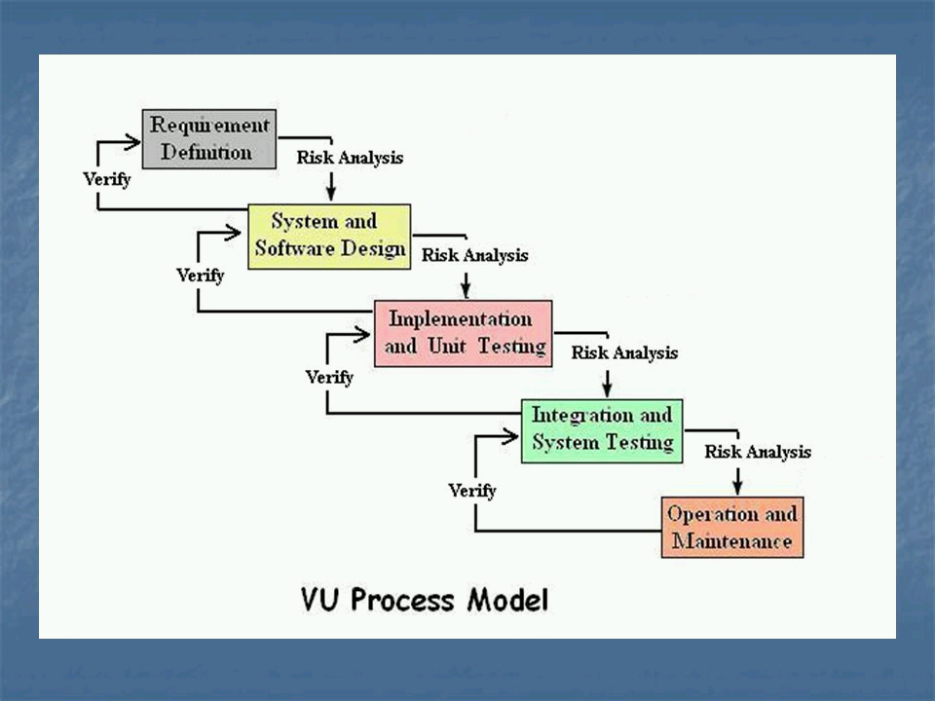

This model is basically based on two models which are Waterfall model and Spiral model. Spiral model is actually the extension of waterfall model. The purpose of selecting this model is brings the advantages of Waterfall model as well as Spiral model. Waterfall relies on teams following a sequence of steps and never moving forward until the previous phase has been completed. Other advantages are timescales are kept, no financial surprises later, testing is easy and result is always crystal clear. Due to these important factors, it is way better and easier to implement in the project “Crime Reporting & Investigation System” and better than other existing SDLC models. VU process model fulfills all the requirements of this project as it promises what you plan is what you get. This project has many requirements and waterfall model makes sure each phase has specific deliverables and review process which assures that project is in the right direction and chances of mistake are least. Apart from that, this model is easy to understand and use rather than other models like Agile. In VU process model, project is completely dependent on development team with least interruption of client. Spiral model is good for large and complex projects. This model also allows the developers to break a big project into smaller pieces and tackle one feature at a time, ensuring nothing is missed. The above reasons show that VU process model which is a combination of two models (Waterfall & Spiral model) is best for CRAIS project.

1. **Work Plan (Use MS project to create schedule/work plan):**

(On the next page)

