# Name: Mahum Samar

# CMS: 290647

# Class: BSCS-9B

# CS-344: Web Engineering

# Lab 01

# Instructor: Mr. Mujatba Haider

# Task 01

## Code:

|  |
| --- |
| <!DOCTYPE html>  <html lang="en">  <head>      <meta charset="UTF-8">      <meta http-equiv="X-UA-Compatible" content="IE=edge">      <meta name="viewport" content="width=device-width, initial-scale=1.0">      <title>Task 01</title>  </head>  <body>      <!-- heading 1 -->      <h1>Lists and Hyperlinks</h1>      <!-- paragraph tag -->      <p>There are two types of <i>lists</i> in HTML:</p>      <!-- ordered list -->      <ol>          <!-- list items -->          <li>Order List.</li>          <li>Unordered List.</li>      </ol>      <!-- paragraph tag -->      <p>This is an ordered list</p>      <!-- ordered list -->      <ol>          <!-- ordered list items -->          <li>Ordered list item 1</li>          <li>Ordered list item 2</li>          <li>Ordered list item 3</li>          <li>Ordered list item 4</li>          <li>Ordered list item 5</li>      </ol>      <!-- paragraph tag -->      <p>This is an Unordered list</p>      <!-- unordered list -->      <ul>          <!-- unordered list items -->          <li>Unordered list item 1</li>          <li>Unordered list item 2</li>          <li>Unordered list item 3</li>          <li>Unordered list item 4</li>          <li>Unordered list item 5</li>      </ul>      <!-- paragraph tag -->      <p>This is nested unordered list of links:</p>      <!-- unordered list -->      <ul>          <!-- unordered list items -->          <li>Online Validator:</li>          <!-- level 2 unordered list. -->          <ul>              <!-- list item. -->              <li>W3C Online HTML Validator @                  <!-- link to website -->                  <a href="https://validator.w3.org/" target="blank">https://validator.w3.org/</a>              </li>              <li>W3C Online CSS Validator @                  <a href="https://jigsaw.w3.org/css-validator/" target="blank">https://jigsaw.w3.org/css-validator/</a>              </li>          </ul>          <li>Specification:</li>          <ul>              <li>HTML5 @                  <a href="https://www.w3.org/TR/html52/" target="blank">https://www.w3.org/TR/html52/</a>              </li>              <li>CSS Selectors @                  <a href="https://www.w3.org/TR/selectors-3/" target="blank">https://www.w3.org/TR/selectors-3/</a>              </li>          </ul>      </ul>  </body>  </html> |

## Output:

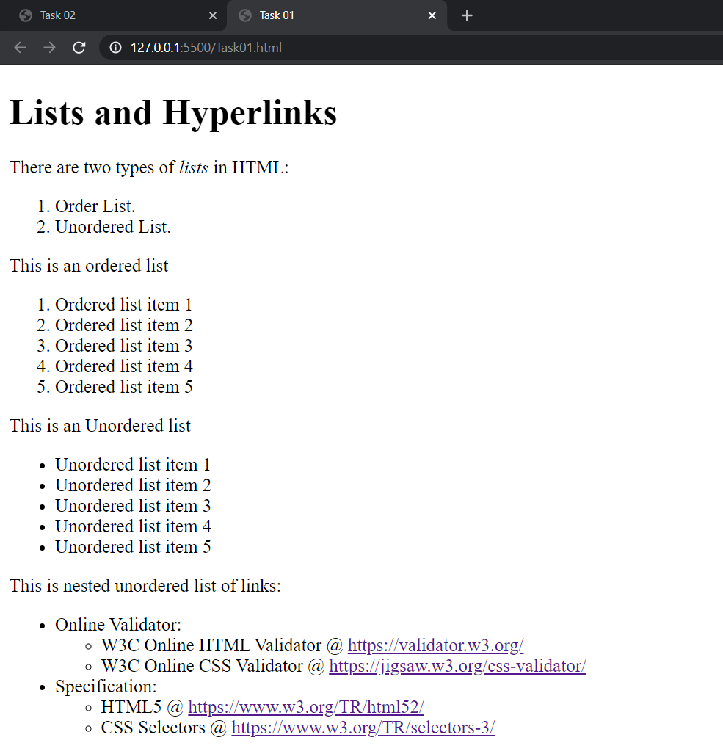

# Task 02

## Code:

|  |
| --- |
| <!DOCTYPE html>  <html lang="en">  <head>      <meta charset="UTF-8">      <meta http-equiv="X-UA-Compatible" content="IE=edge">      <meta name="viewport" content="width=device-width, initial-scale=1.0">      <title>Task 02</title>      <style>          /* using css */          /* style for table so that solid border comes on each row and column */          table,          th,          td {              border: 1px solid black;          }      </style>  </head>  <body>      <!-- heading 1 -->      <h1>My Schedule</h1>      <!-- table start -->      <table>          <tr>              <!-- 1st row for table column heading using <th> tag -->              <th>Subject</th>              <th>Day</th>              <th>Time</th>              <th>Instructor</th>          </tr>          <!-- 2nd and onwards rows -->          <!-- 1st row. -->          <tr>              <td>CAO</td>              <td>Monday</td>              <td>9:00-10:00</td>              <td>Instructor</td>          </tr>          <!-- 2nd row. -->          <tr>              <td>CAO</td>              <td>Tuesday</td>              <td>10:00-11:00</td>              <td>Instructor</td>          </tr>          <!-- 3rd row. -->          <tr>              <td>CAO</td>              <td>Wednesday</td>              <td>14:00-15:00</td>              <td>Instructor</td>          </tr>          <!-- 4th row. -->          <tr>              <td>WE</td>              <td>Wednesday</td>              <td>9:00-10:00</td>              <td>Instructor</td>          </tr>          <!-- 5th row. -->          <tr>              <td>WE</td>              <td>Thursday</td>              <td>9:00-10:00</td>              <td>Instructor</td>          </tr>          <!-- 6th row. -->          <tr>              <td>WE</td>              <td>Friday</td>              <td>9:00-10:00</td>              <td>Instructor</td>          </tr>      </table>  </body>  </html> |

## Output:

