# Name: Mahum Samar

# CMS: 290647

# Class: BSCS-9B

# CS-344: Web Engineering

# Lab 08

# Instructor: Mr. Mujatba Haider

# Task 01

## Code:

|  |
| --- |
| $(document).ready(function () {    var $li = $("li");    $li.on("click", liAppend);  });  function liAppend() {    var monthName = [      "Jan",      "Feb",      "Mar",      "Apr",      "May",      "Jun",      "Jul",      "Aug",      "Sep",      "Oct",      "Nov",      "Dec",    ];    var dayName = ["Mon", "Tue", "Wed", "Thu", "Fri", "Sat", "Sun"];    var d = new Date();    var month = d.getMonth();    var date = d.getDate();    var day = d.getDay();    var dt = new Date();    var time = dt.getHours() + ":" + dt.getMinutes() + ":" + dt.getSeconds();    var output =      " Clicked on " +      dayName[day] +      " " +      monthName[month] +      " " +      date +      " " +      d.getFullYear() +      " at " +      time;    $("li").each(function () {      $("span").empty();    });    $(this).append('<span class="date">' + output + "</span>");  } |

## HTML :

|  |
| --- |
| <!DOCTYPE html>  <html>    <head>      <title>Task 01</title>      <link rel="stylesheet" href="css/c07.css" />    </head>    <body>      <div id="page">        <h1 id="header">List</h1>        <h2>Buy groceries</h2>        <ul>          <li id="one" class="hot"><em>fresh</em> figs</li>          <li id="two" class="hot">pine nuts</li>          <li id="three" class="hot">honey</li>          <li id="four">balsamic vinegar</li>        </ul>      </div>      <script src="js/jquery-1.11.0.js"></script>      <script src="js/task01.js"></script>    </body>  </html> |

## Output:

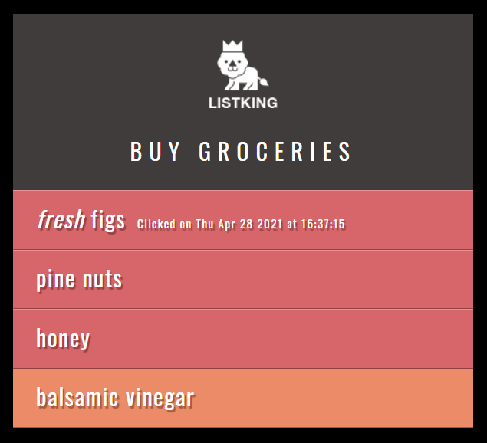 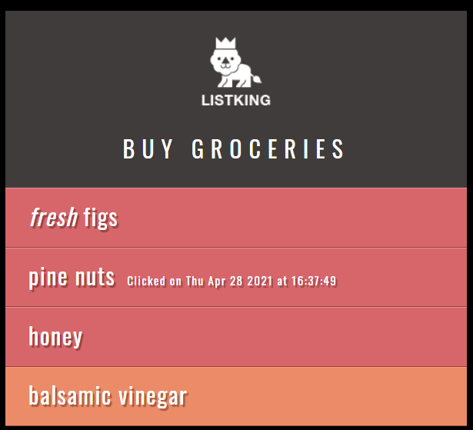

# Task 02

## Code:

|  |
| --- |
| $(document).ready(function () {    var li = $("li");    li.on("click", function (e) {      var item = $(this).text();      var status = "";      if (item == "honey" || item == "pine nuts") {        status = "Important";      } else {        status = "Available";      }      var output =        "Item: " +        item +        "<br>" +        "Status: " +        status +        "<br>" +        "Event: " +        e.type;      $("#itemInfo").empty();      $("#itemInfo").append(output);    });    li.on("mouseover", function (e) {      var item = $(this).text();      var status = "";      if (item == "honey" || item == "pine nuts") {        status = "Important";      } else {        status = "Available";      }      var output =        "Item: " +        item +        "<br>" +        "Status: " +        status +        "<br>" +        "Event: " +        e.type;      $("#itemInfo").empty();      $("#itemInfo").append(output);    });  }); |

## HTML:

|  |
| --- |
| <!DOCTYPE html>  <html>    <head>      <title>Task 02</title>      <link rel="stylesheet" href="css/c07.css" />    </head>    <body>      <div id="page">        <h1 id="header">List</h1>        <h2>Buy groceries</h2>        <ul>          <li id="one" class="hot"><em>fresh</em> figs</li>          <li id="two" class="hot">pine nuts</li>          <li id="three" class="hot">honey</li>          <li id="four">balsamic vinegar</li>        </ul>        <div id="itemInfo">Click or mouseover a hot item...</div>      </div>      <script src="js/jquery-1.11.0.js"></script>      <script src="js/task02.js"></script>    </body>  </html> |

## Output:

## 

## 

# Task 03

## Code:

|  |
| --- |
| $(document).ready(function () {    $(window).on("scroll", function () {      window.onscroll = function () {        var curPos = $(window).scrollTop();        var pos = $("#footer").offset().top - $(window).height() - 500;        if (curPos >= pos) {          $("#slideAd").animate({ opacity: "1" }, 0);        } else {          $("#slideAd").animate({ opacity: "0" }, 0);        }      };    });  }); |

HTML:

|  |
| --- |
| <!DOCTYPE html>  <html>  <head>      <title>Task 03</title>      <link rel="stylesheet" href="css/c07.css" />  </head>  <body>      <div id="page">          <h1 id="header">List</h1>          <h2>Buy groceries</h2>          <ul>              <li id="one" class="hot"><em>fresh</em> figs</li>              <li id="two" class="hot">pine nuts</li>              <li id="three" class="hot">honey</li>              <li id="four">balsamic vinegar</li>              <li>linguine</li>              <li>cream</li>              <li>coconut milk</li>              <li>mushrooms</li>              <li>apples</li>              <li>strawberries</li>              <li>rice crackers</li>              <li>brie</li>              <li>rice</li>              <li>green tea</li>              <li>vine-ripened tomatoes</li>              <li>bananas</li>              <li>red kidney beans</li>              <li>haricot beans</li>              <li>lettuce</li>              <li>organic brown rice vinegar</li>              <li>sushi nori</li>              <li>garlic</li>              <li>ginger</li>              <li>red onions</li>              <li>goat's cheese</li>              <li>baby leaf spinach</li>              <li>coconut</li>              <li>avocado</li>              <li>leeks</li>              <li>carrots</li>              <li>pears</li>              <li>apples</li>              <li>organic free-range eggs</li>              <li>cashew nut butter</li>              <li>lemons</li>              <li>coconut oil</li>              <li>sourdough bread</li>              <li>almond milk</li>              <li>kale</li>              <li><em>gluten-free </em>soy sauce</li>              <li>quinoa</li>          </ul>          <div id="footer">              &copy; ListKing          </div>          <div id="slideAd">              buy listking pro for only $1.99          </div>      </div>      <script src="js/jquery-1.11.0.js"></script>      <script src="js/task03.js"></script>  </body>  </html> |

## Output:

## 

# Task 04

## Code:

|  |
| --- |
| $(document).ready(function () {    //you code here    $(".add-row").click(function () {      $("#error").empty();      if ($("#name").val() != "" && $("#email").val() != "") {        var name = $("#name").val();        var email = $("#email").val();        var tableValue = $("table tbody");        var row =          '<tr><td><input type="checkbox" name="record"></td>' +          "<td>" +          name +          "</td>" +          "<td>" +          email +          "</td>";        tableValue.append(row);      } else {        $("#error").append("Enter the name and email");      }    });    $(".delete-row").click(function () {      $("table input:checked").parents("tr").remove();    });  }); |

HTML:

|  |
| --- |
| <!DOCTYPE html>  <html lang="en">  <head>      <meta charset="utf-8">      <title>jQuery Add / Remove Table Rows Dynamically</title>      <style type="text/css">          form {              margin: 20px 0;          }          form input,          button {              padding: 5px;          }          table {              width: 100%;              margin-bottom: 20px;              border-collapse: collapse;          }          table,          th,          td {              border: 1px solid #cdcdcd;          }          table th,          table td {              padding: 10px;              text-align: left;          }          #error {              color: red;          }      </style>      <script src="js/jquery-1.11.0.js"></script>      <script src="js/task04.js"></script>  </head>  <body>      <p id="error"></p>      <form>          <input type="text" id="name" placeholder="Name">          <input type="text" id="email" placeholder="Email Address">          <input type="button" class="add-row" value="Add Row">      </form>      <table>          <thead>              <tr>                  <th>Select</th>                  <th>Name</th>                  <th>Email</th>              </tr>          </thead>          <tbody>              <tr>                  <td><input type="checkbox" name="record"></td>                  <td>Peter Parker</td>                  <td>peterparker@mail.com</td>              </tr>          </tbody>      </table>      <button type="button" class="delete-row">Delete Row</button>  </body>  </html> |

## Output:

If nothing entered in text boxes and add button pressed error displayed in red text.

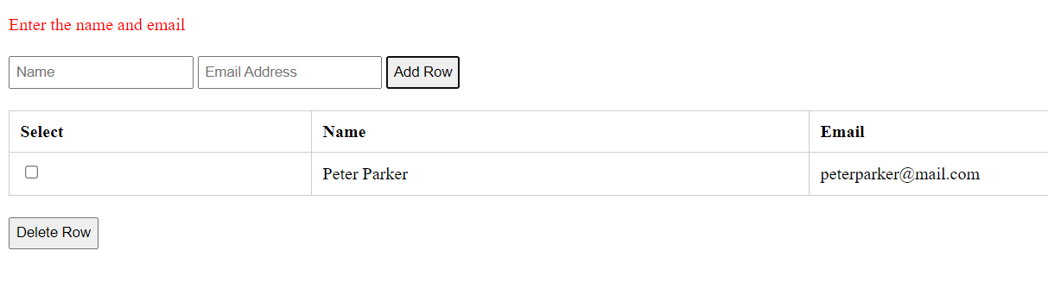

When new row added.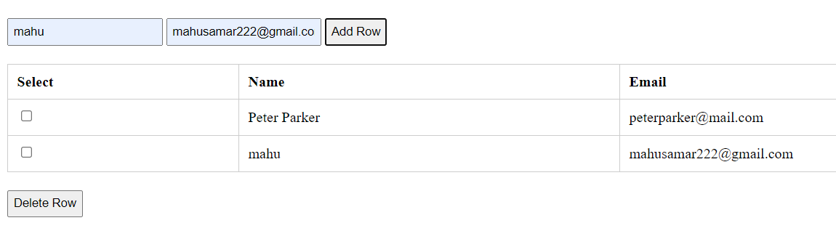 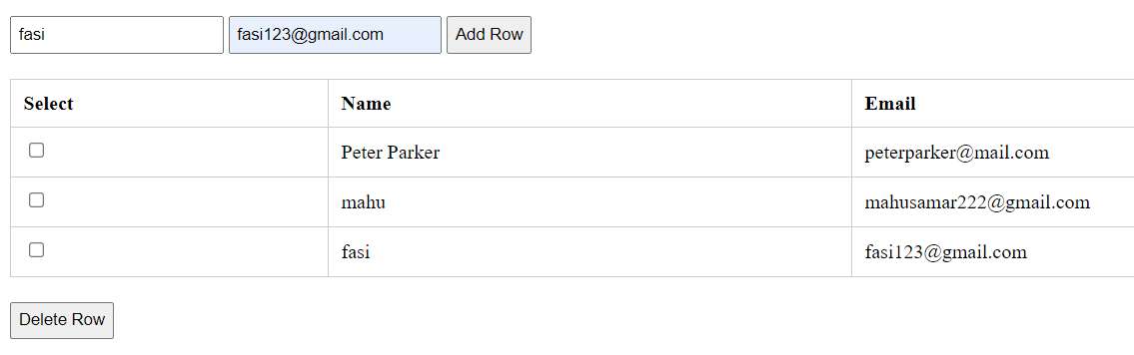 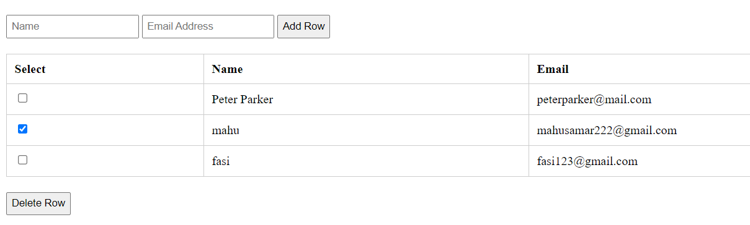

When selected row is deleted.