# Name: Mahum Samar

# CMS: 290647

# Class: BSCS-9B

# CS-344: Web Engineering

# Lab 10

# Instructor: Mr. Mujatba Haider

# Task 01

## Output:

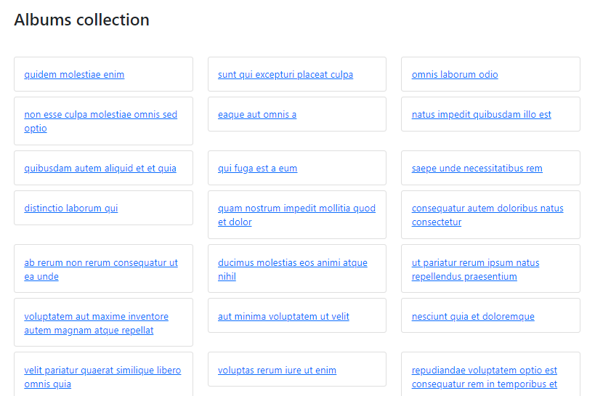 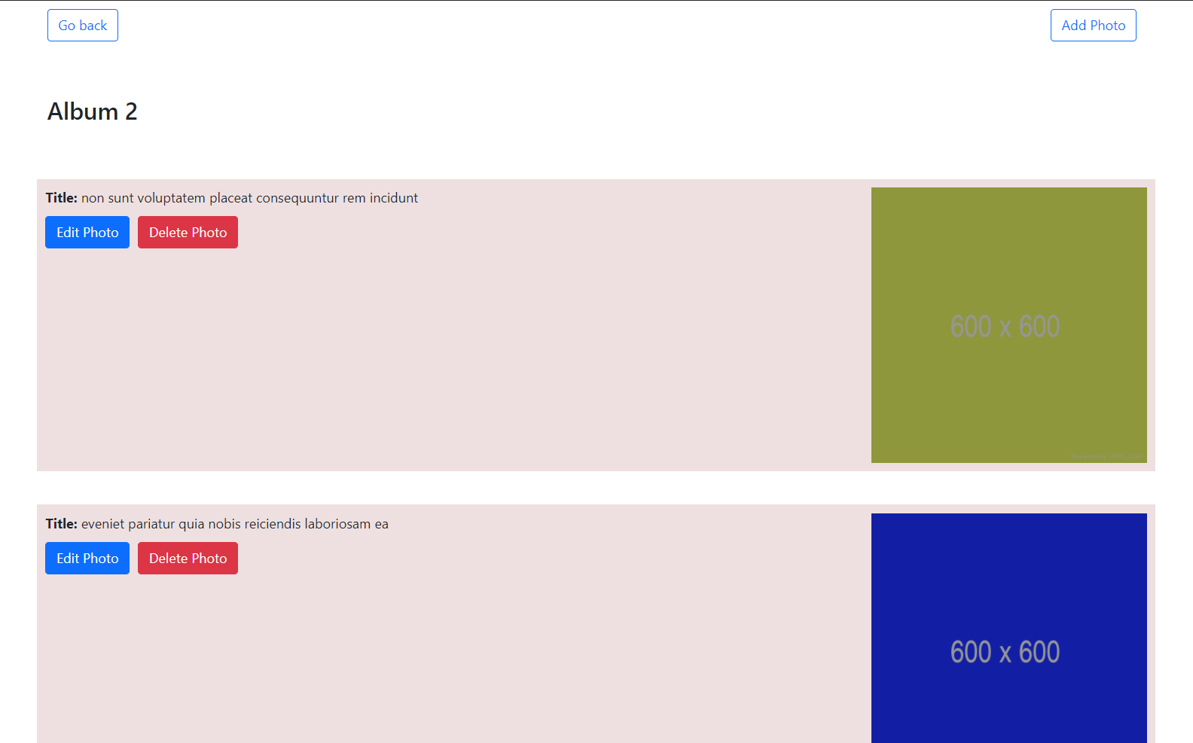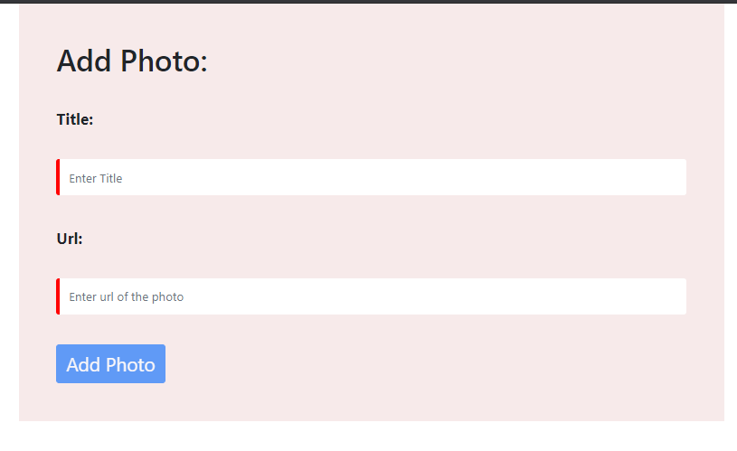 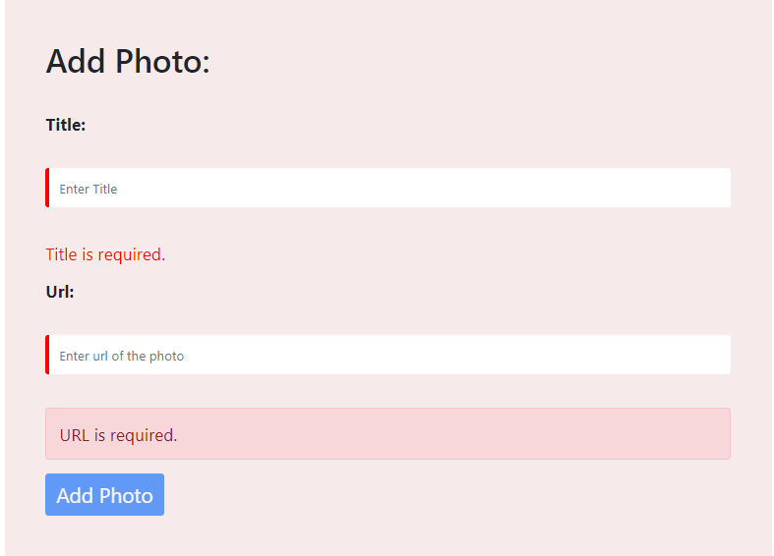 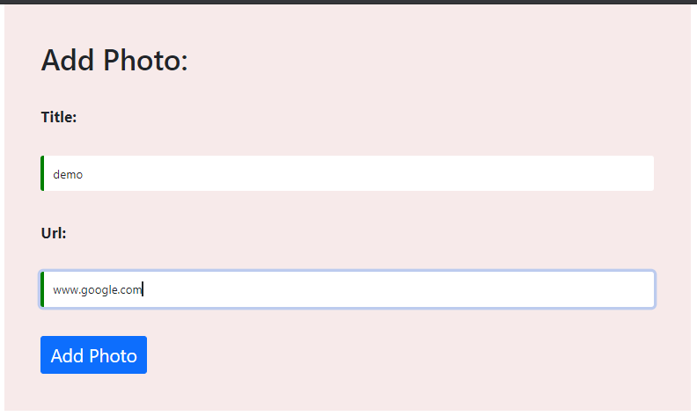

Adding a photo:

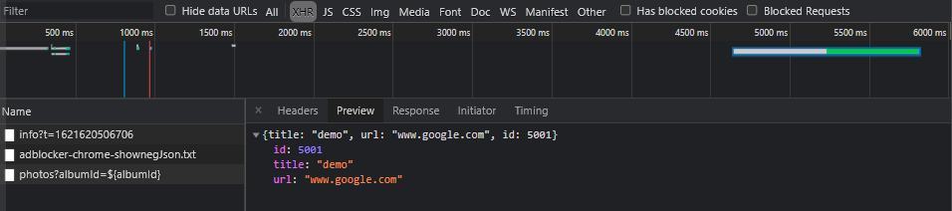 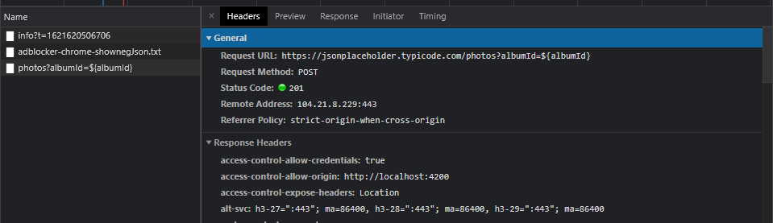

Deleting a photo:

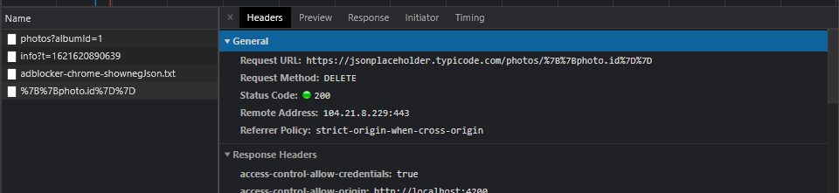

Code:

add-photo.component.css

|  |
| --- |
| h1{      margin-bottom: 40px;  }  .container{      margin: auto;      padding: 50px;      background-color: rgb(247, 234, 234);      font-size: 1.3em;  }  label, input{  margin-bottom: 40px;  }  label{      font-weight: bold;  }  input{      border: none;      height: 3em;  }  button{      font-size: 1.2em;  }  input.ng-invalid{      border-left: 5px solid red;  }  input.ng-valid{      border-left: 5px solid green;  }  .error{      color: red;  } |

add-photo.component.html:

|  |
| --- |
| <div class="container">      <h1>Add Photo:</h1>      <form [formGroup]="addForm" id="form" method="POST">          <div class="form-group">              <label class="col-md-3">Title:</label>              <input id="title" type="text" formControlName="title" placeholder="Enter Title" class="col-md-9"                  class="form-control">              <p class="error" *ngIf="f.title.invalid && f.title.touched">Title is required.</p>          </div>          <div class="form-group">              <label class="col-md-3">Url:</label>              <input id="url" type="text" placeholder="Enter url of the photo" formControlName="url" class="col-md-9"                  class="form-control">              <div *ngIf="f.url.touched && f.url.invalid" class="alert alert-danger">                  <div *ngIf="f.url.errors?.required">URL is required.</div>                  <div *ngIf="f.url.errors?.pattern">Please enter valid url.</div>              </div>          </div>          <button id="btnSub" (click)=addPhoto() class="btn btn-primary" type="submit" [disabled]="!addForm.valid">Add              Photo</button>      </form>  </div> |

add-photo.component.spec.ts:

|  |
| --- |
| import { ComponentFixture, TestBed } from '@angular/core/testing';  import { AddPhotoComponent } from './add-photo.component';  describe('AddPhotoComponent', () => {    let component: AddPhotoComponent;    let fixture: ComponentFixture<AddPhotoComponent>;    beforeEach(async () => {      await TestBed.configureTestingModule({        declarations: [ AddPhotoComponent ]      })      .compileComponents();    });    beforeEach(() => {      fixture = TestBed.createComponent(AddPhotoComponent);      component = fixture.componentInstance;      fixture.detectChanges();    });    it('should create', () => {      expect(component).toBeTruthy();    });  }); |

add-photo.component.ts:

|  |
| --- |
| import { Component, OnInit } from '@angular/core';  import { FormControl, FormGroup, Validators } from '@angular/forms';  @Component({    selector: 'app-add-photo',    templateUrl: './add-photo.component.html',    styleUrls: ['./add-photo.component.css'],  })  export class AddPhotoComponent implements OnInit {    constructor() {}    addForm = new FormGroup({      title: new FormControl('', Validators.required),      url: new FormControl('', [        Validators.required,        Validators.pattern(          '(https?://)?([\\da-z.-]+)\\.([a-z.]{2,6})[/\\w .-]*/?'        ),      ]),    });    get f() {      return this.addForm.controls;    }    addPhoto(){      fetch('https://jsonplaceholder.typicode.com/photos?albumId=${albumId}', {        method: 'POST',        body: JSON.stringify({            title: this.f.title.value,            url: this.f.url.value,        }),        headers: {            'Content-type': 'application/json; charset=UTF-8',        },    })        .then((response) => response.json())        .then((json) => console.log(json));    }    ngOnInit(): void {}  } |

albums.component.css:

|  |
| --- |
| h3 {      margin-top: 5%;      margin-bottom: 5%;    }      .card {      margin-bottom: 3%;    }      .card:hover {      background-color: #007bff;    }      .card:hover a {      color: white;    }      .card a:hover {      color: white;      text-decoration: none;    } |

albums.component.html:

|  |
| --- |
| <div>      <h3> Albums collection</h3>      <div class="row">          <div class="col-sm-4" *ngFor="let album of albums | async">              <div class="card">                  <div class="card-body">                      <a routerLink="photos/{{album.id}}">{{album.title}}</a>                  </div>              </div>          </div>      </div>  </div> |

albums.component.specs.ts:

|  |
| --- |
| import { ComponentFixture, TestBed } from '@angular/core/testing';  import { AlbumsComponent } from './albums.component';  describe('AlbumsComponent', () => {    let component: AlbumsComponent;    let fixture: ComponentFixture<AlbumsComponent>;    beforeEach(async () => {      await TestBed.configureTestingModule({        declarations: [ AlbumsComponent ]      })      .compileComponents();    });    beforeEach(() => {      fixture = TestBed.createComponent(AlbumsComponent);      component = fixture.componentInstance;      fixture.detectChanges();    });    it('should create', () => {      expect(component).toBeTruthy();    });  }); |

albums.component.ts:

|  |
| --- |
| import { PhotosService } from './../../services/photos.service';  import { Component, OnInit } from '@angular/core';  import { Observable } from 'rxjs';  @Component({    selector: 'app-albums',    templateUrl: './albums.component.html',    styleUrls: ['./albums.component.css'],  })  export class AlbumsComponent implements OnInit {    albums: any;    constructor(private photosService: PhotosService,) {}    ngOnInit(): void {      this.albums = this.photosService.getAlbums();    }  } |

edit-photo.component.css:

|  |
| --- |
| h1{      margin-bottom: 40px;  }  .container{      margin: auto;      padding: 50px;      background-color: rgb(248, 218, 218);      font-size: 1.3em;  }  label, input{  margin-bottom: 40px;  }  label{      font-weight: bold;  }  input{      border: none;      height: 3em;  }  button{      font-size: 1.2em;  } |

edit-photo.component.html:

|  |
| --- |
| <div class="container">      <h1>Edit Photo:</h1>      <form action="">          <label for="title" class="col-md-3">Title:</label>          <input type="text" placeholder="Enter Title" class="col-md-9">          <label for="url" class="col-md-3">Url:</label>          <input type="text" placeholder="Enter url of the photo" class="col-md-9">          <button type="button" class="btn btn-primary">Edit Photo</button>      </form>  </div> |

edit-photo.component.specs.ts:

|  |
| --- |
| import { ComponentFixture, TestBed } from '@angular/core/testing';  import { EditPhotoComponent } from './edit-photo.component';  describe('EditPhotoComponent', () => {    let component: EditPhotoComponent;    let fixture: ComponentFixture<EditPhotoComponent>;    beforeEach(async () => {      await TestBed.configureTestingModule({        declarations: [ EditPhotoComponent ]      })      .compileComponents();    });    beforeEach(() => {      fixture = TestBed.createComponent(EditPhotoComponent);      component = fixture.componentInstance;      fixture.detectChanges();    });    it('should create', () => {      expect(component).toBeTruthy();    });  }); |

edit-photo.component.ts:

|  |
| --- |
| import { Component, OnInit } from '@angular/core';  @Component({    selector: 'app-edit-photo',    templateUrl: './edit-photo.component.html',    styleUrls: ['./edit-photo.component.css']  })  export class EditPhotoComponent implements OnInit {    constructor() { }    ngOnInit(): void {    }  } |

photos.component.css:

|  |
| --- |
| .photo {      margin-bottom: 3%;      padding: 10px;      background-color: rgb(238, 224, 224);    }    h3 {      margin-bottom: 5%;      margin-top: 5%;    }    button {      margin-top: 10px;      margin-right: 10px;    } |

photos.component.html:

|  |
| --- |
| <div>    <button routerLink="/" class="btn btn-outline-primary">Go back</button>    <button class="btn btn-outline-primary" style="float: right;" routerLink="/add-photo">Add Photo</button>    <h3> Album {{albumId}}</h3>    <div class="row">      <div class="col-md-12 photo" *ngFor="let photo of photos | async">          <strong>Title: </strong> {{photo.title}}          <img src={{photo.url}} class="img-fluid col-md-3" style="float: right;"/>          <br>          <button id="edit" type="button" class="btn btn-primary"  routerLink="/edit-photo">Edit Photo</button>          <button type="button" (click)=deletePhoto(photo.id) class="btn btn-danger">Delete Photo</button>      </div>    </div>  </div> |

photos.component.specs.ts:

|  |
| --- |
| import { ComponentFixture, TestBed } from '@angular/core/testing';  import { PhotosComponent } from './photos.component';  describe('PhotosComponent', () => {    let component: PhotosComponent;    let fixture: ComponentFixture<PhotosComponent>;    beforeEach(async () => {      await TestBed.configureTestingModule({        declarations: [ PhotosComponent ]      })      .compileComponents();    });    beforeEach(() => {      fixture = TestBed.createComponent(PhotosComponent);      component = fixture.componentInstance;      fixture.detectChanges();    });    it('should create', () => {      expect(component).toBeTruthy();    });  }); |

photos.component.ts:

|  |
| --- |
| import { Component, OnInit } from '@angular/core';  import { PhotosService } from './../../services/photos.service';  import { ActivatedRoute } from '@angular/router';  @Component({    selector: 'app-photos',    templateUrl: './photos.component.html',    styleUrls: ['./photos.component.css'],  })  export class PhotosComponent implements OnInit {    photos: any;    albumId: any;    constructor(private photosService: PhotosService,      private route: ActivatedRoute,) {}    ngOnInit(): void {      this.albumId = this.route.snapshot.params.albumId;      this.photos = this.photosService.getPhotos(this.albumId);    }    deletePhoto(photo:any){      fetch(`https://jsonplaceholder.typicode.com/photos/{{photo.id}}`, {    method: 'DELETE',  });    }  } |

photos.service.spec.ts:

|  |
| --- |
| import { TestBed } from '@angular/core/testing';  import { PhotosService } from './photos.service';  describe('PhotosService', () => {    let service: PhotosService;    beforeEach(() => {      TestBed.configureTestingModule({});      service = TestBed.inject(PhotosService);    });    it('should be created', () => {      expect(service).toBeTruthy();    });  }); |

photos.service.ts:

|  |
| --- |
| import { Injectable } from '@angular/core';  import { HttpClient } from '@angular/common/http';  @Injectable({    providedIn: 'root',  })  export class PhotosService {    constructor(private http: HttpClient) {}    getAlbums() {      return this.http.get('https://jsonplaceholder.typicode.com/albums');    }    getPhotos(albumId: any) {      return this.http.get(`https://jsonplaceholder.typicode.com/photos?albumId=${albumId}`);    }  } |

app-routing.module.ts:

|  |
| --- |
| import { NgModule } from '@angular/core';  import { RouterModule, Routes } from '@angular/router';  import { AlbumsComponent } from './components/albums/albums.component';  import { PhotosComponent } from './components/photos/photos.component';  import { AddPhotoComponent } from './components/add-photo/add-photo.component';  import { EditPhotoComponent } from './components/edit-photo/edit-photo.component';  const routes: Routes = [    { path: '', component: AlbumsComponent },    { path: 'photos/:albumId', component: PhotosComponent },    { path: 'add-photo', component: AddPhotoComponent },    { path: 'edit-photo', component: EditPhotoComponent }  ];  @NgModule({    imports: [RouterModule.forRoot(routes)],    exports: [RouterModule]  })  export class AppRoutingModule { } |

app.component.html:

|  |
| --- |
| <div class="container">    <router-outlet></router-outlet>  </div> |

app.module.ts:

|  |
| --- |
| import { NgModule } from '@angular/core';  import { BrowserModule } from '@angular/platform-browser';  import { HttpClientModule } from '@angular/common/http';  import { AppRoutingModule } from './app-routing.module';  import { AppComponent } from './app.component';  import { AlbumsComponent } from './components/albums/albums.component';  import { PhotosComponent } from './components/photos/photos.component';  import { AddPhotoComponent } from './components/add-photo/add-photo.component';  import {ReactiveFormsModule} from '@angular/forms';  @NgModule({    declarations: [      AppComponent,      AlbumsComponent,      PhotosComponent,      AddPhotoComponent    ],    imports: [      BrowserModule,      AppRoutingModule,      HttpClientModule,      ReactiveFormsModule    ],    providers: [],    bootstrap: [AppComponent]  })  export class AppModule { } |

index.html:

|  |
| --- |
| <!doctype html>  <html lang="en">  <head>    <meta charset="utf-8">    <title>Albums</title>    <base href="/">    <meta name="viewport" content="width=device-width, initial-scale=1">    <link rel="icon" type="image/x-icon" href="favicon.ico">    <link href="https://cdn.jsdelivr.net/npm/bootstrap@5.0.1/dist/css/bootstrap.min.css" rel="stylesheet"      integrity="sha384-+0n0xVW2eSR5OomGNYDnhzAbDsOXxcvSN1TPprVMTNDbiYZCxYbOOl7+AMvyTG2x" crossorigin="anonymous">  </head>  <body>    <app-root></app-root>  </body>  </html> |