Dokumentácia k projektu internet vecí 2

**ESP32 teplomer**

15.5.2024 Jakub Kluvánek a Matúš Mahút

**1. Komponenty.**..............................................................................

**2**. **Zapojenie**.....................................................................................

**3**. **Kód**...............................................................................................

**4. Návod na obsluhu**........................................................................

Komponenty :

Esp32

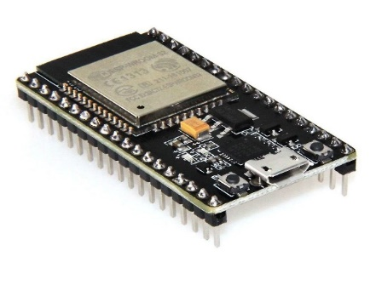

7 Segment display

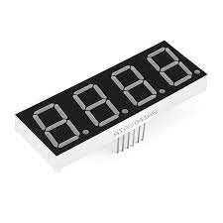

DTH22

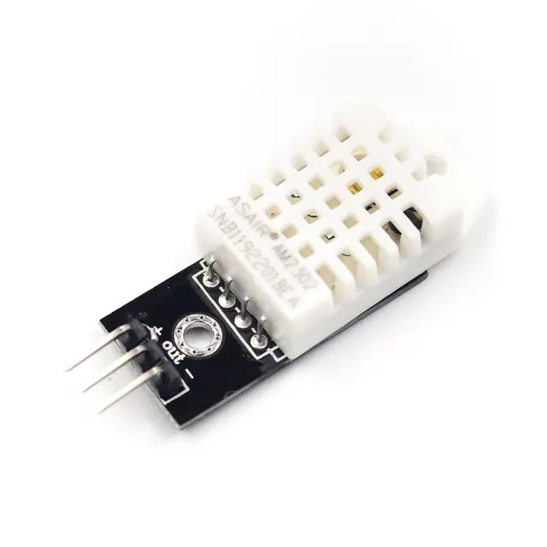

Káble

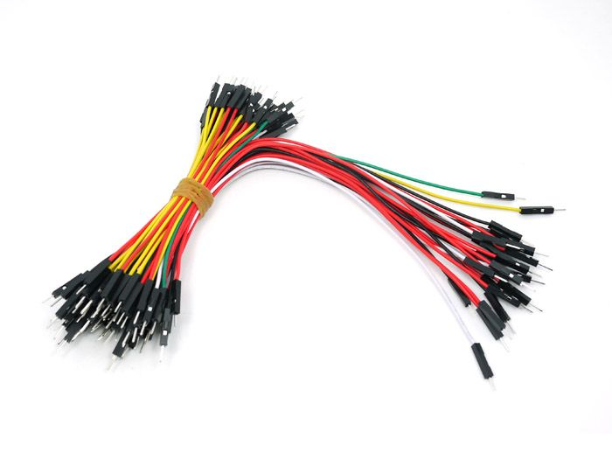

3D Krabička

Zapojenie :

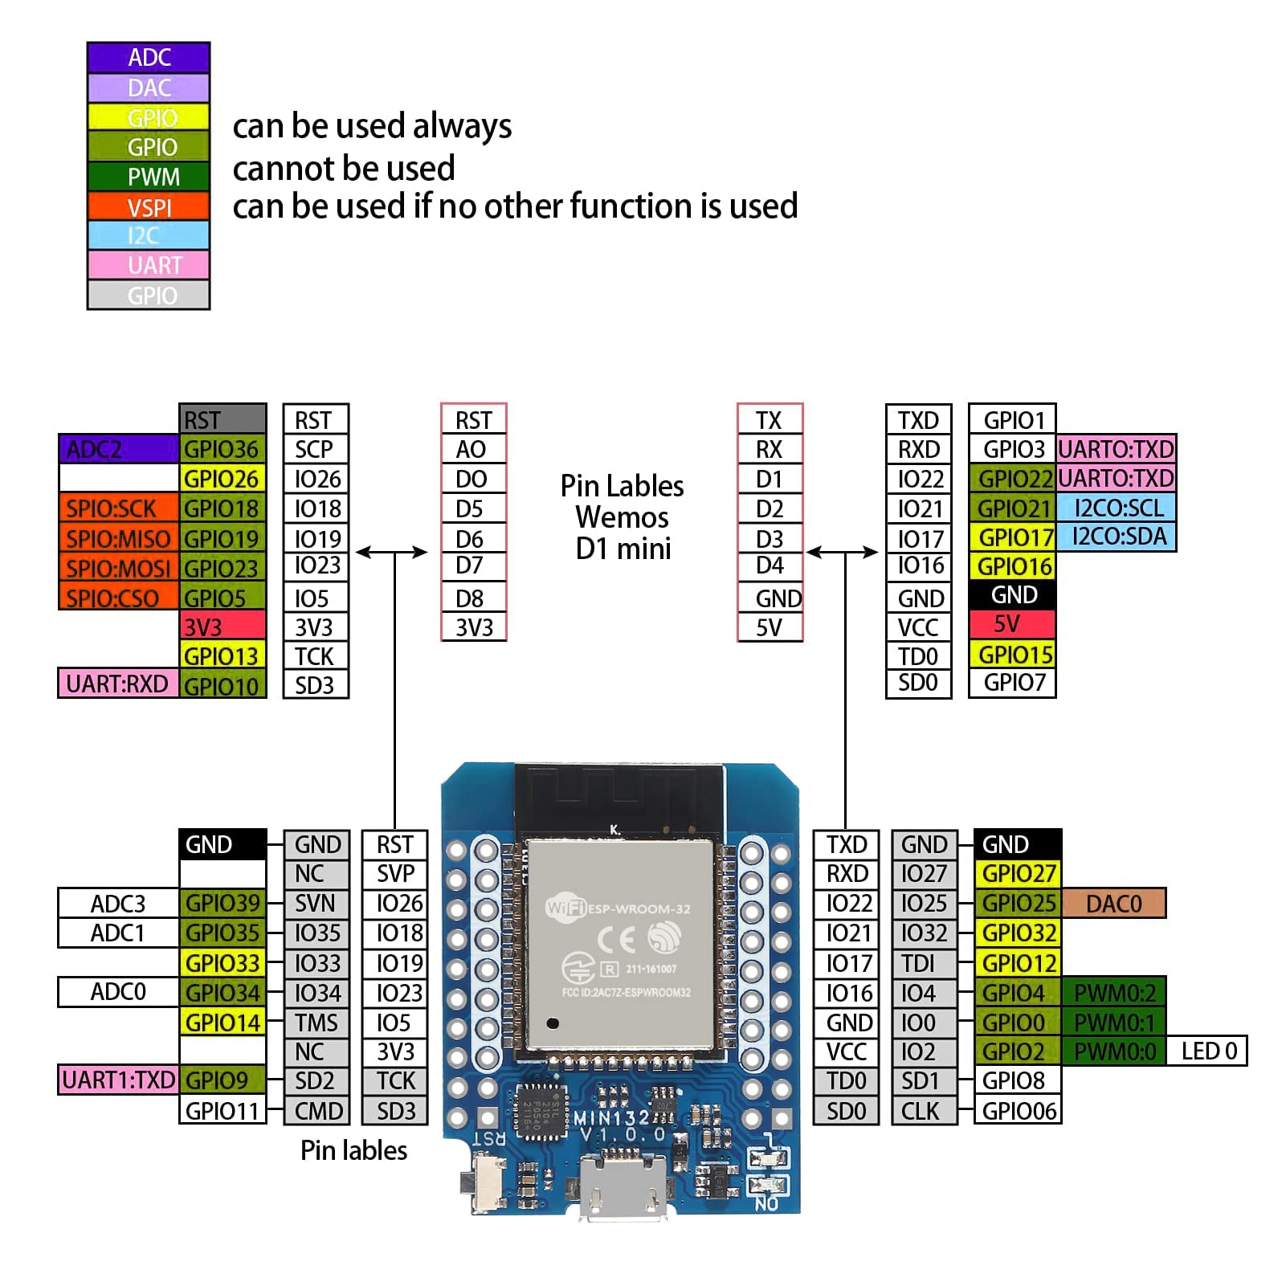

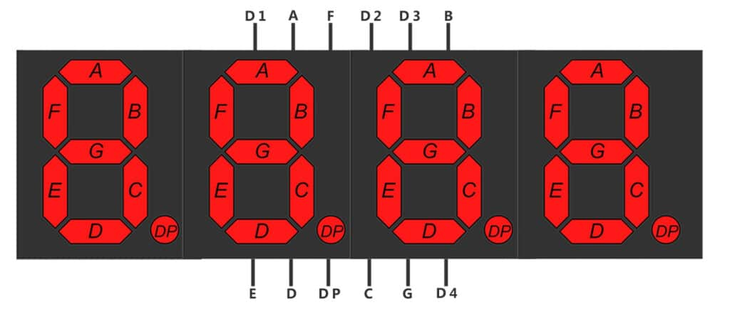

A – GPIO 1

B – GPIO 2

C – GPIO 32

D – GPIO 4

E – GPIO 5

F – GPIO 22

G – GPIO 14

DP – GPIO 26

D1 – GPIO 21

D2 – GPIO 19

D3 – GPIO 16

D4 – GPIO 18

DTH – GPIO 25

BUTTON 1 – GPIO 27

BUTTON 2 – GPIO 19

LED – GPIO 25



KÓD :

#include "DHT.h"

DHT dht;

int a=1;

int b=2;

int c=32;

int d=4;

int e=5;

int f=22;

int g=14;

int h=26;

int led=25;

int button=27;

int button2=19;

int button3=23;

int dig1=21;

int dig2=19;

int dig3=16;

int dig4=18;

void setup() {

pinMode(led,OUTPUT);

pinMode(button,INPUT);

pinMode(button2,INPUT);

pinMode(button3,INPUT);

pinMode(a,OUTPUT);

pinMode(a,OUTPUT);

pinMode(b,OUTPUT);

pinMode(c,OUTPUT);

pinMode(d,OUTPUT);

pinMode(e,OUTPUT);

pinMode(f,OUTPUT);

pinMode(g,OUTPUT);

pinMode(h,OUTPUT);

pinMode(dig1,OUTPUT);

pinMode(dig2,OUTPUT);

pinMode(dig3,OUTPUT);

pinMode(dig4,OUTPUT);

dht.setup(25);

}

void loop() {

delay(dht.getMinimumSamplingPeriod());

while(true){

float humidity = dht.getHumidity();

float temperature = dht.getTemperature();

if (temperature >= 10 && temperature <11 ) {

digit4();

celzia();

delay(2);

digit3();

zero();

delay(2);

digit2();

one();

delay(2);

}

if (temperature >= 11 && temperature <12 ) {

digit4();

celzia();

delay(2);

digit3();

one();

delay(2);

digit2();

one();

delay(2);

}

if (temperature >= 12 && temperature <13 ) {

digit4();

celzia();

delay(2);

digit3();

two();

delay(2);

digit2();

one();

delay(2);

}

if (temperature >= 13 && temperature <14 ) {

digit4();

celzia();

delay(2);

digit3();

three();

delay(2);

digit2();

one();

delay(2);

}

if (temperature >= 14 && temperature <15 ) {

digit4();

celzia();

delay(2);

digit3();

four();

delay(2);

digit2();

one();

delay(2);

}

if (temperature >= 15 && temperature <16 ) {

digit4();

celzia();

delay(2);

digit3();

five();

delay(2);

digit2();

one();

delay(2);

}

if (temperature >= 16 && temperature <17 ) {

digit4();

celzia();

delay(2);

digit3();

six();

delay(2);

digit2();

one();

delay(2);

}

if (temperature >= 17 && temperature <18 ) {

digit4();

celzia();

delay(2);

digit3();

seven();

delay(2);

digit2();

one();

delay(2);

}

if (temperature >= 18 && temperature <19 ) {

digit4();

celzia();

delay(2);

digit3();

eight();

delay(2);

digit2();

one();

delay(2);

}

if (temperature >= 19 && temperature <20 ) {

digit4();

celzia();

delay(2);

digit3();

nine();

delay(2);

digit2();

one();

delay(2);

}

if (temperature >= 20 && temperature <21 ) {

digit4();

celzia();

delay(2);

digit3();

zero();

delay(2);

digit2();

two();

delay(2);

}

if (temperature >= 21 && temperature <22 ){

digit4();

celzia();

delay(2);

digit3();

one();

delay(2);

digit2();

two();

delay(2);

}

if (temperature >= 22 && temperature <23 ){

digit4();

celzia();

delay(2);

digit3();

two();

delay(2);

digit2();

two();

delay(2);

}

if (temperature >= 23 && temperature <24 ){

digit4();

celzia();

delay(2);

digit3();

three();

delay(2);

digit2();

two();

delay(2);

}

if (temperature >= 24 && temperature <25 ){

digit4();

celzia();

delay(2);

digit3();

four();

delay(2);

digit2();

two();

delay(2);

}

if (temperature >= 25 && temperature <26 ){

digit4();

celzia();

delay(2);

digit3();

five();

delay(2);

digit2();

two();

delay(2);

}

if (temperature >= 26 && temperature <27 ){

digit4();

celzia();

delay(2);

digit3();

six();

delay(2);

digit2();

two();

delay(2);

}

if (temperature >= 27 && temperature <28 ){

digit4();

celzia();

delay(2);

digit3();

seven();

delay(2);

digit2();

two();

delay(2);

}

if (temperature >= 28 && temperature <29 ){

digit4();

celzia();

delay(2);

digit3();

eight();

delay(2);

digit2();

two();

delay(2);

}

if (temperature >= 29 && temperature <30 ){

digit4();

celzia();

delay(2);

digit3();

nine();

delay(2);

digit2();

two();

delay(2);

}

if (temperature >= 30 && temperature <31 ){

digit4();

celzia();

delay(2);

digit3();

zero();

delay(2);

digit2();

three();

delay(2);

}

if (temperature >= 31 && temperature <32 ){

digit4();

celzia();

delay(2);

digit3();

one();

delay(2);

digit2();

three();

delay(2);

}

if (temperature >= 32 && temperature <33 ){

digit4();

celzia();

delay(2);

digit3();

two();

delay(2);

digit2();

three();

delay(2);

}

if (temperature >= 33 && temperature <34 ){

digit4();

celzia();

delay(2);

digit3();

three();

delay(2);

digit2();

three();

delay(2);

}

if (temperature >= 34 && temperature <35 ){

digit4();

celzia();

delay(2);

digit3();

four();

delay(2);

digit2();

three();

delay(2);

}

if (temperature >= 35 && temperature <36 ){

digit4();

celzia();

delay(2);

digit3();

five();

delay(2);

digit2();

three();

delay(2);

}

if (temperature >= 36 && temperature <37 ){

digit4();

celzia();

delay(2);

digit3();

six();

delay(2);

digit2();

three();

delay(2);

}

if (temperature >= 37 && temperature <38 ){

digit4();

celzia();

delay(2);

digit3();

seven();

delay(2);

digit2();

three();

delay(2);

}

if (temperature >= 38 && temperature <39 ){

digit4();

celzia();

delay(2);

digit3();

eight();

delay(2);

digit2();

three();

delay(2);

}

if (temperature >= 39 && temperature <40 ){

digit4();

celzia();

delay(2);

digit3();

nine();

delay(2);

digit2();

three();

delay(2);

}

if (temperature >= 40 && temperature <41 ){

digit4();

celzia();

delay(2);

digit3();

zero();

delay(2);

digit2();

four();

delay(2);

}

if (temperature >= 41 && temperature <42 ){

digit4();

celzia();

delay(2);

digit3();

one();

delay(2);

digit2();

four();

delay(2);

}

if (temperature >= 42 && temperature <43 ){

digit4();

celzia();

delay(2);

digit3();

two();

delay(2);

digit2();

four();

delay(2);

}

if (temperature >= 43 && temperature <44 ){

digit4();

celzia();

delay(2);

digit3();

three();

delay(2);

digit2();

four();

delay(2);

}

if (temperature >= 44 && temperature <45 ){

digit4();

celzia();

delay(2);

digit3();

four();

delay(2);

digit2();

four();

delay(2);

}

if (temperature >= 45 ){

digit4();

celzia();

delay(2);

digit3();

five();

delay(2);

digit2();

four();

delay(2);

}

}

}

void celzia(){

digitalWrite(a, LOW);

digitalWrite(b, LOW);

digitalWrite(c, LOW);

digitalWrite(d, LOW);

digitalWrite(e, HIGH);

digitalWrite(f, HIGH);

digitalWrite(g, HIGH);

}

void zero(){

digitalWrite(a, LOW);

digitalWrite(b, LOW);

digitalWrite(c, LOW);

digitalWrite(d, LOW);

digitalWrite(e, LOW);

digitalWrite(f, LOW);

digitalWrite(g, HIGH);

}

void one(){

digitalWrite(a, HIGH);

digitalWrite(b, HIGH);

digitalWrite(c, HIGH);

digitalWrite(d, HIGH);

digitalWrite(e, LOW);

digitalWrite(f, LOW);

digitalWrite(g, HIGH);

}

void two(){

digitalWrite(a, LOW);

digitalWrite(b, LOW);

digitalWrite(c, HIGH);

digitalWrite(d, LOW);

digitalWrite(e, LOW);

digitalWrite(f, HIGH);

digitalWrite(g, LOW);

}

void three(){

digitalWrite(a, LOW);

digitalWrite(b, HIGH);

digitalWrite(c, HIGH);

digitalWrite(d, LOW);

digitalWrite(e, LOW);

digitalWrite(f, LOW);

digitalWrite(g, LOW);

}

void four(){

digitalWrite(a, HIGH);

digitalWrite(b, HIGH);

digitalWrite(c, LOW);

digitalWrite(d, HIGH);

digitalWrite(e, LOW);

digitalWrite(f, LOW);

digitalWrite(g, LOW);

}

void five(){

digitalWrite(a, LOW);

digitalWrite(b, HIGH);

digitalWrite(c, LOW);

digitalWrite(d, LOW);

digitalWrite(e, HIGH);

digitalWrite(f, LOW);

digitalWrite(g, LOW);

}

void nine(){

digitalWrite(a, LOW);

digitalWrite(b, HIGH);

digitalWrite(c, LOW);

digitalWrite(d, LOW);

digitalWrite(e, LOW);

digitalWrite(f, LOW);

digitalWrite(g, LOW);

}

void seven(){

digitalWrite(a, HIGH);

digitalWrite(b, HIGH);

digitalWrite(c, HIGH);

digitalWrite(d, LOW);

digitalWrite(e, LOW);

digitalWrite(f, LOW);

digitalWrite(g, HIGH);

}

void eight(){

digitalWrite(a, LOW);

digitalWrite(b, LOW);

digitalWrite(c, LOW);

digitalWrite(d, LOW);

digitalWrite(e, LOW);

digitalWrite(f, LOW);

digitalWrite(g, LOW);

}

void six(){

digitalWrite(a, LOW);

digitalWrite(b, LOW);

digitalWrite(c, LOW);

digitalWrite(d, LOW);

digitalWrite(e, HIGH);

digitalWrite(f, LOW);

digitalWrite(g, LOW);

}

void digit1(){

digitalWrite(dig1, LOW);

digitalWrite(dig2, LOW);

digitalWrite(dig3, LOW);

digitalWrite(dig4, HIGH);

digitalWrite(h, HIGH);

}

void digit2(){

digitalWrite(dig1, LOW);

digitalWrite(dig2, LOW);

digitalWrite(dig3, HIGH);

digitalWrite(dig4, LOW);

digitalWrite(h, HIGH);

}

void digit3(){

digitalWrite(dig1, LOW);

digitalWrite(dig2, HIGH);

digitalWrite(dig3, LOW);

digitalWrite(dig4, LOW);

digitalWrite(h, HIGH);

}

void digit4(){

digitalWrite(dig1, HIGH);

digitalWrite(dig2, LOW);

digitalWrite(dig3, LOW);

digitalWrite(dig4, LOW);

digitalWrite(h, LOW);

}

Návod na obsluhu :