|  |
| --- |
| Hotel Chocolat in germany  Student Name  Student ID  Date |
|  |



Table of Contents

1. Introduction 3

2. Recommendations on future products/services in Germany 3

3. Pricing strategy for Hotel Chocolat in Germany 5

3.1. Critical factors needed to be considered 6

4. Most suitable method to enter in Germany for Hotel Chocolat 6

5. Marketing Communication plan for Hotel Chocolat in Germany 7

6. Conclusion 8

References 9

# Introduction

Hotel Chocolat is one of the leading chocolate companies of the world, having presence in many nations and always looking to expand further and further. The company is based in British and having shops in UK all over the country. With the passage of time, this company has been able to generate quite a lot of revenues, and that too by expanding to different nations and meeting the demands of customers. The revenues of the company can be seen in the figure below:

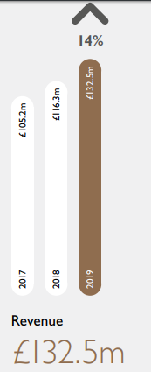

Figure revenues (Annual Report of Hotel Chocolat, 2019)

The revenues above indicate that this company is progressing each year and many firms in both the UK and other nations consider it as a major threat. This report presents the recommendation to the management of Hotel Chocolat to expand to Germany, where market of chocolate is good. The explanation of future products which should be launched in Germany along with marketing tactics is explained in this report.

# Recommendations on future products/services in Germany

Before presenting the recommendations on future product to be launched, it is important to observe the chocolate trends which have been seen in Germany hence making it an attractive market to be launched in this country. In an investigation of Kawasaki and Asahi (2019), it is stated that chocolate consumption in Germany and Japan both is increasing. Especially in Germany, the annual consumption is 5 times more as compared to other nations of the world. Hence, making it an attractive market to enter in Germany. Due to this reason, the management of Hotel Chocolat must be looking to enter in Germany to secure competitive advantage.

When the management of Hotel Chocolat will be entering in Germany, it would be developing it’s competitive advantage rapidly if given recommendations are applied, which will assist this company to enter in the market and become sustainable in the given time period. In the investigation of Slavova (2017), Germany is one of the most historical countries, where chocolate is manufactured in big quantities. Based on the assessment of the chocolate consumption, the management of Hotel Chocolat should be willing to introduce only the best products in Germany, because if the quality is good, the management would be able to generate desired revenues. Gohlke (2017) presented the following figure showing chocolate consumption in different nations:

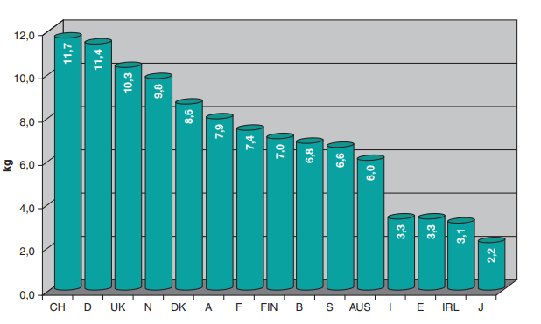

Figure consumption of chocolate in Germany and other countries (Gohlke, 2017)

The second column indicates chocolate consumption in Germany, which is significantly higher as compared to other nations.

After seeing the consumption of chocolate above, it can be stated that Germany is being observed as one of the leading nations where market can be established. Based on the assessment above, the following products range should be introduced in Germany:

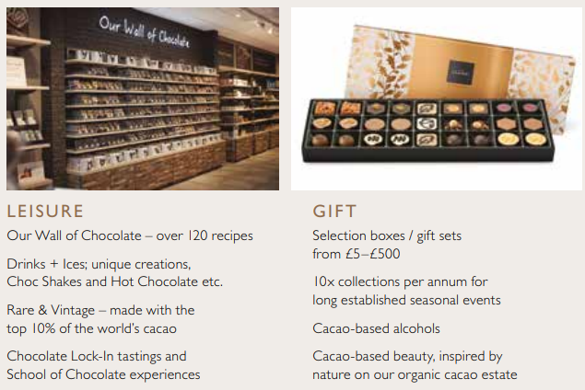

Figure recommended chocolate range

The management of Hotel Chocolat should not be introducing new products in Germany, because it’s already products are quire diversified. Some of the most important products, which should be launched are outlined below:

1. Chocolate range with different ingredients. For example, Florentine Isabelle, Pistachio, Cashew nuts, Dizzy Praline, Illegal Gianduja, Hazelnut and Peanut Butter. According to Akoakwa (2016), different forms of chocolates are now being researched in Germany, and hazelnut, pistachio etc, sit on top of the list.
2. The management of Hotel Chocolat is selling the products in different cities, and some of the top selling products come from the use of Cacao. It is recommended that management should sell The alcohol bottles in Germany, especially with flavours of Cacao Gin, Salted Caramel Vodka and Chocolate Cream Liqueur. Reason to recommend this is because it is top selling in the UK, and alcohol is also consumed in Germany.

# Pricing strategy for Hotel Chocolat in Germany

The pricing strategy is considered one of the most important aspects in new nation, especially when not much is known about that country. In an Investigation of Fedeseeva et al., (2017), it is stated that management of different organisations in Germany keep pricing of chocolate products significantly high, and it is because most of the people in Germany are rich and can afford. There are numerous pricing strategies followed by the competitors of Hotel Chocolat, which will be required to be considered before launching the products. The table below explains some of the most top-selling products in chocolate category in Germany:

Table Price comparison of different chocolate bars (Fedeseeva et al., 2017)

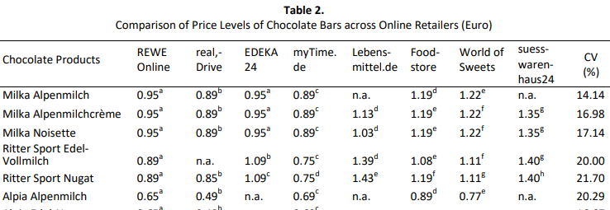

The prices above indicate that most of the prices are not very high, and range between 0.90 Euros to 1.43 Euros per product. Considering the above price range, it can be stated that performance of the organisations will depend on following low-to-medium prices set for the products. Considering the above prices, it is recommended that the management of Hotel Chocolat should be looking to sell their products at the price, which is also in between them. The next heading explains some critical success factors needed to be considered in Germany.

## Critical factors needed to be considered

The pricing strategy will be playing an important role in launching and selling the products of Hotel Chocolat in Germany. If prices are kept more than 2 Euros per bar, it would be difficult to generate sales, because average cost of even top products in chocolate category is lying between 1-1.5 euros as analysed in the last heading. In addition, the findings of Bose (2016) reported that many factors should be considered when making international business entry and one of them is policy development in new workplace, innovation development platform, operations management, and modes of entry sit on top of the list. Hence, these are some of the CSFs, which would be needed to be considered by the management of Hotel Chocolat.

# Most suitable method to enter in Germany for Hotel Chocolat

There are many methods to enter in a nation, and one of the most suited for the management of Hotel Chocolat is making use of retail stores and outlet in Germany. According to the investigation of Lomachenko and Kokodey (2020), most of the organisations selling their products in Germany by using bakeries, retail stores and company-owned outlets. Considering the fact that management of Hotel Chocolat is having retained earnings of 33,358,932 pounds, the management should be using 10% only (i.e 3,335,893 pounds) of this retain earning to open at least 50 stores in different cities of Germany. The cities, where chocolate is consumed in highest numbers are titled as Munich, Berlin, Cologne, and many other big cities, where it can be sold.

Considering the fact, that Hotel Chocolat has extensive experience of operating in other European nations like Denmark and Ireland, it would not be facing too many issues in opening stores in Germany. When the management would be willing to open stores in Germany, it should also keep contract with the retail stores in this nation. In addition, before launching the products, the license must be obtained, and permission should be taken with government.

# Marketing Communication plan for Hotel Chocolat in Germany

The marketing communication plan is considered an important perspective in the development of new business market, especially when little experience is seen in that market. Since Mr Thirlwell added that Hotel Chocolat had received approaches to open new stores in Europe, Canada and South Korea but he said that he wanted the company to restrain itself, the methods of marketing communication are explained in this perspective. In an investigation of De Perlmaeker (2016), it is believed that marketing communication plan best plays a role in chocolate selling, when advertisement campaigns are launched. However, these marketing campaigns should be launched by making creative campaigns, which comprise of colourful visualization of the products.

Considering the above recommendations, the management of Hotel Chocolat should be willing to introduce the products by looking at the consumer purchasing intentions, and believing that they would produce fruitful results for the management. For this purpose, social media marketing on Facebook, Instagram, Snapchat and Twitter should be launched. In addition, Television is watched by people of all age group, who can be targeted, (illustrated in the figure below):

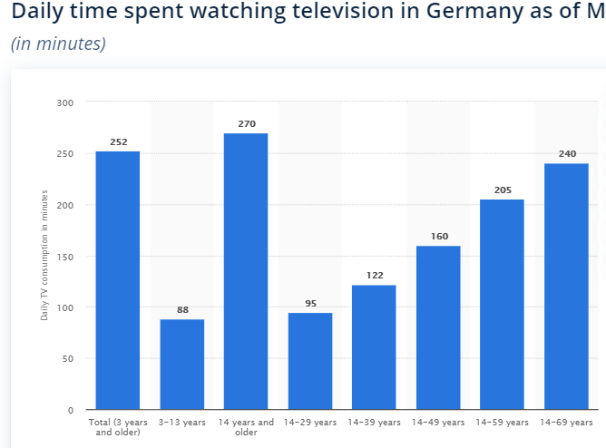

Figure Daily time spent watching television in Germany as of March 12, 2020, by age group (in minutes) (Statista, 2020)

The above statistics indicate that if appropriate investment is done on TV campaigns, people of all age groups can be attracted by the management of Hotel Chocolat.

# Conclusion

This report explained how the management of Hotel Chocolat can enter in Germany, and the reason it should. In this investigation, the focus was on the development of new market entry strategies for the management. After analysing the market for Hotel Chocolat it can be recommended that Germany is country where is consumed by almost all the people, hence proving to be a lucrative market for the management. In addition, the management should be launching the products using social media and electronic media marketing, and by launching stores in big cities of Germany.

# References

Afoakwa, E.O., 2016. *Chocolate science and technology*. John Wiley & Sons.

Annual Report of Hotel Chocolat (2019). *Annual Report.* [online] available at: <https://www.hotelchocolat.com/on/demandware.static/-/Sites-HotelChocolat-Library/default/dw73fc2dda/ANNUAL%20REPORT%20AND%20ACCOUNTS%20FY19%20-%2010TH%20OCTOBER%202019.pdf> [accessed 13 July 2020]

Bose, T.K., 2016. Critical success factors of SME internationalization. *Journal of Small Business Strategy*, *26*(2), pp.87-109.

De Pelsmaeker, S., 2016. *Understanding sensory analysis in consumer-driven product development in chocolate confectionary* (Doctoral dissertation, Ghent University).

Fedoseeva, S., Grein, T. and Herrmann, R., 2017. How German online retailers price foods: An empirical analysis for chocolate products. *International Journal on Food System Dynamics*, *8*(1), pp.32-44.

Gohlke, H., 2017. General Principles of Nutrition Support in Cardiac Rehabilitation. In *Cardiac Rehabilitation Manual* (pp. 31-72). Springer, Cham.

Kawasaki, K. and Asahi, Y., 2019, July. New Habits to Increase 5 Times the Annual Chocolate Consumption of Japan. In *International Conference on Human-Computer Interaction* (pp. 437-448). Springer, Cham.

Lomachenko, T.I. and Kokodey, T.A., 2020, January. Profiling of agro-industrial enterprises as a prerequisite for efficient strategic management. In *IOP Conference Series: Earth and Environmental Science* (Vol. 421, No. 2, p. 022052). IOP Publishing.

Slavova, G., 2017. Global and domestic bulgarian production of cocoa and chocolate articles for the period 2013-2016. *Trakia J. Sci*, *15*, pp.10-17.

Statista (2020). *Daily time spent watching television in Germany as of March 12, 2020, by age group(in minutes)*. [online] available at: <https://www.statista.com/statistics/380266/daily-tv-consumption-germany/> [accessed 13 July 2020]