Operations management McDonald’s

By [name]

[Class name]

[Professor]

[School name]

[City and the state]

[The date]

Table of Contents

1 Introduction 4

2 Part one 4

2.1. Background of operations 4

3 Part – 2 Transformation process at McDonald’s 5

3.1. Operations management through the transformation process 6

3.2. The ‘4Vs’ analysis in McDonald’s 7

3.2.1. Volume 8

3.2.2. Variety 8

3.2.3. Variation 8

3.2.4. Visibility 9

3.3. Five performance objectives at McDonald’s and the 9

3.3.1. Speed 10

3.3.2. Dependability 10

3.3.3. Flexibility 10

3.3.4. Cost 11

3.3.5. Quality 11

4 Part 3 - Process design 11

4.1. Key process in McDonald’s 11

4.2. Layout and flow of customers, materials (supply chain) and information 12

4.2.1. Location selection methods 12

4.2.2. Restaurant layout and flow of customers 12

4.3. Supply chain 13

4.4. The issue in operations, along with the solution and control strategies 14

5 Conclusion 15

References 16

# Introduction

McDonald’s is one of the biggest food chains in the world, with more than 36,000 restaurants in 119 countries (Laudon and Laudon, 2018). McDonald’s also operates in the UK, with an estimated revenue contribution of 30% in the overall revenue (Laudon and Laudon, 2018). The operations management at McDonald’s is diversified, and it is believed that the management of McDonald’s is capable to meet the operations and supply chain issues in the UK. This report outlines some important parameters of McDonald’s operations management and evaluates them by working on the following objective:

* To investigate and analyse the operations, and process management of McDonald’s in the UK with a focus to investigate the supply chain management practices.

# Part one

## Background of operations

McDonald’s first restaurant came in 1948 by two brothers in San Bernardino, California (Lal and Bharadwaj, 2015). The restaurant was expanded by Ray Kroc, the 1st CEO of McDonald’s. McDonald’s is a chain of restaurant, which aims to expand to all the countries, however, it faces intense competition from many restaurants. According to the study of Laudon and Laudon, (2018) McDonald’s currently stands at the fifth largest company by employing approximately 2 million people. McDonald’s currently suffers competition with small as well as big restaurants in the UK. In addition, the products range offered by McDonald’s include burgers, shakes, wraps, filets, fries, salads, and a variety of McCafe special products (Laudon and Laudon, 2018).

In the UK, many competitors create problems for the McDonald’s and force the management to take risks every day to beat them. Lal and Bharadwaj, (2015) found that leading competitors of McDonald’s in the UK are, Starbucks, Burger King and Subway. The management of McDonald’s targets people of different age groups, which mostly lie in the range of 16-60 years (Mădălina 2015). The recent performance of the McDonald’s can be noticed in the graph below:

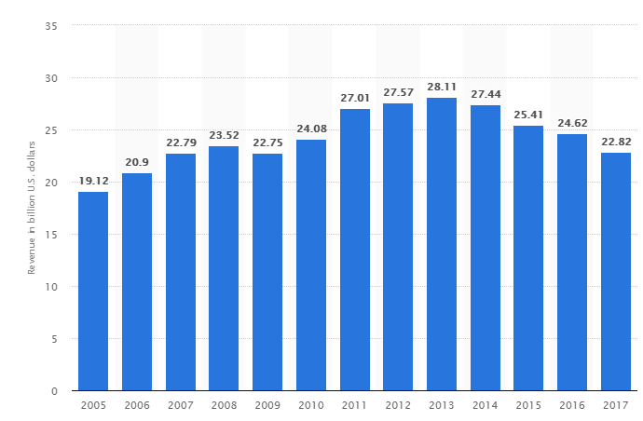

Figure 1 McDonald’s revenues 2017 (Source: Statista, 2018)

In the revenues generated by the McDonald’s is can be seen that the management performed well in the last few years. Although revenues of McDonald’s currently declining, it is not severe, and the management can overcome them by adopting different strategies (Rowley and McMurtrey, 2016). According to the study of Pullman and Collins, (2013) McDonald’s can improve the performance by working on some parameters, which include the development of quality products, increasing the product range and by offering hygienic food to the customers.

# Part – 2 Transformation process at McDonald’s

Operations management at McDonald’s plays a major role in allowing the management to achieve desired revenues. Although different countries and regions have different foods and the taste buds, nevertheless, the management of McDonald’s is able to develop new products every time other restaurants find hard to achieve.

## Operations management through the transformation process

To present the operations management at McDonald’s, the ‘input-transformation-output’ process model is applied in this section. Mădălina (2015) wrote that the services nature offered by McDonald’s can be taken as the input elements as they produce outputs for the McDonald’s. Input system in the presented model is the one, which acts as the factor contributing to the value and economics of McDonald’s. The figure below provides the inputs of McDonald’s. McDonald’s has inputs which depend on raw materials, and the methods used to receive them, storekeeping them and warehousing (Rowley and McMurtrey, 2016).

Furthermore, Pullman and Collins, (2013) wrote that sales information should be considered, along with car parking, equipment, payment to the staff and support also contribute to the elements. The transformation procedures normally followed in the McDonald’s, UK include bun toasting, assembling and picking up the products immediately (Pullman and Collins, 2013; Mahajan 2014). If all the operations are carried out within quick times, it leads to some outputs, which include satisfied customers and a cosy environment in the restaurant. Mădălina (2015) and Rowley and McMurtrey, (2016) wrote that the influencers in McDonald’s are diversified, which include economical standards, technology advancement, economics and environmental changes. While the management makes use of customer feedback to improve the operation’s weaknesses.

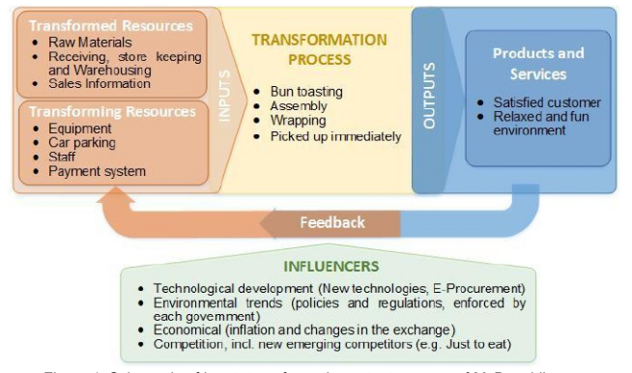

Figure 2 Transformation process (Source: Pullman and Collins, 2013)

## The ‘4Vs’ analysis in McDonald’s

The method of 4Vs is also a way to explain the transformation process at a restaurant, as it describes the means of 4 relevant aspects, volume, variety, visibility and variations (Mădălina 2015). The four aspects of the 4Vs followed by McDonald’s can be noticed in the figure below:

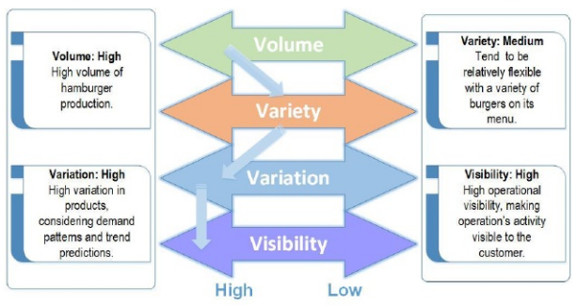

Figure 3 4Vs in operations of McDonald’s (Source: Pullman and Collins, 2013)

### Volume

According to the study of Mahajan (2014), the McDonald’s need to produce a large portion of buns in order to meet the production demands on a daily basis. Dai, Peng and Li, (2017) wrote that McDonald’s manage the production by using special technologies in order to achieve high-volume process at a low cost.

### Variety

McDonald’s is famous to deliver a good variety of food especially the volume of burgers sit at the top of the list. According to the study of Mirzabeiki (2013) although the customers in different areas prefer to eat different items, therefore, in accordance to the context of shop localisation, the variety of burgers are quite rare. The delivery process at McDonald’s is standardised.

### Variation

Gubán and Kása, (2013) wrote that McDonald’s has a high variation of demand. McDonald’s receives customer demands in variations at different times of the day. Variations in season also occur at McDonald’s and the management knows when the trend or season will come. Koh et al. (2014) also wrote that the management of McDonald’s knows when the customer will arrive and at what time. Therefore, the management is always ready to serve by following Just-in-time (JIT) methodology.

### Visibility

McDonald’s increase operational visibility to the visiting customers, by making use of many marketing platforms as argued by Mirzabeiki (2013). For example, McDonald’s sponsors different companies and events; in addition, Czajkowska and Stasiak-Betlejewska, (2015) wrote that McDonald’s takes conscious steps by ensuring transparency in the restaurants. This makes McDonald’s a restaurant with high visibility.

## Five performance objectives at McDonald’s and the

In order to allocate the resources effectively during the operations, it must be ensured that operations performance parameters are recorded, monitored and reviewed (Wieland 2013). Osman, Johns and Lugosi, (2014) wrote that performance cannot be improved without the use of appropriate performance measuring parameters, which should be in line with the internal and external competitive performance parameters. At McDonald’s, the operations execution depends on the five performance objectives, which are:

* Flexibility
* Quality
* Cost
* Dependability
* Speed

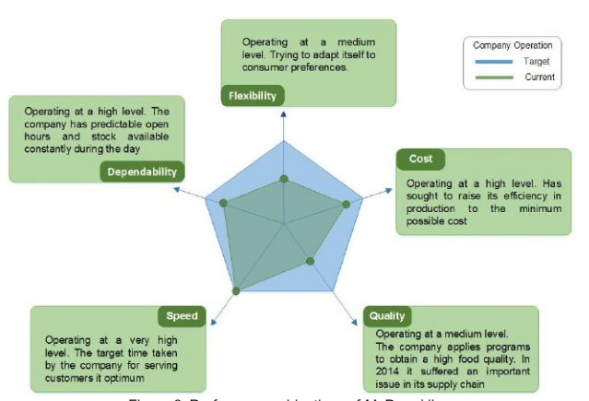

Figure 4 Performance objectives (Source: Wieland, 2013)

### Speed

McDonald’s is famous for quick operations in the UK, and according to two studies of Priyono (2017) and Osman, Johns and Lugosi, (2014) the restaurant staff follows “Speedee Service System”. By following the approach, they are able to deliver the orders within 60-120 seconds (Priyono 2017).

### Dependability

The management of McDonald’s operates at a high-level operations. Belvedere (2014) wrote that McDonald’s operates on predictable opening hours and stock availability, which allows the management to deliver orders with the same speed.

### Flexibility

As noticed in the figure that flexibility operates at medium level. Brown et al. (2013) argue that McDonald’s makes use of digital media boards to present key customer demographics. This approach allows the management to adapt to change in every country it operates. However, Jacobs, Chase and Lummus, (2014) wrote that the management of McDonald’s should look for the possibility to accommodate the shifts according to the special schedules.

### Cost

McDonald’s’ cost operates at a high level, and the management wants to increase its efficiency in production, by minimising the risks in the inputs (Jacobs, Chase and Lummus, 2014). According to the study of Priyono (2017) currently, McDonald’s follows Just in time methodology in the operations, which means that shop cooks or assembles food when an order is received.

### Quality

The quality operates at the medium level and Mădălina (2015), wrote that McDonald’s applies Hazard Analysis and Critical Control Point (HACCP), which assists the management to ensure that food supply chain is safe. HACCP is a program which allows the management of McDonald’s in identifying the potential hazards in the production line, on a real-time basis.

# Part 3 - Process design

## Key process in McDonald’s

It is the necessity of an organisation to arrange diverse machines and departments to reduce the production time and the achieve maximum output (Laudon and Laudon, 2018). Currently, the key process to be analysed in this part is to address the issue of facility location, which needs attention (Rowley and McMurtrey, 2016; Dai, Peng and Li, 2017). The issue is considered by looking the number of customers needed to be served and the satisfying them by taking location decisions.

## Layout and flow of customers, materials (supply chain) and information

### Location selection methods

Rowley and McMurtrey, (2016) argue that McDonald’s always locates, by looking at the business generating locations, play lands and shopping areas. Arguing with the statement, Koh et al. (2014) wrote that McDonald’s open the branch in areas where the target market comprises of the corporate market and people of the working category. In addition, McDonald’s also open the restaurant on targeted locations where play lands and shopping areas are present.

### Restaurant layout and flow of customers

The layout design in the manufacturing systems plays a vital role. McDonald’s suffers from facility layout problem (FLP), and any changes in the layout will significantly increase the expenses (Mădălina 2015); Rowley and McMurtrey, 2016). Interior and exterior of McDonald’s are explained under the headings below:

#### Exterior

The exterior of the McDonald’s’ restaurant is according to the customers’ numbers and flow (Jacobs, Chase and Lummus, 2014). According to Wieland (2013), the restaurant design is standard, with slight differences according to locations. The design aims to reduce the time and achieve customer satisfaction without losing food quality. Exterior design plays an important role in identifying McDonald’s from outside (Belvedere 2014).

#### Interior

Standard interior design is used by McDonald’s, supported with indoor seating, including breakfast in the menu, drive-through windows and developing play-areas (Mahajan 2014). McDonald’s offers touch-screen ordering, customizable burgers, and table service (Rowley and McMurtrey, 2016). The kitchen design followed by McDonald’s is given in the image below:

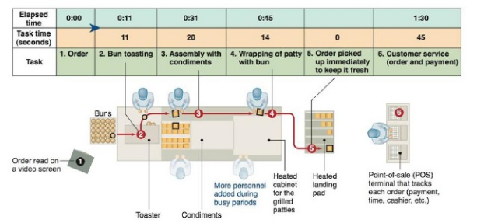

Figure 5 Kitchen design (Source: Mahajan, 2014)

The layout allows the management to prepare sandwiches in quick succession due to the shortening of some steps. For example, a new bun toasting machine allows the management to meet cooking targets quickly, and it is estimated that this new design of kitchen saves $100,000,000/ year in the food costs (Gubán and Kása, 2013).

The management of McDonald’s is able to achieve the business objectives effectively by working on the shorter deadlines, however, some issues reported are analysed under next heading.

## Supply chain

McDonald’s work established suppliers only in the UK who provide food, equipment, packaging and equipment on strict deadlines (Mirzabeiki 2013). Lal and Bharadwaj, (2015) wrote that McDonald’s use the Electronic-Procurement platform (E-procurement) to meet the business targets, and the system is managed for controlling the information flow and collecting the information on an online software platform. E-mac digital is the company, which provides the software, and the way it is followed can be looked in the figure below:

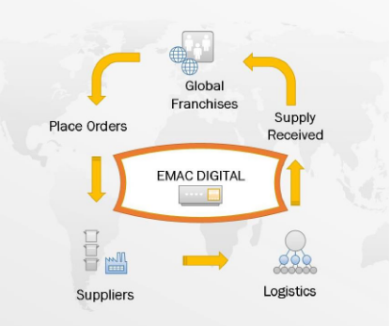

Figure 6 McDonald's e-procurement model (Source: Mahajan, 2014)

Suppliers in McDonald’s are divided into two tiers:

**Tier-1 suppliers (food processing technology):** Keystone and Ecsa are the major distributors.

**Tier-2 suppliers (growing processing):** Moy Park, Sun Valley, Coca-Cola, Tropicana and Buxton send the materials to Keystone Distributors, who deliver them to McDonald’s (Brown et al. 2013).

## The issue in operations, along with the solution and control strategies

Mădălina (2015) and Belvedere (2014) found that McDonald’s serves fast food, which is unhealthy, especially to children. It is believed to be one of the leading causes of obesity in the UK. Obesity leads to other chronic diseases, therefore, it must be improved. It is noticed that the management of McDonald’s was unable to meet the issues and the revenues dropped in the last 3 years as noticed in figure 1.

McDonald’s can resolve the issue associated with the performance by looking at the needs and wants of people. For example, the management should produce hygienic products to increase the market share in the UK, and maintain the customers (Mahajan 2014). While, Dai, Peng and Li, (2017) recommends that the management should find new methods, to incorporate technology in the workplace. The aim should be to increase innovation and efficiency in service delivery.

# Conclusion

In the report, the purpose was to find out the strategies adopted by McDonald’s in the UK, and the problems in them. It is noticed that the management of McDonald’s is good at maintaining the competition by using e-procurement model in the supply chain, and JIT methodology in the restaurants. In addition, the management follows a standard restaurant layout design (both interior and exterior). Currently, McDonald’s is suffering from the issue of bad-quality food, resulting in obesity, which should be controlled by using new products. In addition, the kitchen should be open for all, so that people can easily visit, and look at the food being cooked.

# References

Belvedere, V., (2014). Defining the scope of service operations management: an investigation on the factors that affect the span of responsibility of the operations department in service companies. *Production Planning & Control*, *25*(6), pp.447-461.

Brown, S., Blackmon, K., Cousins, P. and Maylor, H., (2013). *Operations management: policy, practice and performance improvement*. Routledge.

Czajkowska, A. and Stasiak-Betlejewska, R., (2015). Quality management tools applying in the strategy of logistics services quality improvement. *Serbian Journal of Management*, *10*(2), pp.225-234.

Dai, J., Peng, S. and Li, S., (2017). Mitigation of Bullwhip Effect in Supply Chain Inventory Management Model. *Procedia engineering*, *174*, pp.1229-1234.

Gubán, Á. and Kása, R., (2013). A literature based review of business process amelioration methods and techniques regarding service orientation. *Journal of Advanced Management Science Vol*, *1*(2), pp.1-8.

Jacobs, F.R., Chase, R.B. and Lummus, R.R., (2014). *Operations and supply chain management*. New York, NY: McGraw-Hill/Irwin.

Koh, H.L., Teh, S.Y., Wong, C.K., Lim, H.K. and Migin, M.W., (2014), July. Improving queuing service at McDonald's. In *AIP Conference Proceedings* (Vol. 1605, No. 1, pp. 1073-1078). AIP.

Lal, P. and Bharadwaj, S.S., (2014). Leveraging cloud-based information technologies for organizational agility: A conceptual model. *NMIMS Management Review, XXIV*, pp.73-88.

Laudon, K.C. and Laudon, J.P., (2018). *Management information systems: managing the digital firm*. Pearson.

Mădălina, A., (2015). INNOVATIVE INTEGRATION OF SOCIAL RESPONSIBILITY IN BUSINESS STRATEGY. *Annals of'Constantin Brancusi'University of Targu-Jiu. Economy Series*, *6*, pp.1-7.

Mahajan, S., (2014). Competitive advantage through training and development in Mcdonald's: a case study. *International Journal of Management, IT and Engineering*, *4*(10), pp.403-410.

Mirzabeiki, V., (2013). An overview of freight intelligent transportation systems. *International Journal of Logistics Systems and Management*, *14*(4), pp.473-489.

Osman, H., Johns, N. and Lugosi, P., (2014). Commercial hospitality in destination experiences: McDonald's and tourists' consumption of space. *Tourism Management*, *42*, pp.238-247.

Priyono, I., (2017). Effect of Quality Products, Services and Brand on Customer Satisfaction at McDonald's. *Journal of Global Economics*, *5*(2), pp.1-4.

Pullman, M. and Collins, D.E., (2013). Reshaping the Operations and Supply Chain Management Core Class Curriculum to Include Business Sustainability. *Operations Management Education Review*, *7*, pp.1-12.

Rowley, B. and McMurtrey, M.E., (2016). McDonald’s and the Triple Bottom Line: A Case Study of Corporate Sustainability. *Journal of Strategic Innovation and Sustainability*, *11*(1), pp.33-37.

Statista (2018). *McDonald's: revenue 2005-2017 | Statista*. [online] Available at: https://www.statista.com/statistics/208917/revenue-of-the-mcdonalds-corporation-since-2005/ [Accessed 17 Dec. 2018].

Wieland, A., (2013). Selecting the right supply chain based on risks. *Journal of Manufacturing Technology Management*, *24*(5), pp.652-668.