|  |  |
| --- | --- |
| Programme | BSc Business Management |
| Module name | Service and Operations |
| QAA Level | 6 |
| Schedule Term | 5 |
| Group Number (As provided by the Module Leader - Do not put individual names or SRN’s on this page) |  |
| Report/Assignment Title |  |
| Date of Submission (Please attach the confirmation of any extension received) |  |
|  | |
|  | |
| **Declaration of the original work**  I hereby declare that I have read and understood BPP’s regulations on plagiarism and that this is my original work, researched, undertaken, completed and submitted in accordance with the requirements of BPP Business School.  The word count, excluding the Executive Summary, contents table, bibliography and appendices, is 2019 words.  Group Number: xxxxx Date: xxxxxxxxx | |
| By submitting this coursework, you agree to all rules and regulations of BPP regarding assessments and awards for programmes. **Please note, submission is your declaration you are fit to sit.**  BPP University reserves the right to use all submitted work for educational purposes and may  request that work be published for a wider audience  **BPP Business School** | |

# Title page

**Service and Operational Excellence**

**The Hot Spot Café**

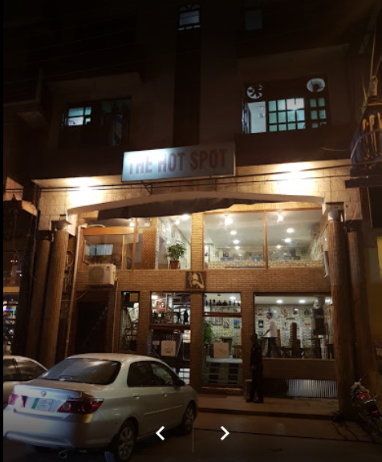

# Introduction

The Hotspot Café is a café which started in 2007, and is currently serves a large base of customers. The location of the café is in Lahore and located in one of the top class residency areas of Lahore named as DHA. The location of the map is attached in the image below:

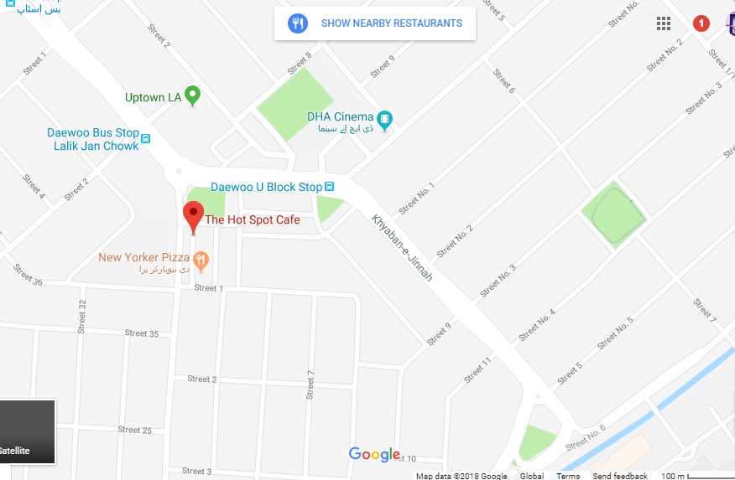

Figure 1 Location (source: Google maps)

The Hot Spot Café is one of the established food brands in Lahore, serving a huge database of customers and aiming to increase the brand presence in Lahore furthermore. The café is located on a prime location of DHA, which is rated as one of the best locations in Lahore because rich people reside there. In addition, the products range of the café depends on hot spot items, desserts, brownies, ice-creams- espresso, juices, cakes, crepes corner, and some of the most popular and special items.

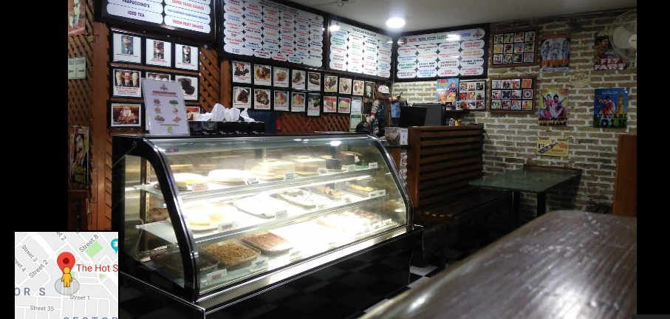

Figure 2 The Hot Spot Cafe interior (source: Facebook)

The owner of the café is Mr Muhammad Ali and the management of the hotel is dependent on the number of employees which include 5 people currently. One manager and 4 serving staff assigned different duties (Hou, 2013). The pricing range of the products are moderate, and hours of operation are 11 am – 12 pm. In figure 2. The image of the restaurant can be seen, showing that the environment is peaceful and soothing.

# Layout

The layout of the Hotspot café is based on the following design:

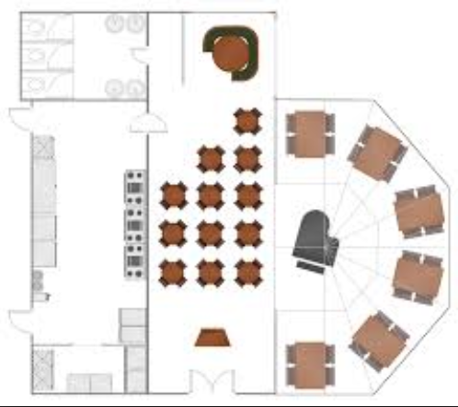

Figure 3 Hotel layout (Ground floor, functional layout) (self)

The outside view of the Hotspot Café is given in the image below:

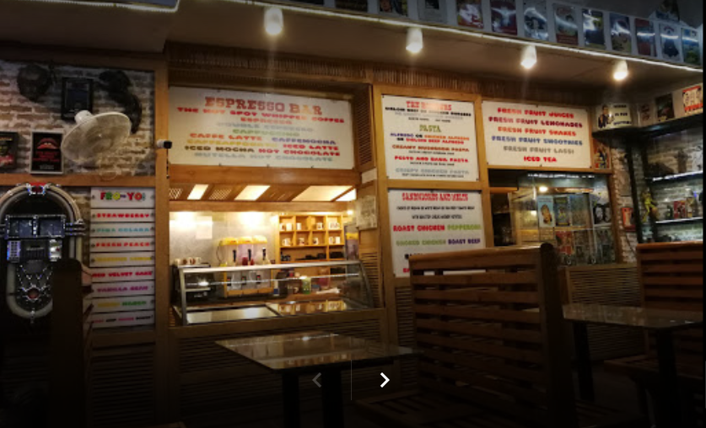

Figure 4 The Hotspot Cafe (source: Facebook)

There is only one floor in Hot Spot Café, which is a concern for the management in peak hours. The management can use ‘set in order’ factor from 5S improvement framework to set the chairs in an order to avoid any mishaps in the peak times. In the analysis to the layout, it can be said that the functional layout design is followed in Hotspot Café. The counter can be located at the centre of the café as in the image. In addition, the café is located on the busiest streets of Lahore (Khaqan et al. 2016). It is found that the management of the hotel provides the customers with both waiter service and self-service. In addition, people can easily approach the counter as tables are very near to the counter.

The kitchen is also located downstairs and it is the duty of the staff to provide all the products from the counter located nearby to the counter (Hou, 2013; Adam and Ahmed, 2017). Customers can easily take their products as the counter is easily approachable and the staff is also present near an approachable region making it easier for the management to serve the customers. Within the quick succession of time. Customers can also use the stools on the ground floor, however, they are used in peak times only. It is also noticed that the management of café is able to meet the requirements of spacing during peak times, but service delivery takes time.

# Process

Every hotel follows some sort of process during service delivery. On average, there is twenty order that is processed by the hotel management, with a higher ratio on the weekends (Zia and Yasmeen, 2014). It is also believed that the management suffers from many management issues on the weekends when people come in high numbers and suffer from the management issues. According to the study of Shahzadi et al. (2018), the management of Hot Spot Café suffers from some issues during the weekends, when it is unable to meet rushing people. More or less, the management also receives home delivery orders on weekends in high numbers.

The process flow in Hot Spot Café, when a customer orders flows in this way.

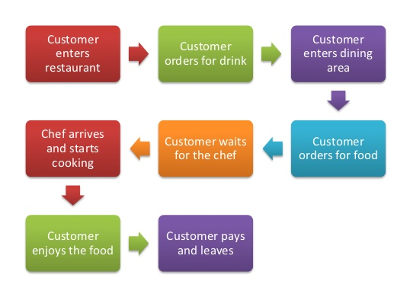

Figure 5 Process flow (self-created)

When a dish is requested by a customer, such as a special milk shake, a special chef is assigned to cook that food and the management is able to deliver that special dish. When a customer finishes eating, he then requests the bill from the waiter or goes to the counter to pay the bill and leave (Kausar et al. 2014). This is an important step by the management to provide both the options to the customers, which releases a little burden from people’s minds and they have two options to pay the bill. All food-related items on the menu are prepared in the kitchen and served at the tables or picked up by the customers.

# Waste

In the management of the issues, it is noticed that Hot Spot Café is wasting a lot of food items from transportation, and inventory. Sometimes it is possible that the management is not working hard according to the quality standards and needs improvement. In Hot Spot Café it is noticed that the waste management system and procedures are excellent and appropriate as they should be. There are 7 wastes in total managed by The Hot Spot Café on different occasions.

The transport waste is managed by the café managers through the development of a recycling plant, which is used by the hotel management to manage the waste. This allows the management to manage the transportation waste effectively and with sustainability (Sultana et al. 2013).

Inventory management at the Hot Spot Café is supported by the development of an enhanced platform support with the latest technology. For example, the inventory is present at the café, which has the capacity to store materials for 7 days including the peak times (Azim et al. 2014).

Motion at the Hot Spot Café is achieved by keeping the distance between the work stations and tables near and easy to reach (Sabir et al. 2014).

Waiting time significantly contributes to the waste of time between the departments of the company. According to the study of Zafar and Lodhi, (2015), waste management for wait cannot be achieved without dividing the workload between the workers. The same practice is followed at the Hot Spot Café during the peak times.

Over-processing at the Hot Spot Café is managed by the hiring of professional employees, who ensure that the issues are managed well by the management during the peak times. It is rarely a case when over-processing takes place because the management is easily able to achieve the objectives (Ishaq et al. 2014).

Over-production at the café does not take place, because it is a café and it serves all the food items in proportion to the customers. It is also believed that the management does not play with the feelings of the customers, especially when it wants to maintain check and maintain balance during the peak times. During the peak times, the management of Hot Spot Café hires 2 more staff members to combat with the peak time issues (Murtaza et al. 2014).

Defects play an important role in the management of issues and the best ways deployed by the Hot Spot Café in the management of defect is to hire the marketing team and use them to do marketing of the new items (Spadoni et al. 2014).

# Quality

The quality parameters in a company play an important role in the development and the objectives it wants to achieve. According to the study of Murtaza et al. (2014), it is the responsibility of hotel management to ensure that it includes the number of items in the restaurant and ensure that quality does not get down. At the Hot Spot café, it should be ensured that orders are taken and delivered on time.

On an average, every customer at the Hot Spot spends less than an hour because it is a fast food restaurant. Customers should be offered to select from a variety of food items, such as coffee, cakes ice creams, shakes and soft drinks. All these items should be prepared according to the formalised and systematic structure (Sabir et al. 2014). The management of the hotel should also ensure that it increases the percentage of the products regularly and with increased attention. It should be ensured by the management that quality material for all the products it offers, could survive for more than a month, therefore, purchasing should be done accordingly (Murtaza et al. 2014).

One more quality component in the management which Hot Spot café should be doing right things and providing goods that are ‘fit for the purpose. This achievement can be achieved by the management by following ethical rules and providing the customer with ethically and high quality sourced products. The study of Zafar and Lodhi, (2014) argued that providing ethically and correct sourced products is not an easy task and ISO 9001 standards should be followed.

Another quality standard recommended to the management of Hot Spot Café to increase the satisfaction level of the customers is to increase quality services. The study of Azim et al. (2014) and Sultana, Awan and Tehseen, (2013) argued that quality service depends on two components which include timely delivery and excellent products. This approach should be followed by the management of Hop Spot cafe, because it would allow it to increase the revenues accordingly.

One last component recommended for implementation by the management of Hot Spot Café is the deployment of the comfortable and soothing environment in the café. When people come in the café, they look for good food and soothing environment. The management of Hot Spot Café should serve them with the quality food and an excellent ambience making it easy and approachable for the management to increase the awareness among people by becoming popular (Sultana, Awan and Tehseen, 2013; Khan, Husssain and Yaqoob, 2013). These are the three recommendations which would increase the quality level of the delivery at the Hot Spot.

# Recommendations

According to the study of Kausar et al. (2014) and Shahzadi et al. (2018), the performance in a café cannot be improved unless the management is willing to participate in the activities assigned to them. In order to become a sustainable café in Karachi, it is recommended that the management should focus on increasing the revenues by attracting customers through social media marketing campaigns. According to the study of Azim et al. (2014), social media marketing campaigns will play an important role in developing new markets for the café because it is one of the best ways to keep the customers engaged.

Another recommendation to increase the size of the café because it becomes difficult for the management to increase the revenues on weekends as space in the restaurant finishes. To meet the customer demands, it is necessary that the management does not only has enough food products in the hotel, it must also have a good space to meet the demands during peak times.

After looking at the issues above, it can be said that the management of the Hot Spot Café needs to increase the size because it faces a lot of space issues in peak times. It is also recommended by the study of Azim et al. (2014) that the management of the Hot Spot Café is not good in managing peak times, especially space is very less during the peak hours, and the management faces severe issues during these times. In order to meet the demands in peak hours, it is recommended that the management of Hot Spot café should hire more people, and more seats should be installed both inside and outside of the restaurant. In this way, some people would be able to accommodate themselves outside, while some inside.

Another issue faced by the management is the high pricing as complained by some visitors on the social media page. On Facebook, it can be seen that the management of the Hot Spot Café is providing some products at a significantly high rate as compared to competitors. Therefore, the management needs to resolve this issue, because it can decrease the number of customers in future. In addition, the management of the café must ensure that it decreases the prices rather than increasing. One approach, which can be adopted to decrease the cost burden, is to introduce discounted products at a higher rate and increase the purposefulness in them. For example, discounted products should be supported with the increased percentage such as 50% on all products or 30% off on the weekends. This recommendation is also supported by Zafar and Lodhi, (2015) and Murtaza et al. (2014) who argued that discounted products attract all the people, especially when the percentage is high. therefore, the management of the Hot Spot Café should use this approach and increase the revenues and retain the customers.

# References

Adam, M.A. and Ahmed, F., 2017. Contemporary digital marketing practices in food chains in Pakistan. *International Journal of Business and Management Review*, *5*(6), pp.72-119.

Azim, A., Shah, N.A., Mehmood, Z., Mehmood, S. and Bagram, M.M.M., 2014. Factors effecting the customers selection of restaurants in Pakistan. *International Review of Management and Business Research*, *3*(2), p.1003.

Hou, C.I., 2013. Study on decision-making for cafe management alternatives. *International Journal of Computer Science & Information Technology*, *5*(6), p.67.

Ishaq, M.I., Hussain, N., Asim, A.I. and Cheema, L.J., 2014. Brand equity in the Pakistani hotel industry. *Revista de Administração de Empresas*, *54*(3), pp.284-295.

Kausar, R., Malik, S.A. and Akram, B., 2014. Effects and outcome of service quality and consumer attitudes towards restaurant brands: a study of fine dining restaurants in Pakistan. *International Journal of Hospitality and Event Management*, *1*(2), pp.187-202.

Khan, S., Hussain, S.M. and Yaqoob, F., 2013. Determinants of Customer Satisfaction in Fast Food Industry A Study of Fast Food Restaurants Peshawar Pakistan. *Studia commercialia Bratislavensia*, *6*(21), pp.56-65.

Khaqan, M., Siddiqui, A. and Siddiqui, K., 2016. Brand Failure in Pakistan: Content Analytic Findings. *Journal of Marketing Management and Consumer Behavior*, *1*(3), pp.1-4.

Murtaza, I.A., Akhtar, N., Ijaz, A. and Sadiqa, A., 2014. Impact of corporate social responsibility on firm financial performance: A case study of Pakistan. *International Review of management and business research*, *3*(4), p.1914.

Sabir, R.I., Ghafoor, O., Hafeez, I., Akhtar, N. and Rehman, A.U., 2014. Factors affecting customers satisfaction in restaurants industry in Pakistan. *International Review of Management and Business Research*, *3*(2), p.869.

Shahzadi, M., Malik, S.A., Ahmad, M. and Shabbir, A., 2018. Perceptions of fine dining restaurants in Pakistan: What influences customer satisfaction and behavioral intentions?. *International Journal of Quality & Reliability Management*, *35*(3), pp.635-655.

Spadoni, R., Lombardi, P., Canavari, M. and Hingley, M., 2014. Private food standard certification: analysis of the BRC standard in Italian agri-food. *British Food Journal*, *116*(1), pp.142-164.

Sultana, A., Awan, A. and Tehseen, I., 2013. Sanitation practices among food handlers working in street restaurants in Rawalpindi, Pakistan. *Rawal Med J*, *38*(4), pp.425-7.

Zafar, R. and Lodhi, S., 2015. The Study Of Ethical Issues In Restaurant Of Karachi, Pakistan. *International Journal of Scientific & Technology Research*, *4*(11), pp.370-374.

Zia, S. and Yasmeen, S., 2014. Service Effectiveness of Local and Multinational Restaurants in Pakistan. *International Journal of Arts and Commerce*, *3*(4), pp.113-132.