Muhammad Mahyar Zeb
Internee ID: NFS-2607-1125
Task1
Zero-Shot Prompt
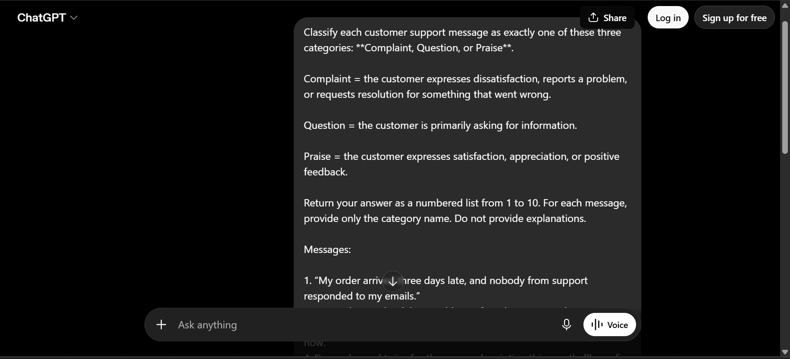
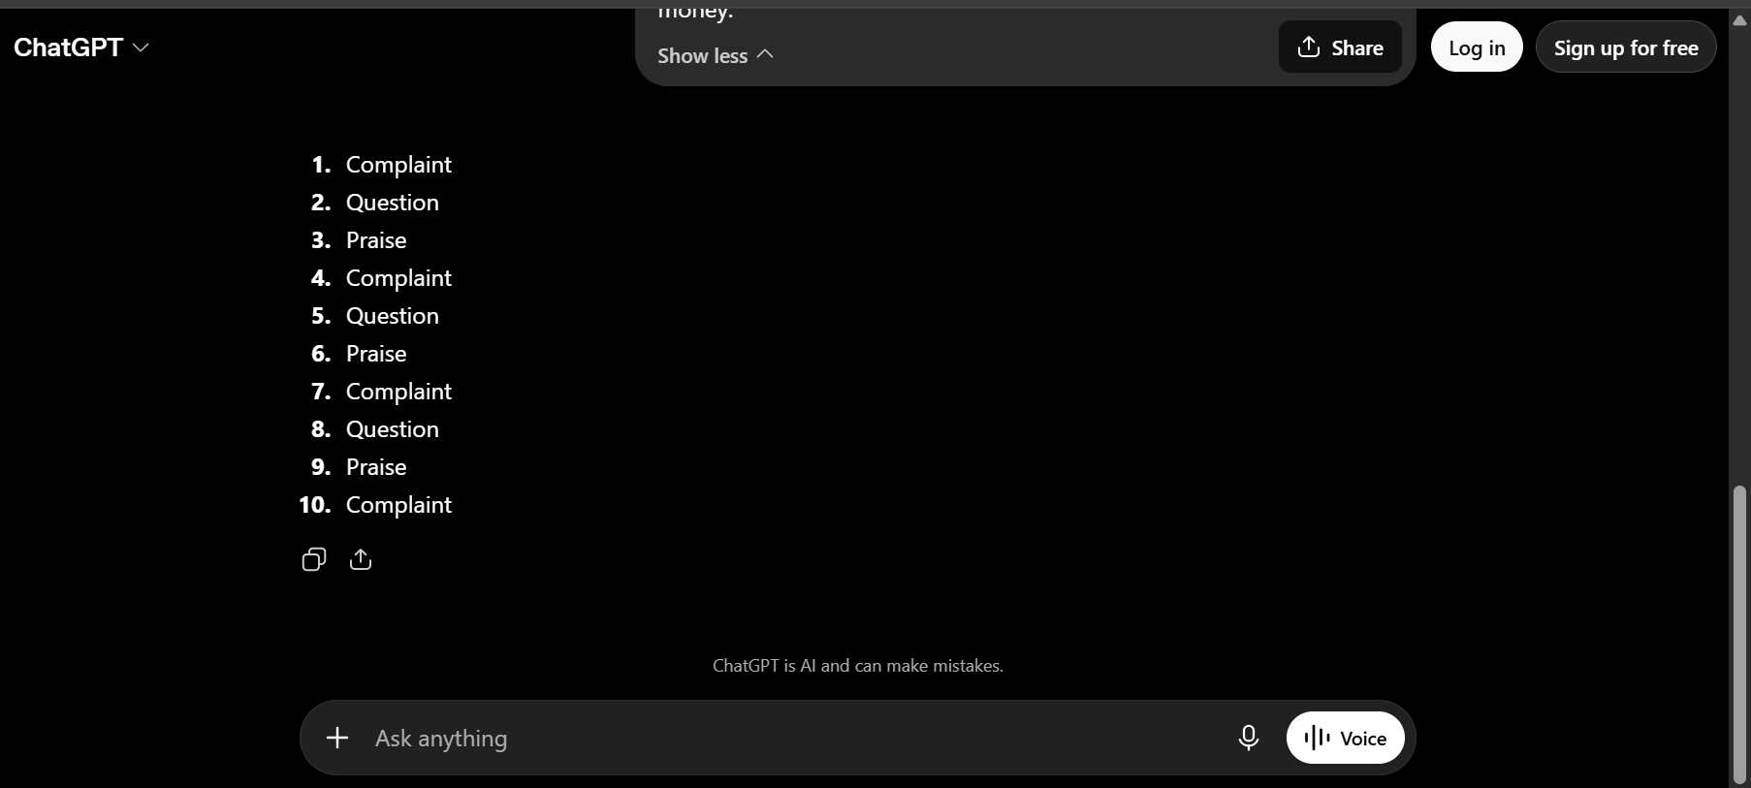

Few-Shot Prompt
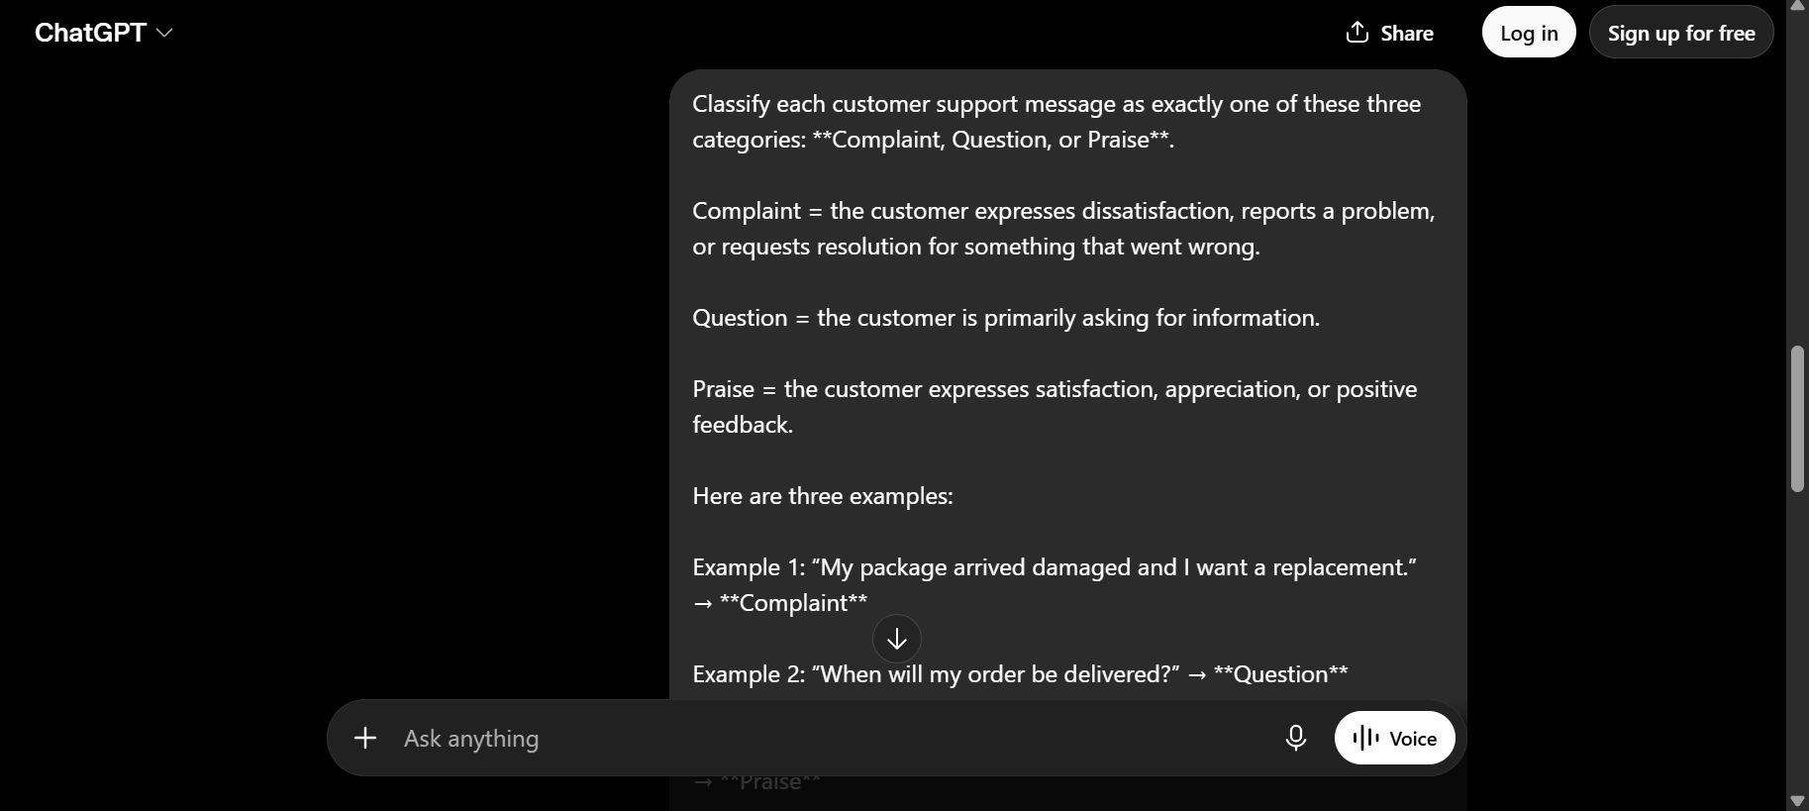
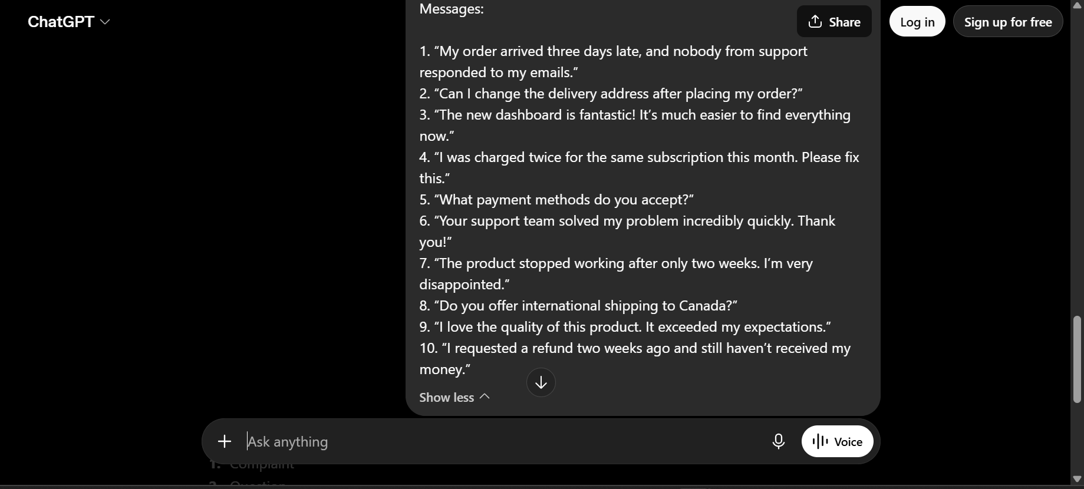
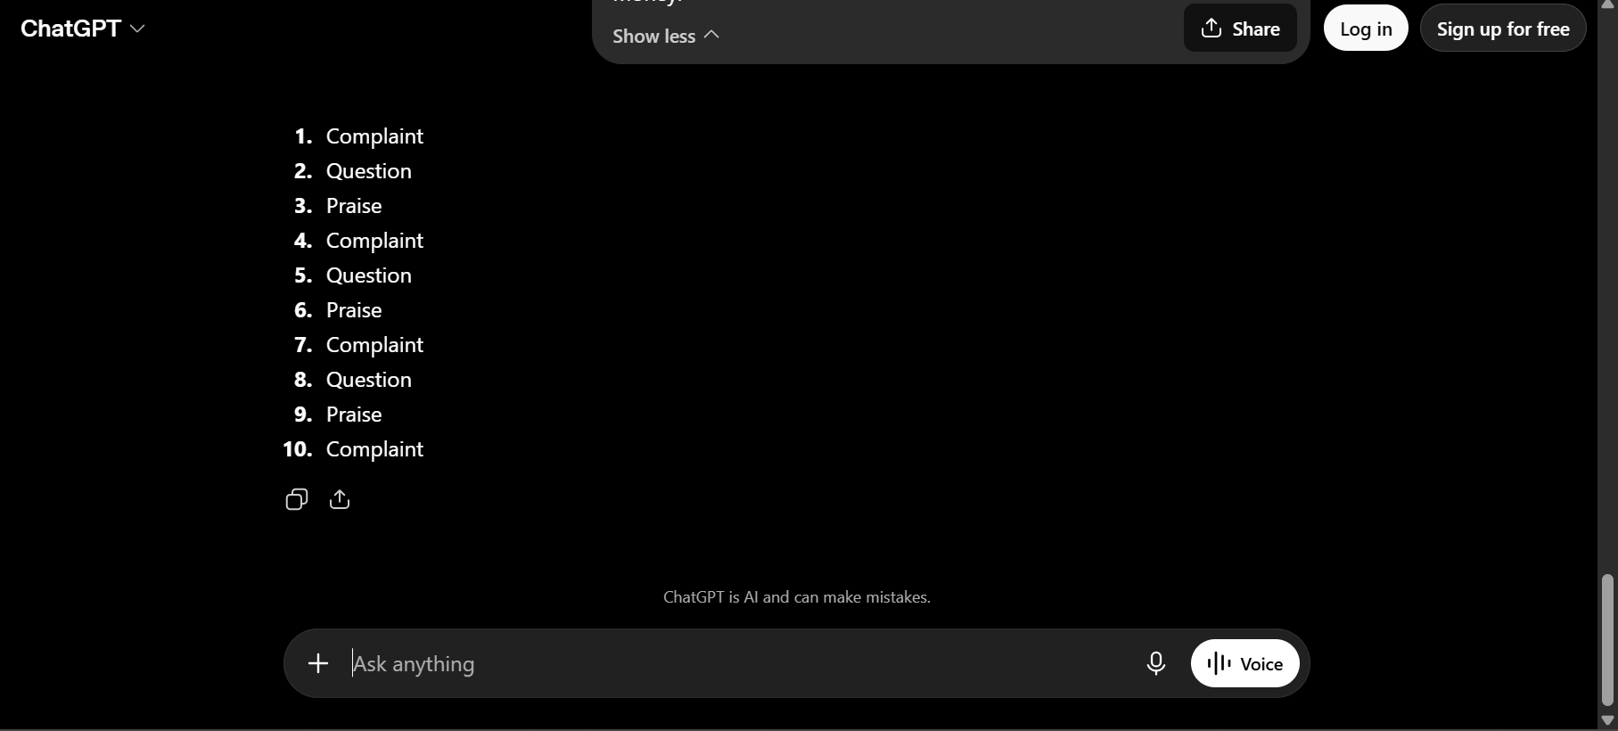
Both zero-shot and few-shot got 10/10 correct (100%) on this test.
Approach Accuracy
Zero-shot 100%
Few-shot 100%
Takeaway: In this particular test, both approaches performed equally well because the 10 messages were fairly clear and unambiguous. Few-shot prompting still provides additional guidance by showing examples of exactly how the labels should be applied. On more complex or ambiguous customer messages, few-shot prompting would likely provide more consistent results.

