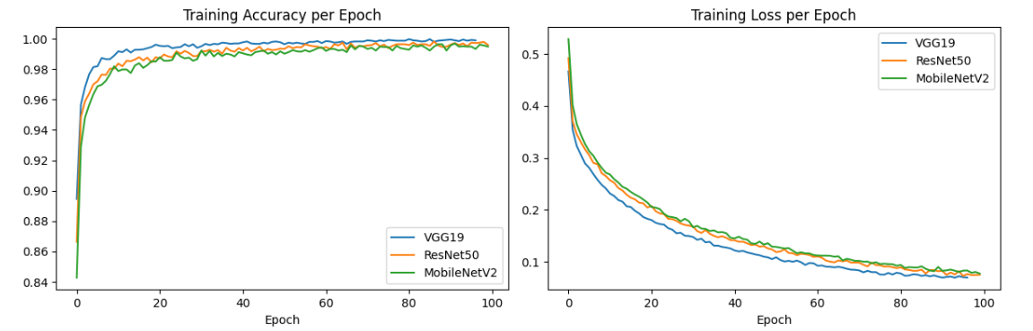
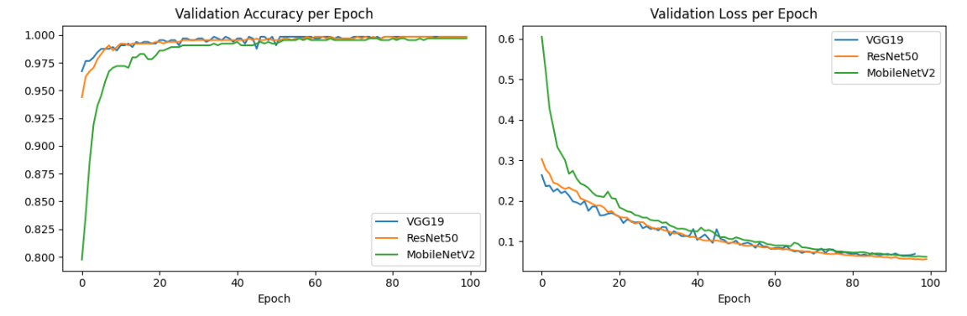
Model Class Precision Recall F1
VGG19 Fetal brain 1.000 0.991 0.996
VGG19 Fetal thorax 0.987 1.000 0.993
VGG19 Maternal cervix 0.998 1.000 0.999
ResNet50 Fetal brain 0.999 0.995 0.997
ResNet50 Fetal thorax 0.992 0.998 0.995
ResNet50 Maternal cervix 0.998 1.000 0.999
MobileNetV2 Fetal brain 0.990 0.994 0.992
MobileNetV2 Fetal thorax 0.990 0.983 0.986
MobileNetV2 Maternal cervix 0.998 1.000 0.999
