### 

***UX Design***

**Code: CSCUMN5**

*Assignment 2021*

**Cloud Computing**

**Course Lecturer:** Ms. Hameetha Begum

Submitted by

**Stirling No:** 2840080

**Main HTML file:** index.html

Submitted on

14-Nov-2021

**Table of contents**

1. Introduction ………………………………….……………..3
2. Descriptions…………………………….………..….……....4
   1. what is the website?...............................................4
   2. Target People............................................5
      1. Two specific people…….…...5
3. Design………………………………………………………..5
4. Design Decisions………………….…………………………8

## 4.1- Schneiderman’s Golden Rules………………………9

4.2 Moqups- Prototype Images…………………………..16

1. Navigation Map …………………………………….……….3
2. Persona Scenarios……………………………………………20
3. Style Guild…………………………………………………..22
4. Prototype Description………………………………………24
5. Test…………………………………………………………26

9.1 Usability test…………………………………………26

9.1.1 Test plan …………………………………………...26

9.1.2 External & Internal Test……………………………27

10- Task result summary………………………………………31

1. Sources…………………………………….………………..29
2. **Introduction**

For my assignment, I have been assigned with creating cloud computing website among the many proposed topics. so, I am going to be creating my website around cloud computing. Cloud computing provides a storage that provides many diverse services over that internet, for example resources, where data, programs and others are stored in cloud computing for academics and companies **[1]**.

When designing the cloud computing website, I will be using animations and following [**Tree/Hierarchical** **structure**], and I will be also following [**Schneiderman’s Golden Rules**], harmonic colors and forms, for the website Rules to help me with coming up with good and easy designs for the users. Using these rules will help me design and production a good design that will shows consistency and a good use of design practice and skills.

Throughout the website sections, I plan on going into good details about what the website is? and purpose and goal for this website? Also, I will explain about my justification of why I have chosen this design. I will also be talking about the target people along with creating three distinct personas and how the website will be aimed to them in different sides.

1. **Descriptions**
   1. **What is the website?**

My concept for my prototype website application is a website that provides explanations, hints, Shortcuts, as well as some of the sites and books I advise those interested in reading, and introduce people to cloud computing. For the purpose, I will be creating one main html page that will be connected to 5 html pages by using the (tree structure).

It is not necessary to have a good background in "Cloud Computing" to visit my site, because the site gives the user's information for beginners or for all groups in a good, easy and beautiful way.

In addition, in order to achieve the goal of satisfying the needs of both the user and the customer, I have added in my website all the understandable points that are conducive to quality education, as well as various multimedia.

My plan is to create three individual pages for this website, in future development maybe I will plan on developing more than three pages and more awesome things, but for this prototype website I feel this is an appropriate about to represent each page understandably and clearly.

The website will include explanations about cloud computing that will walk the users sequentially through the website of different tasks step by step with multimedia (pictures, video and some links). My website provides easy access to the main parts of the site, by adding hyperlinks, so one of the goals of the site is to be eye-catching and have an unobtrusive uniform color.

I will also be adding hints and tools for the users on page, further plan to make sure that the website style and layout is very simple and perfect to help users understand the aim of website and easy to use it.

* 1. **Target People**

The target people that I will be aiming my website towards will users that are of companies or academics. The age range I would set would be started from 18, furthermore the website will appropriate for anyone. For the understanding of how my website design will be malleable to different types of users, I am going to create 2 separate personas. then I will try to make all of these persons are different as possible.

* + 1. **Two specific people**
* **professor** **Mike**

The first persona is 35-year-old man named Mike who works as professor at university, He has short sight, He is Not very well in technology , he is currently married and has small awesome family, when Mike taught, always he had a very limited time to log students grades in his university computer system, before they were due, so the most important pain to Maik is going to his home and starting to doing grades again and again to avoid losing the students marks if his computer crashes or other things happen for this data. Mike is a one of the people that likes to get things done as soon as possible to get free time to enjoys attending films with his family.

* **Student Mai**

The second persona is 23 years old student named Mai who is currently in his 3rd year of studding computing science at one of Oman university, Mai don’t like phosphoric colors, Mai has 12 modules in this semester, always brings a big 12 books with her laptop, to the university, being girl, she always looking from someone else to help her carry the books. she likes to doing all in her laptop, iPad. Mai's prefers to study in her laptop or iPad, she is preferring not study by books. but instead, she tries to find her own solution to her problems. Her experience in information technology in general is excellent

* 1. **Prototype Delivery**

I have plan to have my website prototype completed and submitted in Canvas before 11AM on 14th November. I will be deposing all required files also, media files with the required report into one a zip folder, that will then be uploaded onto CSCUMN5 Canvas. The main site it will be as **Index.html**

1. **Design**

My website is tailored to what the [**UX**] user needs, as well as I will use [**Schneiderman’s rules**] mentioned earlier in section 1 [Introduction]. I will be going through each Golden Rule in next [section 3.1.1] that applies to my website that I have followed and discussing how I have followed these rules with references to the web site. also, I will discuss and delve into the exact details of my website about the layout and cross page mobility in the next section 4 [ **Navigation Map**]. as well as I will talk about the use of features and style in next section, on the other hand I will be covering the design features and style in the section 3.2. Wireframes with breakdowns of each induvial page.

**3.1. Design Decisions**

I am going to explain and discuss my design for the website as stated in my **Golden Rules**, and I am going to go through some plans that I can develop my own website in the future according to these eight rules.

I used several sources to base the details on, as I mentioned them at the end of the report.

* Strive for Consistency

My plan to design the site from the beginning was to make it appropriate and consistent, and I think I have achieved it an excellent level, as I have repeatedly confirmed that the design of the site with the layout is proportional to the structure of the site through the flow of information displayed through the site to the user **[3]**. Also, the user can refer to the pages of the site on any page easily, and I kept the site colors, as well the sub pages of the site have one common color, with the exception of the home page of the site to encourage site visitors or users to focus.

* Enable Frequent Users to Use Shortcuts

After I created the web pages, I connected each page to each other to access information sequentially, and I also created some shortcuts on the site to make it easier for the user to access the home page faster rather than having to go back and look for the main page **[3]**.

## Offer Informative Feedback

The implementation of the **Tooltip**on my Home page allows users to kept informed of what is happening, since passing the mouse over the image of the logo of the site, or the list.it will show some hints. I made sure that the **Tooltip**were useful, clear and relevant. I also created animations in home page to attract as many users as possible to my website.

## Design dialogs to yield closure.

At the present time (until this report is written) there is no feature in the default model that follows this rule, but in the future, I plan to do more varied features that display notices and activities that may be of interest to the user **[3]**.

## Prevent errors.

At the time of writing this report, I did not add any features applied in my own website dealing with errors, such as adding some errors notifications and others, my future planner will support this feature, and I will also add some menus that help the user interact more with the site.

## Permit easy reversal of actions.

Through my web site, the user travel to all pages, and the user can access all pages on the site sequentially, even if he accidentally enters the page, through which he can cross- reference and determine the required page through the home page or through the navbar at the top of each page **[3]**.

## Keep users in control.

When a client or user uses my web site, I want him to feel that he is the controller of the site and has the ability to travel between pages freely and in a large range without having to track only one path, my primary goal is to make the user easily use the site so that through these steps he can use the site and understand it in a very short stretch. Through a simple and brilliant design with animated graphics that allows the user to visualize the page clearly and at the same time stay at the site for longer, they can also understand the site in a very short time, causing the user to become fully controlled at the site when it is used **[3]**.

## Reduce short-term memory load.

With my screen design in a consistent way, I showed the user very well, and I used the icons to help the user find what he needed without remembering it, I also split the page harmoniously and split the page with some kind of content to be more user-friendly, for example of remembering what this button does and where it goes?

## 3.2. Wireframes, Content and Media Elements

In this section I will explanations more details about what with wireframe each page is about. The wireframes format of all pages will appear on my website, as it will be the starting point in the software design of my website. I showed all the elements of the content of my website and the media that will be used, and I will discuss in detail all the features that have been implemented, as I will use the **Moqups [4]** site to execute close-up of what my website will look like.

* + 1. Home Page

On all pages, there will be an image at the top of the page which will be the main logo of the website (cloud computing logo) but will also be used as a home button with the use of animation to change the image into a button (1). also, it will contain a list of (About us, Service, contacts), and entry for research. Another feature that will be included with home page is the menu bar in the right page (2). This provides quicker navigation the social networks (Facebook, Twitter, Instagram), as well as help buttons (Share, looking for answers questions) (2). The homepage will also include animations in right side (3) with the use JavaScript, which will speed up the user staying longer on my site. The left side contains the headline of the sites theme, as well as definition (4). It will also have a mobility button (Take a Tour) from the main page of the next page, which contains more and more accurate information. The big feature I used in my website is the animation feature, where I took advantage of the background by making binary numbers up and down by using <div> in html (3), I also used only one button, which is the basic button in the home page, this is because to make it easier for the user to focus and not disperse.

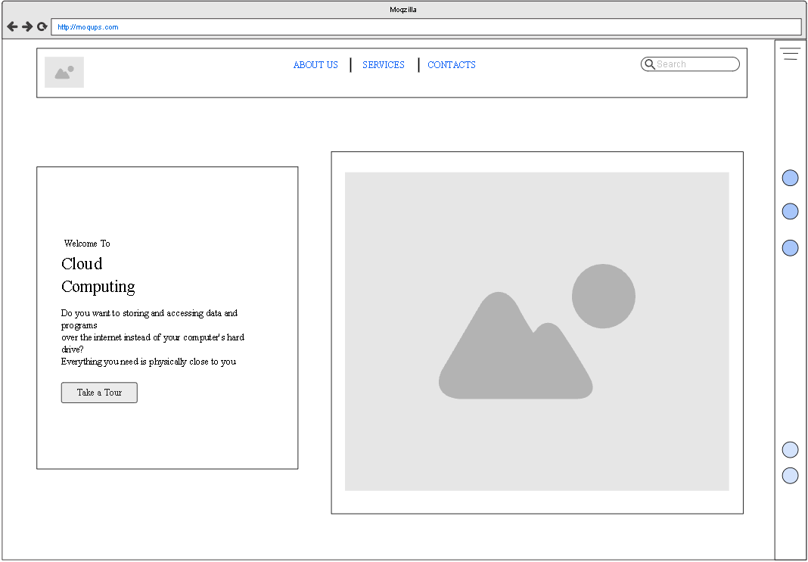

2

1

4

3

Figure 1- Home Page Design

* + 1. Take a Tour Page

The (Take a Tour) page will only have details about information's about cloud computing, multiple pictures and video. But I have divided this information and media in two different pages, Through an extra button (4) at the end of this page. because the user will often get bored when the information and media must be stacked in one page, so I make sure that the information is distributed correctly and harmoniously in the page.

at the top of the headline in addition to the logo of the website through page, it will contain the which the user can refer to the main page (1). In the same page, I put in the information that relates to the main theme of my website (2), I made sure to add some of the companies that provide the cloud service.

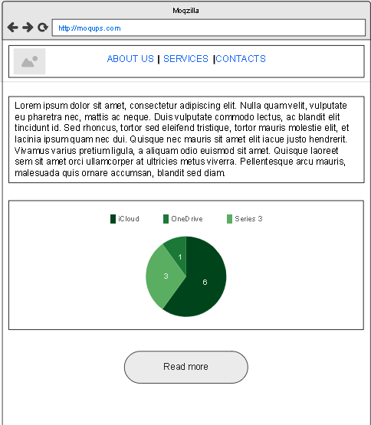

4

3

2

1

Figure 2- Take a tour Design

and then multimedia to make the user more informed and understanding. And then the images, I designed these images through JavaScript, where it allows the user a comfortable eye view as well as a special, wonderful form, I tried very well to make the sequence of images good for the user (3) And then the video comes, where I finally added the video because I feel like the user prefer to have audio-visual content at the end (4).

and I also added many different sources that make the user fully dependent on the website for its search (2). as well as I have added chat graph to simplify the users understanding of the information (3). I have chosen to do this because I feel as though it is a good example of the user would like to read first and see the subject carefully, and I also tried to anticipate the questions that the user would be curious about the subject, like companies and the way the cloud service is activated.

* + 1. Read more Page

In this page, it is confirmed that information is distributed and not stored in a single page harmoniously to the user, the main objective being to have the user read the information with satisfaction and focus. So, I was able to distribute the information to the user nicely.

In this page, I based on media and simple information about cloud computing only defined.

The new feature I used in this page is the **Slider** **[6]** I made sure that the slider of the images was used in my own website to keep users involved in my website…

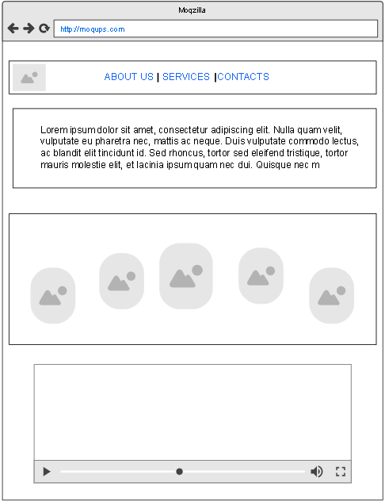

3

1

2

4

Figure 3-Read more page

As well as the images will all be visible on a specific page of the page where the users will react to view the content, and on the other hand I feel that the slider of the images will create a comma in the page for the follower below (3).

Eventually I added a YouTube video.

* + 1. About me Page

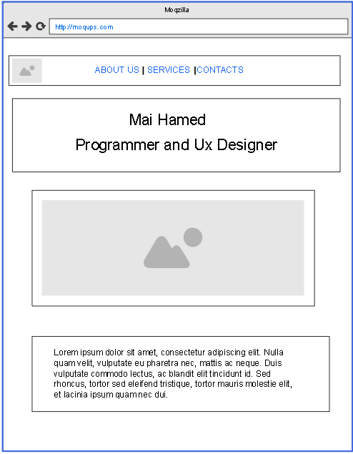

This is what the (About Us) Page will look like, it will include menu it will have the same logo to make the user go back easily to the home page (1) in this page I tried so hard to put it so simple and beautiful that the user would love to know (who we are?) or who created this site? I added a very small definition (4). I added a simple caption with his photos (3), and at the bottom I made a simple definition about me.

4

3

2

1

Figure 4- ABOUT US Design

* + 1. Service Page

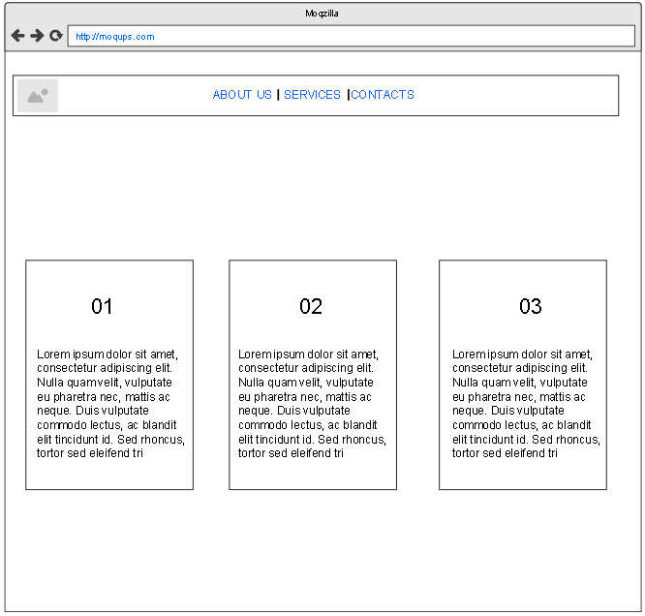

1

In this page, I tried to make it simple, easy and quick to read, I split services a little bit, and by passing the mouse the color will change (1).

Figure 5- Service Design

* + 1. Contacts Page

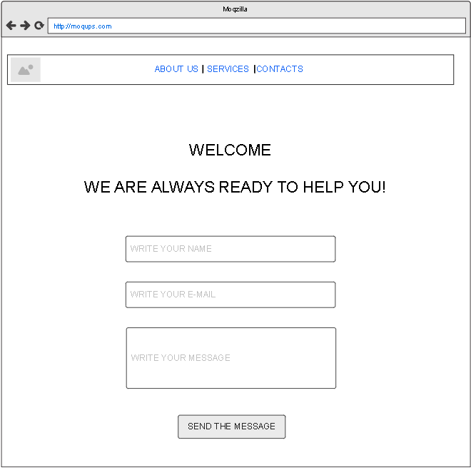

1

In this page it is where the websites owners are interacting through mailing, so far, I haven’t activated this feature, but in next version of the site I will activate it by JavaScript (1).

Figure 6- Contacts page Design

1. **Moqups- Prototype Images**

I used **Moqups [4]** site to create awireframe [section 3.2] to give an approximation of what using the color list shown in [3.4.1 section], I have taken into account people with color blindness or in general people with any visual handicap that might affect their color vision by trying to minimize the number of color's I have used in my website to avoid any impact that might affect these people **[4]**. I used blue as the primary color on my website because blue is quiet and relaxing color, according to the Times of India report **[6]** plus, it is my favorite color for color blindness, also, it reduces stress and creates a sense of relaxation and calm for the user, so it is likely that these colors will be suitable for all visitors to my website.

The **moqups** I created shows where I am going to put all the content of my website, as well as diverse media such as photos and videos.

### 3.4.1. Homepage

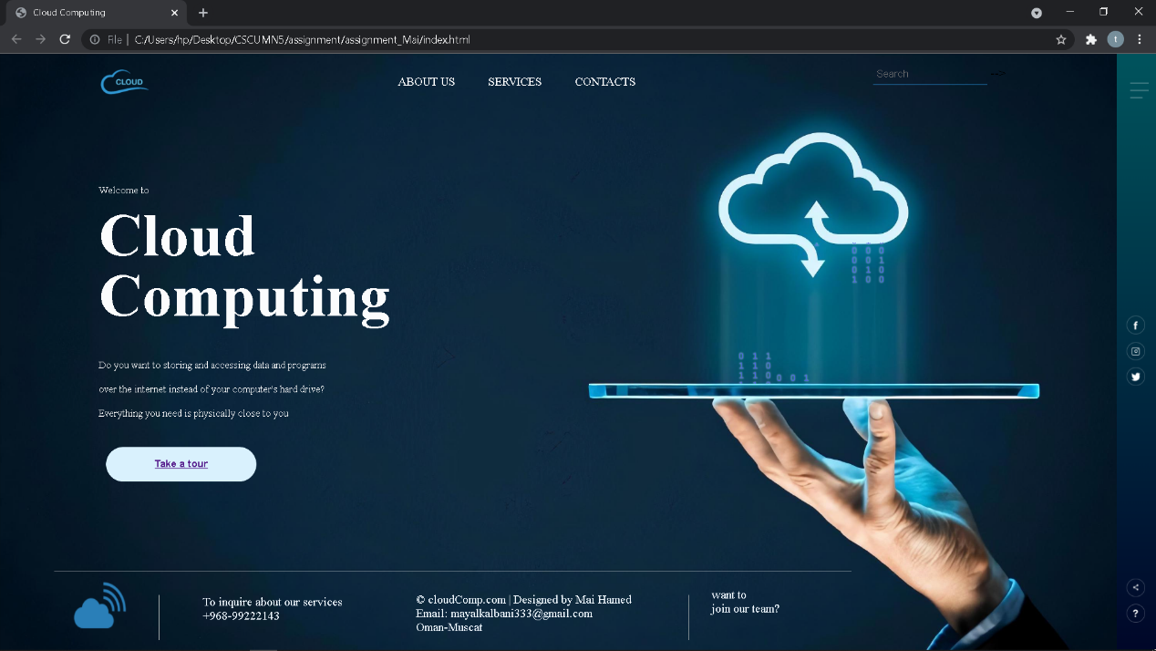

Figure 7- Home page

The home page has been implemented and images and colors have been added, as well as the animation feature and others, Read about Wireframe for Home page in **section 3.2.1**

* + 1. Take a Tour Page

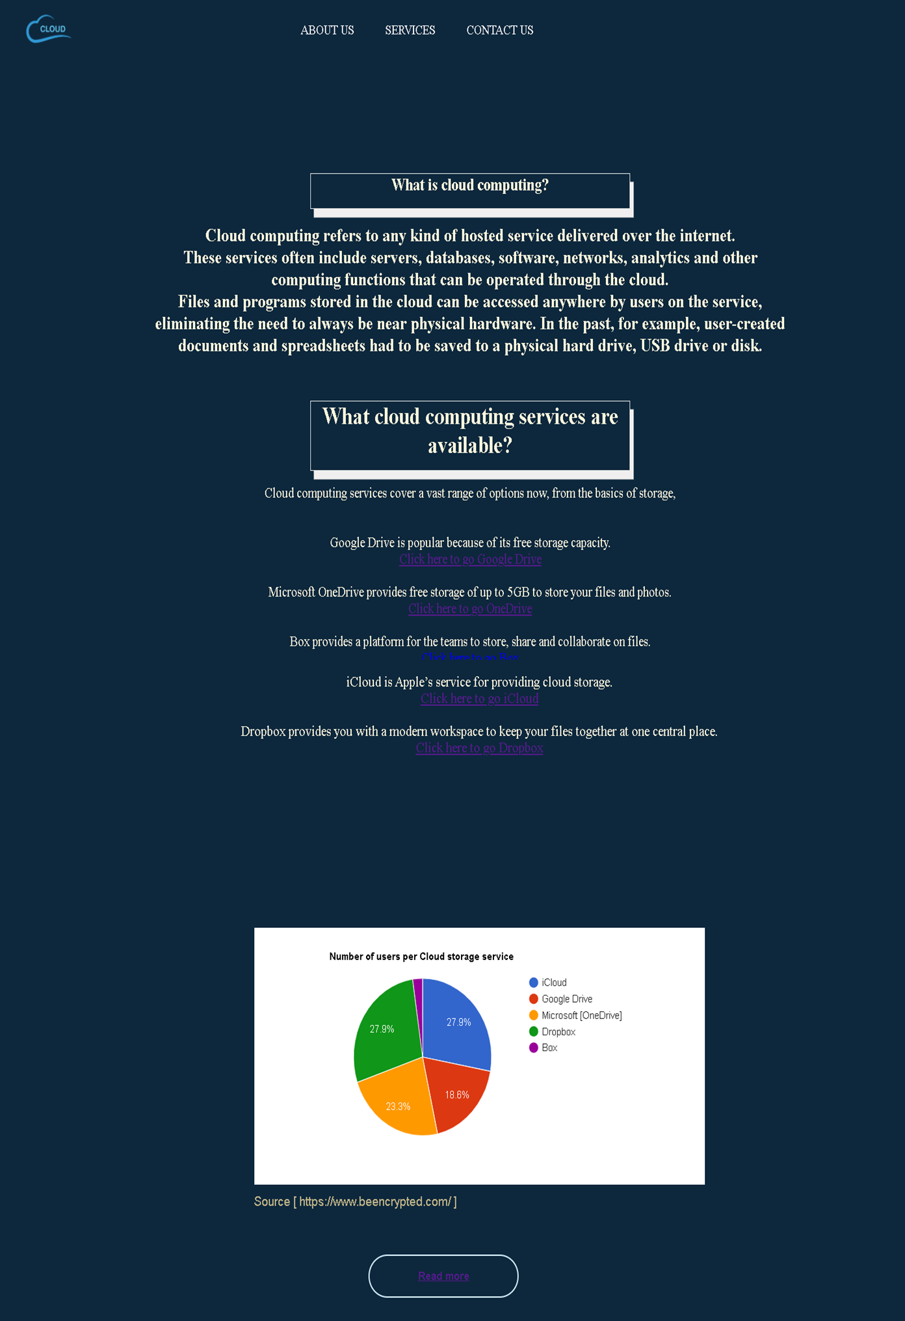

Figure 8-Take tour page

The Take tour page has been implemented and chart graphic also backgraound colors have been added, as well as the websites links, Read about Wireframe for Take tour page in section 3.2.2

* + 1. Read more page

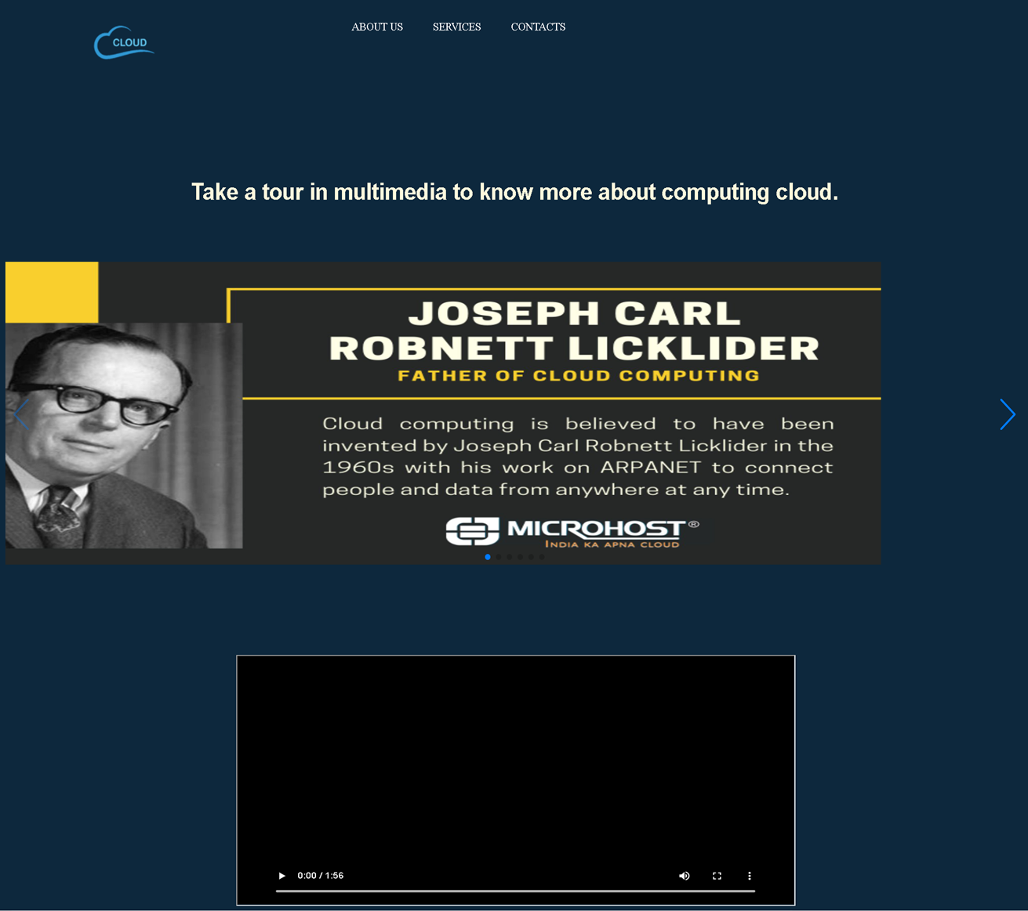

Figure 9- Read more page

The "Read more page" has been implemented and Slider for pictures also backgraound colors have been added, as well as the vide, Read about Wireframe for (Read more page) in **section 3.2.3**

1. **Navigation Map**

I have created nav-map of what cloud computing web-site will look like. the website needs a basic design to build it properly. with all of multiple pages connecting to Home Page, but these pages can be accessible by the side menus [look in section 3.2] - **About us**, **Service**, **contact us**. The home page will be linked to the other pages as shown in the format, some **hints** will be displayed on the site through which the user will benefit, the Navigation map will show what the website will look like in general.

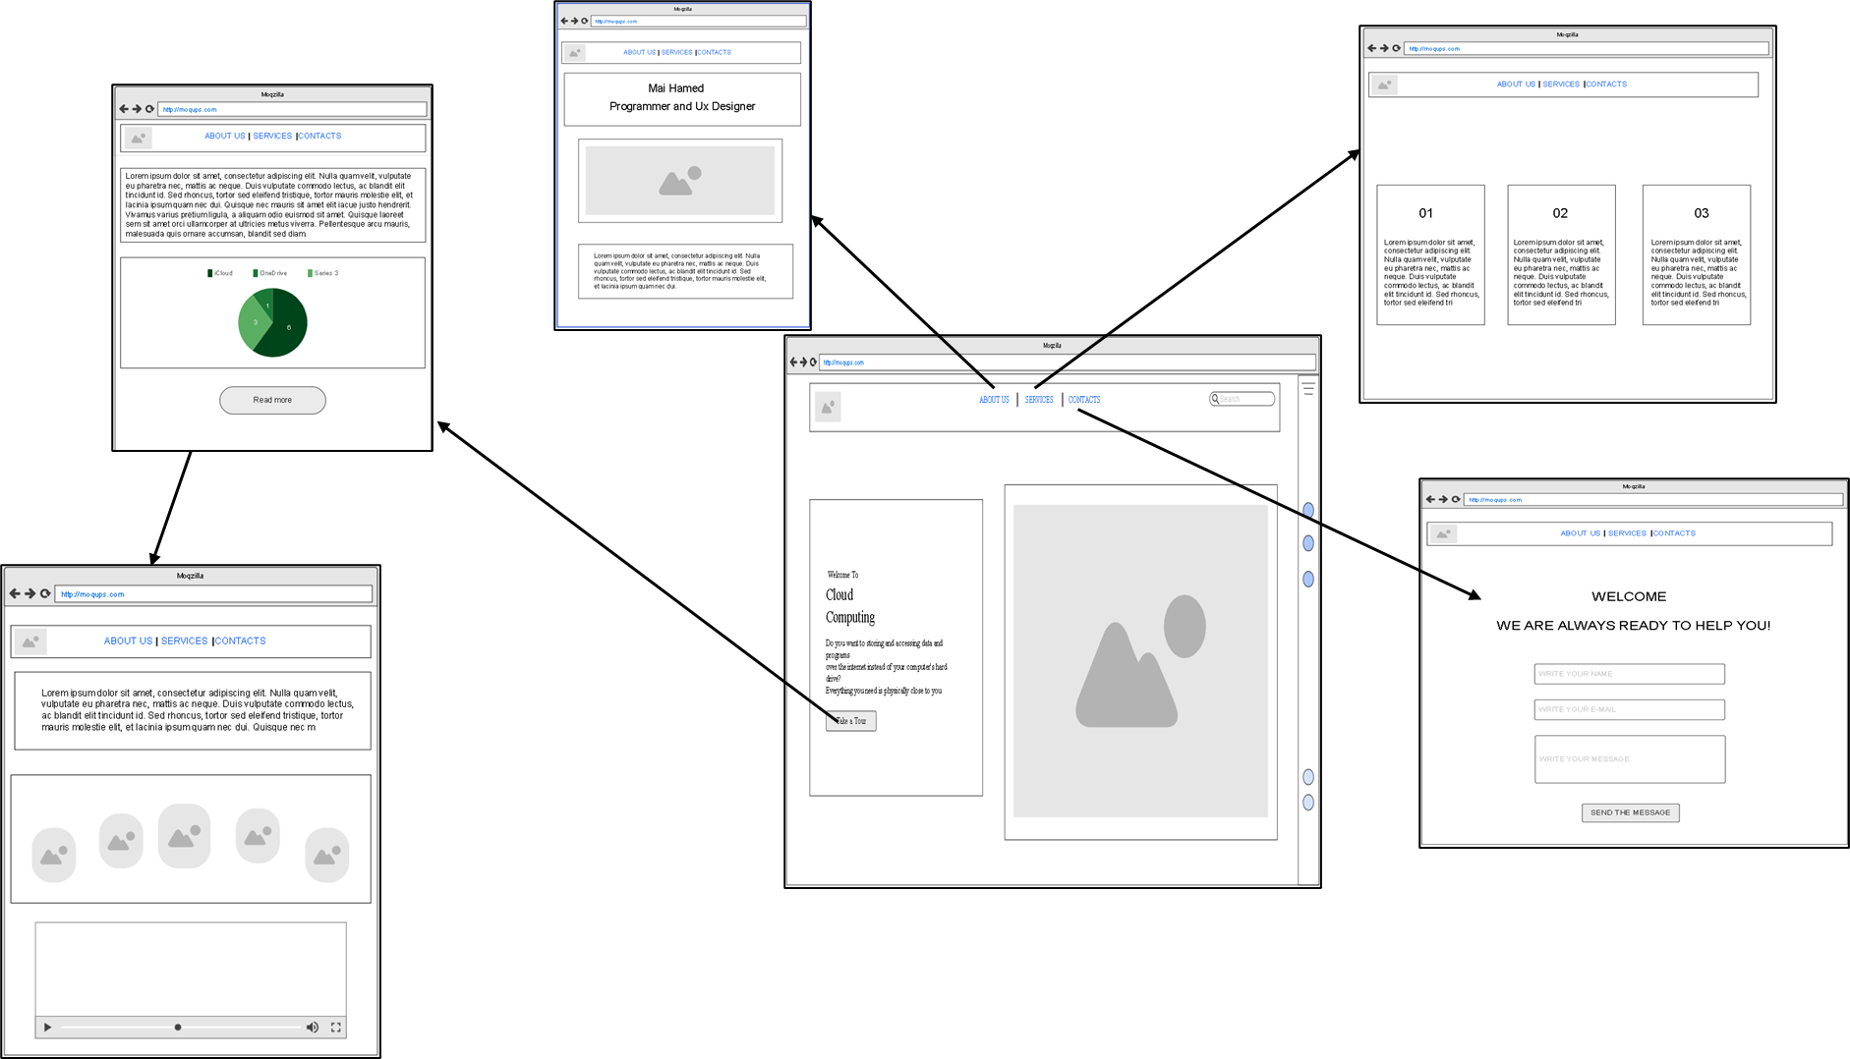

Figure 10- nav map

1. **Persona Scenarios - PACT**

I am going to create two scenarios for the two people in section 2.2.1, I have done some research about **PACT**, **[13]** so I devoted the next two scenarios to it, I will focus for (people with **disabilities**, **psychological** side and **Cognitive Abilities**.).

* 1. **. Scenario One**
     1. The first scenario: Mike. [section 2.2.1]

Mike recently received a letter from the university principal describing Mikes delay in publishing students' grads. Mike explained that his reason for being late was that the computer in his office at the university did not contain enough room to make Mike write students grades in papers. Mike is very determined to find a solution to his problem as soon as possible, He has decided to select one of the most important technical services that could help him deploy the scores in a timely manner, namely, cloud computing. He doesn’t know anything about cloud computing, so Mike decided to search online for what cloud computing is, and what companies support this service, and so he finds himself clicking on my website, He able to see the font size clearly, and Mikes been able to figure out what cloud computing is, and he is been able to figure out what companies support this service and follow the steps of entering and sending files through the cloud computing.

|  |  |
| --- | --- |
| **No** | **Task that is Carried Out** |
| **1** | Click on website |
| **2** | The website loads fast because it has a few content |
| **3** | He clicks on "Take a tour" |
| **4** | He reads the information and below, then he looks at the chart through which he will decide what service many people use |
| **6** | He clicks "read more", and he saw several of links of companies. |
| **7** | After he entering the company's website, he comes back to my website, to follow the steps for signing up in the cloud in video. |
| **8** | He may click on one of the menu buttons to see some details of the site and communicate with the developer |
| **9** | He has found what he has been looking for and can now start using to uploading students' grades. |

* 1. . **Scenario Two**
     1. The second scenario: - Mai. [section 2.2.1]

Mai just started in the fall to study computer science with her roommates, so now she has no plans how to start her studies and what methods she can follow in school. On the other hand, Buthina has a hard time sharing with her friends' transcripts and books because of COVID-19. Mai has a little knowledge of cloud computing, so she decides to meet with her roommates to start looking for common solution to all these problems. Mai is looking for website quickly as she clicks on my website, and then she goes and she find the companies that do these cloud services.

I will be describing the steps below:

|  |  |
| --- | --- |
| **No** | **Task that is done** |
| **1** | Click on website |
| **2** | The website loads fast because it has a few content |
| **3** | she direct clicks on "Take a tour" |
| **4** | She found what she was looking for, clicked on the OneDrive company like to complete the registration and her file transfer procedures, as well as her friend. |
| **5** | She is back to the website and click "read more" to see the vid about cloud computing |

## 3.7. Style Guild

* + 1. **. Color Scheme**

After I have done some research on many people's favorite colors, considering people with vision diseases or vision disabilities as color blindness, I thought about the color system I would use on my website, and I figured out that **Blue** was the **right color**, as I mentioned, it is one of the colors that is quiet and easy to look at for all groups of people. I also made sure to keep the blue in all pages of my website where no other color is available, I showed below the two main color I used in my site design.

* + 1. **. Color blindness**

I did some testing of the colors on my website, specifically on the home page of the site, by: ***blindness.com* [12]**, I made sure that there is a difference in colors for all options, which means that all patients with problems identifying colors can see all the items on the site:

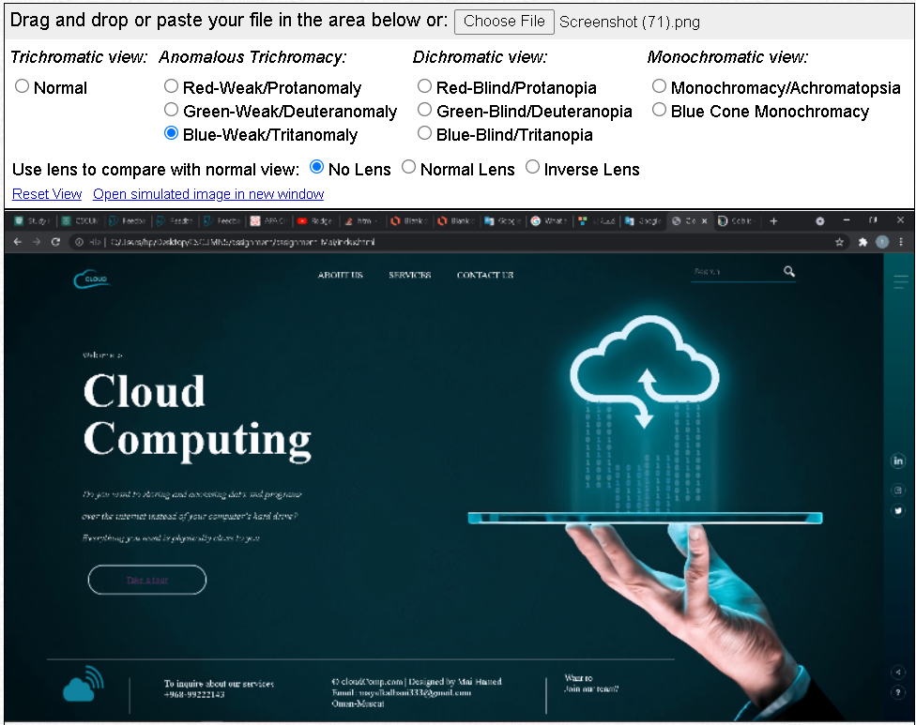

Figure - Test Home-Page color

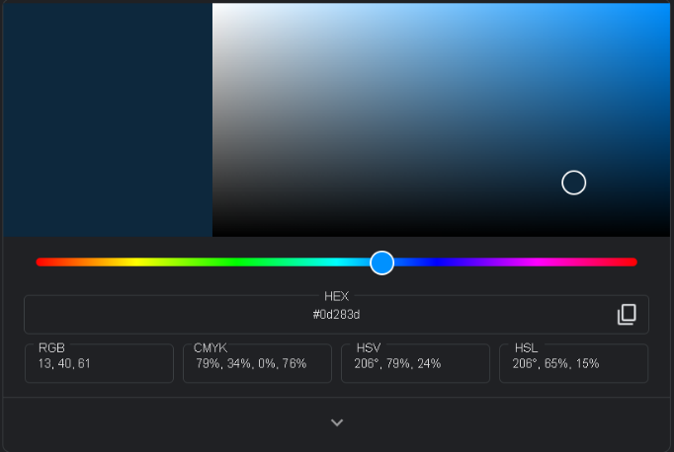

Figure 12- my website colors

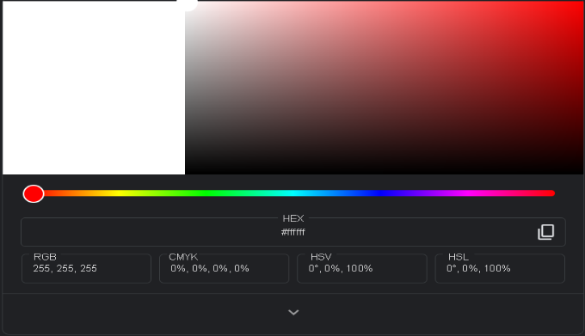

Figure - color of words

* 1. **. Font Choices**

For the font of the website, I decided the [**Times New Romar**] font, I chose the quality of the font so that it would be very easy to read and understand by the user, as well as having a beautiful appearance at the same time, especially people with a little reading difficulty who might be a little easier to read using the font that I chose on the site, below, the basic font that I used on the site:

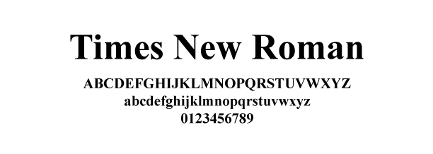

Figure - font type

## 3.7. Prototype Description

In this section, I will elaborate on what my assignment contains and information as well and what features I have not added at this time, since it is just an initial release, I have already covered a lot of features about what my website contains, as well as the special elements, animations, features, Wireframes...etc.

* 1. **Prototype - Features and Elements**

My (initial) model follows the design and layout I created using Wireframes, and I implemented all the elements I had previously planned, Also, I made sure that the visitor or users could understand the idea of the site in less than 5 seconds. making sure (animations, back icon, menu buttons, animation, multimedia) they were working as required and expected, in all the pages of the website, I was able to display all the pages associated with the main page, plus I did a direct shortcut from the other pages to the main page by pressing my website logo.

I have added visual nav in all options, whether they are in the menu or through the buttons, as when the mouse is hovered, the color of the button changes or visible line appears, also it is easy for the users to read the info quickly due to the **Text-aligned: Center**.

I added **multimedia** to attract the visitors interest as well as to create a visual interaction for the reader, for example I added: (video, pic sliders, chart, animation). I made sure to add titles on every page with the site icon. On the other hand, I added the **jQuery** it is one of **JavaScript** library, it contains many features. **[10]**

Another feature available in the **home page** is animation by using **JavaScript**, I loved adding this feature in my website because I think it would be a great addition. The user would probably prefer to stay longer on the site if he found the animation feature as reasonably and tidy as I did in the **Home Page**. The feature is a Binary number that appears against the background of the main site up and down.

I used the **chart** feature by Google, to display the data/info and invite visitors to the site to explore the topic, I made sure to use it to give the users a brief and quick overview. **[11]**

The other feature that I was able to implement in (Take a tour) page, by using **JavaScript**, it was a beautiful and smooth **image slider** opponent, by pressing both ways to move images, the reason why I choose this design is because the user likes to move between images so easily is that the user prefers all images to be visible at the same time and that is what I did on my website.

The last element I was able to include on my website is the **video clip**, which is because the user is given the option to take the information about cloud computing, whether by photo, paragraphs, or video.

|  |  |
| --- | --- |
| **video clip** | <iframe  class="video" src="cloud-vid.mp4">                </iframe> |
| **image slider** | <img src="swip-10.jpg_large"> |
| **Google chart** | src="https://www.gstatic.com/charts/loader.js"> |
| **jQuery** | <script src='jquery.min.js'></script> |

### 3.7.1. The features and elements are NOT Included

In the current model, I was able to create some features and elements, but not all of them, I have decided that it was not necessary to display all features immediately, but that they would be completed later to develop the website. Also, in the next development, I will add **404 page**, which I will add in links or pages that do not work, to make easier for the user to know that the link does not work.

I have already decided to create the main pages of the site, as they meet the users need only in principle, since all the pages on the site work well and smoothly, though, these pages do not contain any **educational software**, I have created a page (Take a tour) because I felt I have delivered the required idea well enough.

On the other hand, I made sure to added everything the user needs to know all the concepts, steps, etc... related to cloud computing.

Last thing, in next design, I will also create a **screen resolution**, where the user can experience my site on all devices with different accuracy in all modes, whether the device is horizontal or vertical.

## 4. Testing:

I attended a lab and tested my site with 5 different people.

|  |  |  |  |  |  |
| --- | --- | --- | --- | --- | --- |
| **Tester Name** | **Age** | **Gander** | **Education** | **Computer Experience** | **Why they use website?** |
| **Ahmed** | 16 | Male | Student | No | Learning about cloud computing |
| **Aysha** | 22 | Female | University  Student | Yes | Looking for the best company have cloud services |
| **Buthina** | 22 | Female | N/A | No | Learning about cloud computing |
| **Talal** | 34 | Male | Teacher At University | Yes | Looking for companies that provide cloud service |
| **Mohammed** | 32 | Male | Director | Yes | Looking for companies that provide cloud service |

## 4.1 Usability Testing:

I will test my website by UX (user experience) I will test the web page in several ways, display the test result and find out the problems that users of the site are experiencing.

So, my test will be Online, and it will be on the web page, so the test will be of two types, the first type will be about the external (how user look the website?) and internal (how user can use the website?)

## 4.1.1 Test Plan:

I will give them a specific time to test, which is only 8 minutes, and then I will study the result, and correct problems, errors, and read the all notes

* **External Test**

**Questionnaire Test:**

|  |  |
| --- | --- |
| **No** | **To Do** |
| **1** | Find where you can find multimedia |
| **2** | What is cloud computing? |
| **3** | Looking for companies that provide cloud computing? |
| **4** | Look for the icon back to the home page |
| **5** | What is the purpose of using cloud computing? Where can you find this information? |
| **6** | Find the chart |
| **7** | Write 3 concepts you have understood from my website. |
| **8** | Find what services we can provide to you? |
| **9** | What is the official phone number to contact the website designer? |
| **10** | Try to write a massage in [contact us] section |
| **11** | How many users prefer to use the iCloud service? |
| **12** | Play the video |
| **13** | Try to Contact me in LinkedIn |
| **14** | Find my location |
| **15** | What is the hint shown in Contact Us section? |
| **16** | Write how many second the web spends to open? |
| **17** | Find my email |

* **Internal Test**

This is a random sample of the answers to the Questionnaire was published to the testers:

|  |  |
| --- | --- |
| **Usability Experience** | **Tester Answers** |
| What did you notice the first time you entered the site? | The site is good and easy to go for others pages, but it is not completed in logging in, registering or searching. |
| Were the colors of the site good and beautiful and appropriate? | Yes |
| Can you use the transition between pages easily? | Yes |
| Did you find pic and videos on the site? | Yes |
| Are you able to locate the buttons on home page? | Yes |
| How was my site experience on one of your devices? | good |
| What exactly is stopping you from doing what we expect you to do on the site? | Maybe the Privacy |
| Was the font size appropriate? | Yes |
| Was the size of web controls appropriate enough? | Yes |
| Do you think you had to click a lot to get what you are looking for? | No |
| On a scale of 0 out of 10, how do you rate my website? | 8/10 |
| What do you like about my site? | Animation and slider |
| Did the links take you to the requested pages? | Yes |
| Did the website help you understand about cloud computing? | Yes |
| On the scale of 0 to 10, how would you rate the content and clarity of the content? | 10/10 |
| Does the (YouTube) video player have the required controls? | Yes |
| Did the site take too long to display details? | No |
| How many times have you visited my site? | 3 times |
| On a scale of 1 out of 10, how likely are you to recommend my website to your friends? | 9/10 |
| Would you like to participate with us in designing the site? If the answer is yes, please sharing your contact details. | Actually, I don’t have much experience in web design. |
| Do you have any other suggestions to help us develop the site in the future? | No |

## 4.1.2 Task result summary:

* How Happy or Sad did Tester find my website:

**Sad**

**Happy**

Figure - Emotional state chart

* How difficult or easy did Tester find my website:

**Very difficult**

**Very easy**

Figure Task Usibilty chart

1. **Sources**

*[1] How Cloud Computing Works. (2019, May 18). Investopedia.* [*https://www.investopedia.com/terms/c/cloud-computing.asp*](https://www.investopedia.com/terms/c/cloud-computing.asp)

*[2] Wikipedia contributors. (2021, October 18). Cloud computing. Wikipedia.* [*https://en.wikipedia.org/wiki/Cloud_computing*](https://en.wikipedia.org/wiki/Cloud_computing)

*[3] Ben Shneiderman. (2016, May). Williams.* [*https://www.cs.umd.edu/users/ben/goldenrules.html*](https://www.cs.umd.edu/users/ben/goldenrules.html)

*[4] Online Mockup, Wireframe & UI Prototyping Tool · Moqups. (n.d.). Moqups.* [*https://app.moqups.com/*](https://app.moqups.com/)

*[5] Website Design Guide for Color Blind. (2019, May 4). Design Mantic.* [*https://www.designmantic.com/community/website-design-guide-color-blind.php*](https://www.designmantic.com/community/website-design-guide-color-blind.php)

*[6] Pangin, I. S. (2017, July 6). 7 relaxing colors and how they affect your mood! - Times of India. The Times of India.* [*https://timesofindia.indiatimes.com/life-style/health-fitness/de-stress/7-relaxing-colors-and-how-they-affect-your-mood/articleshow/46946305.cms*](https://timesofindia.indiatimes.com/life-style/health-fitness/de-stress/7-relaxing-colors-and-how-they-affect-your-mood/articleshow/46946305.cms)

*[7] Page not found | Built In. (2010). Unkonwn. https://builtin.com/clhttps://builtin.com/cloud-computingoud-computing*

*[8] Swiper Demos. (n.d.). Swiper. https://swiperjs.com/demos*

*[9] 10 BEST Free Cloud Storage Providers (Online Storage 2021). (2021, October 7). Software Testing Help.* [*https://www.softwaretestinghelp.com/cloud-storage-providers/#11_Google_Drive*](https://www.softwaretestinghelp.com/cloud-storage-providers/#11_Google_Drive)

*[10] Otto, M. J. T. (n.d.). Bootstrap. JQuery.* [*https://getbootstrap.com/*](https://getbootstrap.com/)

*[11] Charts | google chart. (n.d.). Google Developers.* [*https://developers.google.com/chart*](https://developers.google.com/chart)

*[12] Name, P. E. Y. (n.d.). Coblis — Color Blindness Simulator – Colblindor. Color Blindness.* [*https://www.color-blindness.com/coblis-color-blindness-simulator/*](https://www.color-blindness.com/coblis-color-blindness-simulator/)

*[13] PACT Analysis Example 1. (n.d.). PACT. https://hci.ilikecake.ie/req_pactexample1.htm*

***End.***