Họ và Tên: Mai Nguyễn Trường Duy

MSSV: 1150070006

Lớp: 11_ĐH_TMĐT

**Bài Tập Lý Thuyết 2**

**FrameLayout**

B1: Chọn New Project để tạo dự án mới🡪 Chọn Empty Views Activity

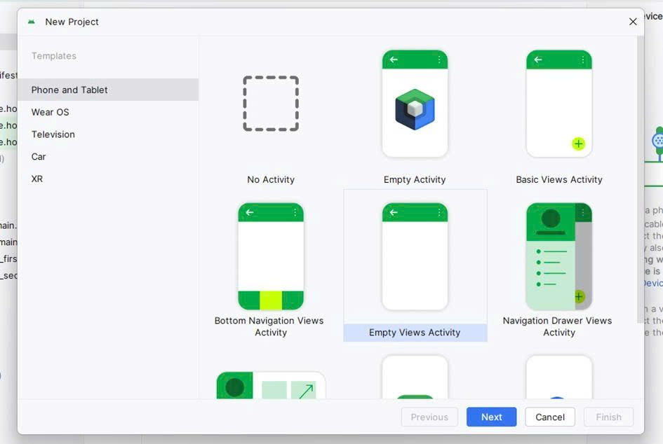

B2: Bắt đầu thiết kế “FrameLayout”🡪 activity_main.XML🡪 đổi nội dung đoạn code theo FrameLayout mới

|  |
| --- |
| <?xml version="1.0" encoding="utf-8"?>  <androidx.constraintlayout.widget.ConstraintLayout xmlns:android="http://schemas.android.com/apk/res/android"  xmlns:app="http://schemas.android.com/apk/res-auto"  xmlns:tools="http://schemas.android.com/tools"  android:id="@+id/main"  android:layout_width="match_parent"  android:layout_height="match_parent"  tools:context=".MainActivity">    <ImageView  android:id="@+id/blueImage"  android:layout_width="0dp"  android:layout_height="0dp"  android:scaleType="centerCrop"  android:src="@drawable/blue"  app:layout_constraintTop_toTopOf="parent"  app:layout_constraintBottom_toBottomOf="parent"  app:layout_constraintStart_toStartOf="parent"  app:layout_constraintEnd_toEndOf="parent" />    <ImageView  android:id="@+id/redImage"  android:layout_width="200dp"  android:layout_height="200dp"  android:src="@drawable/red"  app:layout_constraintTop_toTopOf="parent"  app:layout_constraintBottom_toBottomOf="parent"  app:layout_constraintStart_toStartOf="parent"  app:layout_constraintEnd_toEndOf="parent" />    <LinearLayout  android:id="@+id/infoBox"  android:layout_width="wrap_content"  android:layout_height="wrap_content"  android:orientation="vertical"  android:padding="16dp"  android:background="#80000000"  app:layout_constraintBottom_toBottomOf="parent"  app:layout_constraintStart_toStartOf="parent"  app:layout_constraintEnd_toEndOf="parent"  android:layout_marginBottom="24dp">  <TextView  android:id="@+id/txtName"  android:layout_width="wrap_content"  android:layout_height="wrap_content"  android:text="Mai Nguyễn Trường Duy"  android:textSize="20sp"  android:textColor="@android:color/white"  android:textStyle="bold" />  <TextView  android:id="@+id/txtId"  android:layout_width="wrap_content"  android:layout_height="wrap_content"  android:text="Mã SV: 1150070006"  android:textSize="16sp"  android:textColor="@android:color/white" />  <TextView  android:id="@+id/txtClass"  android:layout_width="wrap_content"  android:layout_height="wrap_content"  android:text="Lớp: 11_ĐH_TMĐT"  android:textSize="16sp"  android:textColor="@android:color/white" />  </LinearLayout>  </androidx.constraintlayout.widget.ConstraintLayout> |

B3: MainActivity.java🡪 thay đổi nội dung code

|  |
| --- |
| package com.example.baitaplythuyet2;  import android.os.Bundle;  import android.widget.TextView;  import androidx.activity.EdgeToEdge;  import androidx.appcompat.app.AppCompatActivity;  import androidx.core.graphics.Insets;  import androidx.core.view.ViewCompat;  import androidx.core.view.WindowInsetsCompat;  public class MainActivity extends AppCompatActivity {  @Override  protected void onCreate(Bundle savedInstanceState) {  super.onCreate(savedInstanceState);  EdgeToEdge.enable(this);  setContentView(R.layout.activity_main);  ViewCompat.setOnApplyWindowInsetsListener(findViewById(R.id.main), (v, insets) -> {  Insets systemBars = insets.getInsets(WindowInsetsCompat.Type.systemBars());  v.setPadding(systemBars.left, systemBars.top, systemBars.right, systemBars.bottom);  return insets;  });  TextView txtName = findViewById(R.id.txtName);  TextView txtId = findViewById(R.id.txtId);  TextView txtClass = findViewById(R.id.txtClass);  txtName.setText("Mai Nguyễn Trường Duy");  txtId.setText("Mã SV: 1150070006");  txtClass.setText("Lớp: 11_ĐH_TMĐT");  }  } |

B4: Để gán hình ảnh vào 🡪 android:src="@drawable/blue" 🡪 download ảnh và chọn đuôi png 🡪 copy file ảnh đã tải🡪 res 🡪 drawable 🡪 Paste

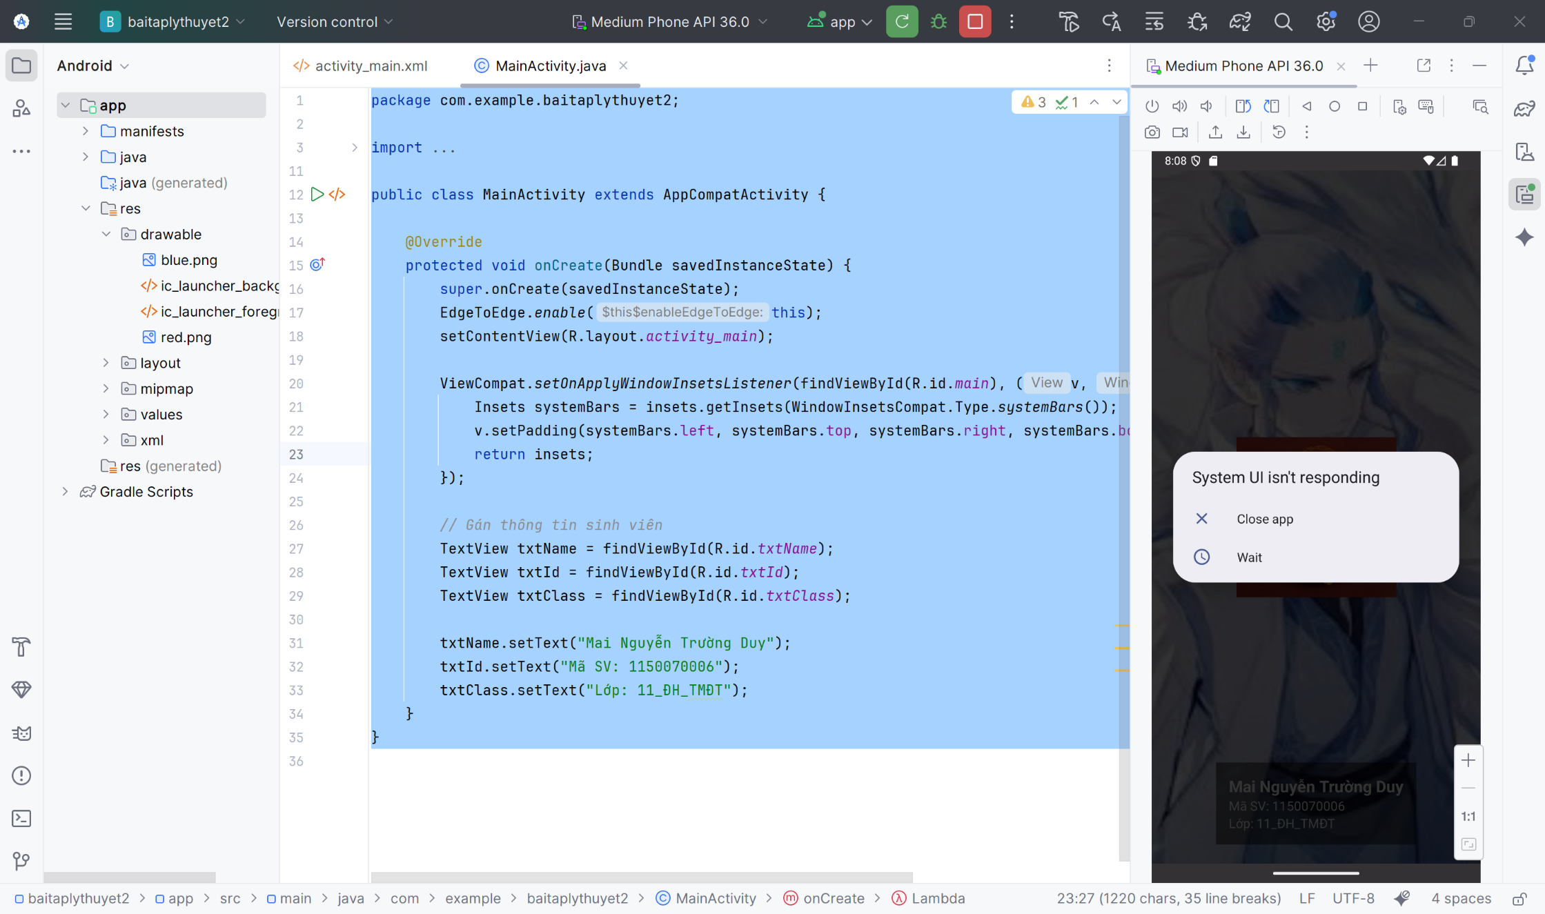

B5: Giao diện kết quả

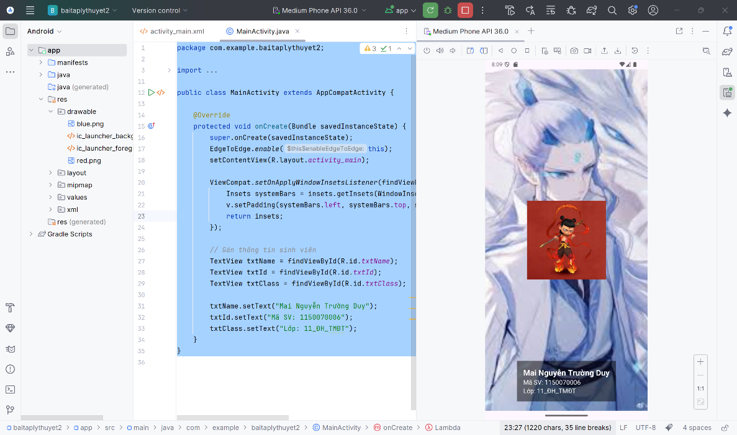

Linear Layout

B1:Khởi tạo New Project

B2: activity_man.xml

main.xml

<?xml version="1.0" encoding="utf-8"?>

<FrameLayout xmlns:android="http://schemas.android.com/apk/res/android"

android:layout_width="match_parent"

android:layout_height="match_parent">

<!-- Toàn bộ layout màu -->

<LinearLayout

android:layout_width="match_parent"

android:layout_height="match_parent"

android:orientation="vertical">

<!-- Dải đen trên -->

<LinearLayout

android:layout_width="match_parent"

android:layout_height="0dp"

android:layout_weight="1"

android:background="@color/color0" />

<!-- Phần dưới -->

<LinearLayout

android:layout_width="match_parent"

android:layout_height="0dp"

android:layout_weight="2"

android:orientation="horizontal">

<!-- Cột trái -->

<LinearLayout

android:layout_width="0dp"

android:layout_height="match_parent"

android:layout_weight="1"

android:orientation="vertical">

<LinearLayout

android:layout_width="match_parent"

android:layout_height="0dp"

android:layout_weight="1"

android:background="@color/color2" />

<LinearLayout

android:layout_width="match_parent"

android:layout_height="0dp"

android:layout_weight="1"

android:background="@color/color3" />

</LinearLayout>

<!-- Cột phải -->

<LinearLayout

android:layout_width="0dp"

android:layout_height="match_parent"

android:layout_weight="1"

android:background="@color/color1" />

</LinearLayout>

</LinearLayout>

<!-- Text hiển thị tên + MSSV (đè lên trên) -->

<LinearLayout

android:layout_width="wrap_content"

android:layout_height="wrap_content"

android:orientation="vertical"

android:layout_gravity="top|start"

android:padding="8dp">

<TextView

android:id="@+id/txtName"

android:layout_width="wrap_content"

android:layout_height="wrap_content"

android:text="Tên: Mai Nguyễn Trường Duy"

android:textColor="@android:color/white"

android:textStyle="bold"

android:textSize="16sp" />

<TextView

android:id="@+id/txtMSSV"

android:layout_width="wrap_content"

android:layout_height="wrap_content"

android:text="MSSV: 1150070006"

android:textColor="@android:color/white"

android:textSize="16sp" />

</LinearLayout>

</FrameLayout>

B3: tạo thêm activity_second.xml

main_second.xml

<?xml version="1.0" encoding="utf-8"?>

<LinearLayout xmlns:android="http://schemas.android.com/apk/res/android"

android:layout_width="match_parent"

android:layout_height="match_parent"

android:orientation="vertical">

<LinearLayout

android:layout_width="match_parent"

android:layout_height="0dp"

android:layout_weight="1"

android:background="@color/color0" />

<LinearLayout

android:layout_width="match_parent"

android:layout_height="0dp"

android:layout_weight="2"

android:orientation="horizontal">

<!-- Cột trái: 3 hàng -->

<LinearLayout

android:layout_width="0dp"

android:layout_height="match_parent"

android:layout_weight="1"

android:orientation="vertical">

<LinearLayout

android:layout_width="match_parent"

android:layout_height="0dp"

android:layout_weight="1"

android:background="@color/colorCyan" />

<LinearLayout

android:layout_width="match_parent"

android:layout_height="0dp"

android:layout_weight="1"

android:background="@color/colorWhite" />

<LinearLayout

android:layout_width="match_parent"

android:layout_height="0dp"

android:layout_weight="1"

android:background="@color/color3" />

</LinearLayout>

<!-- Cột phải: đỏ -->

<LinearLayout

android:layout_width="0dp"

android:layout_height="match_parent"

android:layout_weight="1"

android:background="@color/color1" />

</LinearLayout>

</LinearLayout>

B4: MainActivity.java

main.java

package com.example.baitaplythuyet2;

import android.os.Bundle;

import androidx.appcompat.app.AppCompatActivity;

public class MainActivity extends AppCompatActivity {

@Override

protected void onCreate(Bundle savedInstanceState) {

super.onCreate(savedInstanceState);

// Chọn layout nào muốn hiển thị

setContentView(R.layout.activity_main); // hình 1

// setContentView(R.layout.activity_second); // hình 2 (nếu bạn có file activity_second.xml)

}

}  
B5: Kết quả

