Shri Ramswaroop Memorial University



MINI PYTHON PROJECT REPORT
on
PASSWORD GENERATOR
Submitted by:
Name | Roll No. | Course | Group
Khushal Kumar | 202410101240073 | B.Tech CS (AI/ML) | 53
Praful Singh | 202410101240087 | B.Tech CS (AI/ML) | 53
Suyash Srivastava | 202410101240067 | B.Tech CS (AI/ML) | 53
Mohit Singh | 202410101240089 | B.Tech CS (AI/ML) | 53

Course: B.Tech CS (AI & ML)
Groups: 53

1. Introduction
Passwords are the first line of defence for digital accounts, and weak or reused passwords remain one of the most common causes of security breaches. This project implements a Password Generator in Python that creates strong, random passwords using letters, numbers and symbols, so that users no longer need to think of passwords manually.
The project was built incrementally: starting from a simple script that only prepares the character sets, then adding random password generation, then adding user-controlled options and clipboard support, and finally wrapping everything in a graphical user interface (GUI) built with Tkinter. This step-by-step approach helped in understanding how a small script can evolve into a complete, user-friendly application.

1.1 Objective
- To generate strong, random passwords of a user-defined length.
- To allow the user to choose which character types (letters, numbers, symbols) are included.
- To make the generated password easy to use by copying it directly to the clipboard.
- To build a simple and interactive graphical interface for non-technical users.

1.2 Tools and Libraries Used
- Python 3 — core programming language.
- string module — to access predefined sets of letters, digits and punctuation symbols.
- random module — to randomly pick characters and build the password.
- tkinter module — to build the graphical user interface and access the system clipboard.

1.3 Project Files
The project consists of four Python files, each representing one stage in the development of the final application:
- pass_gen_base_.py — sets up the character sets (base structure).
- pass_gen_randomlibrary_.py — generates a random password using the random module.
- pass_gen_Choicebased_.py — adds user choices and clipboard copy (console-based).
- password_gui.py — the final Tkinter GUI application (main deliverable).

2. Methodology — Stage-wise Development

Stage 1: Base Structure (pass_gen_base_.py)
This is the starting point of the project. It only takes the desired password length from the user and prints the available character sets (letters, numbers, symbols) without yet generating a password. This stage was used to confirm that the character pools were set up correctly.
import string

print("===== PASSWORD GENERATOR =====")

length = int(input("Enter password length: "))

letters = string.ascii_letters
numbers = string.digits
symbols = string.punctuation

print("Letters:", letters)
print("Numbers:", numbers)
print("Symbols:", symbols)

Stage 2: Random Password Generation (pass_gen_randomlibrary_.py)
This stage combines the letters, numbers and symbols into a single pool of characters and uses random.choice() in a loop to build a password of the requested length. This is the first version that actually produces a usable password.
import string
import random

print("===== PASSWORD GENERATOR =====")

length = int(input("Enter password length: "))

letters = string.ascii_letters
numbers = string.digits
symbols = string.punctuation

characters = letters + numbers + symbols

password = ""

for i in range(length):
password += random.choice(characters)

print("Your password is:", password)

Stage 3: User Choices + Clipboard Copy (pass_gen_Choicebased_.py)
This stage adds input validation (the length must be a positive number) and lets the user choose which character types to include (letters / numbers / symbols) by answering y/n prompts. Once the password is generated, it is automatically copied to the clipboard using Tkinter, so it can be pasted directly wherever needed.
import string
import random
import tkinter as tk

print("===== PASSWORD GENERATOR =====")

while True:
try:
length = int(input("Enter password length: "))

if length <= 0:
print("Please enter a positive number.")
else:
break

except ValueError:
print("Please enter a valid number.")

include_letters = input("Include letters? (y/n): ").lower()
include_numbers = input("Include numbers? (y/n): ").lower()
include_symbols = input("Include symbols? (y/n): ").lower()

characters = ""

if include_letters == "y":
characters += string.ascii_letters

if include_numbers == "y":
characters += string.digits

if include_symbols == "y":
characters += string.punctuation

if characters == "":
print("You must select at least one character type!")
else:
password = ""

for i in range(length):
password += random.choice(characters)

print("Your password is:", password)

root = tk.Tk()
root.withdraw()

root.clipboard_clear()
root.clipboard_append(password)
root.update()

print("Password copied to clipboard!")
root.destroy()

Stage 4: Final GUI Application (password_gui.py)
The final stage converts the console program into a full graphical application using Tkinter. The user can enter the password length, choose how many passwords to generate, tick checkboxes for letters/numbers/symbols, click a button to generate multiple passwords at once, and copy all of them to the clipboard with a single click. Error handling (via message boxes) ensures the user enters valid inputs.

3. Output

3.1 Console Output — Stage 1 (Base)
===== PASSWORD GENERATOR =====
Enter password length: 12
Letters: abcdefghijklmnopqrstuvwxyzABCDEFGHIJKLMNOPQRSTUVWXYZ
Numbers: 0123456789
Symbols: !"#$%&'()*+,-./:;<=>?@[\]^_`{|}~

3.2 Console Output — Stage 2 (Random Library)
===== PASSWORD GENERATOR =====
Enter password length: 12
Your password is: vR#[i?d(5PRE

3.3 Console Output — Stage 3 (Choice Based + Clipboard)
===== PASSWORD GENERATOR =====
Enter password length: 12
Include letters? (y/n): y
Include numbers? (y/n): y
Include symbols? (y/n): y
Your password is: 3<`+sev{G,"3
Password copied to clipboard!

3.4 GUI Output — Stage 4 (Final Application)
Below is a screenshot of the final GUI application after clicking "GENERATE PASSWORDS" with length 12 and count 5, with letters, numbers and symbols all enabled:
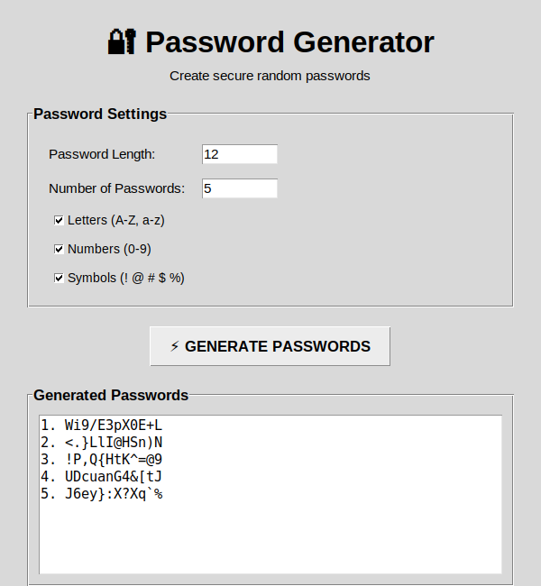

4. Conclusion
This project successfully demonstrates the step-by-step development of a Python Password Generator, starting from basic character-set setup and progressing to a fully functional GUI application. Through this project, concepts such as string handling, the random module, input validation, conditional logic, loops, and GUI programming with Tkinter (including widgets, event handling and clipboard access) were practically applied.
The final application allows a user to generate one or more secure, customizable passwords through a simple and intuitive interface, and copy them instantly for use. This project can be further extended by adding password strength meters, saving generated passwords securely, or excluding ambiguous characters (like 'l' and '1').

