**Polymorphism EG. 1： Shape and its Subclasses**

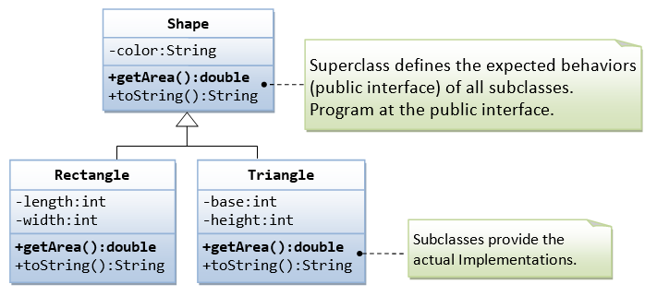

**Write a test driver to test all methods of Rectangle and Triangle**

/*

* A test driver for Shape and its subclasses

*/

public class **TestShape** {

public static void main(String[] args) {

Shape s1 = new Rectangle("red", 4, 5); // Upcast

System.out.println(s1); // Run Rectangle's toString()

System.out.println("Area is " + s1.getArea()); // Run Rectangle's getArea()

Shape s2 = new Triangle("blue", 4, 5); // Upcast

System.out.println(s2); // Run Triangle's toString()

System.out.println("Area is " + s2.getArea()); // Run Triangle's getArea()

}

}

The expected outputs are:

Rectangle[length=4,width=5,Shape[color=red]]

Area is 20.0

Triangle[base=4,height=5,Shape[color=blue]]

Area is 10.0

**Polymorphism EG. 2： Circle and its Subclasses**

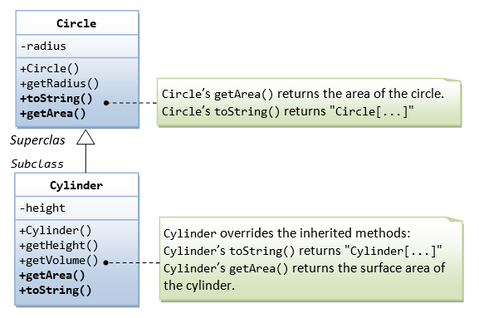

**Write a test driver to test all methods of Circle and Cylinder**