Buying tickets at TicketBooth
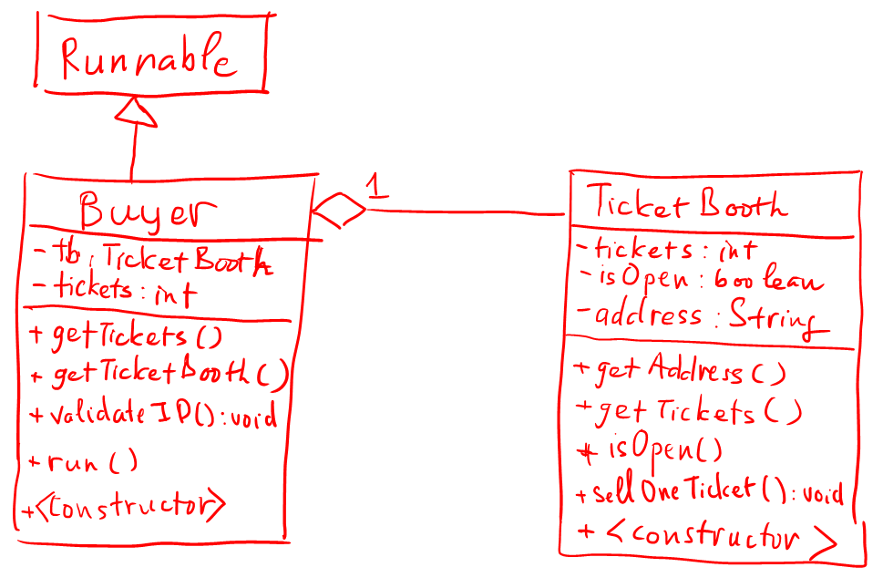

TicketBooth class:
sellOneTicket(){
tickets--;
}
Buyer class:
validateID() {
//demonstrate a time-consuming work
Thread.sleep(100);
}
run() {
validateID();
//if ticket booth is open
//ticketbooth sellOneTicket() 02 times
//buyer’s ticket += 2
}
Main method:
//Initiate a TicketBooth: 500 tickets, isOpen = true, address = “My Dinh”
//initiate an ExecutorService
//initiate a list of 100 buyers to buy tickets in parallele
//After all buyers finish, calculate the total tickets bought by buyers
//calculate total tickets left at the booth
//sum up the 2 totals
- Without using synchronized keyword, prove that the program can go wrong
- Use synchronized keyword to make program work correctly

Limited-Coin-Selling Machine
In a game center, players have to buy coins from a coin-selling-machine.
Initially, the machine has 5000 coins in stock.
1 player can buy 20 coins at one time.
The game center has a few rules which are:
if the machine has less than 500 coins in stock, next players voluntarily return 10 coins back to the machine after it churns out 20 coins. This rule is to promote coin sharing among late comers.
if the machine has no coin left, players receive 0 coins.

1. Design LimitedCoinSellingMachine class
2. Design Player class which implements Runnable and stores the number of coins it bought.
3. Write the main method which allows 300 players to buy coins at the same time.
Calculate the total number of coins all players have.
Is the total always equal to 5000?
If not, how do you change your program to make it right?

