Tên: Phạm Mai Duy
Mssv: 22002115
Link github: https://github.com/MaiDuyy/LAB_NEWTECHNOLOGY/tree/main/PhamMaiDuy_22002115_Lab1
Lab 1: Node.js Fundamentals (3 hours)
Tasks:
1. Install Node.js + 2. Create a simple Node.js program
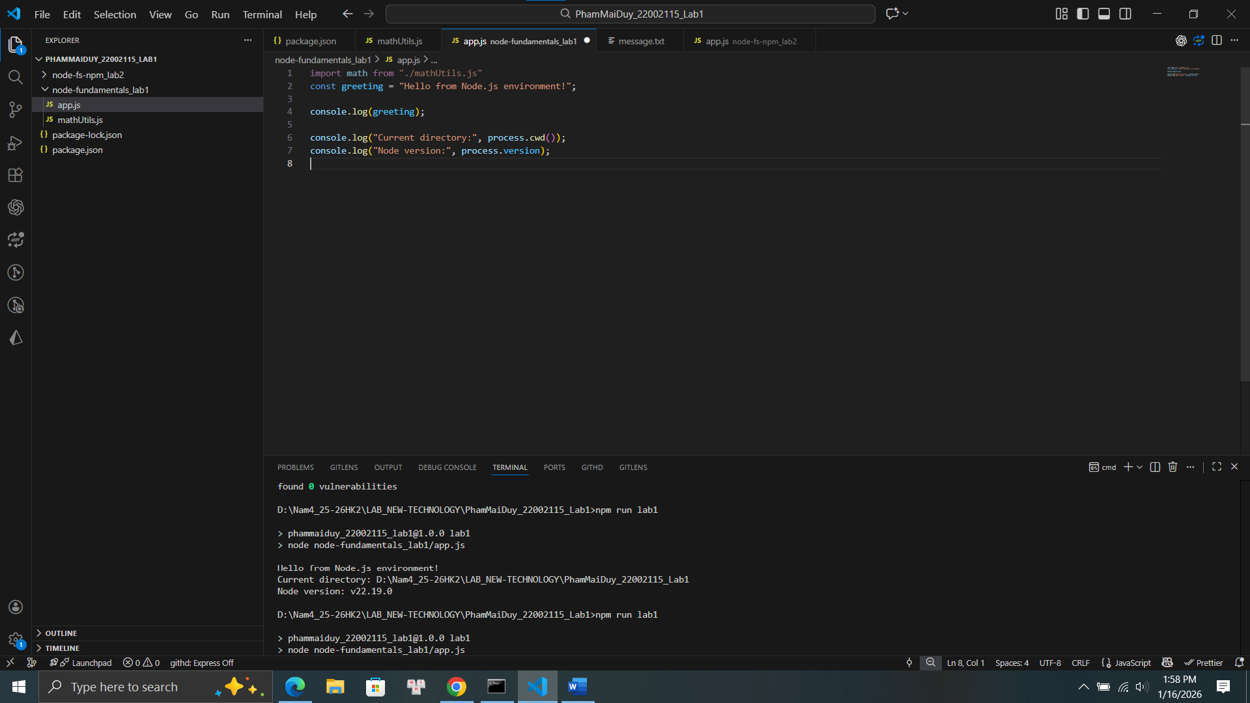
3. Create a custom module and import it
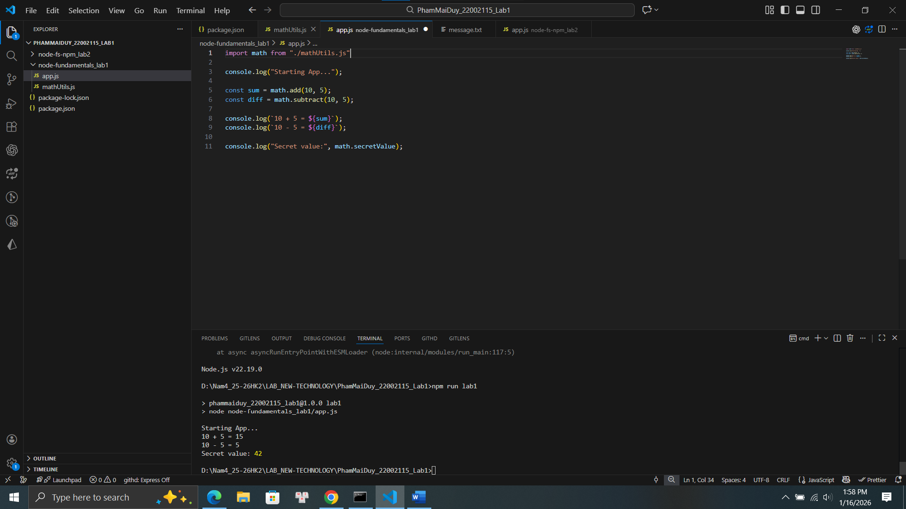
Lab 2: File System & NPM (3 hours)
Tasks:
1. Read and write files asynchronously
1.1 Read file
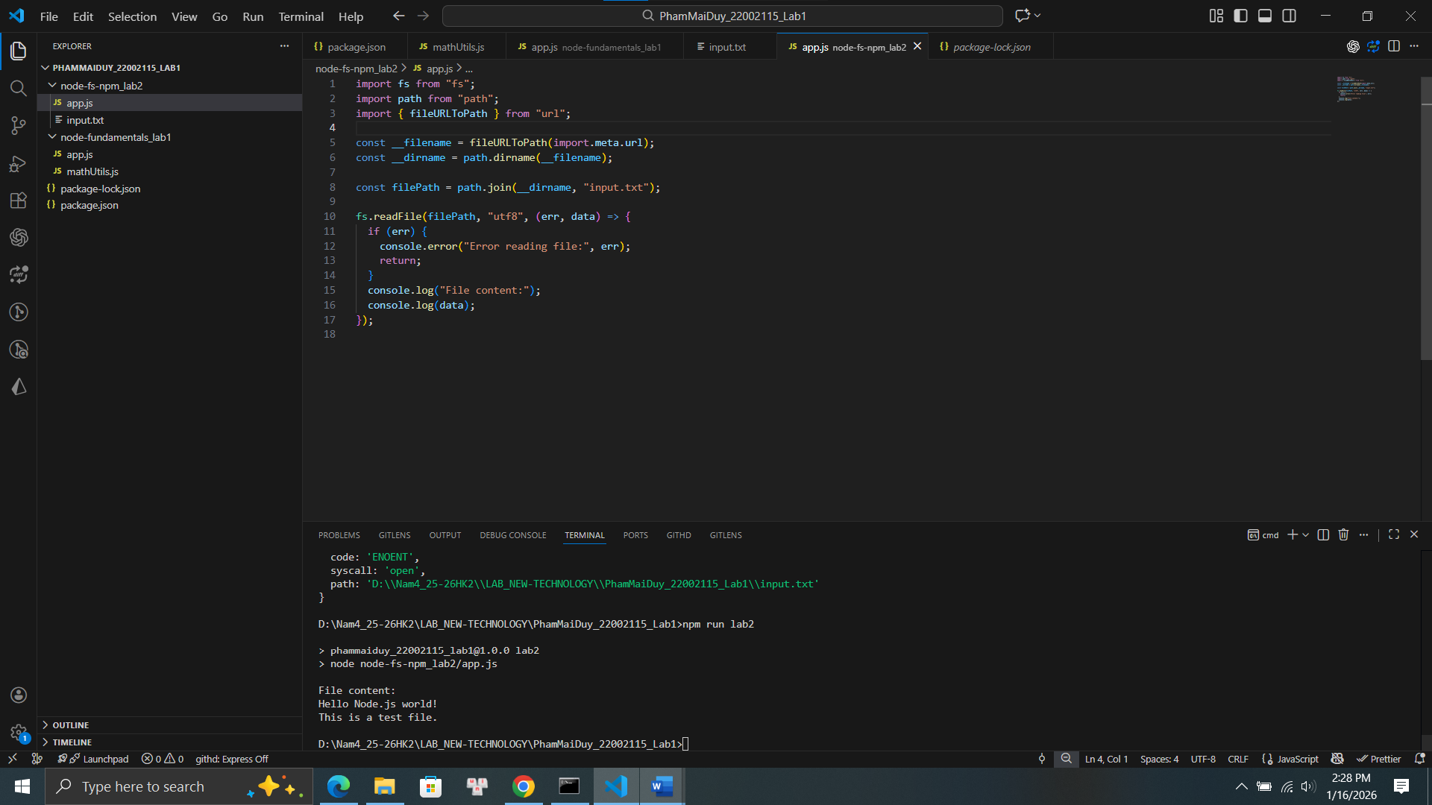
1.2 Write file
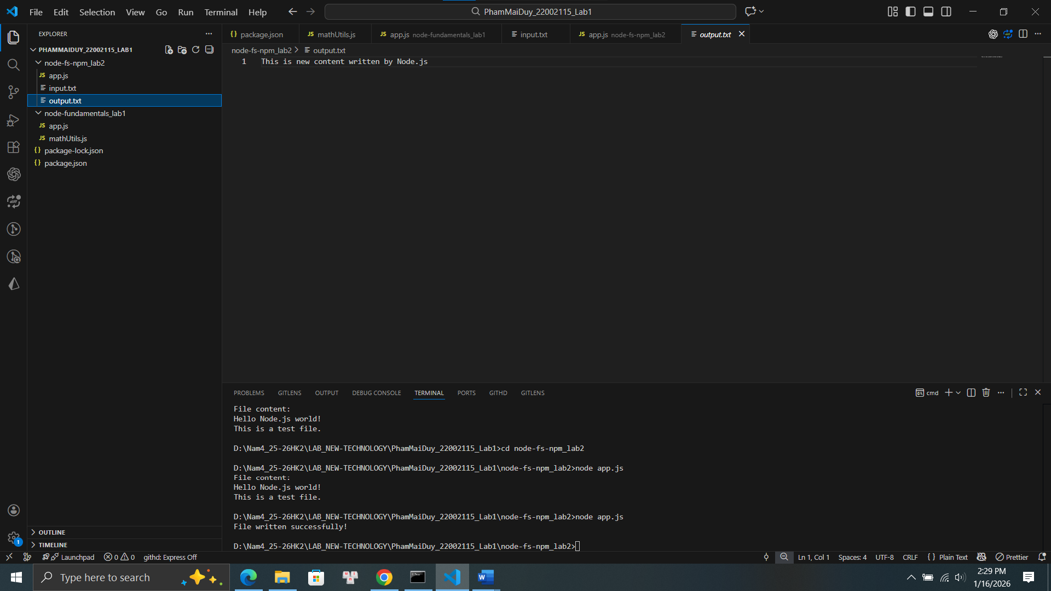
2. Initialize npm project +3. Install and use third-party package
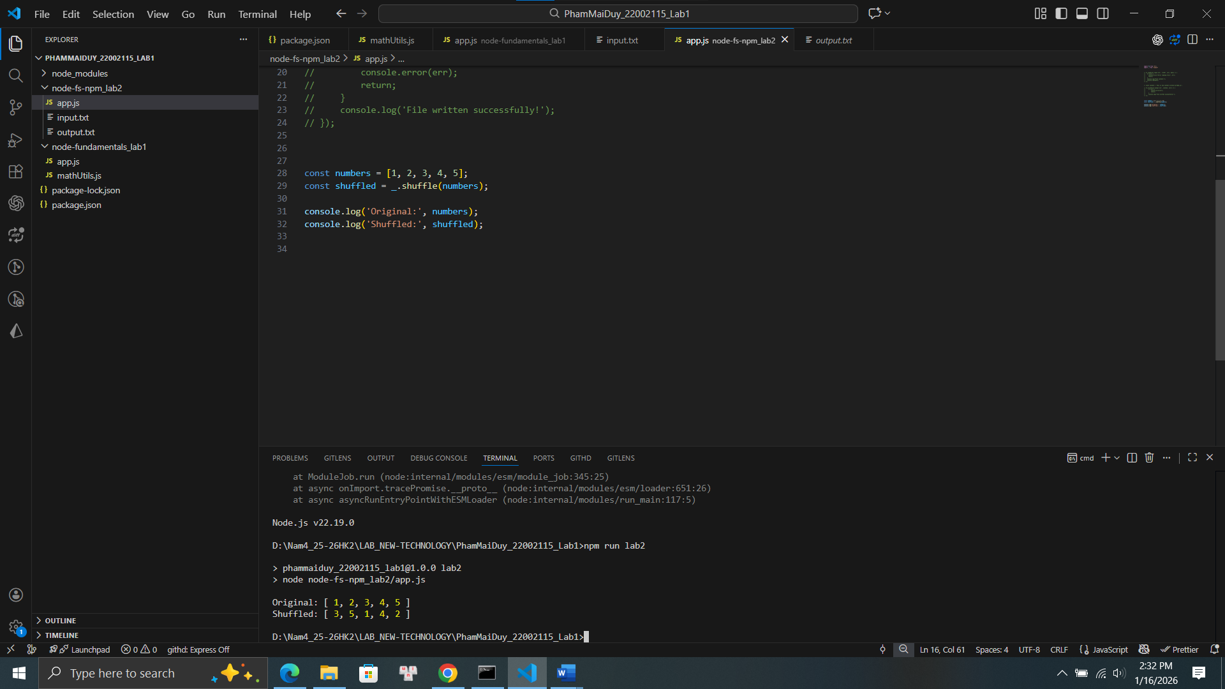

Lab 3: Event-driven Mini Project
Mini Project: Student Activity Logger
- Emit events when student action occurs
- Log activities to file
- Use EventEmitter and fs
