TRUONG DAI HOC THUY LOI (TLU)
KHOA CONG NGHE THONG TIN
BAO CAO PHAN TICH, THIET KE VA XAY DUNG HE THONG
XAY DUNG HE THONG QUAN LY VA DAT SAN THE THAO TAI TLU
De tai 6 - Nhom 2 - Dich vu sinh vien va khuon vien
Pham vi trien khai: Vong 1
Thong tin | Noi dung
De tai | Xay dung he thong quan ly va dat san the thao tai TLU
Cong nghe | Laravel 12, PHP 8.2, Blade, Bootstrap 5, MySQL, phpMyAdmin
Mo hinh kien truc | MVC
Sinh vien thuc hien | [Dien ho ten]
Ma sinh vien | [Dien ma sinh vien]
Lop | [Dien lop]
Giang vien huong dan | [Dien ten giang vien huong dan]
Thoi gian | Thang 08 nam 2026
Luu y: truoc khi nop ban chinh thuc, sinh vien chi can dien thong tin ca nhan tren bia va kiem tra lai muc luc, so trang.

Loi mo dau
Trong boi canh chuyen doi so trong giao duc, nhu cau tin hoc hoa cac dich vu ho tro sinh vien khong chi duoc dat ra doi voi cac nghiep vu hoc tap ma con mo rong sang nhom dich vu trong khuon vien. Voi cac hoat dong the chat, giao luu va ren luyen, viec quan ly san the thao neu thuc hien thu cong se de phat sinh trung lich, kho theo doi tinh trang san va kho tong hop bao cao su dung.
Tu bai toan thuc te do, de tai "Xay dung he thong quan ly va dat san the thao tai TLU" duoc lua chon nham xay dung mot he thong web ho tro quan ly danh muc san, lich mo, tiep nhan yeu cau dat san, kiem tra xung dot, phan quyen nguoi dung va tong hop thong ke su dung. He thong huong toi hai doi tuong chinh la quan tri vien va sinh vien, trong do moi doi tuong duoc cap dung chuc nang theo vai tro.
Bao cao nay trinh bay toan bo qua trinh phan tich nghiep vu, xac dinh yeu cau, thiet ke co so du lieu, xay dung kien truc MVC va danh gia ket qua dat duoc cua phien ban hien tai. Noi dung duoc viet theo huong co the nop truc tiep cho vong 1, dong thoi de san kha nang mo rong cho cac vong tiep theo neu can.

Muc luc
Muc luc duoc sinh tu dong theo Heading. Khi mo file bang Microsoft Word, neu can co the bam Update Table de cap nhat so trang.
Loi mo dau 2
Muc luc 3
Chuong 1. Tong quan de tai 5
1.1. Ly do chon de tai 5
1.2. Muc tieu de tai 5
1.3. Doi tuong va pham vi nghien cuu 5
1.4. Phuong phap thuc hien 5
Chuong 2. Phan tich yeu cau he thong 6
2.1. Boi canh nghiep vu 6
2.2. Tac nhan su dung he thong 6
2.3. Cac chuc nang chinh 6
2.4. Use Case tong quat 7
2.5. Workflow dat san 8
2.6. Yeu cau chuc nang 8
2.7. Yeu cau phi chuc nang 9
Chuong 3. Thiet ke he thong 9
3.1. So do kien truc MVC 9
3.2. So do module 10
3.3. Bieu do ERD 11
3.4. Thiet ke CSDL 11
3.5. Data dictionary 12
3.5.1. Bang users 12
3.5.2. Bang sport_types 13
3.5.3. Bang courts 13
3.5.4. Bang time_slots 13
3.5.5. Bang court_schedules 14
3.5.6. Bang bookings 14
3.5.7. Bang booking_details 14
3.5.8. Bang usage_logs 15
3.6. Ma tran phan quyen 15
Chuong 4. Xay dung va cai dat he thong 16
4.1. Cong nghe su dung 16
4.2. Moi truong cai dat 16
4.3. Cac chuc nang da hoan thanh 17
4.4. Minh hoa giao dien 17
Ket luan 18
Danh gia tong quat 18
Han che hien tai 18
Huong phat trien 19

Chuong 1. Tong quan de tai

1.1. Ly do chon de tai
Trong khuon vien truong, nhu cau dat san bong da, bong chuyen, bong ro hoac cau long dien ra thuong xuyen. Neu viec quan ly van duoc thuc hien bang so tay, bang tinh hoac thong bao thu cong thi rat de xay ra trung lich, kho kiem soat tinh trang san va kho tong hop bao cao muc do su dung. Vi vay, mot he thong web tap trung la can thiet de chuan hoa quy trinh dat san.

1.2. Muc tieu de tai
- So hoa quy trinh quan ly va dat san the thao trong khuon vien truong.
- Han che tinh trang trung lich giua cac yeu cau dat san cung ngay va cung ca gio.
- Cho phep theo doi tinh trang san, lich mo, booking, usage log va bao cao su dung.
- Phan quyen ro rang giua admin va sinh vien theo dung workflow nghiep vu.
- Dam bao du an co the cai dat lai nhanh bang migration, seeder va du lieu demo.

1.3. Doi tuong va pham vi nghien cuu
Doi tuong nghien cuu cua de tai gom he thong quan ly san the thao, quy trinh dat san cua sinh vien, nghiep vu phe duyet cua quan tri vien va du lieu thong ke su dung san trong khuon vien truong.
- Tap trung vao huong trien khai "San the thao" trong De tai 6 cua giang vien.
- Phien ban hien tai su dung 8 bang nghiep vu cot loi: users, sport_types, courts, time_slots, court_schedules, bookings, booking_details, usage_logs.
- He thong chua trien khai thanh toan, thong bao email va lich bao tri nang cao theo ca.
- Bao cao dat trong pham vi project ca nhan lam local, quan ly ma nguon bang Git va day len GitHub.

1.4. Phuong phap thuc hien
- Khao sat bai toan va xac dinh quy trinh nghiep vu dat san theo vai tro nguoi dung.
- Phan tich tac nhan, use case, quy tac rang buoc va cac tinh huong xung dot can xu ly.
- Thiet ke co so du lieu theo quan he cha - con va mo hinh MVC cho ung dung Laravel.
- Xay dung migration, seeder, model, controller, blade view va bo phan xac thuc, phan quyen.
- Kiem thu bang du lieu demo, kiem tra dang nhap, booking, duyet, huy va thong ke.

Chuong 2. Phan tich yeu cau he thong

2.1. Boi canh nghiep vu
Bai toan dat ra la xay dung mot he thong cho phep nha truong quan ly danh muc san the thao, lich mo theo tung thu va tung ca gio, dong thoi ho tro sinh vien gui yeu cau dat san trong khung thoi gian hop le. He thong phai giai quyet duoc bai toan trung lich, the hien ro tinh trang san dang khai thac hay bao tri va luu vet ket qua su dung thuc te sau moi buoi dat san.

2.2. Tac nhan su dung he thong
Tac nhan | Quyen chinh | Muc tieu su dung
Admin | Dang nhap, CRUD danh muc, duyet booking, cap nhat usage log, xem bao cao | Quan ly toan bo tai nguyen va workflow he thong
Sinh vien | Dang nhap, tao booking, xem, sua, huy booking cua chinh minh | Su dung san the thao phu hop nhu cau hoc tap va sinh hoat

2.3. Cac chuc nang chinh
Chuc nang | Mo ta
Dang nhap va phan quyen | Xac thuc nguoi dung va hien thi dung pham vi chuc nang theo vai tro admin / sinh vien.
Quan ly danh muc san | Quan ly mon the thao, san, ca gio va tinh trang san.
Quan ly lich mo | Gan lich mo cho tung san theo thu trong tuan va tung ca gio.
Dat san | Sinh vien tao phieu dat, nhap muc dich, so nguoi, ngay dat va ca gio.
Phe duyet va huy booking | Admin duyet / tu choi booking; sinh vien duoc huy booking cua minh khi con hop le.
Usage log va bao cao | Cap nhat ket qua su dung thuc te va tong hop dashboard, thong ke.

2.4. Use Case tong quat
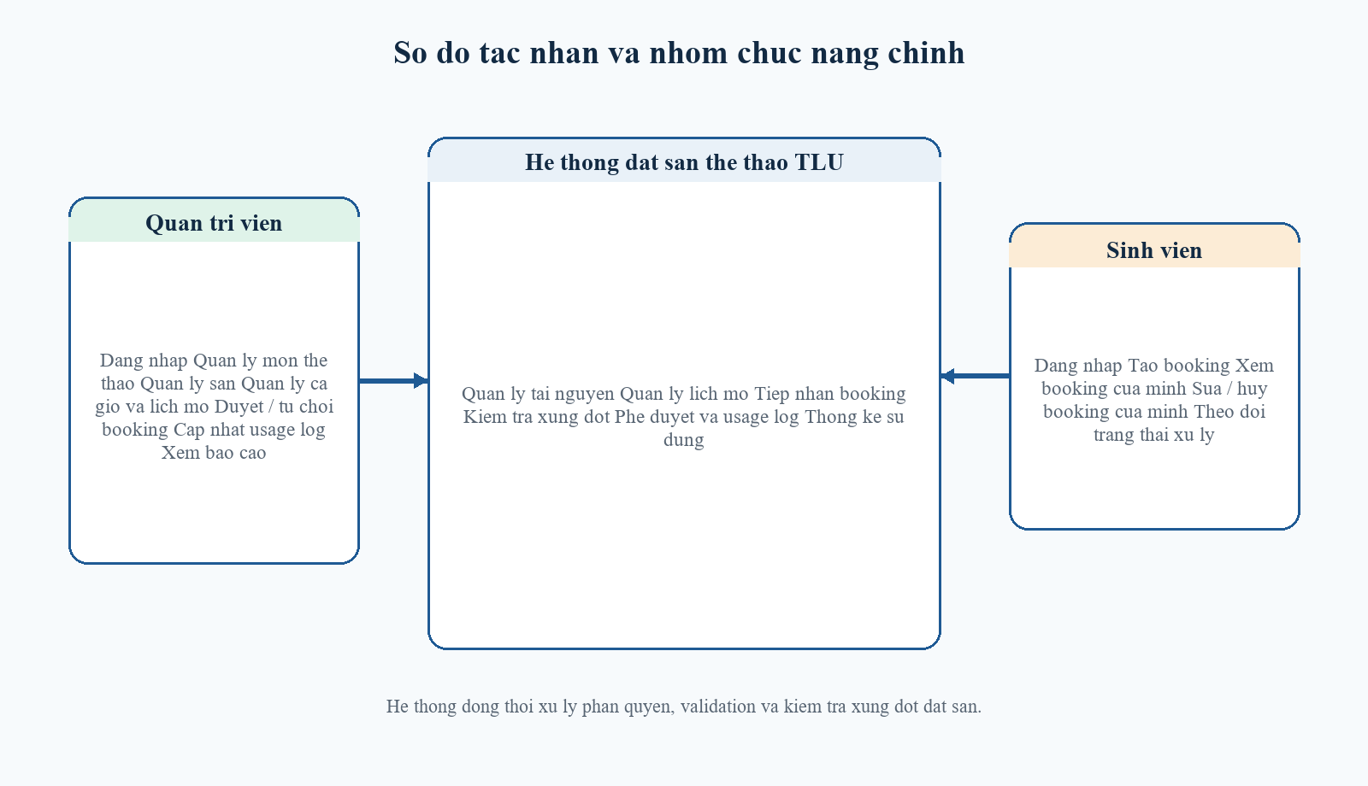
Hinh 2.1. Use Case tong quat cua he thong
Ma | Use case | Tac nhan | Mo ta ngan
UC01 | Dang nhap he thong | Admin, Sinh vien | Nguoi dung xac thuc de truy cap he thong theo vai tro.
UC02 | Quan ly mon the thao | Admin | Them, sua, xoa danh muc mon the thao phuc vu khai bao san.
UC03 | Quan ly san | Admin | Them, sua, xoa san; cap nhat suc chua, vi tri va trang thai.
UC04 | Quan ly ca gio | Admin | Khai bao cac khung gio su dung cho dat san.
UC05 | Quan ly lich mo san | Admin | Gan lich mo theo thu trong tuan va tung ca gio cho moi san.
UC06 | Tao booking | Sinh vien | Nhap thong tin dat san va gui yeu cau den he thong.
UC07 | Kiem tra xung dot | He thong | Chan dat san neu trung lich, san bao tri hoac khong mo lich.
UC08 | Duyet hoac tu choi booking | Admin | Cap nhat trang thai booking va ly do tu choi neu co.
UC09 | Huy booking | Sinh vien | Sinh vien huy phieu dat cua chinh minh khi chua hoan tat.
UC10 | Cap nhat usage log | Admin | Ghi nhan used, no_show hoac cancelled sau buoi dat san.
UC11 | Xem bao cao | Admin | Tong hop thong ke booking, usage log, top san va top sinh vien.

2.5. Workflow dat san
Workflow dat san la luong nghiep vu trung tam cua he thong, bat dau tu khai bao tai nguyen, tiep nhan yeu cau dat san, kiem tra rang buoc, phe duyet booking va ket thuc o usage log va bao cao.
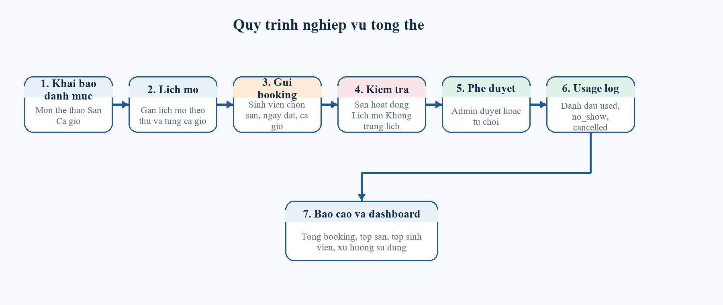
Hinh 2.2. Workflow dat san tu khai bao tai nguyen den usage log
- Admin khai bao mon the thao, san, ca gio va lich mo.
- Sinh vien chon san, ngay dat, ca gio va nhap thong tin booking.
- He thong kiem tra tinh trang san, suc chua, lich mo va xung dot.
- Neu hop le, booking duoc tao o trang thai pending.
- Admin duyet hoac tu choi booking.
- Sau buoi dat san, admin cap nhat usage log.
- Dashboard va bao cao tong hop du lieu su dung san.

2.6. Yeu cau chuc nang
- Dang nhap va dang xuat he thong theo tai khoan da cap.
- Quan ly danh muc mon the thao, san, ca gio va lich mo cua tung san.
- Cho phep sinh vien tao phieu dat san voi thong tin muc dich, so nguoi, ngay dat va ca gio.
- Kiem tra xung dot booking theo san, ngay, ca gio va tinh trang hoat dong cua san.
- Cho phep admin duyet hoac tu choi booking, luu ly do tu choi khi can.
- Cho phep sinh vien xem, sua, huy booking cua chinh minh khi con hop le.
- Cap nhat usage log sau buoi dat san de dong bo trang thai booking.
- Tong hop dashboard va bao cao thong ke theo khoang thoi gian.
Rang buoc chuc nang quan trong: san bao tri khong duoc dat; booking khong duoc trung san - trung ngay - trung ca; sinh vien chi duoc thao tac tren booking cua chinh minh.

2.7. Yeu cau phi chuc nang
- Giao dien de hieu, viet hoa tieng Viet va co bo cuc ro rang cho form, bang va dashboard.
- Du lieu duoc validate o backend; khong thao tac thay doi du lieu bang GET.
- Mat khau duoc ma hoa; route quan tri duoc bao ve boi middleware va policy.
- He thong co the cai dat lai bang migrate:fresh --seed de phuc vu demo nhanh.
- Cau truc MVC ro rang, View khong query database va Controller khong chua SQL dai.

Chuong 3. Thiet ke he thong

3.1. So do kien truc MVC
Du an duoc xay dung tren Laravel theo mo hinh MVC. Request tu trinh duyet di qua route, middleware va controller; controller thuc hien validation, thao tac model va tra ket qua ve Blade View. Cach to chuc nay giup ma nguon de doc, de bao tri va phu hop voi yeu cau mon hoc.
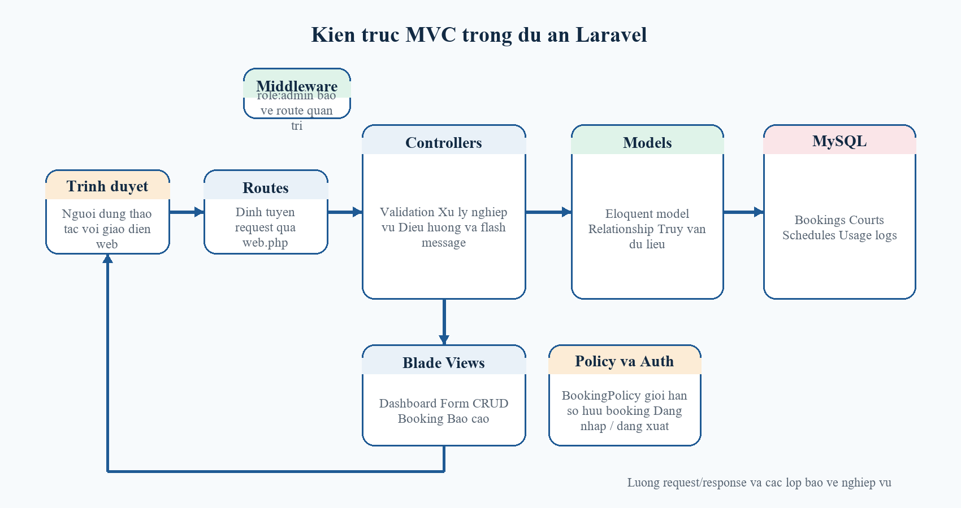
Hinh 3.1. Kien truc MVC cua du an Laravel

3.2. So do module
He thong duoc tach thanh cac module theo nhom nghiep vu chinh, giup viec phan chia chuc nang, ma nguon va du lieu tro nen ro rang hon.
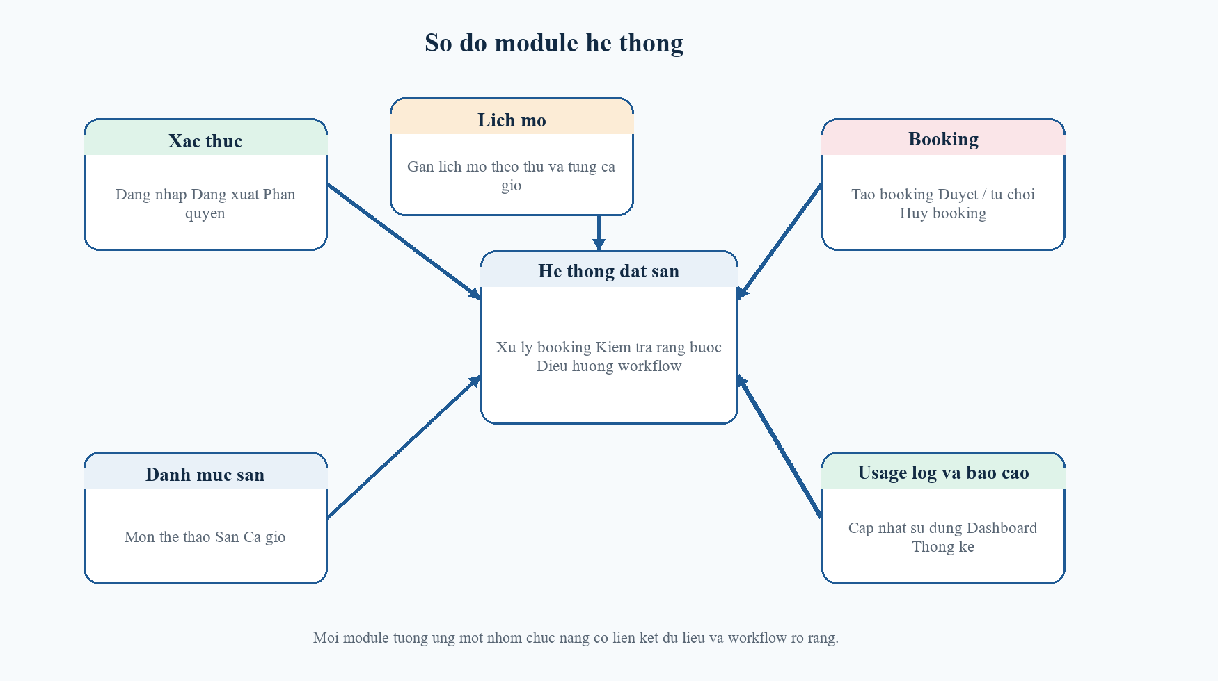
Hinh 3.2. So do module cua he thong
Module | Noi dung
Module xac thuc | Dang nhap, dang xuat va phan quyen theo vai tro.
Module danh muc | Quan ly mon the thao, san, ca gio va trang thai san.
Module lich mo | Khai bao lich mo cho tung san theo thu va khung gio.
Module booking | Tao, xem, sua, huy, duyet va tu choi booking.
Module usage log | Cap nhat used, no_show, cancelled cho booking detail.
Module bao cao | Thong ke booking, top san, top sinh vien va xu huong su dung.

3.3. Bieu do ERD
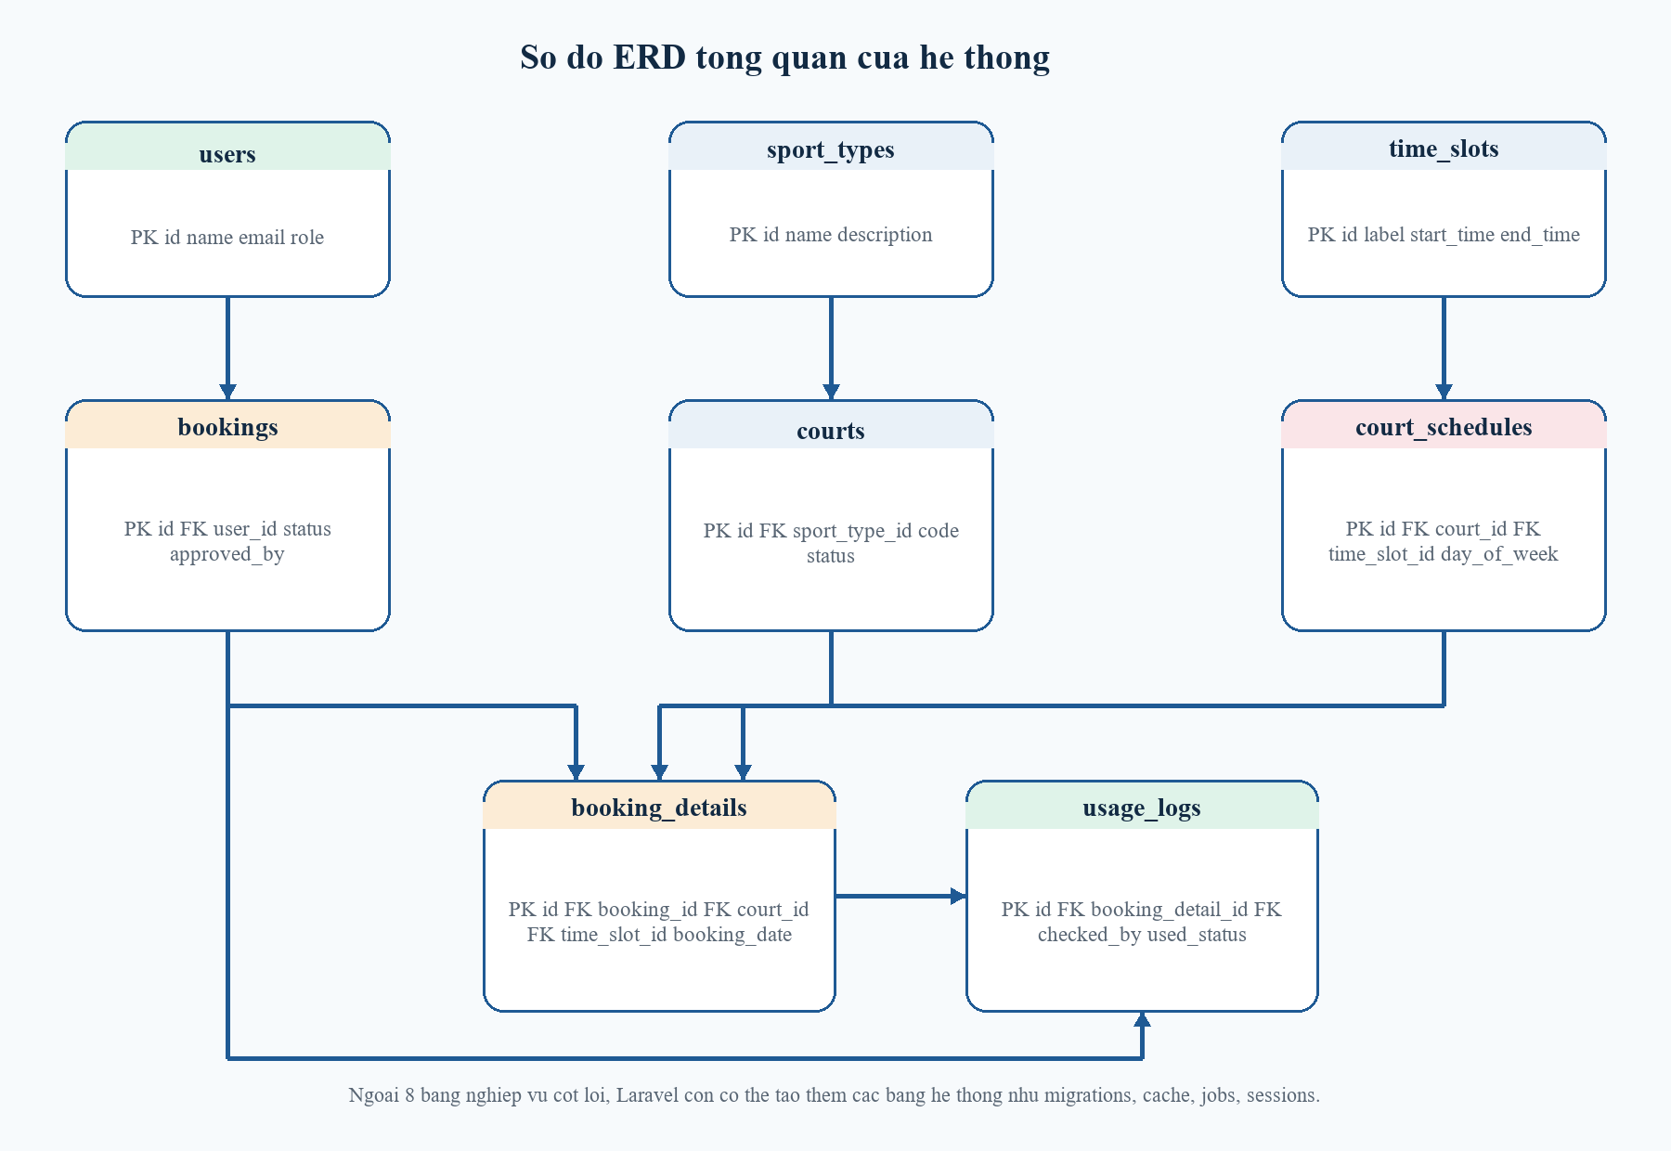
Hinh 3.3. Bieu do ERD tong quan cua he thong

3.4. Thiet ke CSDL
Nhom bang |  | Cac bang |  | Y nghia
Nhom tai khoan |  | users |  | Luu thong tin dang nhap, vai tro va lien ket nguoi tao booking.
Nhom danh muc |  | sport_types, courts, time_slots |  | Quan ly mon the thao, san va khung gio.
Nhom lich |  | court_schedules |  | Quy dinh san nao mo vao thu nao, ca gio nao.
Nhom giao dich |  | bookings, booking_details |  | Luu phieu dat va chi tiet ngay dat, san dat, ca gio.
Nhom theo doi |  | usage_logs |  | Ghi nhan ket qua su dung thuc te sau buoi dat san.
Ngoai 8 bang nghiep vu cot loi, trong phpMyAdmin co the xuat hien them cac bang nhu migrations, cache, jobs, sessions... Day la cac bang ha tang cua Laravel, khong phai bang nghiep vu chinh cua de tai.
Bang nguon | Bang dich |  | Kieu |  | Y nghia
users | bookings |  | 1 - N |  | Mot nguoi dung co the tao nhieu phieu dat.
users | bookings (approved_by) |  | 1 - N |  | Mot admin co the duyet nhieu booking.
sport_types | courts |  | 1 - N |  | Mot mon the thao co nhieu san.
courts | court_schedules |  | 1 - N |  | Mot san co nhieu lich mo theo thu va ca.
time_slots | court_schedules |  | 1 - N |  | Mot ca gio co the ap dung cho nhieu san.
bookings | booking_details |  | 1 - N |  | Mot phieu dat co the mo rong nhieu dong chi tiet.
courts | booking_details |  | 1 - N |  | Mot san xuat hien trong nhieu booking detail.
time_slots | booking_details |  | 1 - N |  | Mot ca gio xuat hien trong nhieu booking detail.
booking_details | usage_logs |  | 1 - 1 |  | Moi dong chi tiet co toi da mot usage log.
users | usage_logs |  | 1 - N |  | Admin cap nhat usage log cho tung buoi su dung.

3.5. Data dictionary
Phan nay tong hop cac cot quan trong, kieu du lieu va rang buoc chinh cua tung bang nghiep vu. Noi dung nay giup minh chung ro tieu chi A1, A2 va A4 trong barem cham diem.

3.5.1. Bang users
Bang luu thong tin tai khoan dang nhap va vai tro nguoi dung.
Cot | Kieu du lieu | Rang buoc | Y nghia
id | bigint | PK, auto increment | Ma nguoi dung
name | varchar(255) | not null | Ho ten hien thi
email | varchar(255) | unique, not null | Email dang nhap
password | varchar(255) | not null | Mat khau da hash
role | varchar(20) | default student, index | Vai tro admin/student
remember_token | varchar(100) | nullable | Token ghi nho dang nhap
created_at | timestamp | nullable | Thoi gian tao
updated_at | timestamp | nullable | Thoi gian cap nhat

3.5.2. Bang sport_types
Danh muc mon the thao de gan cho tung san.
Cot | Kieu du lieu | Rang buoc | Y nghia
id | bigint | PK, auto increment | Ma mon the thao
name | varchar(255) | unique, not null | Ten mon
description | text | nullable | Mo ta ngan
created_at | timestamp | nullable | Thoi gian tao
updated_at | timestamp | nullable | Thoi gian cap nhat

3.5.3. Bang courts
Thong tin san the thao va tinh trang khai thac.
Cot | Kieu du lieu | Rang buoc | Y nghia
id | bigint | PK, auto increment | Ma san
sport_type_id | bigint | FK -> sport_types.id | Mon the thao cua san
name | varchar(255) | not null | Ten san
code | varchar(255) | unique, not null | Ma san
location | varchar(255) | not null | Vi tri san
capacity | unsigned int | not null | Suc chua toi da
status | varchar(20) | default active, index | active/inactive/maintenance
description | text | nullable | Mo ta bo sung

3.5.4. Bang time_slots
Danh muc cac khung gio dat san.
Cot | Kieu du lieu | Rang buoc | Y nghia
id | bigint | PK, auto increment | Ma ca gio
label | varchar(255) | unique, not null | Nhan hien thi
start_time | time | not null | Gio bat dau
end_time | time | not null | Gio ket thuc
created_at | timestamp | nullable | Thoi gian tao
updated_at | timestamp | nullable | Thoi gian cap nhat

3.5.5. Bang court_schedules
Lich mo cua san theo thu trong tuan va ca gio.
Cot | Kieu du lieu | Rang buoc | Y nghia
id | bigint | PK, auto increment | Ma lich mo
court_id | bigint | FK -> courts.id | San duoc gan lich
day_of_week | tinyint | not null | Thu trong tuan
time_slot_id | bigint | FK -> time_slots.id | Ca gio duoc mo
is_open | boolean | default true | Co mo hay khong
created_at | timestamp | nullable | Thoi gian tao
updated_at | timestamp | nullable | Thoi gian cap nhat

3.5.6. Bang bookings
Bang header cua phieu dat, the hien nguoi dat va ket qua xu ly.
Cot | Kieu du lieu | Rang buoc | Y nghia
id | bigint | PK, auto increment | Ma booking
user_id | bigint | FK -> users.id | Nguoi tao booking
purpose | varchar(255) | not null | Muc dich dat san
player_count | unsigned int | not null | So nguoi tham gia
contact_phone | varchar(20) | not null | So dien thoai lien he
status | varchar(20) | default pending, index | pending/approved/rejected/cancelled/completed
approved_by | bigint | FK -> users.id, nullable | Admin duyet
approved_at | timestamp | nullable | Thoi diem duyet
rejection_reason | text | nullable | Ly do tu choi
cancel_reason | text | nullable | Ly do huy
cancelled_at | timestamp | nullable | Thoi diem huy

3.5.7. Bang booking_details
Chi tiet ngay dat, san dat va ca gio; dung de kiem tra trung lich.
Cot | Kieu du lieu | Rang buoc | Y nghia
id | bigint | PK, auto increment | Ma dong chi tiet
booking_id | bigint | FK -> bookings.id | Thuoc booking nao
court_id | bigint | FK -> courts.id | San duoc dat
booking_date | date | index, not null | Ngay su dung san
time_slot_id | bigint | FK -> time_slots.id | Ca gio dat
created_at | timestamp | nullable | Thoi gian tao
updated_at | timestamp | nullable | Thoi gian cap nhat

3.5.8. Bang usage_logs
Nhat ky ghi nhan ket qua su dung thuc te sau buoi dat san.
Cot | Kieu du lieu | Rang buoc | Y nghia
id | bigint | PK, auto increment | Ma nhat ky
booking_detail_id | bigint | unique, FK -> booking_details.id | Moi booking detail toi da mot nhat ky
checked_by | bigint | FK -> users.id, nullable | Nguoi cap nhat
used_status | varchar(20) | default used | used/no_show/cancelled
checked_in_at | timestamp | nullable | Moc bat dau
checked_out_at | timestamp | nullable | Moc ket thuc
note | text | nullable | Ghi chu bo sung
created_at | timestamp | nullable | Thoi gian tao
updated_at | timestamp | nullable | Thoi gian cap nhat

3.6. Ma tran phan quyen
Chuc nang | Admin | Sinh vien | Ghi chu
Dang nhap / dang xuat | Co | Co | Tat ca nguoi dung da cap tai khoan deu su dung duoc.
CRUD mon the thao | Co | Khong | Chi admin quan ly danh muc sport_types.
CRUD san | Co | Khong | Chi admin quan ly courts.
CRUD ca gio va lich mo | Co | Khong | Chi admin quan ly time_slots va court_schedules.
Tao booking | Khong | Co | Sinh vien chu dong gui yeu cau dat san.
Xem tat ca booking | Co | Khong | Admin theo doi toan bo workflow.
Xem booking cua minh | Khong | Co | Policy gioi han theo user_id.
Sua / huy booking cua minh | Khong | Co | Chi khi booking chua o trang thai cancelled/completed.
Duyet / tu choi booking | Co | Khong | Admin xu ly workflow pending.
Cap nhat usage log | Co | Khong | Admin ghi nhan ket qua su dung.
Xem dashboard va bao cao | Co | Co mot phan | Sinh vien xem dashboard ca nhan; bao cao tong hop danh cho admin.

Chuong 4. Xay dung va cai dat he thong

4.1. Cong nghe su dung
Cong nghe | Vai tro | Ly do lua chon
PHP 8.2 | Ngon ngu lap trinh backend | Phu hop Laravel va de trien khai local tren XAMPP.
Laravel 12 | Framework MVC | Ho tro route, middleware, Eloquent, validation va Blade.
Blade | Template engine | Xay dung giao dien dashboard, form CRUD va trang booking.
Bootstrap 5 | CSS framework | Giup giao dien responsive va thong nhat bo cuc.
MySQL | He quan tri CSDL | Luu du lieu booking, danh muc, lich mo va usage log.
phpMyAdmin | Quan ly CSDL | Quan sat bang va du lieu local trong qua trinh demo.
Git va GitHub | Quan ly ma nguon | Luu vet cac moc hoan thien va day du an len kho ma nguon.

4.2. Moi truong cai dat
Thanh phan | Gia tri | Vai tro
He dieu hanh | Windows | Moi truong phat trien local tren may ca nhan.
PHP | 8.2.12 | Chay Laravel thong qua XAMPP / CLI.
Composer | 2.10.2 | Quan ly dependency PHP.
Node.js | v24.16.0 | Build tai nguyen frontend bang Vite.
npm | 11.13.0 | Cai dat package frontend.
Web server | Apache (XAMPP) | Phuc vu ung dung local.
Database | MySQL (XAMPP) | Luu du lieu nghiep vu cua he thong.
Cong cu CSDL | phpMyAdmin | Quan sat schema va du lieu demo.
Terminal | Git Bash | Thuc hien cac lenh cai dat, git va artisan.

4.3. Cac chuc nang da hoan thanh
Nhom chuc nang | Noi dung da xay dung
Xac thuc va phan quyen | Dang nhap, dang xuat, middleware role:admin va BookingPolicy.
Quan ly tai nguyen | CRUD sport_types, courts, time_slots, court_schedules.
Workflow booking | Tao booking, kiem tra xung dot, xem, sua, huy, duyet va tu choi.
Usage log | Ghi nhan used, no_show, cancelled va dong bo trang thai booking.
Dashboard va bao cao | Thong ke tong quan theo vai tro, top san, top sinh vien va xu huong dat san.
Du lieu demo | Seeder tai khoan, san, lich mo, booking va usage log de demo nhanh.
Tai khoan demo hien co: admin@campus.local / password, student1@campus.local / password, student2@campus.local / password.

4.4. Minh hoa giao dien
De phuc vu bao cao, duoi day la hinh minh hoa cho ba man hinh dai dien cua he thong gom trang dang nhap, dashboard quan tri va form dat san.
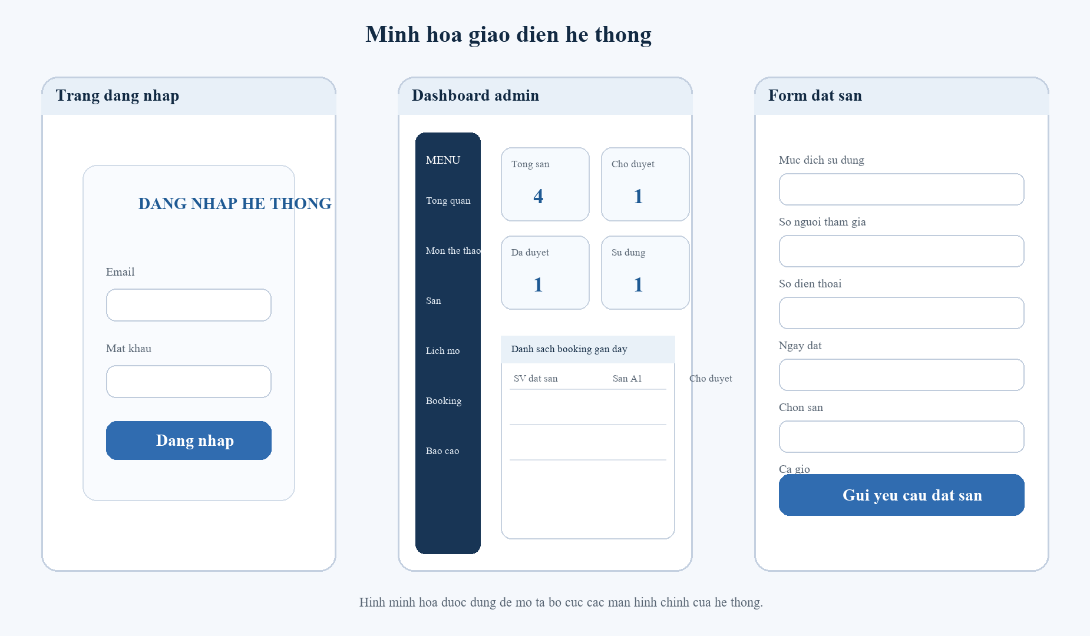
Hinh 4.1. Minh hoa mot so man hinh chinh cua he thong
Khi demo truc tiep, co the dang nhap bang tai khoan admin de minh hoa dashboard, CRUD danh muc va phe duyet booking; sau do dang nhap bang tai khoan sinh vien de minh hoa form dat san.

Ket luan
De tai "Xay dung he thong quan ly va dat san the thao tai TLU" da dat duoc muc tieu chinh trong pham vi vong 1: hinh thanh mot he thong web co quy trinh ro rang, co kiem soat xung dot, co phan quyen nguoi dung va co kha nang bao cao su dung san. Ket qua nay tao nen mot nen tang tot de tiep tuc mo rong them cac tinh nang nang cao trong cac vong sau, dong thoi dap ung phan lon tieu chi diem nen cua mon hoc.

Danh gia tong quat
Muc do hoan thanh hien tai co the xem la da dap ung tot nhom tieu chi A1 den A8. Hai noi dung can hoan thien them truoc khi nop la bo sung thong tin ca nhan tren bia, chot commit minh chung theo moc va ra soat README / ERD de dong bo voi ban nop cuoi.

Han che hien tai
- Chua co thong bao email hoac he thong nhac lich sau khi booking duoc duyet.
- Chua trien khai gioi han so lan dat san theo tuan cho tung sinh vien.
- Chua tach lich bao tri thanh mot module rieng co khung thoi gian cu the.
- Chua xuat bao cao sang PDF/Excel ngay trong giao dien web.

Huong phat trien
- Bo sung booking policy nang cao: gioi han so slot / sinh vien / tuan.
- Them module bao tri san theo khoang thoi gian de khoa san tam thoi.
- Tich hop email, toast notification hoac thong bao trong he thong.
- Bo sung xuat bao cao PDF/Excel va lich su thao tac audit log.
- Mo rong dat nhieu ca gio trong cung mot phieu booking neu de tai yeu cau.

