TRUONG DAI HOC THUY LOI (TLU)
KHOA CONG NGHE THONG TIN
BAO CAO PHAN TICH, THIET KE VA XAY DUNG HE THONG
XAY DUNG HE THONG QUAN LY VA DAT SAN THE THAO TAI TLU
De tai 6 - Nhom 2 - Dich vu sinh vien va khuon vien
Pham vi trien khai: Vong 1
Thong tin | Noi dung
De tai | Xay dung he thong quan ly va dat san the thao tai TLU
Cong nghe | Laravel 12, PHP 8.2, Blade, Bootstrap 5, MySQL, phpMyAdmin
Mo hinh kien truc | MVC
Sinh vien thuc hien | [Dien ho ten]
Ma sinh vien | [Dien ma sinh vien]
Lop | [Dien lop]
Giang vien huong dan | [Dien ten giang vien huong dan]
Thoi gian | Thang 08 nam 2026
Luu y: truoc khi nop ban chinh thuc, sinh vien chi can dien thong tin ca nhan tren bia va kiem tra lai muc luc, so trang.

Loi mo dau
Trong boi canh chuyen doi so trong giao duc, nhu cau tin hoc hoa cac dich vu ho tro sinh vien khong chi duoc dat ra doi voi cac nghiep vu hoc tap ma con mo rong sang nhom dich vu trong khuon vien. Voi cac hoat dong the chat, giao luu va ren luyen, viec quan ly san the thao neu thuc hien thu cong se de phat sinh trung lich, kho theo doi tinh trang san va kho tong hop bao cao su dung.
Tu bai toan thuc te do, de tai "Xay dung he thong quan ly va dat san the thao tai TLU" duoc lua chon nham xay dung mot he thong web ho tro quan ly danh muc san, lich mo, tiep nhan yeu cau dat san, kiem tra xung dot, phan quyen nguoi dung va tong hop thong ke su dung. He thong huong toi hai doi tuong chinh la quan tri vien va sinh vien, trong do moi doi tuong duoc cap dung chuc nang theo vai tro.
Bao cao nay trinh bay toan bo qua trinh phan tich nghiep vu, xac dinh yeu cau, thiet ke co so du lieu, xay dung kien truc MVC va danh gia ket qua dat duoc cua phien ban hien tai. Noi dung duoc viet theo huong co the nop truc tiep cho vong 1, dong thoi de san kha nang mo rong cho cac vong tiep theo neu can.

Muc luc
Muc luc duoc sinh tu dong theo Heading. Khi mo file bang Microsoft Word, neu can co the bam Update Table de cap nhat so trang.
Loi mo dau 2
Muc luc 3
Chuong 1. Tong quan de tai 5
1.1. Ly do chon de tai 5
1.2. Muc tieu thuc hien 5
1.3. Pham vi nghien cuu va trien khai 5
1.4. Phuong phap thuc hien 5
1.5. Ket cau bao cao 6
Chuong 2. Phan tich yeu cau nghiep vu 6
2.1. Boi canh nghiep vu 6
2.2. Tac nhan va phan quyen 6
2.3. Yeu cau chuc nang 6
2.4. Yeu cau phi chuc nang 7
2.5. So do tac nhan va nhom chuc nang 7
2.6. Danh sach use case 7
2.7. Workflow nghiep vu tong the 8
2.8. Quy tac va rang buoc nghiep vu 9
Chuong 3. Thiet ke he thong 9
3.1. Kien truc tong the theo mo hinh MVC 9
3.2. Thiet ke co so du lieu 10
3.3. So do ERD tong quan 11
3.4. Quan he giua cac bang 11
3.5. Ma tran phan quyen 12
3.6. Tu dien du lieu 12
3.6.1. Bang users 12
3.6.2. Bang sport_types 13
3.6.3. Bang courts 13
3.6.4. Bang time_slots 13
3.6.5. Bang court_schedules 14
3.6.6. Bang bookings 14
3.6.7. Bang booking_details 15
3.6.8. Bang usage_logs 15
Chuong 4. Xay dung va cai dat he thong 15
4.1. Cong nghe su dung 15
4.2. Cau truc thu muc chinh 16
4.3. Cac chuc nang da hoan thanh 16
4.4. Huong dan cai dat va chay bang Git Bash 17
4.5. Tai khoan demo 17
Chuong 5. Ket qua, danh gia va huong phat trien 18
5.1. Ket qua dat duoc 18
5.2. Doi chieu theo tieu chi cham diem 18
5.3. Han che hien tai 18
5.4. Huong phat trien 19
Ket luan 19
Tai lieu tham khao 19
Phu luc 19
Phu luc A. Cac lenh Git Bash thuong dung 19
Phu luc B. Kich ban demo va van dap 20

Chuong 1. Tong quan de tai

1.1. Ly do chon de tai
Trong khuon vien truong, nhu cau dat san bong da, bong chuyen, bong ro hoac cau long dien ra thuong xuyen. Neu viec quan ly van duoc thuc hien bang so tay, bang tinh hoac thong bao thu cong thi rat de xay ra trung lich, kho kiem soat tinh trang san va kho tong hop bao cao muc do su dung. Vi vay, mot he thong web tap trung la can thiet de chuan hoa quy trinh dat san.

1.2. Muc tieu thuc hien
• So hoa quy trinh quan ly va dat san the thao trong khuon vien truong.
• Han che tinh trang trung lich giua cac yeu cau dat san cung ngay va cung ca gio.
• Cho phep theo doi tinh trang san, lich mo, booking, usage log va bao cao su dung.
• Phan quyen ro rang giua admin va sinh vien theo dung workflow nghiep vu.
• Dam bao du an co the cai dat lai nhanh bang migration, seeder va du lieu demo.

1.3. Pham vi nghien cuu va trien khai
• Tap trung vao huong trien khai "San the thao" trong De tai 6 cua giang vien.
• Phien ban hien tai su dung 8 bang nghiep vu cot loi: users, sport_types, courts, time_slots, court_schedules, bookings, booking_details, usage_logs.
• He thong chua trien khai thanh toan, thong bao email va lich bao tri nang cao theo ca.
• Bao cao dat trong pham vi project ca nhan lam local, quan ly ma nguon bang Git va day len GitHub.

1.4. Phuong phap thuc hien
• Khao sat bai toan va xac dinh quy trinh nghiep vu dat san theo vai tro nguoi dung.
• Phan tich tac nhan, use case, quy tac rang buoc va cac tinh huong xung dot can xu ly.
• Thiet ke co so du lieu theo quan he cha - con va mo hinh MVC cho ung dung Laravel.
• Xay dung migration, seeder, model, controller, blade view va bo phan xac thuc, phan quyen.
• Kiem thu bang du lieu demo, kiem tra dang nhap, booking, duyet, huy va thong ke.

1.5. Ket cau bao cao
Thanh phan | Noi dung
Chuong 1 | Tong quan de tai
Chuong 2 | Phan tich yeu cau nghiep vu
Chuong 3 | Thiet ke he thong
Chuong 4 | Xay dung va cai dat he thong
Chuong 5 | Ket qua, danh gia va huong phat trien
Ket luan | Tong ket cac ket qua dat duoc cua de tai
Phu luc | Lenh demo, kich ban van dap va thong tin bo sung

Chuong 2. Phan tich yeu cau nghiep vu

2.1. Boi canh nghiep vu
Bai toan dat ra la xay dung mot he thong cho phep nha truong quan ly danh muc san the thao, lich mo theo tung thu va tung ca gio, dong thoi ho tro sinh vien gui yeu cau dat san trong khung thoi gian hop le. He thong phai giai quyet duoc bai toan trung lich, the hien ro tinh trang san dang khai thac hay bao tri va luu vet ket qua su dung thuc te sau moi buoi dat san.

2.2. Tac nhan va phan quyen
Tac nhan | Quyen chinh | Muc tieu su dung
Admin | Dang nhap, CRUD danh muc, duyet booking, cap nhat usage log, xem bao cao | Quan ly toan bo tai nguyen va workflow he thong
Sinh vien | Dang nhap, tao booking, xem, sua, huy booking cua chinh minh | Su dung san the thao phu hop nhu cau hoc tap va sinh hoat

2.3. Yeu cau chuc nang
• Dang nhap va dang xuat he thong theo tai khoan da cap.
• Quan ly danh muc mon the thao, san, ca gio va lich mo cua tung san.
• Cho phep sinh vien tao phieu dat san voi thong tin muc dich, so nguoi, ngay dat va ca gio.
• Kiem tra xung dot booking theo san, ngay, ca gio va tinh trang hoat dong cua san.
• Cho phep admin duyet hoac tu choi booking, luu ly do tu choi khi can.
• Cho phep sinh vien xem, sua, huy booking cua chinh minh khi con hop le.
• Cap nhat usage log sau buoi dat san de dong bo trang thai booking.
• Tong hop dashboard va bao cao thong ke theo khoang thoi gian.

2.4. Yeu cau phi chuc nang
• Giao dien de hieu, viet hoa tieng Viet va co bo cuc ro rang cho form, bang va dashboard.
• Du lieu duoc validate o backend; khong thao tac thay doi du lieu bang GET.
• Mat khau duoc ma hoa; route quan tri duoc bao ve boi middleware va policy.
• He thong co the cai dat lai bang migrate:fresh --seed de phuc vu demo nhanh.
• Cau truc MVC ro rang, View khong query database va Controller khong chua SQL dai.

2.5. So do tac nhan va nhom chuc nang
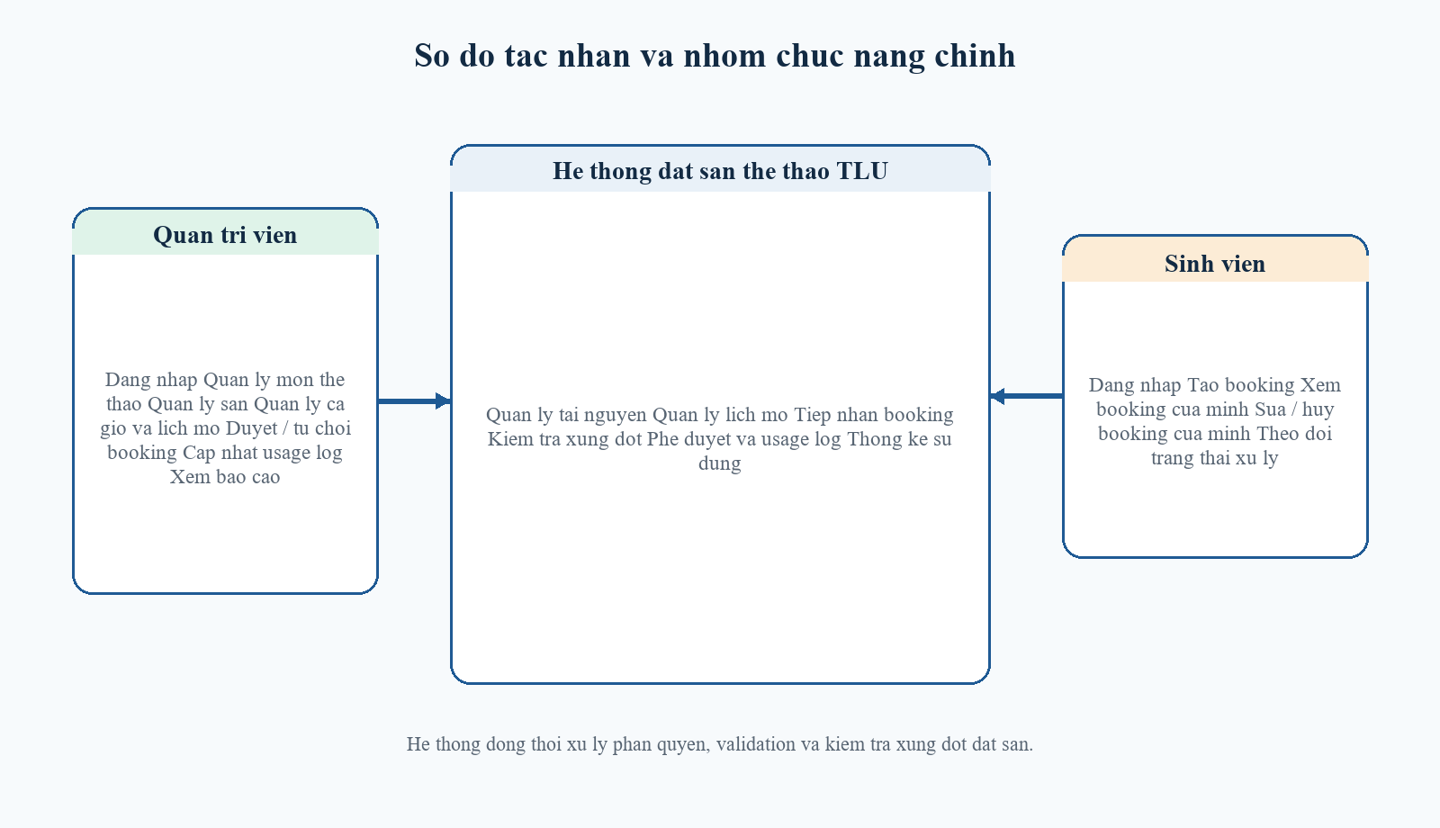
Hinh 2.1. So do tac nhan va nhom chuc nang chinh

2.6. Danh sach use case
Ma | Use case | Tac nhan | Mo ta ngan
UC01 | Dang nhap he thong | Admin, Sinh vien | Nguoi dung xac thuc de truy cap he thong theo vai tro.
UC02 | Quan ly mon the thao | Admin | Them, sua, xoa danh muc mon the thao phuc vu khai bao san.
UC03 | Quan ly san | Admin | Them, sua, xoa san; cap nhat suc chua, vi tri va trang thai.
UC04 | Quan ly ca gio | Admin | Khai bao cac khung gio su dung cho dat san.
UC05 | Quan ly lich mo san | Admin | Gan lich mo theo thu trong tuan va tung ca gio cho moi san.
UC06 | Tao booking | Sinh vien | Nhap thong tin dat san va gui yeu cau den he thong.
UC07 | Kiem tra xung dot | He thong | Chan dat san neu trung lich, san bao tri hoac khong mo lich.
UC08 | Duyet hoac tu choi booking | Admin | Cap nhat trang thai booking va ly do tu choi neu co.
UC09 | Huy booking | Sinh vien | Sinh vien huy phieu dat cua chinh minh khi chua hoan tat.
UC10 | Cap nhat usage log | Admin | Ghi nhan used, no_show hoac cancelled sau buoi dat san.
UC11 | Xem bao cao | Admin | Tong hop thong ke booking, usage log, top san va top sinh vien.

2.7. Workflow nghiep vu tong the
He thong duoc van hanh theo chuoi workflow tu khai bao tai nguyen den usage log va bao cao. Phan duoi mo ta trinh tu xu ly tong quat cua de tai.
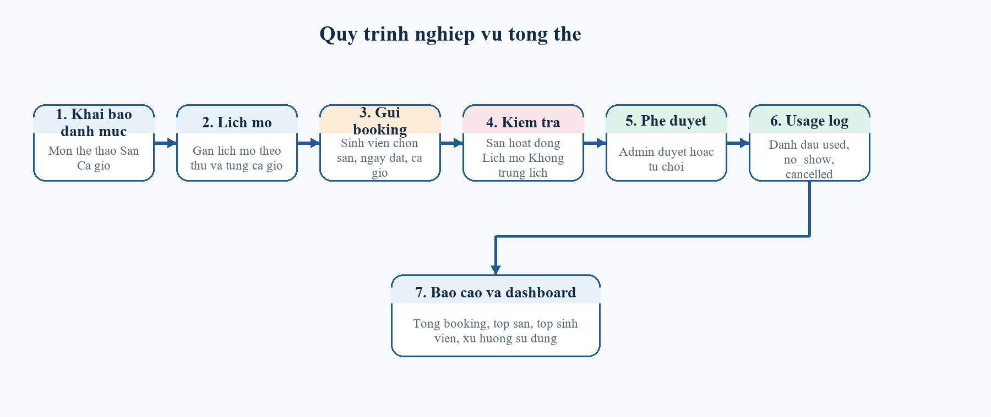
Hinh 2.2. Quy trinh nghiep vu tu khai bao san den usage log
• Admin khai bao mon the thao, san, ca gio va lich mo.
• Sinh vien chon san, ngay dat, ca gio va nhap thong tin booking.
• He thong kiem tra tinh trang san, suc chua, lich mo va xung dot.
• Neu hop le, booking duoc tao o trang thai pending.
• Admin duyet hoac tu choi booking.
• Sau buoi dat san, admin cap nhat usage log.
• Dashboard va bao cao tong hop du lieu su dung san.

2.8. Quy tac va rang buoc nghiep vu
Ma | Quy tac | Cach the hien trong he thong
BR01 | San dang bao tri khong duoc phep dat. | Kiem tra courts.status = active truoc khi tao booking.
BR02 | So nguoi tham gia khong duoc vuot qua suc chua cua san. | So sanh player_count voi courts.capacity.
BR03 | San chi duoc dat trong khung gio da mo. | Doi chieu court_schedules theo court_id, day_of_week va time_slot_id.
BR04 | Khong duoc co hai booking giao nhau cung san, cung ngay va cung ca gio. | Tra cuu booking_details ket hop bookings co status pending hoac approved.
BR05 | Sinh vien chi duoc thao tac tren phieu dat cua chinh minh. | Policy so sanh booking.user_id voi user hien tai.
BR06 | Chi admin moi duoc CRUD danh muc va duyet booking. | Route staff-only duoc bao ve boi middleware role:admin.
BR07 | Moi booking detail chi co toi da mot usage log. | unique tren usage_logs.booking_detail_id.

Chuong 3. Thiet ke he thong

3.1. Kien truc tong the theo mo hinh MVC
Du an duoc xay dung tren Laravel theo mo hinh MVC. Request tu trinh duyet di qua route, middleware va controller; controller thuc hien validation, thao tac model va tra ket qua ve Blade View. Cach to chuc nay giup ma nguon de doc, de bao tri va phu hop voi yeu cau mon hoc.
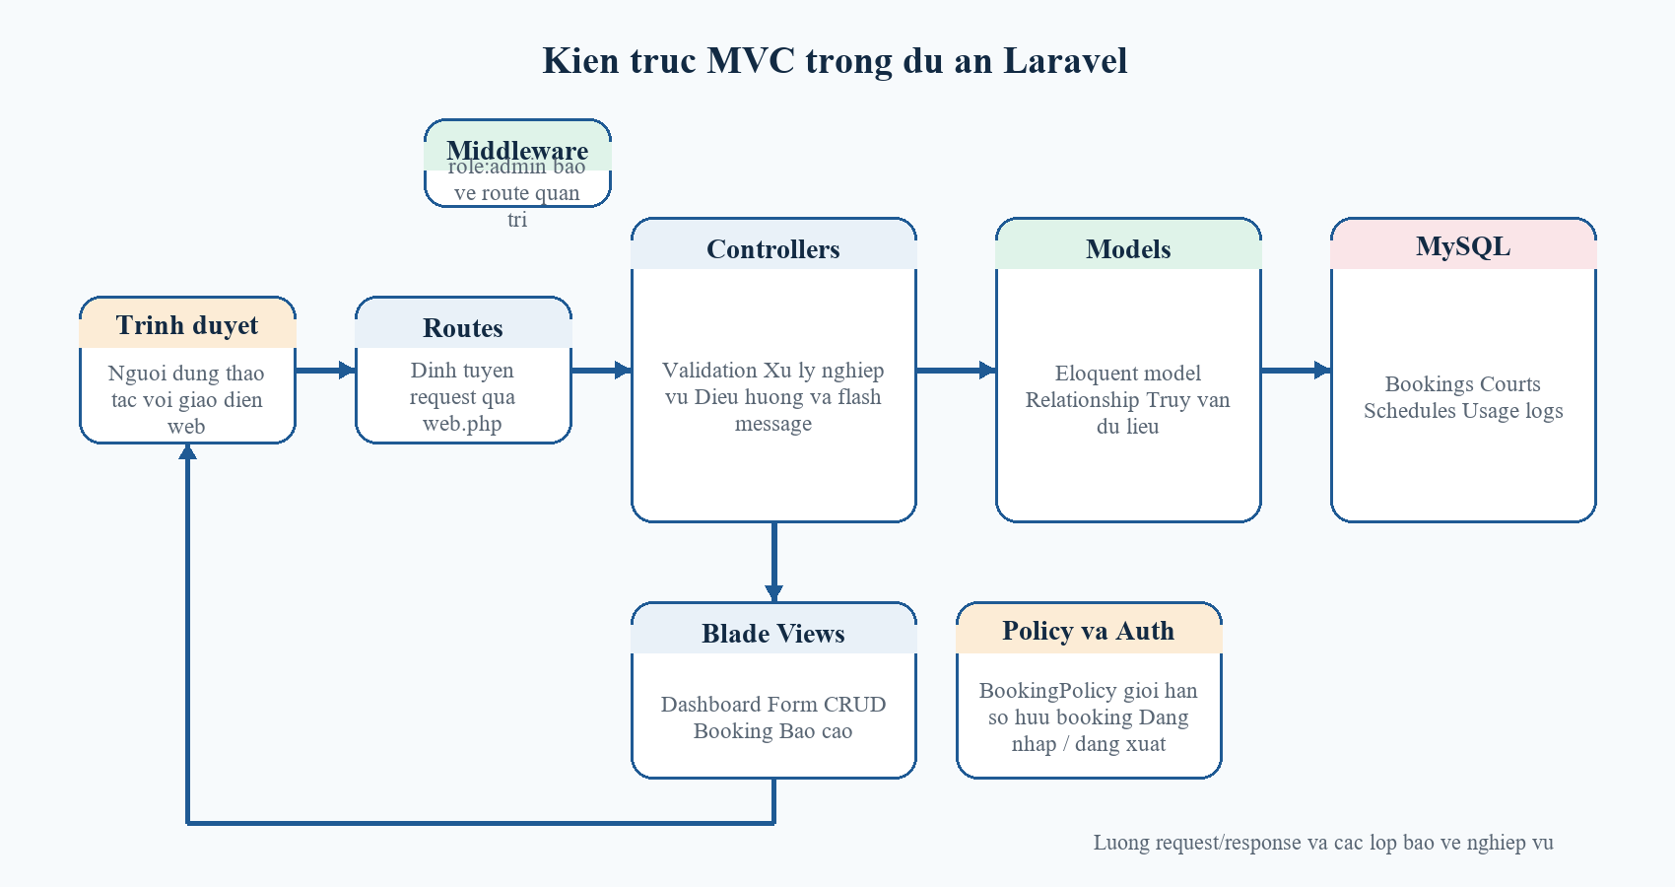
Hinh 3.1. Kien truc MVC cua du an Laravel

3.2. Thiet ke co so du lieu
Nhom bang | Cac bang | Y nghia
Nhom tai khoan | users | Luu thong tin dang nhap, vai tro va lien ket nguoi tao booking.
Nhom danh muc | sport_types, courts, time_slots | Quan ly mon the thao, san va khung gio.
Nhom lich | court_schedules | Quy dinh san nao mo vao thu nao, ca gio nao.
Nhom giao dich | bookings, booking_details | Luu phieu dat va chi tiet ngay dat, san dat, ca gio.
Nhom theo doi | usage_logs | Ghi nhan ket qua su dung thuc te sau buoi dat san.
Ngoai 8 bang nghiep vu cot loi, trong phpMyAdmin co the xuat hien them cac bang nhu migrations, cache, jobs, sessions... Day la cac bang ha tang cua Laravel, khong phai bang nghiep vu chinh cua de tai.

3.3. So do ERD tong quan
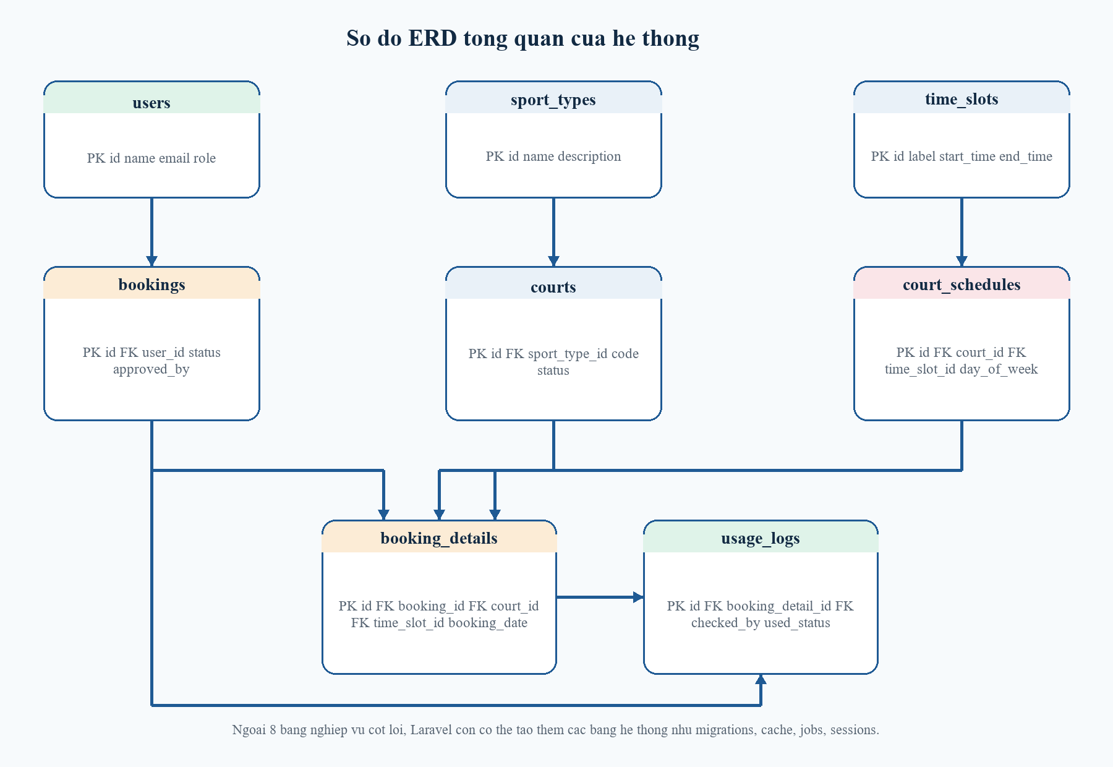
Hinh 3.2. So do ERD tong quan cua he thong dat san the thao

3.4. Quan he giua cac bang
Bang nguon | Bang dich | Kieu | Y nghia
users | bookings | 1 - N | Mot nguoi dung co the tao nhieu phieu dat.
users | bookings (approved_by) | 1 - N | Mot admin co the duyet nhieu booking.
sport_types | courts | 1 - N | Mot mon the thao co nhieu san.
courts | court_schedules | 1 - N | Mot san co nhieu lich mo theo thu va ca.
time_slots | court_schedules | 1 - N | Mot ca gio co the ap dung cho nhieu san.
bookings | booking_details | 1 - N | Mot phieu dat co the mo rong nhieu dong chi tiet.
courts | booking_details | 1 - N | Mot san xuat hien trong nhieu booking detail.
time_slots | booking_details | 1 - N | Mot ca gio xuat hien trong nhieu booking detail.
booking_details | usage_logs | 1 - 1 | Moi dong chi tiet co toi da mot usage log.
users | usage_logs | 1 - N | Admin cap nhat usage log cho tung buoi su dung.

3.5. Ma tran phan quyen
Chuc nang | Admin | Sinh vien | Ghi chu
Dang nhap / dang xuat | Co | Co | Tat ca nguoi dung da cap tai khoan deu su dung duoc.
CRUD mon the thao | Co | Khong | Chi admin quan ly danh muc sport_types.
CRUD san | Co | Khong | Chi admin quan ly courts.
CRUD ca gio va lich mo | Co | Khong | Chi admin quan ly time_slots va court_schedules.
Tao booking | Khong | Co | Sinh vien chu dong gui yeu cau dat san.
Xem tat ca booking | Co | Khong | Admin theo doi toan bo workflow.
Xem booking cua minh | Khong | Co | Policy gioi han theo user_id.
Sua / huy booking cua minh | Khong | Co | Chi khi booking chua o trang thai cancelled/completed.
Duyet / tu choi booking | Co | Khong | Admin xu ly workflow pending.
Cap nhat usage log | Co | Khong | Admin ghi nhan ket qua su dung.
Xem dashboard va bao cao | Co | Co mot phan | Sinh vien xem dashboard ca nhan; bao cao tong hop danh cho admin.

3.6. Tu dien du lieu
Phan nay tong hop cac cot quan trong, kieu du lieu va rang buoc chinh cua tung bang nghiep vu. Noi dung nay giup minh chung ro tieu chi A1, A2 va A4 trong barem cham diem.

3.6.1. Bang users
Bang luu thong tin tai khoan dang nhap va vai tro nguoi dung.
Cot | Kieu du lieu | Rang buoc | Y nghia
id | bigint | PK, auto increment | Ma nguoi dung
name | varchar(255) | not null | Ho ten hien thi
email | varchar(255) | unique, not null | Email dang nhap
password | varchar(255) | not null | Mat khau da hash
role | varchar(20) | default student, index | Vai tro admin/student
remember_token | varchar(100) | nullable | Token ghi nho dang nhap
created_at | timestamp | nullable | Thoi gian tao
updated_at | timestamp | nullable | Thoi gian cap nhat

3.6.2. Bang sport_types
Danh muc mon the thao de gan cho tung san.
Cot | Kieu du lieu | Rang buoc | Y nghia
id | bigint | PK, auto increment | Ma mon the thao
name | varchar(255) | unique, not null | Ten mon
description | text | nullable | Mo ta ngan
created_at | timestamp | nullable | Thoi gian tao
updated_at | timestamp | nullable | Thoi gian cap nhat

3.6.3. Bang courts
Thong tin san the thao va tinh trang khai thac.
Cot | Kieu du lieu | Rang buoc | Y nghia
id | bigint | PK, auto increment | Ma san
sport_type_id | bigint | FK -> sport_types.id | Mon the thao cua san
name | varchar(255) | not null | Ten san
code | varchar(255) | unique, not null | Ma san
location | varchar(255) | not null | Vi tri san
capacity | unsigned int | not null | Suc chua toi da
status | varchar(20) | default active, index | active/inactive/maintenance
description | text | nullable | Mo ta bo sung

3.6.4. Bang time_slots
Danh muc cac khung gio dat san.
Cot | Kieu du lieu | Rang buoc | Y nghia
id | bigint | PK, auto increment | Ma ca gio
label | varchar(255) | unique, not null | Nhan hien thi
start_time | time | not null | Gio bat dau
end_time | time | not null | Gio ket thuc
created_at | timestamp | nullable | Thoi gian tao
updated_at | timestamp | nullable | Thoi gian cap nhat

3.6.5. Bang court_schedules
Lich mo cua san theo thu trong tuan va ca gio.
Cot | Kieu du lieu | Rang buoc | Y nghia
id | bigint | PK, auto increment | Ma lich mo
court_id | bigint | FK -> courts.id | San duoc gan lich
day_of_week | tinyint | not null | Thu trong tuan
time_slot_id | bigint | FK -> time_slots.id | Ca gio duoc mo
is_open | boolean | default true | Co mo hay khong
created_at | timestamp | nullable | Thoi gian tao
updated_at | timestamp | nullable | Thoi gian cap nhat

3.6.6. Bang bookings
Bang header cua phieu dat, the hien nguoi dat va ket qua xu ly.
Cot | Kieu du lieu | Rang buoc | Y nghia
id | bigint | PK, auto increment | Ma booking
user_id | bigint | FK -> users.id | Nguoi tao booking
purpose | varchar(255) | not null | Muc dich dat san
player_count | unsigned int | not null | So nguoi tham gia
contact_phone | varchar(20) | not null | So dien thoai lien he
status | varchar(20) | default pending, index | pending/approved/rejected/cancelled/completed
approved_by | bigint | FK -> users.id, nullable | Admin duyet
approved_at | timestamp | nullable | Thoi diem duyet
rejection_reason | text | nullable | Ly do tu choi
cancel_reason | text | nullable | Ly do huy
cancelled_at | timestamp | nullable | Thoi diem huy

3.6.7. Bang booking_details
Chi tiet ngay dat, san dat va ca gio; dung de kiem tra trung lich.
Cot | Kieu du lieu | Rang buoc | Y nghia
id | bigint | PK, auto increment | Ma dong chi tiet
booking_id | bigint | FK -> bookings.id | Thuoc booking nao
court_id | bigint | FK -> courts.id | San duoc dat
booking_date | date | index, not null | Ngay su dung san
time_slot_id | bigint | FK -> time_slots.id | Ca gio dat
created_at | timestamp | nullable | Thoi gian tao
updated_at | timestamp | nullable | Thoi gian cap nhat

3.6.8. Bang usage_logs
Nhat ky ghi nhan ket qua su dung thuc te sau buoi dat san.
Cot | Kieu du lieu | Rang buoc | Y nghia
id | bigint | PK, auto increment | Ma nhat ky
booking_detail_id | bigint | unique, FK -> booking_details.id | Moi booking detail toi da mot nhat ky
checked_by | bigint | FK -> users.id, nullable | Nguoi cap nhat
used_status | varchar(20) | default used | used/no_show/cancelled
checked_in_at | timestamp | nullable | Moc bat dau
checked_out_at | timestamp | nullable | Moc ket thuc
note | text | nullable | Ghi chu bo sung
created_at | timestamp | nullable | Thoi gian tao
updated_at | timestamp | nullable | Thoi gian cap nhat

Chuong 4. Xay dung va cai dat he thong

4.1. Cong nghe su dung
Cong nghe | Vai tro | Ly do lua chon
PHP 8.2 | Ngon ngu lap trinh backend | Phu hop Laravel va de trien khai local tren XAMPP.
Laravel 12 | Framework MVC | Ho tro route, middleware, Eloquent, validation va Blade.
Blade | Template engine | Xay dung giao dien dashboard, form CRUD va trang booking.
Bootstrap 5 | CSS framework | Giup giao dien responsive va thong nhat bo cuc.
MySQL | He quan tri CSDL | Luu du lieu booking, danh muc, lich mo va usage log.
phpMyAdmin | Quan ly CSDL | Quan sat bang va du lieu local trong qua trinh demo.
Git va GitHub | Quan ly ma nguon | Luu vet cac moc hoan thien va day du an len kho ma nguon.

4.2. Cau truc thu muc chinh
Thu muc / tep | Vai tro
app/Http/Controllers | Chua cac controller xu ly dang nhap, booking, san, lich, usage log va bao cao.
app/Models | Chua Eloquent model va relationship giua cac bang.
app/Http/Middleware | Chua middleware role:admin cho route quan tri.
app/Policies | Chua BookingPolicy de kiem soat quyen so huu booking.
database/migrations | Khai bao cau truc bang va rang buoc khi tai lap CSDL.
database/seeders | Nap du lieu demo cho tai khoan, san, lich mo, booking va usage log.
resources/views | Giao dien Blade cho dashboard, booking, danh muc va bao cao.
routes/web.php | Khai bao route, nhom middleware guest/auth/admin.
docs | Tai lieu bao cao, ERD, data dictionary va file docx nop bai.

4.3. Cac chuc nang da hoan thanh
Nhom chuc nang | Noi dung da xay dung
Xac thuc va phan quyen | Dang nhap, dang xuat, middleware role:admin va BookingPolicy.
Quan ly tai nguyen | CRUD sport_types, courts, time_slots, court_schedules.
Workflow booking | Tao booking, kiem tra xung dot, xem, sua, huy, duyet va tu choi.
Usage log | Ghi nhan used, no_show, cancelled va dong bo trang thai booking.
Dashboard va bao cao | Thong ke tong quan theo vai tro, top san, top sinh vien va xu huong dat san.
Du lieu demo | Seeder tai khoan, san, lich mo, booking va usage log de demo nhanh.

4.4. Huong dan cai dat va chay bang Git Bash
Buoc | Thao tac | Ghi chu
Buoc 1 | Bat Apache va MySQL trong XAMPP | Dam bao localhost va MySQL san sang.
Buoc 2 | Mo Git Bash tai thu muc project | Thao tac thong nhat dung nhu moi truong lam bai.
Buoc 3 | Chay php artisan migrate:fresh --seed | Tai lap CSDL va nap du lieu demo.
Buoc 4 | Neu can giao dien, chay npm install va npm run dev | Khoi dong Vite khi muon sua CSS/JS.
Buoc 5 | Chay php artisan serve | Mo he thong tai http://127.0.0.1:8000.
Buoc 6 | Dang nhap admin va thuc hien duyet booking | Chung minh workflow quan tri.
Buoc 7 | Dang nhap sinh vien va thu mo route quan tri | Chung minh middleware va policy hoat dong.
Neu du an da co file .env va node_modules tu truoc, co the bo qua mot so buoc cai dat. Tuy nhien, de demo truoc giang vien, nen uu tien chay lai migrate:fresh --seed de du lieu dong nhat.

4.5. Tai khoan demo
Email | Mat khau | Vai tro | Muc dich
admin@campus.local | password | Admin | Demo CRUD, duyet booking, usage log va bao cao.
student1@campus.local | password | Sinh vien | Demo tao booking va chinh sua booking cua minh.
student2@campus.local | password | Sinh vien | Demo policy tu choi thao tac booking cua nguoi khac.

Chuong 5. Ket qua, danh gia va huong phat trien

5.1. Ket qua dat duoc
Phien ban hien tai da xay dung duoc mot he thong dat san the thao co workflow tuong doi day du trong pham vi vong 1: quan ly tai nguyen, lich mo, booking, phe duyet, usage log, dashboard va bao cao. Du lieu duoc luu tren MySQL that, co the quan sat truc tiep qua phpMyAdmin va co kha nang tai lap lai nhanh de demo.

5.2. Doi chieu theo tieu chi cham diem
Ma | Tieu chi | Nhan xet | Trang thai
A1 | Phan tich nghiep vu, ERD, thiet ke CSDL | Da co 8 bang nghiep vu, PK/FK, rang buoc unique, data dictionary va so do ERD tong quan. | Dat
A2 | Khoi tao va tai lap CSDL | Da co migration, seeder va SQL backup; co the chay migrate:fresh --seed. | Dat
A3 | Du lieu mau, Seeder/Factory | Da co tai khoan demo, san, lich mo, booking pending/approved/completed va usage log. | Dat
A4 | Model/DAO va Relationship | Da su dung Eloquent relationship dung chieu, fillable va truy van co to chuc. | Dat
A5 | CRUD/Workflow Dashboard | Da co CRUD danh muc, workflow booking, dashboard va bao cao tong hop. | Dat
A6 | Validation, toan ven va bao mat nen | Da co backend validation, CSRF, method dung, middleware va policy. | Dat
A7 | Kien truc va chat luong ma | Da tach controller, model, view ro rang theo MVC. | Dat
A8 | UI va trai nghiem su dung | Da Viet hoa giao dien, bo cuc dashboard, bang, form, flash message va responsive co ban. | Dat
A9 | Git, tich hop va dong gop ca nhan | Da day code len GitHub; nen tiep tuc tach them commit theo moi moc nang cap de dep hon. | Can cai thien
A10 | README, ERD, demo va van dap | Da co README, tai khoan demo va bo khung bao cao; can dien thong tin ca nhan tren bia truoc khi nop. | Gan dat

5.3. Han che hien tai
• Chua co thong bao email hoac he thong nhac lich sau khi booking duoc duyet.
• Chua trien khai gioi han so lan dat san theo tuan cho tung sinh vien.
• Chua tach lich bao tri thanh mot module rieng co khung thoi gian cu the.
• Chua xuat bao cao sang PDF/Excel ngay trong giao dien web.

5.4. Huong phat trien
• Bo sung booking policy nang cao: gioi han so slot / sinh vien / tuan.
• Them module bao tri san theo khoang thoi gian de khoa san tam thoi.
• Tich hop email, toast notification hoac thong bao trong he thong.
• Bo sung xuat bao cao PDF/Excel va lich su thao tac audit log.
• Mo rong dat nhieu ca gio trong cung mot phieu booking neu de tai yeu cau.

Ket luan
De tai "Xay dung he thong quan ly va dat san the thao tai TLU" da dat duoc muc tieu chinh trong pham vi vong 1: hinh thanh mot he thong web co quy trinh ro rang, co kiem soat xung dot, co phan quyen nguoi dung va co kha nang bao cao su dung san. Ket qua nay tao nen mot nen tang tot de tiep tuc mo rong them cac tinh nang nang cao trong cac vong sau, dong thoi dap ung phan lon tieu chi diem nen cua mon hoc.

Tai lieu tham khao
1. Tai lieu huong dan mon hoc va de bai thi cuoi ky CSE485.
2. Tai lieu chinh thuc Laravel 12.x Documentation.
3. MySQL 8.0 Reference Manual.
4. Tai lieu su dung XAMPP va phpMyAdmin de trien khai local.
5. Kho ma nguon du an: MaiHung2804/CSE485_TLU_Nhom9.

Phu luc

Phu luc A. Cac lenh Git Bash thuong dung
Nhung lenh duoi day duoc chon theo dung cach lam local ma du an dang su dung tren may Windows voi Git Bash.
cd "/d/CN WEB LT/CN WEB LT/CN WEB/CSE485_TLU_Nhom9"
copy .env.example .env
php artisan key:generate
php artisan migrate:fresh --seed
npm install
npm run dev
php artisan serve
git add .
git commit -m "Hoan thien bao cao va project dat san the thao"
git push origin main

Phu luc B. Kich ban demo va van dap
Tinh huong | Thao tac | Ket qua mong doi
Tinh huong 1 | Dang nhap bang admin@campus.local | Truy cap dashboard admin va thay menu quan tri day du.
Tinh huong 2 | Dang nhap bang student1@campus.local | Truy cap dashboard sinh vien va tao booking moi.
Tinh huong 3 | Chon san dang bao tri | He thong tu choi dat san va thong bao rang buoc.
Tinh huong 4 | Tao booking trung san, trung ngay, trung ca | He thong chan xung dot va khong luu du lieu sai.
Tinh huong 5 | Dang nhap student2 va mo booking cua student1 | Policy chan sua/huy booking khong thuoc so huu.
Tinh huong 6 | Admin duyet booking | Trang thai booking chuyen tu pending sang approved.
Tinh huong 7 | Admin cap nhat usage log | Booking dong bo sang completed hoac cancelled phu hop.

