Phan 1: Các lệnh cơ bản

|  |  |
| --- | --- |
| 1 | docker –version |
| 2 | docker run hello-world |
| 3 | docker pull nginx |
| 4 | docker images |
| 5 | docker run -d nginx |
| 6 | docker ps |
| 7 | docker ps –a |
| 8 | docker logs <container_id> |
| 9 | docker exec -it <container_id> /bin/sh |
| 10 | docker stop <container_id> |
| 11 | docker restart <container_id> |

Phan 2: Thao tác với DOCKER

Bai 1:

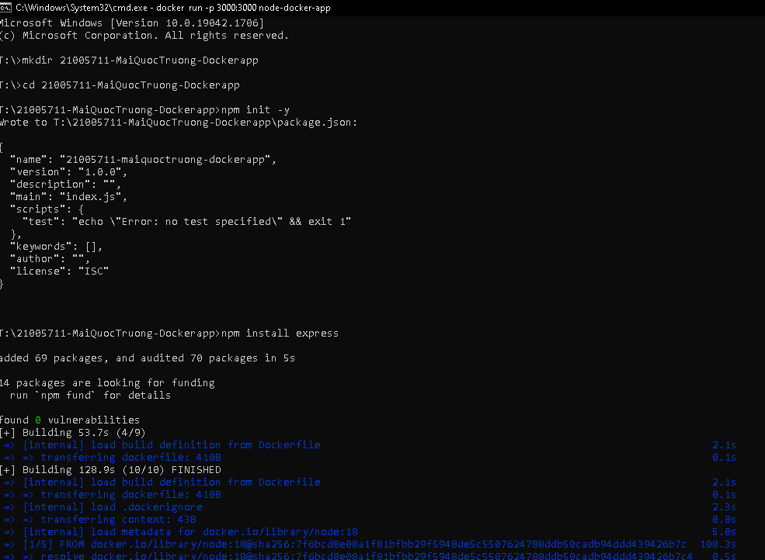

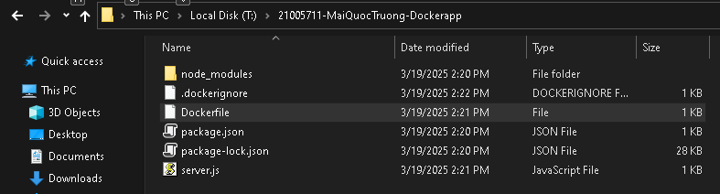

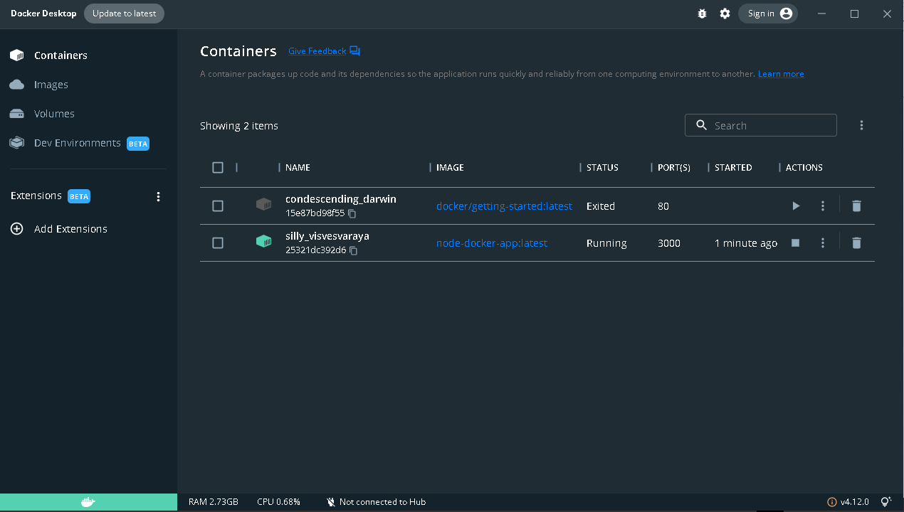

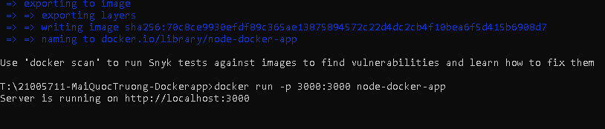

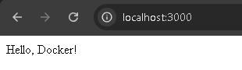

Bai 2:

