Create Database : DBSJ
Create Database DBSJ
Go
Use DBSJ
Go
Create Table Subjects
(
SubjectID char(2) primary key,
SubjectName nvarchar(200)
)

Insert Into Subjects
Values('01',N'The thao')

Insert Into Subjects
Values('02',N'Game')

Select * From Subjects
Create Project : DemoDBSJ

Test Connection :

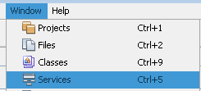

- Add New Driver

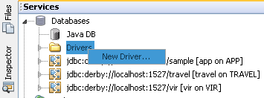

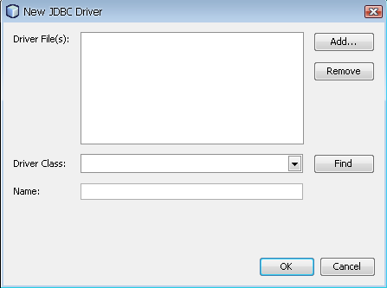

- Add : sqljdbc.jar
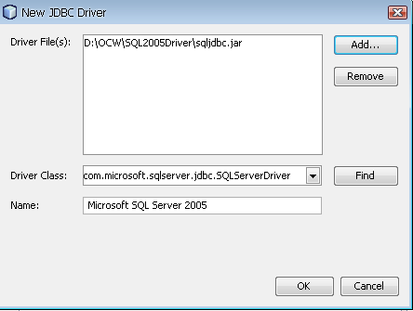

Create Connection :

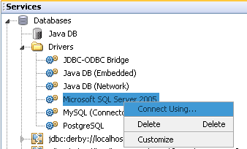

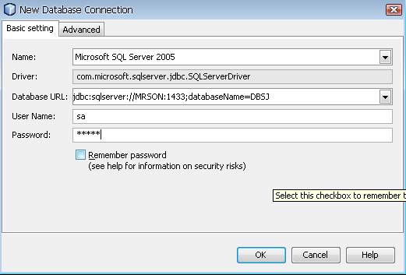

Create JFrame : frmSubject

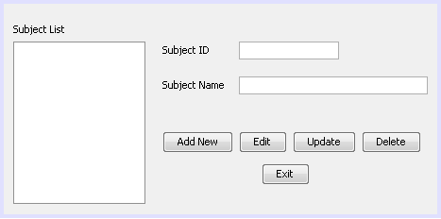

- Add : sqljdbc.jar
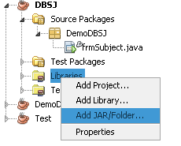
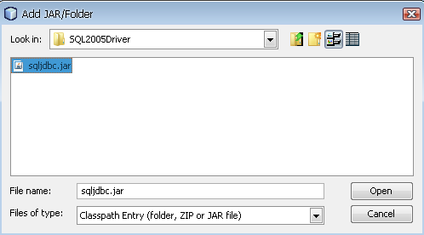

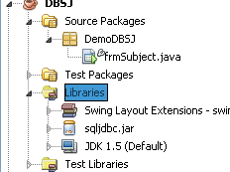

/*
* frmSubject.java
*
* Created on December 16, 2009, 9:59 AM
*/
package DemoDBSJ;

import java.sql.Connection;
import java.sql.DriverManager;
import java.sql.PreparedStatement;
import java.sql.ResultSet;
import java.sql.SQLException;
import java.sql.Statement;
import java.util.logging.Level;
import java.util.logging.Logger;
import javax.swing.DefaultListModel;
import javax.swing.JOptionPane;

/**
*
* @author admin
*/
public class frmSubject extends javax.swing.JFrame {

Connection conn;
String operation;

/** Creates new form frmSubject */
public frmSubject() {
initComponents();
operation = "edit";
try {
//Load Driver
Class.forName("com.microsoft.sqlserver.jdbc.SQLServerDriver");
String url = "jdbc:sqlserver://MRSON:1433;databaseName=DBSJ";
//OPen Connection
conn = DriverManager.getConnection(url, "sa", "ap123");
// if(conn!=null)
// {
// JOptionPane.showMessageDialog(null, "Ket noi thanh cong");
// }
Statement st = conn.createStatement();
String sql = "Select * from Subjects";
ResultSet rsSubject = st.executeQuery(sql);
DefaultListModel model = new DefaultListModel();
while (rsSubject.next()) {
String subjectName = rsSubject.getString("SubjectName");
model.addElement(subjectName);
}
lstSubject.setModel(model);
rsSubject.close();

} catch (Exception ex) {
ex.printStackTrace();
}
}
private void btnAddNewActionPerformed(java.awt.event.ActionEvent evt) {
// TODO add your handling code here:
txtSubjectID.setText("");
txtSubjectName.setText("");
txtSubjectID.requestFocus();
operation = "add";
}

private void btnUpdateActionPerformed(java.awt.event.ActionEvent evt) {
// TODO add your handling code here:
String subjectID = txtSubjectID.getText();
String subjectName = txtSubjectName.getText();
try {
PreparedStatement pst = conn.prepareStatement("Insert into Subjects Values(?,?)");
pst.setString(1, subjectID);
pst.setString(2, subjectName);
int result = pst.executeUpdate();
if (result > 0) {
JOptionPane.showMessageDialog(null, "Them thanh cong", "Thong bao", JOptionPane.INFORMATION_MESSAGE);
}
} catch (SQLException ex) {
ex.printStackTrace();
}
}

/**
* @param args the command line arguments
*/
public static void main(String args[]) {
java.awt.EventQueue.invokeLater(new Runnable() {

public void run() {
new frmSubject().setVisible(true);
}
});
}

// Variables declaration - do not modify
private javax.swing.JButton btnAddNew;
private javax.swing.JButton btnDelete;
private javax.swing.JButton btnEdit;
private javax.swing.JButton btnExit;
private javax.swing.JButton btnUpdate;
private javax.swing.JLabel jLabel1;
private javax.swing.JLabel jLabel2;
private javax.swing.JLabel jLabel3;
private javax.swing.JScrollPane jScrollPane1;
private javax.swing.JList lstSubject;
private javax.swing.JTextField txtSubjectID;
private javax.swing.JTextField txtSubjectName;
// End of variables declaration
}

