C++ fundamentals and Type conversion
Student ID _2014141463269__
Student Name ___袁豪_____________
Start Time ________2016.09.06.16:15_______
Finish Time ________________________

1. Objectives:
To write simple C++ programs covering:
- Understand how a character is stored in memory;
- Understand how an integer is stored in memory;
- Understand array and pointer; and
- Perform conversion from eight bits (character) to eight bytes to be displayed on screen.

2. Type and Format in memory – character, integer, short and float

2.1
This exercise is to determine the memory size of different type.

lab1_1.cpp
//Determine the memory size of declaration and variable type
#include <iostream.h>
#include <stdio.h>
#include <ctype.h>
#include <conio.h>
#include <string.h>
#include <stdlib.h>

void main()
{
char c;
char s[128];
short i;
short n[64];
printf("%3d %3d\n", sizeof(c), sizeof(char));
printf("%3d %3d\n", sizeof(s), sizeof(char[128]));
printf("%3d %3d\n", sizeof(i), sizeof(short));
printf("%3d %3d\n", sizeof(n), sizeof(short[64]));
}

The display is:

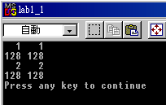

Now execute the above program and fill in the following:

Type | Size in byte | Size in bit
Short | 2 | 16
Char | 1 | 8
Short[32] | 64 | 512
Char[64] | 64 | 512

2.2
Use the approach of the above, determine the memory size of integer, float, integer[128], float[16] (lab1_2.cpp)

Write a program to verify your answer and fill in the following: [hint, use sizeof(…) ]
Type | Size in byte | Size in bit
Int | 4 | 32
Float | 4 | 32
Int[128] | 512 | 4096
Float[16] | 64 | 5124

Write down your codes below:
#include <iostream>
using namespace std;
void main(){
cout<<"int:"<<sizeof(int)<<endl;
cout<<"Float:"<<sizeof(float)<<endl;
cout<<"int[128]:"<<sizeof(int[128])<<endl;
cout<<"Float[16]:"<<sizeof(float[16])<<endl;
}

Write down your expression amongst the difference in size between character, integer, float, short, char[8], int[8], short[8], float[8]
Int[8] = float[8] = 2short[8] = 4char[8] = 8 float = 8 integer = 16 short = 32 character

2.3
This exercise is to display the decimal and octal values so that you know how it is stored in memory.

lab1_3.cpp
//Determine the memory size of declaration and variable type
#include <iostream.h>
#include <stdio.h>
#include <ctype.h>
#include <conio.h>
#include <string.h>
#include <stdlib.h>

void main()
{
for (char i = 30; i <41; ++i)
printf("i: dec=%d oct=%o \n", i, i);
}

the output is:
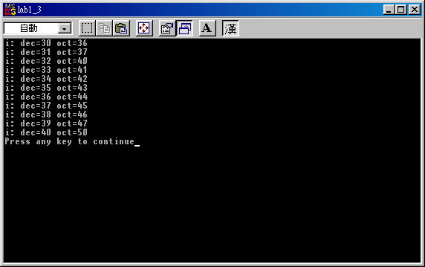

Now modify the above programme to display decimal, octal, hex and unsigned as well. (Hints: hex, %x, unsigned %u)

Write down your codes below:

#include <iostream>
#include <stdio.h>
#include <ctype.h>
#include <conio.h>
#include <string.h>
#include <stdlib.h>
void main()
{
for (char i = 30; i <41; ++i)
printf("i: dec=%d oct=%o hex=%x unsigned=%u\n", i, i, i, i);
}

Write down the output of the first 4 lines so that you understand the difference among them.

i: dec=30 oct=36 hex=1e unsigned=30
i: dec=31 oct=37 hex=1f unsigned=31
i: dec=32 oct=40 hex=20 unsigned=32
i: dec=33 oct=41 hex=21 unsigned=33

2.4
This exercise is to dump the content of memory of different type so that you know how it is stored in memory.
lab1_4.cpp
//Determine the memory size of declaration and variable type
#include <iostream.h>
#include <stdio.h>
#include <ctype.h>
#include <conio.h>
#include <string.h>
#include <stdlib.h>

void main()
{
char a = '0'; // in hex 0x30, not 0
int i = 0x00000013; //in decimal is (1 x 16 + 3) = 19
short j = 18; //occupies two bytes,
float f = 1.25; //occupies 4 bytes
}

In order to display, you have to set a break point by pressing “F9” beside the line, the program will display a red circle as follows:
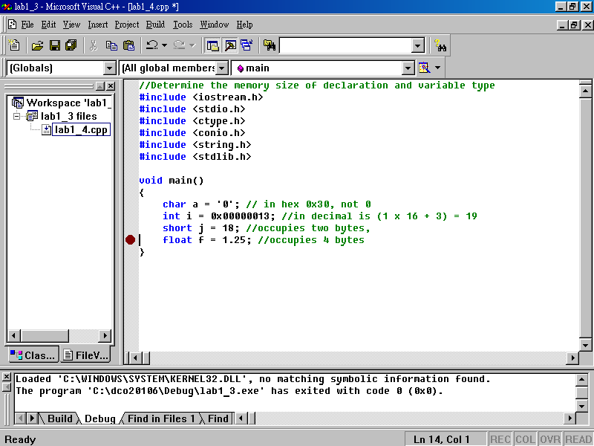

Now, type the address of each variable as shown in the left-bottom frame to locate whether they are. Here, we dump the address of variable ‘a’. Since, visual C++ reserves 4 bytes but char c uses one byte, you can see that the rest three bytes are set to CC CC CC (means 10101010 10101010 10101010 in binary, the default setting).
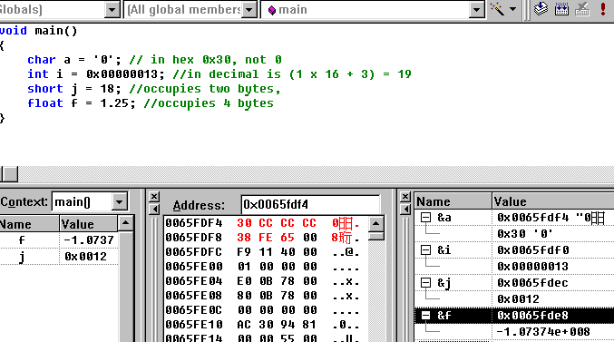

  - memory location of a is 0x0065fdf4, you have to type &a
  - then in the Address, key in 0x0065fdf4,
  - it displays 30 CC CC CC

0x0065FDF4, the hexadecimal is 0x30 (ASCII)

Now, type and execute the above program and fill in the following, note that your addresses might be different from what I have below.

Variable | Memory address | Dec value
a | 0x0113fdf3 | 48
i | 0x0113fed4 | 19
j | 0x0113fdd8 | 18
f | 0x0113fdcc | 1.25
(VS2012显示的value为10进制值)

3. Array and Pointer

3.1

The following is a very simple array definition. It defines an array called char a[4] which occupies 4 bytes, the value is 0x30 0x31 0x32 0x00. Note that 0x30 (ASCII) is 0 in decimal. The last character must be terminated by 0x00 or is called null. (ref. lab1_5.cpp)

lab1_5.cpp
#include <conio.h>
#include <string.h>
#include <stdlib.h>

void main()
{
char a[4] = "012";
}

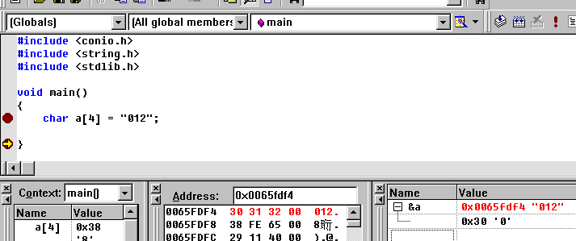
0x30 or 0
Null, 0x00

Based on the above, note that the address of array a is 0x0065fdf4. Now fill in the following:

Address | Type | Dec Value
0x006ff9d0 | a[0] | 48
0x006ff9d1 | a[1] | 49
0x006ff9d2 | a[2] | 50
0x006ff0d3 | a[3] | 0

3.2
The following program will display the content of an array a[11].

#include <ctype.h>
#include <conio.h>
#include <string.h>
#include <stdlib.h>

void main()
{
char a[11] = "0123456789";
for (int i = 0; i <10; ++i)
printf("The value of %d is %c in hex %x \n", i, a[i], a[i]);

}
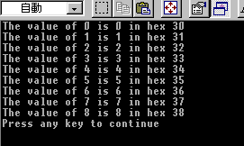

Now modify the above program to display the address of each location in hexadecimal and the value a[12], a[13], explain why you can display a[12] and [13] as you only defined them up to a[10] as follows. (Hint: The address of a[0] is &a[0])

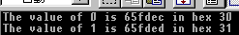 (note that your value might be different.)
Write down the program

#include <ctype.h>
#include <conio.h>
#include <string.h>
#include <stdlib.h>

void main()
{
char a[11] = "0123456789";
for (int i = 0; i <14; ++i)
printf("The value of %d is %c in hex %x \n", i, &a[i], a[i]);
}

Write down your explanation (hint: dump the memory location and look at the location of a[11], a[12] and a[13] etc. you then realise why?)

当我们定义了a[11]之后，系统分配给它随意的一块内存空间，该空间周围可能也是空
闲的，因此溢出的数组依然占有内存地址，但是越界的数组内存块不受系统保护，随时可能被其他应用程序占用。

3.3
#include <iostream.h>
#include <stdio.h>
#include <ctype.h>
#include <conio.h>
#include <string.h>
#include <stdlib.h>

void main()
{
char a[11] = "0123456789";
char *ptr;
ptr = &a[0]; // it can be &a with same effect
for (int i = 0; i <11; ++i, ++ptr)
printf("The value of %d is %x in hex %x \n", i, ptr, *ptr);
}
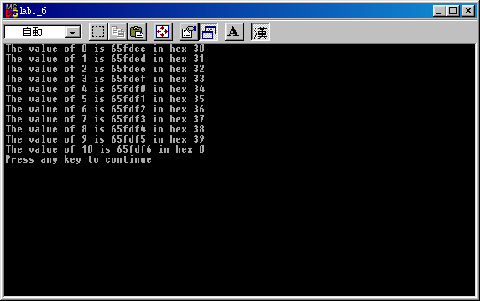
Now explain the meaning of the following of the above program.
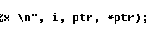
I 是变量，是数组的下标；ptr是指向数组a的指针,最初指在a[0]的位置，每一次ptr++之后向后移动一位；*ptr是指针指向的内存块的存放的数据。

3.4

The following is about the integer array.

#include <iostream.h>
#include <stdio.h>
#include <ctype.h>
#include <conio.h>
#include <string.h>
#include <stdlib.h>

void main()
{
int a[7] = {12, 21, 31, 41, 51, 61};
for (int i = 0; i <6; ++i)
printf("The value of %d is %x in hex %d \n", i, &a[i], a[i]);
}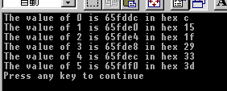
Now explain increment of address is 4 instead of 1.

因为是int型数组，每一个int变量占有4个字符

3.5

Modify the above program with the same output with pointer instead of array a[].

Write down the program

#include <iostream>
#include <stdio.h>
#include <ctype.h>
#include <conio.h>
#include <string.h>
#include <stdlib.h>

void main()
{
int a[7] = {12, 21, 31, 41, 51, 61};
int *ptr = a;
for (int i = 0; i <6; ++i,ptr++)
printf("The value of %d is %x in hex %x \n", i, ptr, *ptr);
}

Further discussion

You don’t need answer the following question, just think about it.
void main()
{
char a[4];
char b[3];
char c;
}
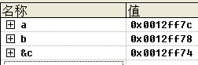

why increment of address is 4 for array b and character c.
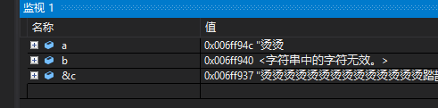
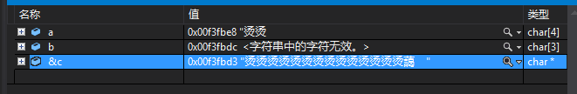
为什么我电脑上增量显示为9？

