NS Lab 3 Answer Sheet
NS3 simulator - TCP Performance Monitoring
Student Name:
Student Surname:
Student Number:

Fahimeh Alizadeh (f.alizadehmoghaddam@uva.nl)
Rex Valkering (rexvalkering@gmail.com)
Sam Ansmink (sam.ansmink@student.uva.nl)
Koen Koning (koenkoning@gmail.com)

Lab date: Nov. 13 & 24, 2014
Hand-in time (submit to blackboard) by Nov. 27, 2014 12:00CEST
Total points: 20 pts
Please provide your answer in the appropriate space for each question

Task 1 – Throughput of TCP client-server connection

Latency | Measured Throughput | Calculated Throughput | Calculation
50ms | 1.33666 Mpbs | 1.311 Mbps | (RWIN * 8) / (2 * delay)
64ms | 1.04442 Mpbs | 1.024 Mbps | (RWIN * 8) / (2 * delay)
96ms | 0.693408 Mpbs | 0.683 Mbps | (RWIN * 8) / (2 * delay)

- The throughput is Inverse proportionality dependent on the RTT. Increasing the latency has direct hit on the throughput.

- Optimal RWIN value: bandwidth(bytes) * latency
Calculation: (5Mbps / 8) * 50 s = 31.25 KBytes
- The new measured throughput is 2.57336 Mbps

Task 2 – Monitoring TCP congestion window
1.
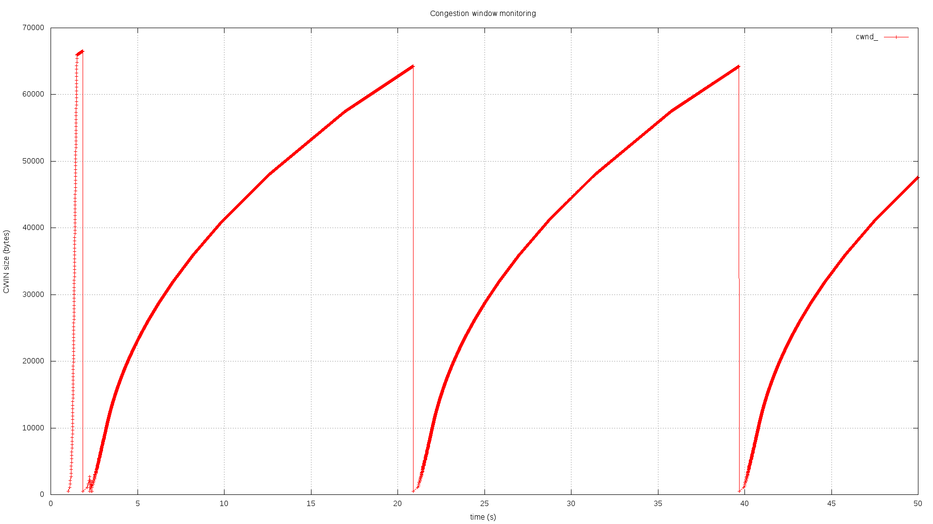
Figure 1: Tahoe – droptail queue = 100
Using a droptail queue of 100, 100 packets can stack up in the queue before packets are dropped. After dropping packets the cwnd is reset, and starts to rebuild slowly( slow-start phase). During the building of the cwnd, the difference in cwnd is getting smaller each step, to avoid filling the queue entirely.

2.a.
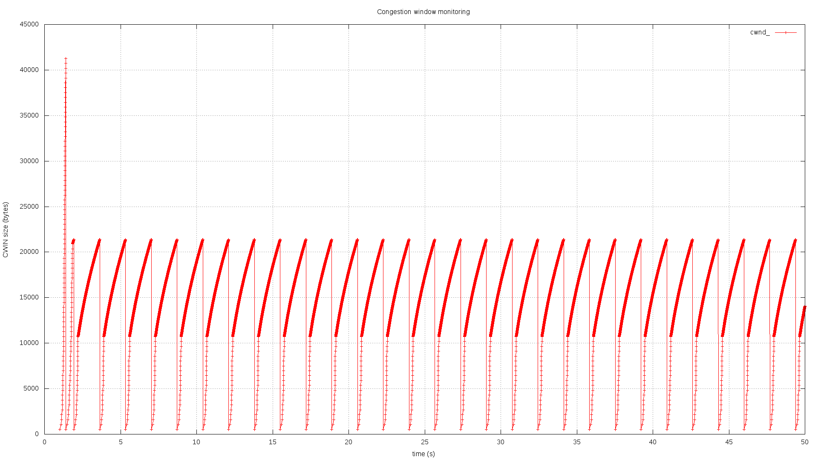

Figure 2: Tahoe, droptail queue = 20

2.b

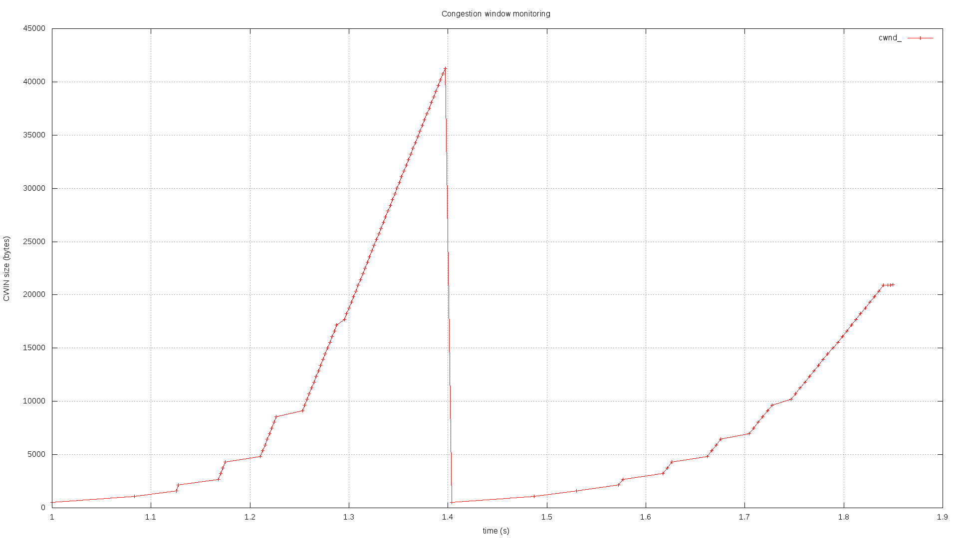
Figure 3: Tahoe, droptail queue = 20 (from 1 until 1.85 secs)

State changes, Tahoe – from 1 until 1.85 secs
Time(sec, accuracy 3 decimal) | cwnd (bytes) | New state
1.000 | 1 | (Initial state)
1.39711 | 41272 | (Triple duplicate ACK)
1.40405 | 536 | (Slow start)
1.72742 | 9648 | (Fast Recovery)

2.c
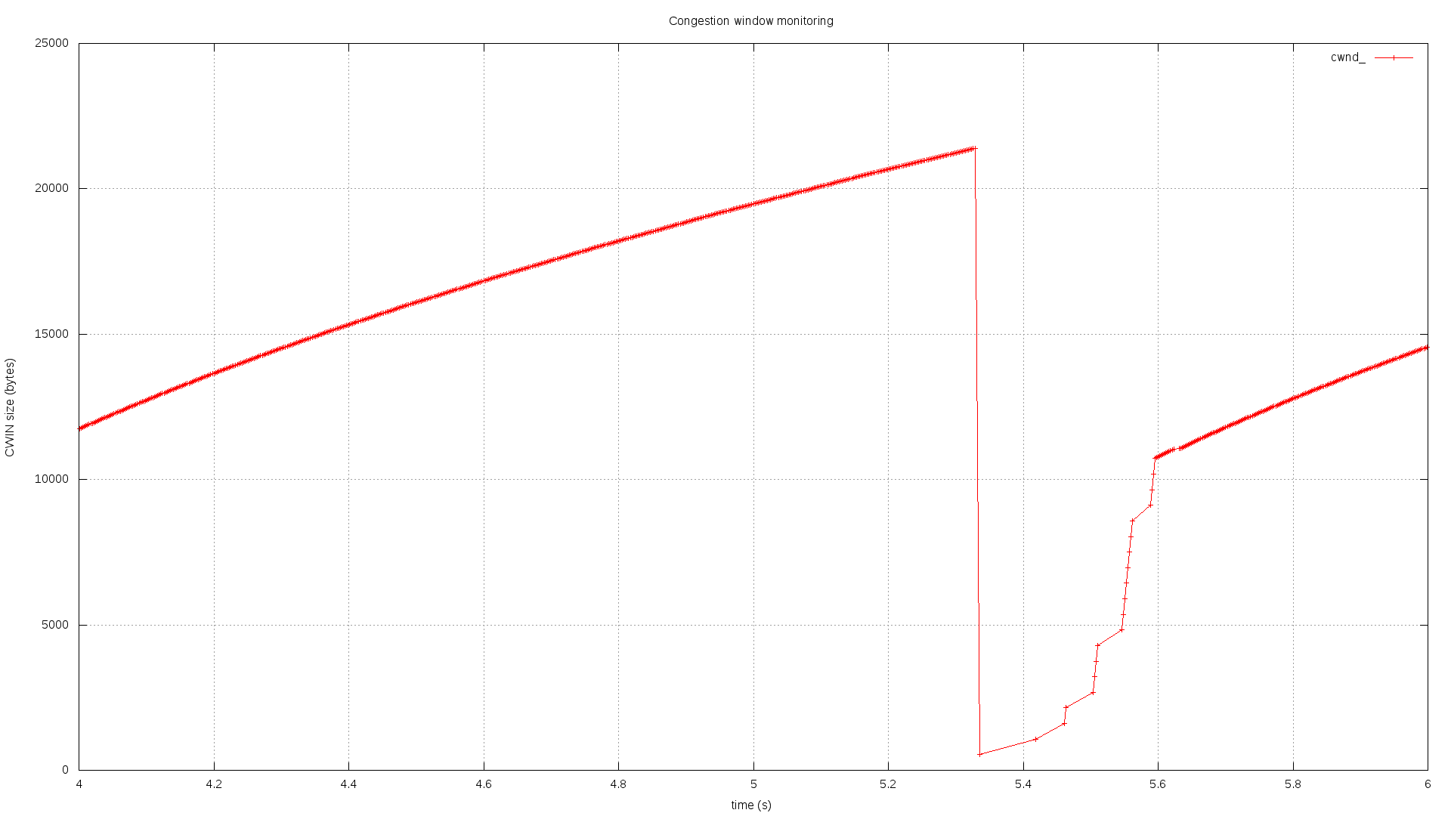
Figure 4: Tahoe, droptail queue = 20 (from 4 until 6 secs)

State changes, Tahoe – from 4 until 6 secs
Time (sec,accuracy 3 decimal) | cwnd (bytes) | New state
4.000 | 11748 | (Initial state)
5.32833 | 21400 | (Congestion avoidance)
5.33526 | 536 | (Fast Recovery)

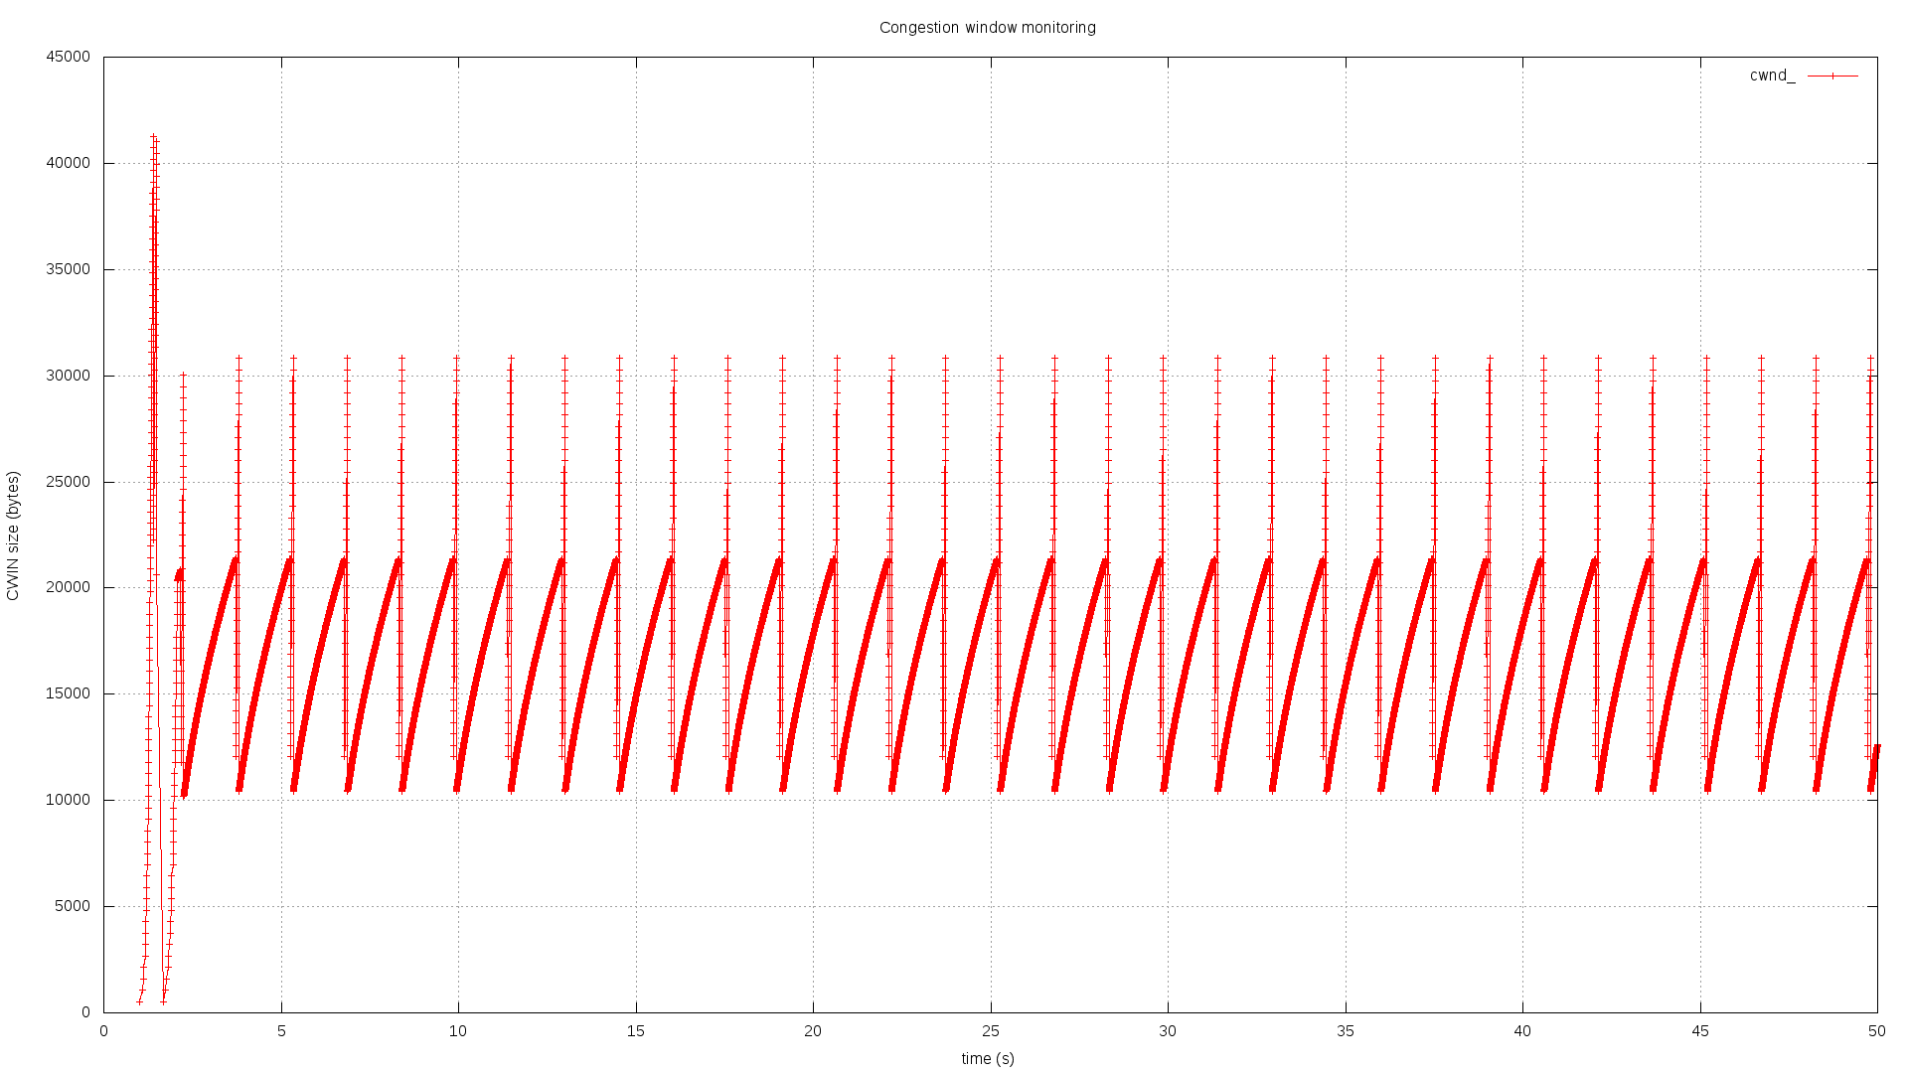
3.a
Figure 5: Reno, droptail queue = 20
3.b
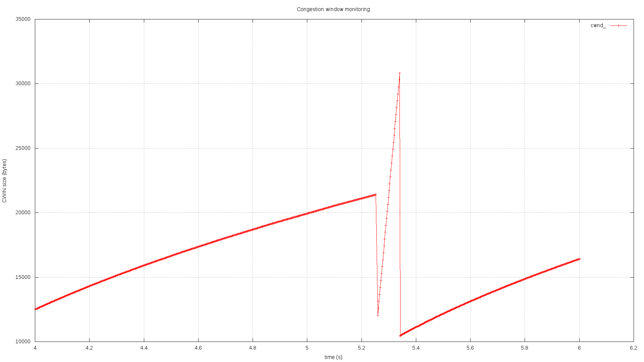
Figure 6: Reno, droptail queue = 20 (from 4 until 6 secs)

State changes, Reno – from 4 until 6 secs
Time (sec, accuracy 3 decimal) | Current cwnd (bytes) | New cwnd (bytes) | New state | Event
4.006 | 12515 | --- | (Initial state) | ---
5.25236 | 21399 | 12060 | (Fast Recovery) | Three duplicate ACK
5.34021 | 30820 | 10452 | (Slow Start) | ACK time-out

Submission
You have to submit:
- Your answers to all the questions. Use this provided answer sheet for you answers and graphs. Provide your answers in the appropriate answer field for each question
- The source codes of the two tasks.
- The graphs and the produced data.
Attention: You have to submit one PDF file that contains all the answers and graphs; the name of the file should be lab3-<lastname_firstletter>.pdf (example: lab1-alizadeh_f.pdf). Additionally you have to submit one zip (or rar) file containing the source codes, the graphs and the data. The name of the file should be: lab3-source-<lastname_firstletter>.zip
Any other kind of submission will not be taken into account. You must also put your full name and your student number at the top of the answer sheet.

